**Supplemental Appendix S1**

**Method 1**

$Asy(\%)=\left(\frac{V_{larger}-V_{lower}}{V_{larger}}\right)×100$

Achilles tendon asymmetry index (*Asy-AT*) was calculated using this equation.

*Asy:* asymmetery index; *Vlarger*: larger value; *Vlower*: lower value.

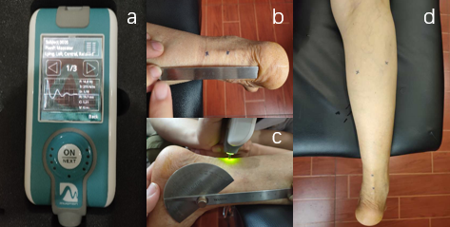

**eFigure 1** Example of measurement performed with the portable digital palpation device (MyotonPRO).

a: MyotonPRO device; b:measurement points of Achilles tendon; c: assessing for Achilles tendon; d: measure points of medial and lateral of gastrocnemius muscle.



a b c

**eFigure 2** comparison of muscle properties in lateral and medial of gastrocnemius.

MG: medial of gastrocnemius; LG: lateral of gastrocnemius; compared to LG, *: P < 0.05; **: P < 0.01.

**eTable 1** Comparison of differences in muscle properties between medial and lateral gastrocnemius.

|  |  |  |  |
| --- | --- | --- | --- |
| Groups | D-MLG | | |
| D-MLG(tone) | D-MLG(stiffness) | D-MLG(elasticity) |
| RHL | 1.510.96 | 26.6521.25 | 0.300.26 |
| RLL | 1.270.84 | 28.6622.47 | 0.320.29 |
| P | 0.114 | 0.776 | 0.968 |

D-MLG: differences in muscle properties between medial and lateral gastrocnemius in the ipsilateral limb; D-MLG(tone): difference in tone; D-MLG(stiffness): difference in stiffness; D-MLG(elasticity): differencein elasticity; RSL: relatively severe leg; RML relatively moderate leg.