Table S1. The ingredients and energy densities of the diets.
Ingredients (g / 100 g diet) | NCD | HFD
Casein | 18.96 | 23.31
L-Cystine | 0.28 | 0.35
Corn Starch | 29.86 | 8.48
Maltodextrin | 3.32 | 11.65
Sucrose | 33.17 | 20.14
Cellulose | 4.74 | 5.83
Soybean Oil | 2.37 | 2.91
Lard | 1.90 | 20.68
Mineral Mix | 2.68 | 3.31
Potassium Citrate, 1 H2O | 1.56 | 1.92
Vitamin Mix | 0.95 | 1.16
Choline Bitartrate | 0.19 | 0.23
Calories supplementation (kcal %)
Proteins | 20 | 20
Carbohydrates | 70 | 35
Fats | 10 | 45
Total calories (kcal / 100 g diet) | 385 | 473

Table S2. The forward primer (F) and reverse primer (R) sequence used for qPCR amplification.
 | Primer name | Sequence (5’ to 3’)
1 | β-actin-F | GTGCTATGTTGCTCTAGACTTCG
2 | β-actin-R | ATGCCACAGGATTCCATACC
3 | PPARγ-F | GCATTTCTGCTCCACACTATGA
4 | PPARγ-R | TCGCACTTTGGTATTCTTGG
5 | PPARα-F | GTCCTCAGTGCTTCCAGAGG
6 | PPARα-R | GGTCACCTACGAGTGGCATT
7 | SHP-F | GGAGTATGCGTACCTGAAG
8 | SHP-R | TGCCTGGAATGTTCTTGAG
9 | FAS-F | TGATGTGGAACACAGCAAG
10 | FAS-R | GGCTGTGGTGACTCTTAGTGATAA
11 | SREBP-1c-F | CCAGCGGCTGCCTTCACACA
12 | SREBP-1c-R | CCAGCCGAAAAGCGAGGCCA
13 | CYP7A1-F | TGGGCATCTCAAGCAAACAC
14 | CYP7A1-R | TCATTGCTTCAGGGCTCCTG

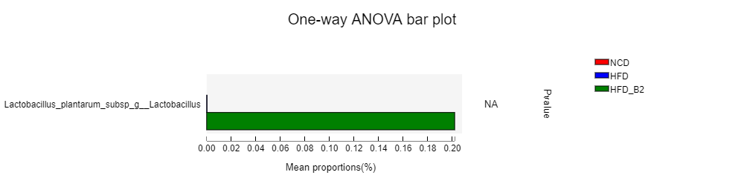
Figure S1. Effects of Lactobacillus plantarum B2 on gut microbiota at Lactobacillus plantarum species in HFD-fed mice.

