Supporting information

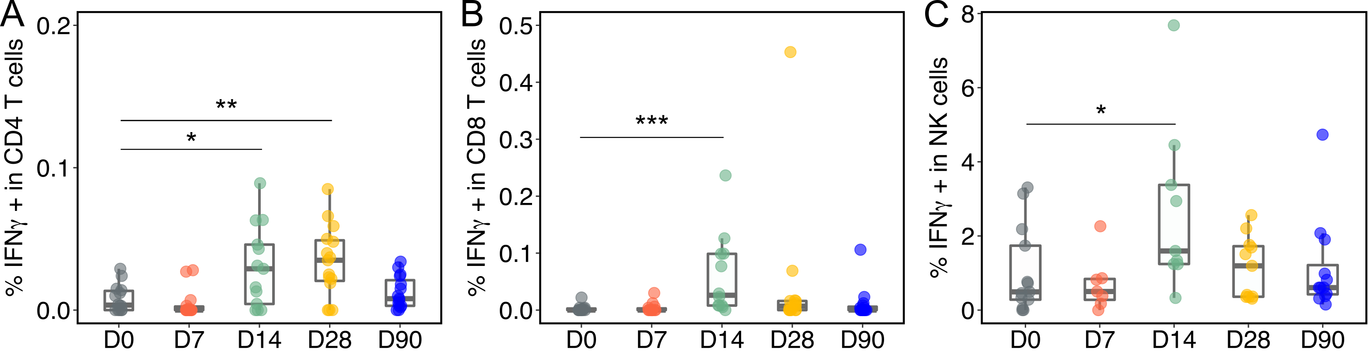
S Fig 1. Kinetics of vaccinia-specific T-cell and NK-cell responses after rTV/HIV-1 boost vaccination.

Vaccinia virus-specific CD4⁺ T-cell (A), CD8⁺ T-cell (B) and NK-cell (C) responses as assessed by intracellular staining assay upon vaccinia antigen specific stimulations. Individual values are presented in box plots. P values of the significance of the difference across two given time points were calculated by the Wilcoxon test.

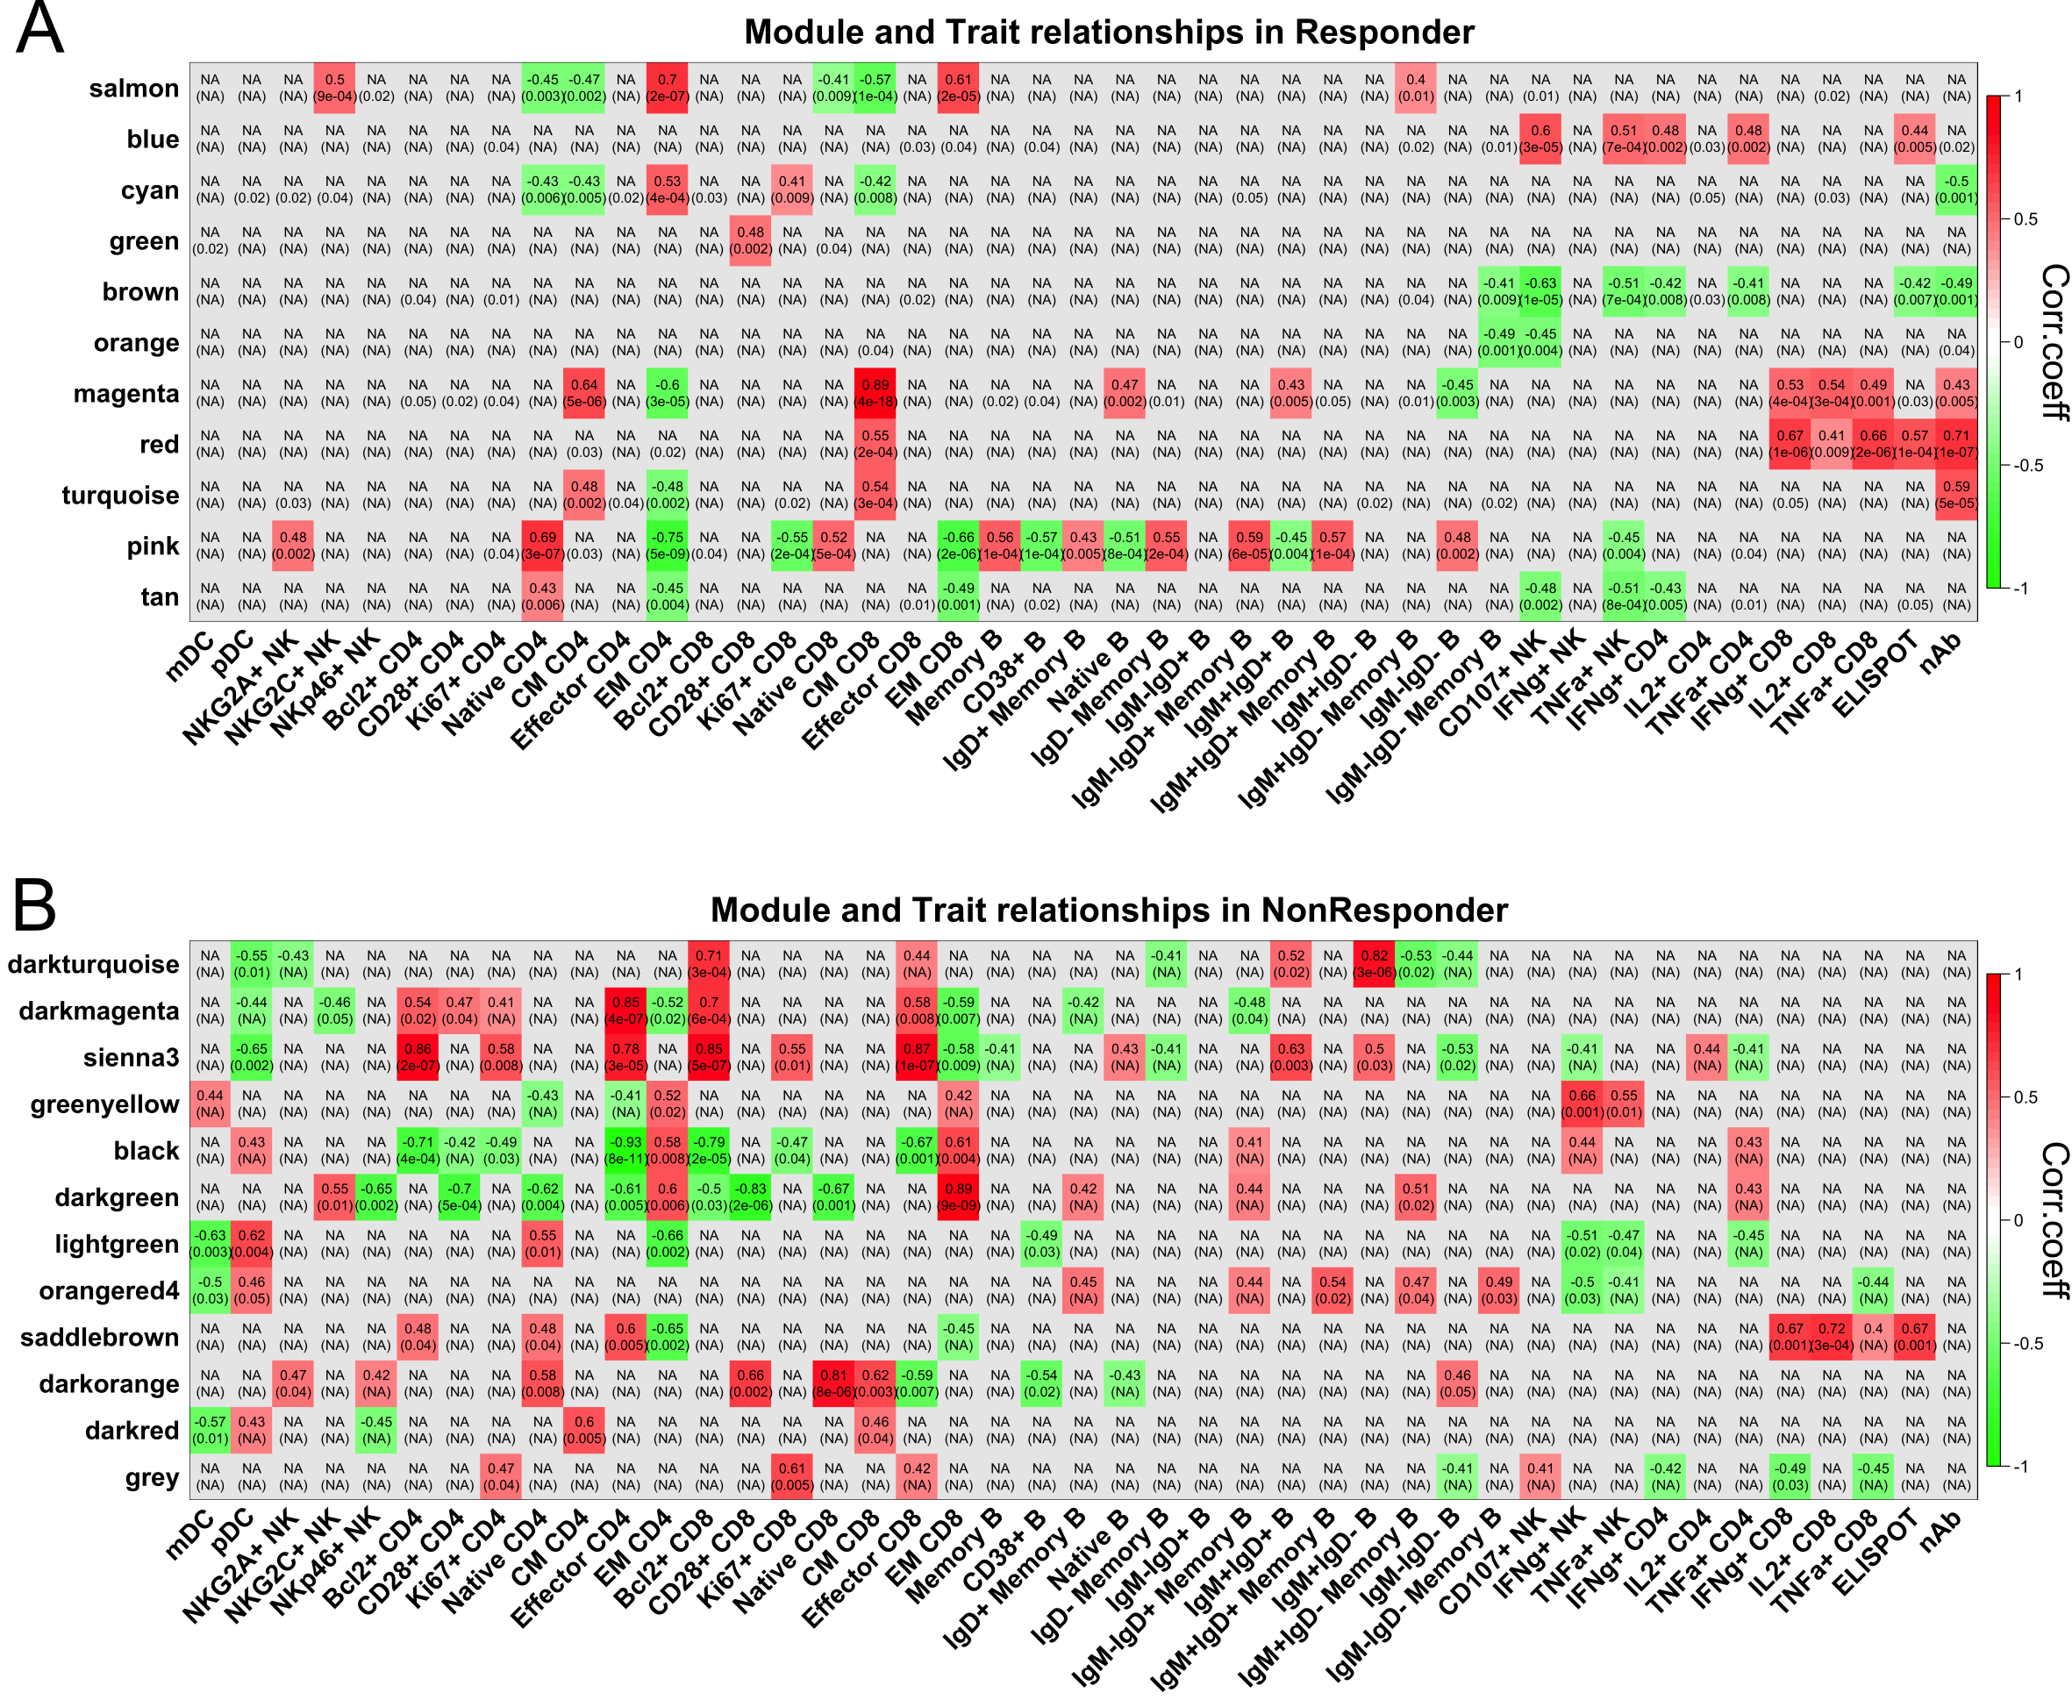
S Fig 2. WGCNA co-expression network in Rs and NRs.

Correlations of WGCNA modules and immune response readouts in Rs (A) and NRs (B). Each row in each table corresponds to a module, and each column to an immune response readout. Numbers in the table report the correlations of the corresponding module and immune response readouts. P-values are shown below the correlations in parentheses. The strength and direction of the correlation are indicated by cell shading (red = positive correlation; green = negative correlation).

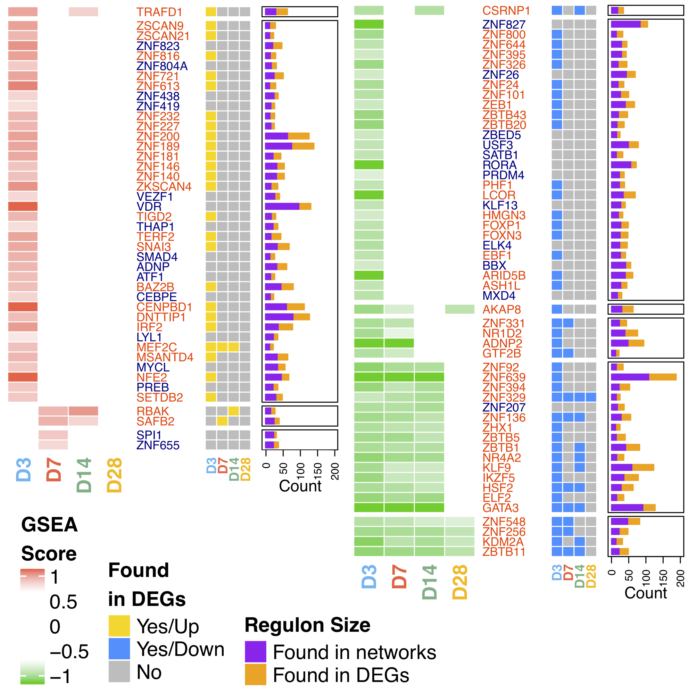
S Fig 3. Reconstruction of transcriptional networks in NRs
Transcriptional networks were reconstructed with expression data in NRs. The identified transcriptional regulatory units were found via network reconstruction. Gene names are shown in red; a yellow square indicates that the DEG was upregulated on the designated time-point, a blue square indicates that the DEG was downregulated on the designated time-point, and a gray square indicates that the DEG was not significantly differentially expressed on the designated time-point. The size of each regulon manipulated by each TF is given in the stacked bar plot. Purple indicates regulons found through the network analysis; mustard indicates regulons present as the DEGs.

S Table 1. Antibodies included in the FACS panels
Antibody | Catalogue | Company | Assay
CD123-FITC | 558663 | BD | Monocytes and DC phenotype
CD19-PE | 555413 | BD | Monocytes and DC phenotype
CD3-ECD | IM2705U | Beckman | Monocytes and DC phenotype
CD11c-PECY5 | 551077 | BD | Monocytes and DC phenotype
CD56-PECY7 | 335791 | BD | Monocytes and DC phenotype
HLADR-APC | 559866 | BD | Monocytes and DC phenotype
CD14-A700 | 557923 | BD | Monocytes and DC phenotype
CD16-APCH7 | 560195 | BD | Monocytes and DC phenotype
CD3-FITC | 555339 | BD | NK phenotype
NKG2C-PERCP | FAB138C | RD | NK phenotype
NKG2A-PE | FAB1059P | RD | NK phenotype
CD20-ECD | IM3607U | Beckman | NK phenotype
CD56-PECY7 | 335791 | BD | NK phenotype
NKP46-APC | 558051 | BD | NK phenotype
CD14-Ax700 | 557923 | BD | NK phenotype
CD16-APCH7 | 560195 | BD | NK phenotype
IgD-FITC | 555778 | BD | B cell phenotype
CD38-PERCP | 551400 | BD | B cell phenotype
CD20-ECD | IM3607U | Beckman | B cell phenotype
CD27-APCCY7 | 560222 | BD | B cell phenotype
IgM-APC | 551062 | BD | B cell phenotype
CD3-Ax700 | 557943 | BD | B cell phenotype
CD19-PECy7 | 557835 | BD | B cell phenotype
TNFα-FITC | 554512 | BD | NK function
CD3-PERCP | 347344 | BD | NK function
CD14-PE | 555398 | BD | NK function
CD19-ECD | A07770 | Beckman | NK function
CD56-PECY7 | 335791 | BD | NK function
CD107a-APC | 560664 | BD | NK function
IFNγ-Ax700 | 557995 | BD | NK function
CD16-APCH7 | 560195 | BD | NK function
CD154-FITC | 555699 | BD | T cell function
CD8-PERCP | 347314 | BD | T cell function
IL2-PE | 559334 | BD | T cell function
CD3-ECD | IM2705U | Beckman | T cell function
CD4-PECY7 | 557852 | BD | T cell function
TNFα-APC | 340534 | BD | T cell function
IFNγ-Ax700 | 557995 | BD | T cell function
CD14-APCH7 | 557831 | BD | T cell function

