Supplementary Material

Supplementary Figures and Tables

Supplementary Figures
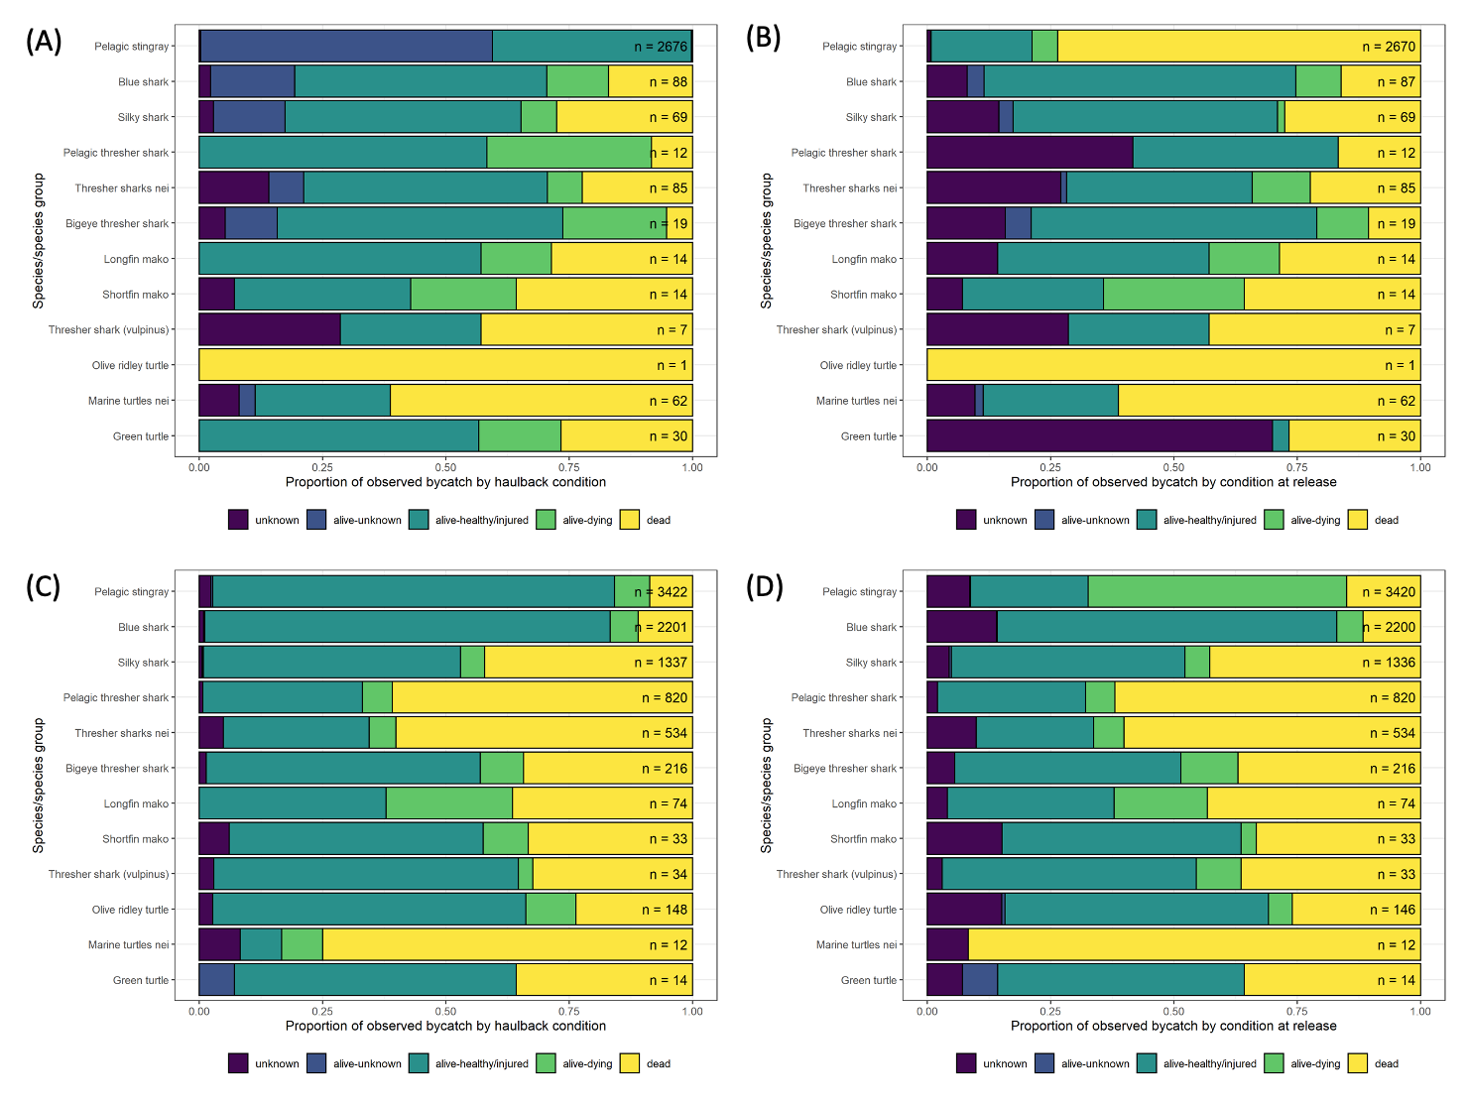
Supplementary Figure 1. Condition at haulback (left) and release (right), respectively, of Species of Special Interest as a proportion of total observed catch of each taxon (n= ) as recorded by (A, B) Electronic Monitoring and (C, D) On-board observers.
(A)
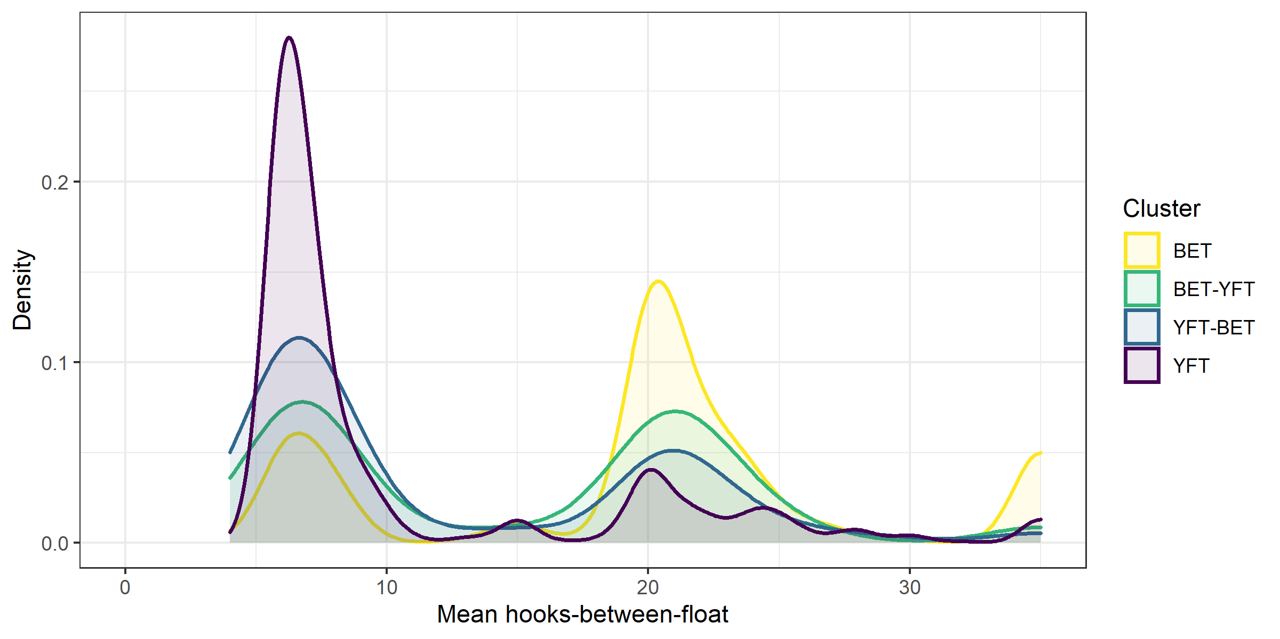
(B)
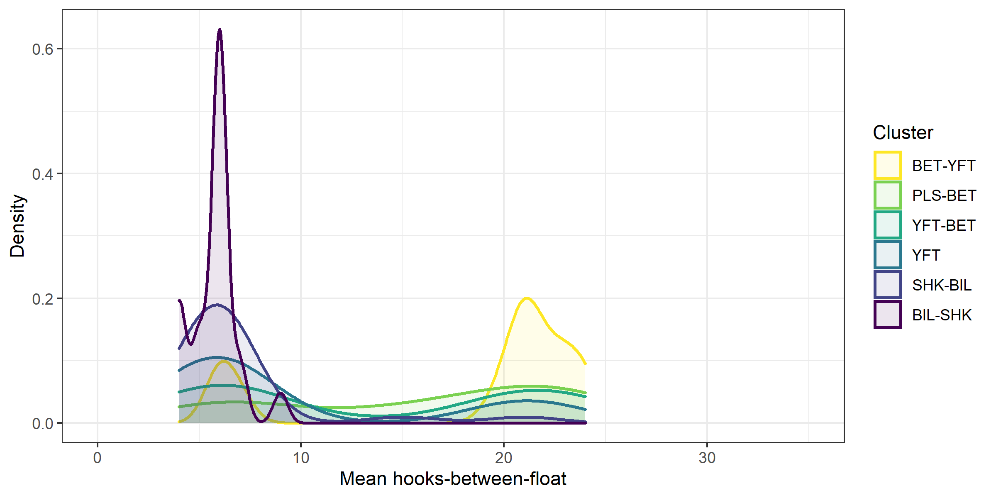
Supplementary Figure 2. Density plots of catch composition cluster against mean hooks-between-float using A) logbook data, and B) observer data.

Supplementary Tables
Supplementary Table 1: Degrees of freedom (d.f. – effective degrees of freedom for splines), Chi squared statistics and approximate p-values for terms of the catch rate models.
Supplementary Table 2: Estimated catch rates (numbers per ‘000 hooks, 95% confidence intervals provided in parentheses) for the locally-based and distant water longline fleets for selected species, using observer data from 2007 to 2019. Species are ranked by descending catch rates across both fleets.
Supplementary Table 3: Estimated annual catches (numbers, 95% confidence intervals provided in parentheses) from 2010 to 2019 for the locally-based and distant-water longline fleets for selected species and species groups. Species/species groups are ranked by descending estimated catch across both fleets.
Supplementary Table 4: Estimated catch rates (numbers per ‘000 hooks, 95% confidence intervals provided in parentheses) for the distant water longline fleet operating outside and inside the limits of the DFZ, for selected species/species groups, using observer data from 2015 to 2019.

Supplementary Table 5: Catch of all taxa in numbers and their percentage contribution to total longline catch recorded in each of the three data sources used in this study (EM, observer, logbook). Teleosts (tunas, billfishes and other finfishes) with < 10 records were excluded. Global status as per the IUCN Red List of Threatened Species is as follows - NA: Not Assessed, LC: Least Concern, NT: Near Threatened, VU: Vulnerable, EN: Endangered, CR: Critically Endangered.
 |  |  | EM |  | Observer |  | Logbook
 | Taxon | IUCN | Number | Percentage | Number | Percentage | Number | Percentage
Tunas |  |  | 5997 | 46.9% | 30504 | 56.4% | 856055 | 91.0%
 | Thunnus albacares | NT | 3765 | 29.4% | 14002 | 25.9% | 468241 | 49.8%
 | Thunnus obesus | VU | 2011 | 15.7% | 14787 | 27.3% | 370964 | 39.4%
 | Thunnus alalunga | NT | 75 | 0.6% | 947 | 1.8% | 15656 | 1.7%
 | Katsuwonus pelamis | LC | 104 | 0.8% | 564 | 1.0% | 917 | 0.1%
 | Acanthocybium solandri | LC | 38 | 0.3% | 169 | 0.3% | 143 | 0.0%
 | Thunnus orientalis | VU | 1 | 0.0% | 5 | 0.0% | 118 | 0.0%
 | Thunnini |  |  | 0.0% | 25 | 0.0% |  | 0.0%
Billfishes |  |  | 358 | 2.8% | 2982 | 5.5% | 38342 | 4.1%
 | Xiphias gladius | LC | 162 | 1.3% | 1491 | 2.8% | 17324 | 1.8%
 | Makaira nigricans | VU | 15 | 0.1% | 667 | 1.2% | 14641 | 1.6%
 | Istiophorus platypterus | LC | 51 | 0.4% | 496 | 0.9% | 5227 | 0.6%
 | Makaira indica | DD | 9 | 0.1% | 76 | 0.1% | 491 | 0.1%
 | Istophoridae - Xiphiidae |  | 53 | 0.4% | 5 | 0.0% | 466 | 0.0%
 | Tetrapturus audax | NT | 60 | 0.5% | 112 | 0.2% | 193 | 0.0%
 | Tetrapturus angustirostris | DD | 8 | 0.1% | 135 | 0.2% |  | 0.0%
Key sharks |  |  | 325 | 2.5% | 6273 | 11.6% | 26965 | 2.9%
 | Carcharhinus falciformis | VU | 69 | 0.5% | 1603 | 3.0% | 16668 | 1.8%
 | Prionace glauca | NT | 88 | 0.7% | 2556 | 4.7% | 8334 | 0.9%
 | Alopias spp. |  | 85 | 0.7% | 545 | 1.0% | 991 | 0.1%
 | Alopias pelagicus | VU | 12 | 0.1% | 857 | 1.6% |  | 0.0%
 | Isurus spp. |  | 8 | 0.1% |  | 0.0% | 597 | 0.1%
 | Alopias superciliosus | VU | 19 | 0.1% | 320 | 0.6% |  | 0.0%
 | Alopias vulpinus | VU | 7 | 0.1% | 106 | 0.2% | 161 | 0.0%
 | Carcharhinus longimanus | CR | 4 | 0.0% | 102 | 0.2% | 99 | 0.0%
 | Isurus paucus | EN | 14 | 0.1% | 82 | 0.2% | 2 | 0.0%
 | Isurus oxyrinchus | EN | 14 | 0.1% | 50 | 0.1% | 11 | 0.0%
 | Sphyrna spp. |  |  | 0.0% |  | 0.0% | 57 | 0.0%
 | Lamna nasus | VU |  | 0.0% |  | 0.0% | 42 | 0.0%
 | Sphyrna zygaena | VU |  | 0.0% | 30 | 0.1% |  | 0.0%
 | Mobula japanica | EN | 1 | 0.0% | 8 | 0.0% |  | 0.0%
 | Mobulidae |  | 1 | 0.0% | 7 | 0.0% |  | 0.0%
 | Sphyrna mokarran | EN |  | 0.0% | 1 | 0.0% | 3 | 0.0%
 | Mobula spp. |  | 2 | 0.0% | 2 | 0.0% |  | 0.0%
 | Sphyrna lewini | EN |  | 0.0% | 3 | 0.0% |  | 0.0%
 | Manta birostris | EN | 1 | 0.0% | 1 | 0.0% |  | 0.0%
Other sharks |  |  | 3398 | 26.6% | 4237 | 7.8% | 3651 | 0.4%
 | Pteroplatytrygon violacea | LC | 2676 | 20.9% | 3913 | 7.2% |  | 0.0%
 | Elasmobranchii |  |  | 0.0% |  | 0.0% | 3635 | 0.4%
 | Carcharhinidae |  | 340 | 2.7% | 38 | 0.1% |  | 0.0%
 | Selachimorpha (Pleurotremata) |  | 236 | 1.8% | 72 | 0.1% |  | 0.0%
 | Pseudocarcharias kamoharai | LC | 8 | 0.1% | 154 | 0.3% |  | 0.0%
 | Rajiformes |  | 108 | 0.8% | 9 | 0.0% |  | 0.0%
 | Dasyatididae |  | 28 | 0.2% |  | 0.0% |  | 0.0%
 | Unknown shark |  |  | 0.0% |  | 0.0% | 14 | 0.0%
 | Carcharhinus brachyurus | VU |  | 0.0% | 10 | 0.0% |  | 0.0%
 | Galeocerdo cuvier | NT | 1 | 0.0% | 8 | 0.0% |  | 0.0%
 | Lamnidae nei |  |  | 0.0% | 7 | 0.0% | 2 | 0.0%
 | Carcharhinus plumbeus | VU |  | 0.0% | 6 | 0.0% |  | 0.0%
 | Scymnodon squamulosus | LC |  | 0.0% | 5 | 0.0% |  | 0.0%
 | Squatina tergocellatoides | EN |  | 0.0% | 5 | 0.0% |  | 0.0%
 | Carcharhinus melanopterus | NT |  | 0.0% | 5 | 0.0% |  | 0.0%
 | Carcharhinus altimus | DD |  | 0.0% | 3 | 0.0% |  | 0.0%
 | Squalidae |  | 1 | 0.0% |  | 0.0% |  | 0.0%
 | Carcharhinus galapagensis | LC |  | 0.0% | 1 | 0.0% |  | 0.0%
 | Carcharhinus leucas | NT |  | 0.0% | 1 | 0.0% |  | 0.0%
Other finfishes |  |  | 2604 | 20.4% | 9883 | 18.3% | 15626 | 1.7%
 | Unknown teleost |  | 1198 | 9.4% | 108 | 0.2% | 5326 | 0.6%
 | Teleostii |  |  | 0.0% | 1 | 0.0% | 4520 | 0.5%
 | Ruvettus pretiosus | LC | 85 | 0.7% | 110 | 0.2% | 2643 | 0.3%
 | Coryphaena hippurus | LC | 23 | 0.2% | 436 | 0.8% | 2158 | 0.2%
 | Lepidocybium flavobrunneum | LC | 235 | 1.8% | 1303 | 2.4% | 769 | 0.1%
 | Alepisaurus ferox | LC | 39 | 0.3% | 2250 | 4.2% |  | 0.0%
 | Gempylus serpens | LC | 252 | 2.0% | 1652 | 3.1% |  | 0.0%
 | Alepisaurus spp. |  | 358 | 2.8% | 1474 | 2.7% |  | 0.0%
 | Bramidae |  | 13 | 0.1% | 1405 | 2.6% |  | 0.0%
 | Lampris guttatus | LC | 42 | 0.3% | 325 | 0.6% | 54 | 0.0%
 | Taractichthys steindachneri | NA | 175 | 1.4% | 221 | 0.4% | 4 | 0.0%
 | Sphyraena barracuda | LC | 37 | 0.3% | 222 | 0.4% | 2 | 0.0%
 | Sphyraena spp. |  |  | 0.0% | 13 | 0.0% | 145 | 0.0%
 | Taractichthys longipinnis | LC |  | 0.0% | 144 | 0.3% |  | 0.0%
 | Taractes rubescens | LC | 3 | 0.0% | 118 | 0.2% |  | 0.0%
 | Alepisaurus brevirostris | LC | 70 | 0.5% | 9 | 0.0% |  | 0.0%
 | Gempylidae |  | 41 | 0.3% |  | 0.0% |  | 0.0%
 | Mola mola | VU | 2 | 0.0% | 16 | 0.0% |  | 0.0%
 | Mene maculata | NA | 15 | 0.1% |  | 0.0% |  | 0.0%
 | Omosudis lowei | NA |  | 0.0% | 13 | 0.0% |  | 0.0%
 | Elagatis bipinnulata | LC | 4 | 0.0% | 8 | 0.0% |  | 0.0%
Turtles |  |  | 105 | 0.8% | 191 | 0.4% |  | 0.0%
 | Lepidochelys olivacea | VU | 1 | 0.0% | 150 | 0.3% |  | 0.0%
 | Testudinata |  | 62 | 0.5% | 15 | 0.0% |  | 0.0%
 | Chelonia mydas | EN | 30 | 0.2% | 16 | 0.0% |  | 0.0%
 | Eretmochelys imbricata | CR | 10 | 0.1% | 5 | 0.0% |  | 0.0%
 | Dermochelys coriacea | VU | 2 | 0.0% | 4 | 0.0% |  | 0.0%
 | Caretta caretta | VU |  | 0.0% | 1 | 0.0% |  | 0.0%
Mammals |  |  | 1 | 0.0% | 7 | 0.0% |  | 0.0%
 | Odontoceti |  |  | 0.0% | 6 | 0.0% |  | 0.0%
 | Delphinidae |  | 1 | 0.0% |  | 0.0% |  | 0.0%
 | Kogia simus | LC |  | 0.0% | 1 | 0.0% |  | 0.0%
Birds |  |  |  | 0.0% | 4 | 0.0% |  | 0.0%
 | Puffinus spp |  |  | 0.0% | 2 | 0.0% |  | 0.0%
 | Birds unspecified |  |  | 0.0% | 2 | 0.0% |  | 0.0%
Total |  |  | 12788 |  | 54081 |  | 940639

