Supplementary Material
2D/3D Copper-Based Metal-Organic Frameworks for Electrochemical Detection of Hydrogen Peroxide

Xiangjian Guo^{1,2}, Chuyan Lin¹, Minjun Zhang¹, Xuewei Duan¹, Xiangru Dong²,Duanping Sun²*, Jianbin Pan³*, Tianhui You¹*

¹ School of Nursing, Guangdong Provincial Key Laboratory of Pharmaceutical Bioactive Substances, Guangdong Pharmaceutical University, Guangzhou 510006, Guangdong, China
² Center for Drug Research and Development, Guangdong Provincial Key Laboratory of Pharmaceutical Bioactive Substances, Guangdong Pharmaceutical University, Guangzhou 510006, China
³ State Key Laboratory of Analytical Chemistry for Life Science, School of Chemistry and Chemical Engineering, Nanjing University, Nanjing 210023, China

* Correspondence:
Duanping. Sun, Jianbin. Pan, Tianhui. You.

sundp@gdpu.edu.cn, jbpan@nju.edu.cn, youth888cn@aliyun.com
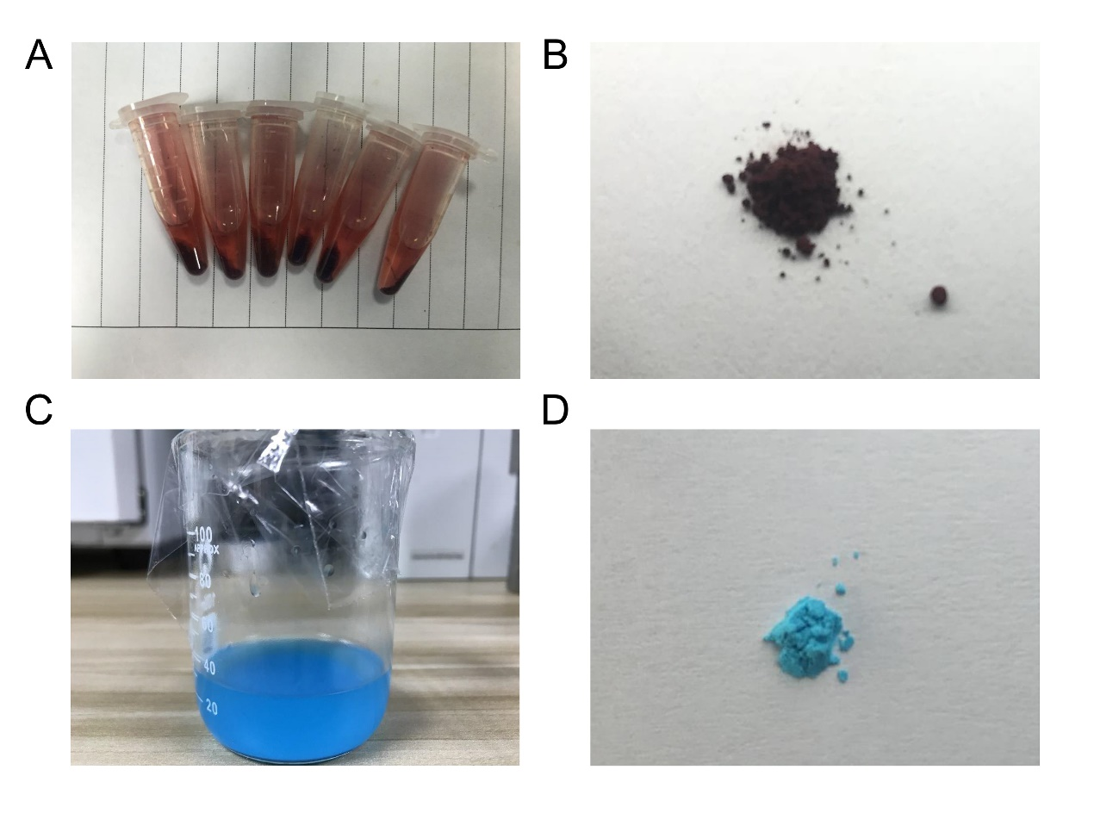
Figure S1. (A, B) Synthesis of Cu-TCPP. (C, D) Synthesis of HKUST-1.

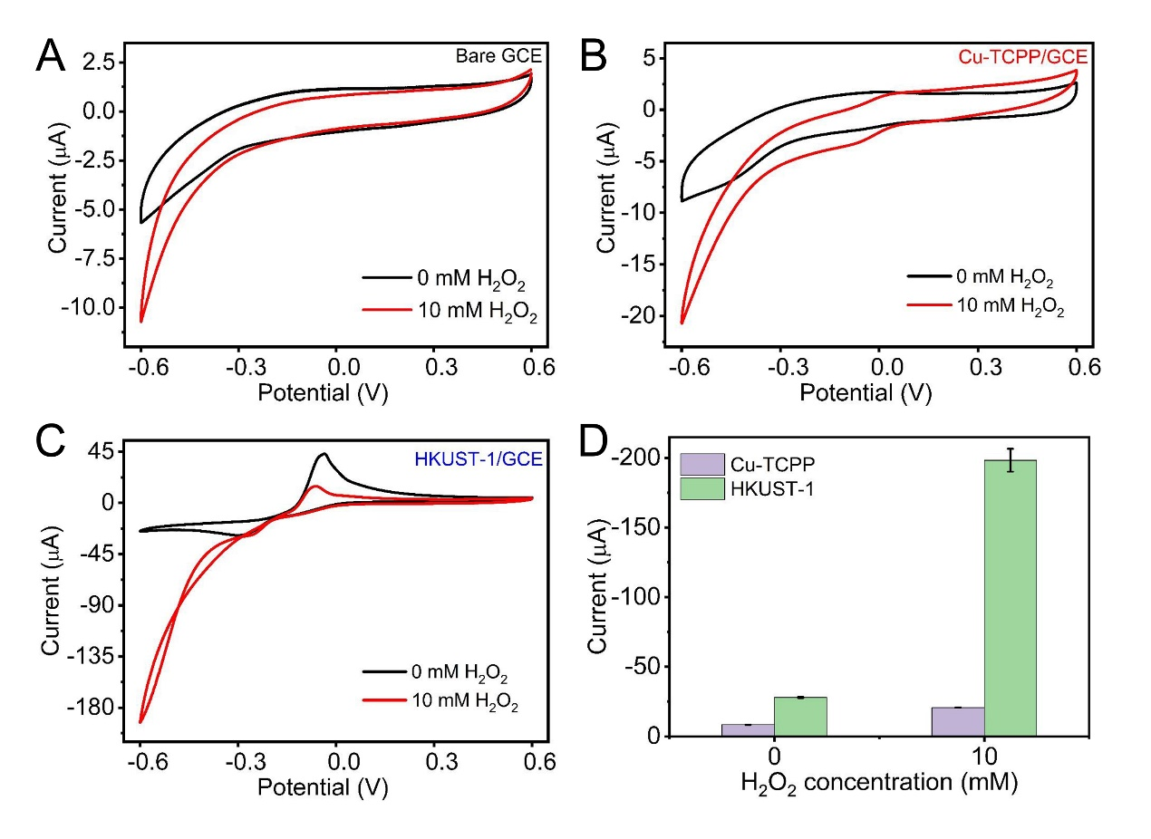
Figure S2. (A,B,C) CV curves of GCE, Cu-TCPP/GCE, HKUST-1/GCE in 0.1 M PBS (the black curve) and 10 mM H₂O₂ (the red curve). (D) Comparison of the current peak of Cu-TCPP/GCE and HKUST-1/GCE in 0.1 M PBS with absent or present 10 mM H₂O₂.(n=3)
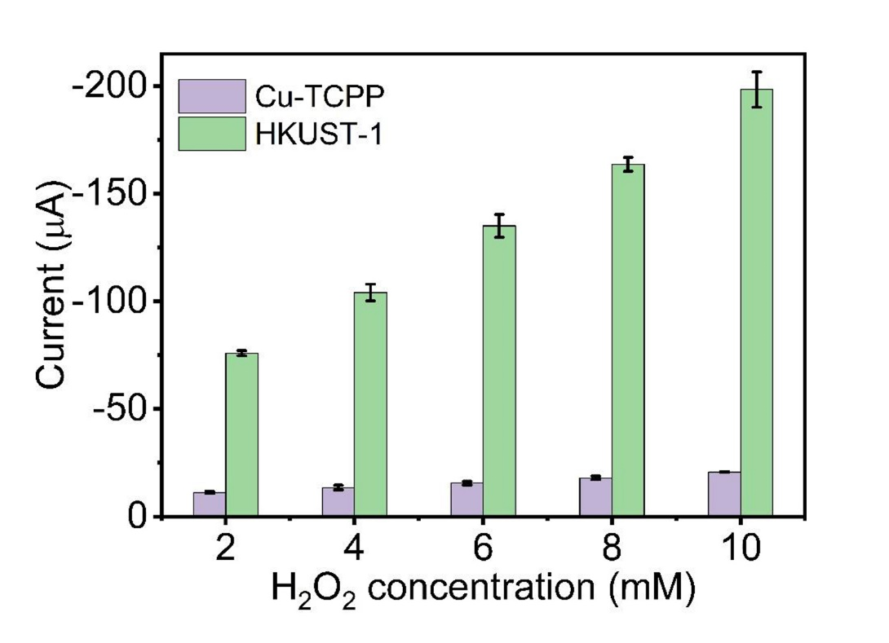
Figure S3. Histograms of the current peak of Cu-TCPP/GCE and HKUST-1/GCE in 0.1 M PBS at different H₂O₂ concentrations (2, 4, 6, 8, and 10 mM) (n=3).

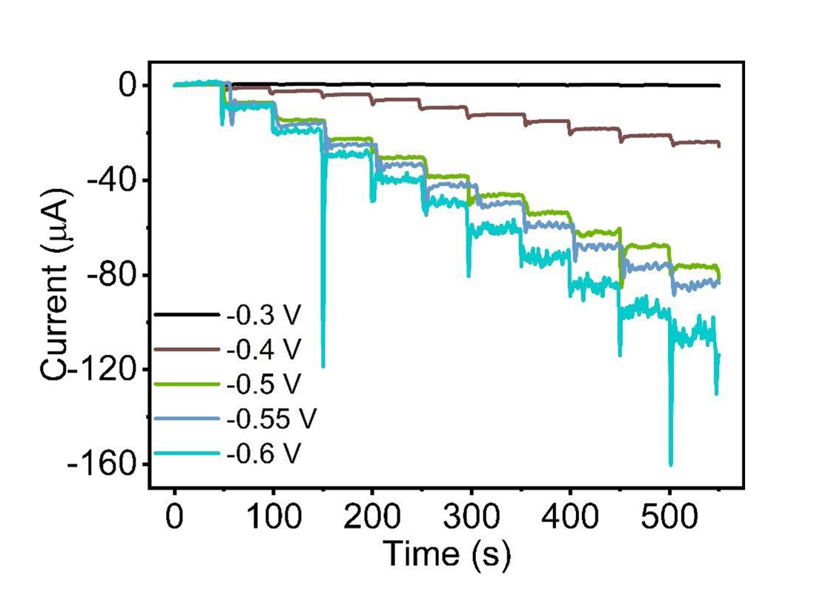
Figure S4. Amperometric responses of HKUST-1/GCE with different applied potentials (-0.3, -0.4, -0.5, -0.55, -0.6 V) by successively injecting 0.4 mM H₂O₂ in PBS solution.

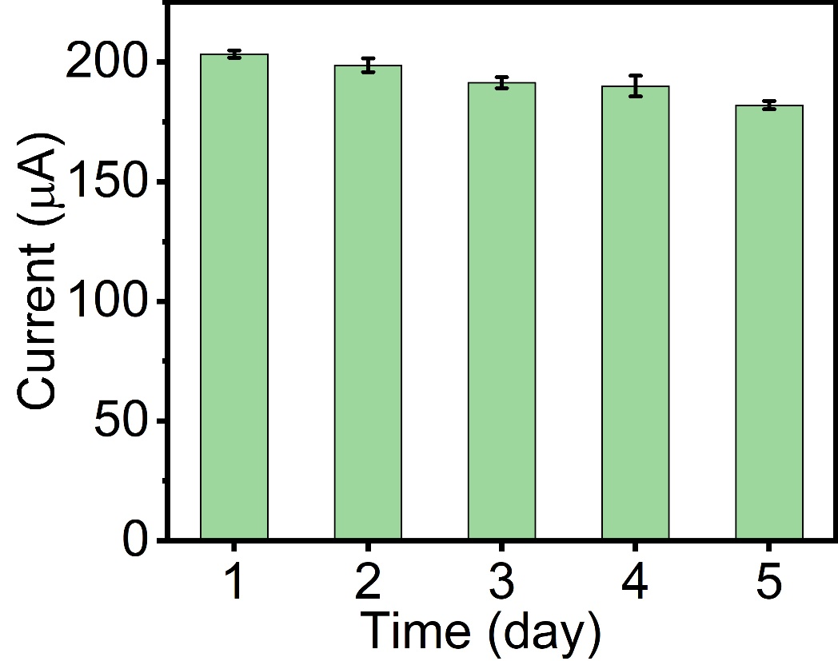
Figure S5. Histograms of stability test over 5 day by CV measurements in PBS solution containing 10 mM H₂O₂ at a scan rate of 100 mV·s⁻¹.

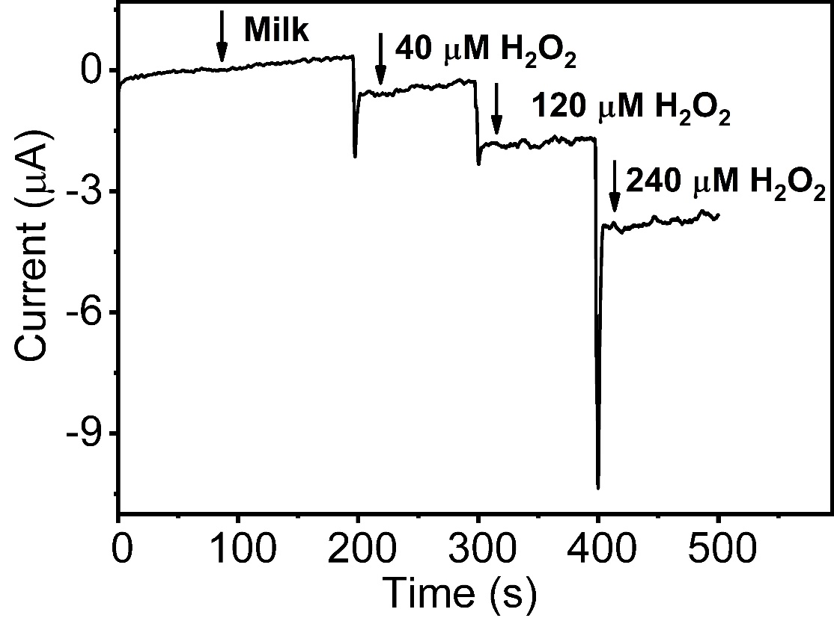
Figure S6. Amperometric responses of HKUST-1/GCE to the successive addition of milk sample containing different concentration of H₂O₂ (0, 40, 80, 120 μM) in PBS solution at an applied potential of -0.5 V.

