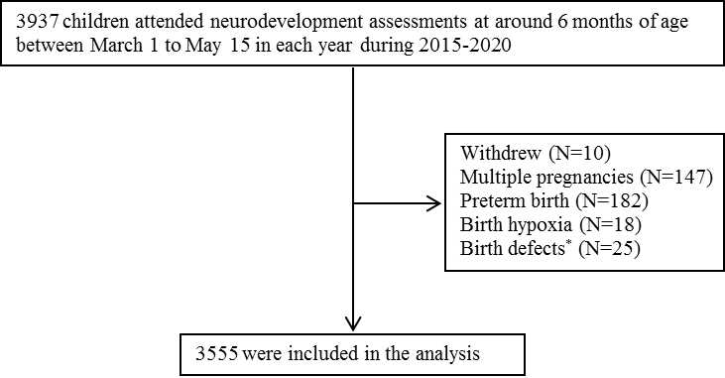
(A)

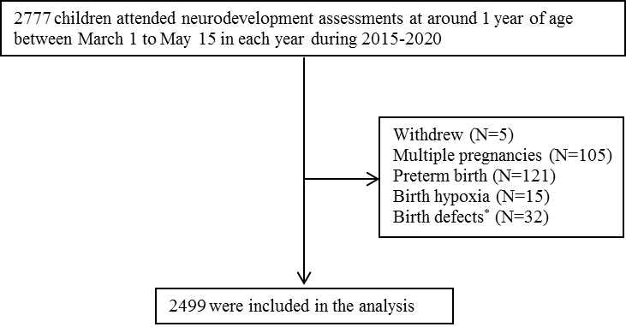
(B)

Supplementary Figure 1. Selection process of the present study. A: children attending neurodevelopment assessments at around six months of age; B: children attending neurodevelopment assessments at around one year of age. *Restricted to birth defects that might affect neurodevelopmental outcomes (including major birth defects and anomalies that affect language and motor functions).

Supplementary Table 1. The prevalence (%) of neurodevelopmental delay by age, year, and birth order.
Cognitive at 6 months |  |  |  | Cognitive at 1 year
Year | All | First-born | Later-born | Year | All | First-born | Later-born
2015 | 6·6 | 6·9 | 4·3 | 2015 | 3·1 | 3·0 | 5·0
2016 | 4·4 | 3·2 | 9·5 | 2016 | 9·4 | 10·2 | 5·6
2017 | 2·4 | 2·4 | 2·3 | 2017 | 1·6 | 1·4 | 2·2
2018 | 4·9 | 4·6 | 5·2 | 2018 | 4·7 | 5·6 | 3·5
2019 | 2·6 | 2·1 | 3·5 | 2019 | 2·9 | 2·5 | 3·7
2020 | 3·5 | 3·1 | 4·4 | 2020 | 5·6 | 5·7 | 5·4
Total | 4·0 | 3·8 | 4·4 | Total | 4·5 | 4·8 | 3·9
Gross motor at 6 months |  |  |  | Gross motor at 1 year
Year | All | First-born | Later-born | Year | All | First-born | Later-born
2015 | 7·9 | 7·8 | 8·5 | 2015 | 15·4 | 16·1 | 5·0
2016 | 11·9 | 12·1 | 10·8 | 2016 | 20·8 | 21·3 | 18·5
2017 | 4·9 | 4·8 | 5·1 | 2017 | 16·3 | 17·3 | 13·3
2018 | 8·1 | 6·4 | 9·9 | 2018 | 16·5 | 16·2 | 16·9
2019 | 5·7 | 4·9 | 7·0 | 2019 | 14·2 | 14·0 | 14·5
2020 | 9·2 | 7·3 | 13·7 | 2020 | 13·3 | 14·8 | 9·3
Total | 7·7 | 7·1 | 8·9 | Total | 15·9 | 16·3 | 15·0
Fine motor at 6 months |  |  |  | Fine motor at 1 year
Year | All | First-born | Later-born | Year | All | First-born | Later-born
2015 | 11·3 | 11·6 | 8·5 | 2015 | 2·5 | 2·3 | 5·0
2016 | 10·9 | 10·2 | 13·5 | 2016 | 6·2 | 5·5 | 9·3
2017 | 4·8 | 4·3 | 5·6 | 2017 | 2·2 | 2·9 | 0·0
2018 | 9·2 | 8·3 | 10·4 | 2018 | 1·6 | 2·1 | 1·0
2019 | 6·2 | 6·4 | 5·8 | 2019 | 0·8 | 0·3 | 1·6
2020 | 7·3 | 6·8 | 8·7 | 2020 | 6·0 | 4·8 | 9·3
Total | 8·1 | 7·9 | 8·4 | Total | 2·6 | 2·6 | 2·7
Communication at 6 months |  |  |  | Communication at 1 year
Year | All | First-born | Later-born | Year | All | First-born | Later-born
2015 | 1·1 | 1·0 | 2·1 | 2015 | 27·9 | 28·4 | 20·0
2016 | 0·3 | 0·3 | 0·0 | 2016 | 33·2 | 32·0 | 38·9
2017 | 0·5 | 0·5 | 0·5 | 2017 | 18·5 | 15·8 | 26·7
2018 | 0·7 | 0·6 | 0·8 | 2018 | 26·5 | 26·8 | 26·0
2019 | 1·2 | 1·9 | 0·0 | 2019 | 25·5 | 24·1 | 27·7
2020 | 1·5 | 1·0 | 2·5 | 2020 | 35·8 | 34·3 | 40·0
Total | 0·9 | 0·9 | 0·8 | Total | 27·7 | 27·2 | 28·7
Personal-social at 6 months |  |  |  | Personal-social at 1 year
Year | All | First-born | Later-born | Year | All | First-born | Later-born
2015 | 11·9 | 11·9 | 12·8 | 2015 | 7·2 | 7·4 | 5·0
2016 | 16·8 | 17·3 | 14·9 | 2016 | 6·5 | 7·1 | 3·7
2017 | 11·2 | 10·7 | 12·2 | 2017 | 7·1 | 7·9 | 4·6
2018 | 9·0 | 7·7 | 10·7 | 2018 | 4·2 | 3·7 | 4·8
2019 | 8·9 | 8·5 | 9·7 | 2019 | 1·8 | 1·2 | 2·8
2020 | 9·7 | 9·1 | 11·2 | 2020 | 6·7 | 5·7 | 9·3
Total | 10·7 | 10·5 | 11·2 | Total | 4·7 | 4·8 | 4·5
Poor neurodevelopmental outcomeª at 6 months |  |  |  | Poor neurodevelopmental outcomeª at 1 year
Year | All | First-born | Later-born | Year | All | First-born | Later-born
2015 | 5·6 | 5·5 | 6·4 | 2015 | 3·1 | 3·0 | 5·0
2016 | 5·2 | 4·5 | 8·1 | 2016 | 7·8 | 7·9 | 7·4
2017 | 1·5 | 1·9 | 0·9 | 2017 | 3·9 | 5·1 | 0·0
2018 | 3·2 | 2·4 | 4·2 | 2018 | 2·7 | 2·3 | 3·2
2019 | 2·2 | 2·1 | 2·3 | 2019 | 1·4 | 1·0 | 2·0
2020 | 2·4 | 1·6 | 4·4 | 2020 | 3·9 | 2·9 | 6·8
Total | 3·1 | 2·9 | 3·5 | Total | 3·3 | 3·2 | 3·3
ªDefined as developmental delay in more than two domains.

