Supplementary Table 1 Wheat - Correlations between environments within all 3-environment combinations (complete phenotyping trial) and between environments in the 3-environment combinations and the expansion environments. The order of correlations within 3-environment combinations is 1st and 2nd, 1st and 3rd, and 2nd and 3rd. The order of correlations between environment in the 3-environment combinations and the expansion environments corresponds to the order of environments in the 3-environment combinations
 | Environments in the 3-enviroment combination | Correlations between environments within 3-environment combinations | Expansion Environments | Correlation between environment in the 3-environment combinations and the expansion environments
Combination 1 | Year2015_TOS1  Year2015_TOS3  Year2016_TOS1 | 0.84, 0.041, 0.062 | Year2016_TOS3  Year2017_TOS1  Year2017_TOS3 | 0.378, 0.388, 0.167  -0.278, -0.355, 0.199  -0.274, -0.234, 0.21
Combination 2 | Year2015_TOS1  Year2015_TOS3  Year2016_TOS3 | 0.84, 0.378, 0.388 | Year2016_TOS1  Year2017_TOS1  Year2017_TOS3 | 0.041, 0.062, 0.167  -0.278, -0.355, -0.266  -0.274, -0.234, -0.204
Combination 3 | Year2015_TOS1  Year2015_TOS3  Year2017_TOS1 | 0.84, -0.278, -0.355 | Year2016_TOS1  Year2016_TOS3  Year2017_TOS3 | 0.041, 0.062, 0.199  0.378, 0.388, -0.266  -0.274, -0.234, 0.322
Combination 4 | Year2015_TOS1  Year2015_TOS3  Year2017_TOS3 | 0.84, -0.274, -0.234 | Year2016_TOS1  Year2016_TOS3  Year2017_TOS1 | 0.041, 0.062, 0.21  0.378, 0.388, -0.204  -0.278, -0.355, 0.322
Combination 5 | Year2015_TOS1  Year2016_TOS1  Year2016_TOS3 | 0.041, 0.378, 0.167 | Year2015_TOS3  Year2017_TOS1  Year2017_TOS3 | 0.84, 0.062, 0.388  -0.278, 0.199, -0.266  -0.274, 0.21, -0.204
Combination 6 | Year2015_TOS1  Year2016_TOS1  Year2017_TOS1 | 0.041, -0.278, 0.199 | Year2015_TOS3  Year2016_TOS3  Year2017_TOS3 | 0.84, 0.062, -0.355  0.378, 0.167, -0.266  -0.274, 0.21, 0.322
Combination 7 | Year2015_TOS1  Year2016_TOS1  Year2017_TOS3 | 0.041, -0.274, 0.21 | Year2015_TOS3  Year2016_TOS3  Year2017_TOS1 | 0.84, 0.062, -0.234  0.378, 0.167, -0.204  -0.278, 0.199, 0.322
Combination 8 | Year2015_TOS1  Year2016_TOS3  Year2017_TOS1 | 0.378, -0.278, -0.266 | Year2015_TOS3  Year2016_TOS1  Year2017_TOS3 | 0.84, 0.388, -0.355  0.041, 0.167, 0.199  -0.274, -0.204, 0.322
Combination 9 | Year2015_TOS1  Year2016_TOS3  Year2017_TOS3 | 0.378, -0.274, -0.204 | Year2015_TOS3  Year2016_TOS1  Year2017_TOS1 | 0.84, 0.388, -0.234  0.041, 0.167, 0.21  -0.278, -0.266, 0.322
Combination 10 | Year2015_TOS1  Year2017_TOS1  Year2017_TOS3 | -0.278, -0.274, 0.322 | Year2015_TOS3  Year2016_TOS1  Year2016_TOS3 | 0.84, -0.355, -0.234  0.041, 0.199, 0.21  0.378, -0.266, -0.204
Combination 11 | Year2015_TOS3  Year2016_TOS1  Year2016_TOS3 | 0.062, 0.388, 0.167 | Year2015_TOS1  Year2017_TOS1  Year2017_TOS3 | 0.84, 0.041, 0.378  -0.355, 0.199, -0.266  -0.234, 0.21, -0.204
Combination 12 | Year2015_TOS3  Year2016_TOS1  Year2017_TOS1 | 0.062, -0.355, 0.199 | Year2015_TOS1  Year2016_TOS3  Year2017_TOS3 | 0.84, 0.041, -0.278  0.388, 0.167, -0.266  -0.234, 0.21, 0.322
Combination 13 | Year2015_TOS3  Year2016_TOS1  Year2017_TOS3 | 0.062, -0.234, 0.21 | Year2015_TOS1  Year2016_TOS3  Year2017_TOS1 | 0.84, 0.041, -0.274  0.388, 0.167, -0.204  -0.355, 0.199, 0.322
Combination 14 | Year2015_TOS3  Year2016_TOS3  Year2017_TOS1 | 0.388, -0.355, -0.266 | Year2015_TOS1  Year2016_TOS1  Year2017_TOS3 | 0.84, 0.378, -0.278  0.062, 0.167, 0.199  -0.234, -0.204, 0.322
Combination 15 | Year2015_TOS3  Year2016_TOS3  Year2017_TOS3 | 0.388, -0.234, -0.204 | Year2015_TOS1  Year2016_TOS1  Year2017_TOS1 | 0.84, 0.378, -0.274  0.062, 0.167, 0.21  -0.355, -0.266, 0.322
Combination 16 | Year2015_TOS3  Year2017_TOS1  Year2017_TOS3 | -0.355, -0.234, 0.322 | Year2015_TOS1  Year2016_TOS1  Year2016_TOS3 | 0.84, -0.278, -0.274  0.062, 0.199, 0.21  0.388, -0.266, -0.204
Combination 17 | Year2016_TOS1  Year2016_TOS3  Year2017_TOS1 | 0.167, 0.199, -0.266 | Year2015_TOS1  Year2015_TOS3  Year2017_TOS3 | 0.041, 0.378, -0.278  0.062, 0.388, -0.355  0.21, -0.204, 0.322
Combination 18 | Year2016_TOS1  Year2016_TOS3  Year2017_TOS3 | 0.167, 0.21, -0.204 | Year2015_TOS1  Year2015_TOS3  Year2017_TOS1 | 0.041, 0.378, -0.274  0.062, 0.388, -0.234  0.199, -0.266, 0.322
Combination 19 | Year2016_TOS1  Year2017_TOS1  Year2017_TOS3 | 0.199, 0.21, 0.322 | Year2015_TOS1  Year2015_TOS3  Year2016_TOS3 | 0.041, -0.278, -0.274  0.062, -0.355, -0.234  0.167, -0.266, -0.204
Combination 20 | Year2016_TOS3  Year2017_TOS1  Year2017_TOS3 | -0.266, -0.204, 0.322 | Year2015_TOS1  Year2015_TOS3  Year2016_TOS1 | 0.378, -0.278, -0.274  0.388, -0.355, -0.234  0.167, 0.199, 0.21

Supplementary Table 2 Wheat - Student’s t-test of the difference between responses to selection of each 3-environment combination with complete phenotypic values and its extended 4-, 5- and 6-environment combinations using genomics-assisted sparse phenotyping. The asterisk indicates the expansion environment(s) resulted in statistically significant higher (P<0.05) response to selection than the 3-environment complete phenotyping trial under each selection ratio (10%-90%)
 | Environments in the 3-enviroment combination | Expansion environment establishing 4-environment combination | t-test | Expansion environment establishing 5-environment combination | t-test | Expansion environment establishing 6 environments | t-test
Combination 1 | Year2015_TOS1,  Year2015_TOS3,  Year2016_TOS1 | Year2016_TOS3 |  | Year2016_TOS3,  Year2017_TOS1 |  | Year2016_TOS3,  Year2017_TOS1,  Year2017_TOS3
 |  | Year2017_TOS1 |  | Year2016_TOS3,  Year2017_TOS3
 |  | Year2017_TOS3 |  | Year2017_TOS1,  Year2017_TOS3
Combination 2 | Year2015_TOS1,  Year2015_TOS3,  Year2016_TOS3 | Year2016_TOS1 |  | Year2016_TOS1,  Year2017_TOS1 |  | Year2016_TOS1,  Year2017_TOS1,  Year2017_TOS3
 |  | Year2017_TOS1 |  | Year2016_TOS1,  Year2017_TOS3
 |  | Year2017_TOS3 |  | Year2017_TOS1,  Year2017_TOS3
Combination 3 | Year2015_TOS1,  Year2015_TOS3,  Year2017_TOS1 | Year2016_TOS1 |  | Year2016_TOS1,  Year2016_TOS3 |  | Year2016_TOS1,  Year2016_TOS3,  Year2017_TOS3
 |  | Year2016_TOS3 |  | Year2016_TOS1,  Year2017_TOS3
 |  | Year2017_TOS3 |  | Year2016_TOS3,  Year2017_TOS3
Combination 4 | Year2015_TOS1,  Year2015_TOS3,  Year2017_TOS3 | Year2016_TOS1 |  | Year2016_TOS1,  Year2016_TOS3 |  | Year2016_TOS1,  Year2016_TOS3,  Year2017_TOS1
 |  | Year2016_TOS3 |  | Year2016_TOS1,  Year2017_TOS1
 |  | Year2017_TOS1 |  | Year2016_TOS3,  Year2017_TOS1
Combination 5 | Year2015_TOS1,  Year2016_TOS1,  Year2016_TOS3 | Year2015_TOS3 | * | Year2015_TOS3,  Year2017_TOS1 |  | Year2015_TOS3,  Year2017_TOS1,  Year2017_TOS3
 |  | Year2017_TOS1 |  | Year2015_TOS3,  Year2017_TOS3
 |  | Year2017_TOS3 |  | Year2017_TOS1,  Year2017_TOS3
Combination 6 | Year2015_TOS1,  Year2016_TOS1,  Year2017_TOS1 | Year2015_TOS3 | * | Year2015_TOS3,  Year2016_TOS3 | * | Year2015_TOS3,  Year2016_TOS3,  Year2017_TOS3
 |  | Year2016_TOS3 |  | Year2015_TOS3,  Year2017_TOS3
 |  | Year2017_TOS3 |  | Year2016_TOS3,  Year2017_TOS3
Combination 7 | Year2015_TOS1,  Year2016_TOS1,  Year2017_TOS3 | Year2015_TOS3 | * | Year2015_TOS3,  Year2016_TOS3 | * | Year2015_TOS3,  Year2016_TOS3,  Year2017_TOS1
 |  | Year2016_TOS3 |  | Year2015_TOS3,  Year2017_TOS1
 |  | Year2017_TOS1 |  | Year2016_TOS3,  Year2017_TOS1
Combination 8 | Year2015_TOS1,  Year2016_TOS3,  Year2017_TOS1 | Year2015_TOS3 | * | Year2015_TOS3,  Year2016_TOS1 | * | Year2015_TOS3,  Year2016_TOS1,  Year2017_TOS3 | *
 |  | Year2016_TOS1 | * | Year2015_TOS3,  Year2017_TOS3 | *
 |  | Year2017_TOS3 |  | Year2016_TOS1,  Year2017_TOS3
Combination 9 | Year2015_TOS1,  Year2016_TOS3,  Year2017_TOS3 | Year2015_TOS3 | * | Year2015_TOS3,  Year2016_TOS1 | * | Year2015_TOS3,  Year2016_TOS1,  Year2017_TOS1 | *
 |  | Year2016_TOS1 | * | Year2015_TOS3,  Year2017_TOS1 | *
 |  | Year2017_TOS1 |  | Year2016_TOS1,  Year2017_TOS1
Combination 10 | Year2015_TOS1,  Year2017_TOS1,  Year2017_TOS3 | Year2015_TOS3 | * | Year2015_TOS3,  Year2016_TOS1 | * | Year2015_TOS3,  Year2016_TOS1,  Year2016_TOS3 | *
 |  | Year2016_TOS1 | * | Year2015_TOS3,  Year2016_TOS3 | *
 |  | Year2016_TOS3 |  | Year2016_TOS1,  Year2016_TOS3 | *
Combination 11 | Year2015_TOS3,  Year2016_TOS1,  Year2016_TOS3 | Year2015_TOS1 | * | Year2015_TOS1,  Year2017_TOS1 |  | Year2015_TOS1,  Year2017_TOS1,  Year2017_TOS3
 |  | Year2017_TOS1 |  | Year2015_TOS1,  Year2017_TOS3
 |  | Year2017_TOS3 |  | Year2017_TOS1,  Year2017_TOS3
Combination 12 | Year2015_TOS3,  Year2016_TOS1,  Year2017_TOS1 | Year2015_TOS1 | * | Year2015_TOS1,  Year2016_TOS3 | * | Year2015_TOS1,  Year2016_TOS3,  Year2017_TOS3
 |  | Year2016_TOS3 |  | Year2015_TOS1,  Year2017_TOS3
 |  | Year2017_TOS3 |  | Year2016_TOS3,  Year2017_TOS3
Combination 13 | Year2015_TOS3,  Year2016_TOS1,  Year2017_TOS3 | Year2015_TOS1 | * | Year2015_TOS1,  Year2016_TOS3 | * | Year2015_TOS1,  Year2016_TOS3,  Year2017_TOS1
 |  | Year2016_TOS3 |  | Year2015_TOS1,  Year2017_TOS1
 |  | Year2017_TOS1 |  | Year2016_TOS3,  Year2017_TOS1
Combination 14 | Year2015_TOS3,  Year2016_TOS3,  Year2017_TOS1 | Year2015_TOS1 | * | Year2015_TOS1,  Year2016_TOS1 | * | Year2015_TOS1,  Year2016_TOS1,  Year2017_TOS3 | *
 |  | Year2016_TOS1 | * | Year2015_TOS1,  Year2017_TOS3 | *
 |  | Year2017_TOS3 |  | Year2016_TOS1,  Year2017_TOS3
Combination 15 | Year2015_TOS3,  Year2016_TOS3,  Year2017_TOS3 | Year2015_TOS1 | * | Year2015_TOS1,  Year2016_TOS1 | * | Year2015_TOS1,  Year2016_TOS1,  Year2017_TOS1 | *
 |  | Year2016_TOS1 | * | Year2015_TOS1,  Year2017_TOS1 | *
 |  | Year2017_TOS1 |  | Year2016_TOS1,  Year2017_TOS1
Combination 16 | Year2015_TOS3,  Year2017_TOS1,  Year2017_TOS3 | Year2015_TOS1 | * | Year2015_TOS1,  Year2016_TOS1 | * | Year2015_TOS1,  Year2016_TOS1,  Year2016_TOS3 | *
 |  | Year2016_TOS1 | * | Year2015_TOS1,  Year2016_TOS3 | *
 |  | Year2016_TOS3 | * | Year2016_TOS1,  Year2016_TOS3 | *
Combination 17 | Year2016_TOS1,  Year2016_TOS3,  Year2017_TOS1 | Year2015_TOS1 |  | Year2015_TOS1,  Year2015_TOS3 | * | Year2015_TOS1,  Year2015_TOS3,  Year2017_TOS3
 |  | Year2015_TOS3 |  | Year2015_TOS1,  Year2017_TOS3
 |  | Year2017_TOS3 |  | Year2015_TOS3,  Year2017_TOS3
Combination 18 | Year2016_TOS1,  Year2016_TOS3,  Year2017_TOS3 | Year2015_TOS1 |  | Year2015_TOS1,  Year2015_TOS3 | * | Year2015_TOS1,  Year2015_TOS3,  Year2017_TOS1
 |  | Year2015_TOS3 |  | Year2015_TOS1,  Year2017_TOS1
 |  | Year2017_TOS1 |  | Year2015_TOS3,  Year2017_TOS1
Combination 19 | Year2016_TOS1,  Year2017_TOS1,  Year2017_TOS3 | Year2015_TOS1 |  | Year2015_TOS1,  Year2015_TOS3 |  | Year2015_TOS1,  Year2015_TOS3,  Year2016_TOS3
 |  | Year2015_TOS3 |  | Year2015_TOS1,  Year2016_TOS3
 |  | Year2016_TOS3 |  | Year2015_TOS3,  Year2016_TOS3
Combination 20 | Year2016_TOS3,  Year2017_TOS1,  Year2017_TOS3 | Year2015_TOS1 | * | Year2015_TOS1,  Year2015_TOS3 | * | Year2015_TOS1,  Year2015_TOS3,  Year2016_TOS1 | *
 |  | Year2015_TOS3 |  | Year2015_TOS1,  Year2016_TOS1 | *
 |  | Year2016_TOS1 | * | Year2015_TOS3,  Year2016_TOS1 | *

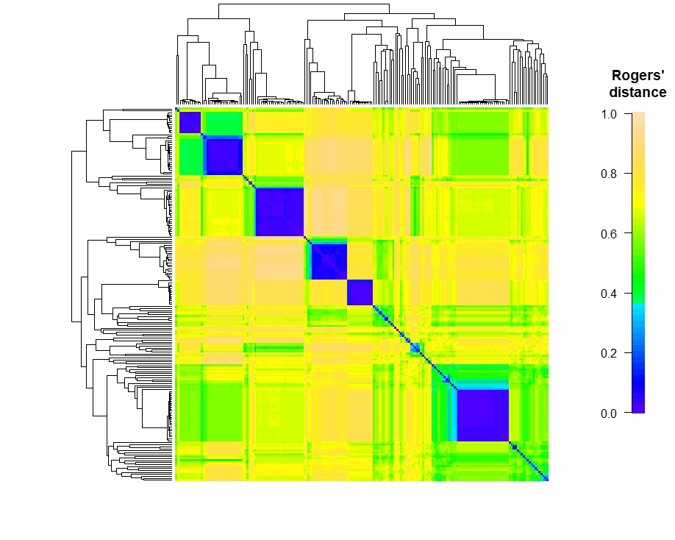
Supplementary Figure 1 Wheat - Pairwise genetic dissimilarities among 189 wheat genotypes described by Rogers’ distance. The complete clustering method was used to order the genotypes

Supplementary Figure 2 Rice - (A) Heritability of grain yield and repeatability in each environment; (B) Distribution of best linear unbiased estimate (BLUE) of genotypes in different environments

Supplementary Figure 3 Rice - Pairwise correlation between environments

Supplementary Figure 4 Rice - 3-environment combinations with complete phenotypic values showing statistically significant (P<0.05) lower response to selection than their extended 4-environment combinations using genomics-assisted sparse phenotyping. Labels of horizontal axis are the scenario numbers of 3-environment combinations. Black dots represent correlation coefficients between the three base environments with complete phenotypic values. Red triangles indicate correlation coefficients between the added environment and base environments

Supplementary Figure 5 Rice - 3-environment combinations with complete phenotypic values showing statistically significant (P<0.05) lower response to selection than their extended 5-environment combinations using genomics-assisted sparse phenotyping. Labels of horizontal axis are the scenario numbers of 3-environment combinations. Black dots represent correlation coefficients between the three base environments with complete phenotypic values. Triangles with different colors indicate correlation coefficients between separate added environments, i.e., the first or second added environment, and base environments

Supplementary Figure 6 Rice - 3-environment combinations with complete phenotypic values showing statistically significant (P<0.05) lower response to selection than using total six environments with genomics-assisted sparse phenotyping. Labels of horizontal axis are the scenario numbers of 3-environment combinations. Black dots represent correlation coefficients between the three base environments with complete phenotypic values. Triangles with different colors indicate correlation coefficients between separate added environments, i.e., the first, second or third added environment, and base environments

Supplementary Figure 7 Rice - responses to selection of 4-environment (one extended environment), 5-environment (two extended environments) and 6-environment (three extended environments) sparse phenotyping combinations belonging to each 3-environment complete phenotyping combination. Labels of horizontal axis are the scenario numbers of 3-environment combinations

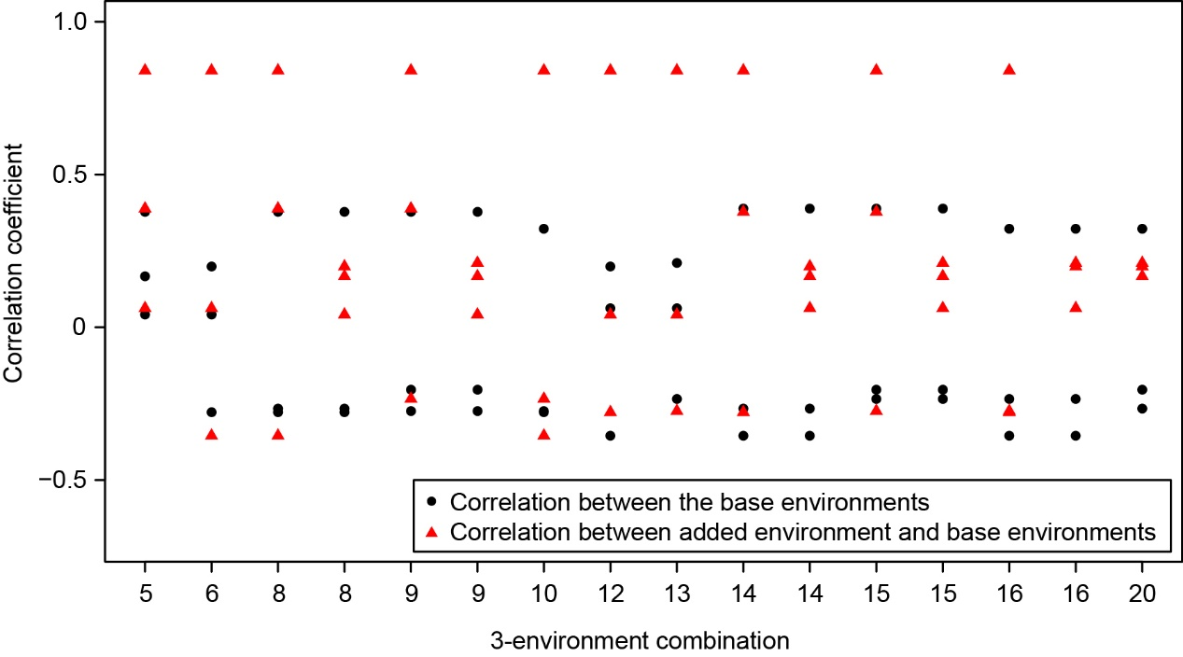
Supplementary Figure 8 Wheat - 3-environment combinations with complete phenotypic values showing statistically significant (P<0.05) lower response to selection than their extended 4-environment combinations using genomics-assisted sparse phenotyping. Relationship between environments was considered in multi-environment genomic prediction model and simulation of response to selection. Environmental relationship matrix was estimated using pairwise complete observations (BLUEs) between environments. Labels of horizontal axis are the scenario numbers of 3-environment combinations. Black dots represent correlation coefficients between the three base environments with complete phenotypic values. Red triangles indicate correlation coefficients between the added environment and base environments

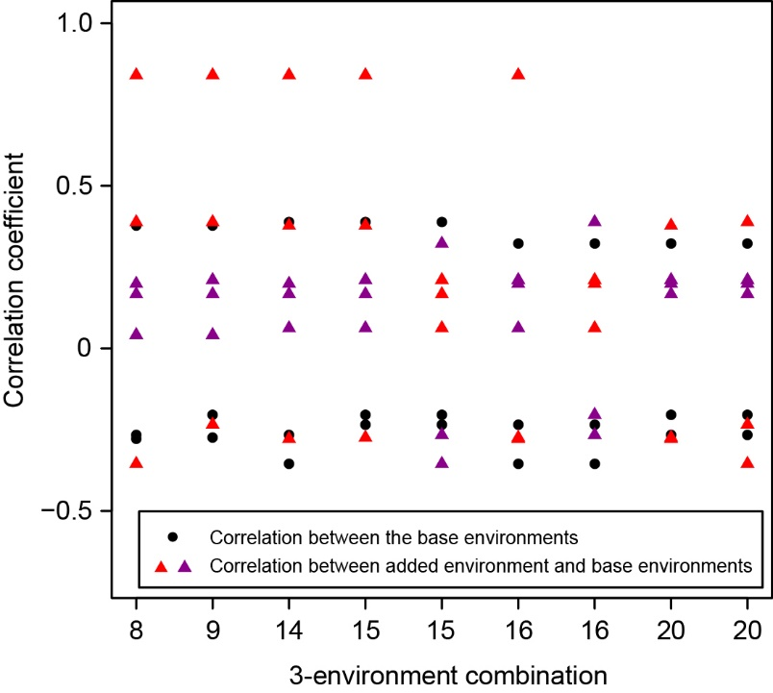
Supplementary Figure 9 Wheat - 3-environment combinations with complete phenotypic values showing statistically significant (P<0.05) lower response to selection than their extended 5-environment combinations using genomics-assisted sparse phenotyping. Relationship between environments was considered in multi-environment genomic prediction model and simulation of response to selection. Environmental relationship matrix was estimated using pairwise complete observations (BLUEs) between environments. Labels of horizontal axis are the scenario numbers of 3-environment combinations. Black dots represent correlation coefficients between the three base environments with complete phenotypic values. Triangles with different colors indicate correlation coefficients between separate added environments, i.e., the first or second added environment, and base environments

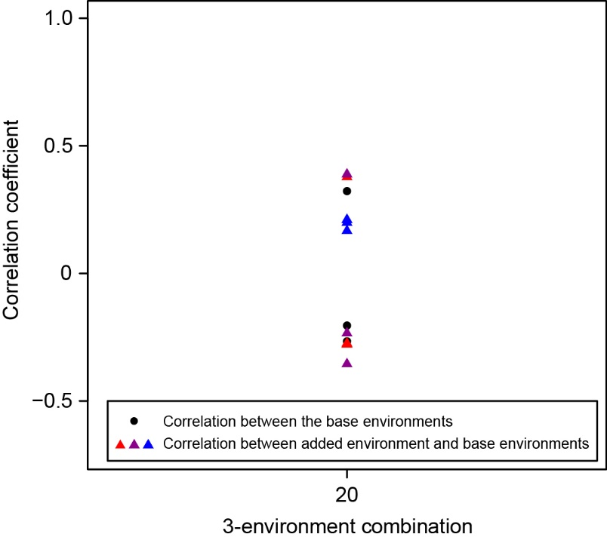
Supplementary Figure 10 Wheat - 3-environment combinations with complete phenotypic values showing statistically significant (P<0.05) lower response to selection than using total six environments with genomics-assisted sparse phenotyping. Relationship between environments was considered in multi-environment genomic prediction model and simulation of response to selection. Environmental relationship matrix was estimated using pairwise complete observations (BLUEs) between environments. Label of horizontal axis is the scenario number of 3-environment combinations. Black dots represent correlation coefficients between the three base environments with complete phenotypic values. Triangles with different colors indicate correlation coefficients between separate added environment, i.e., the first, second or third added environment, and base environments

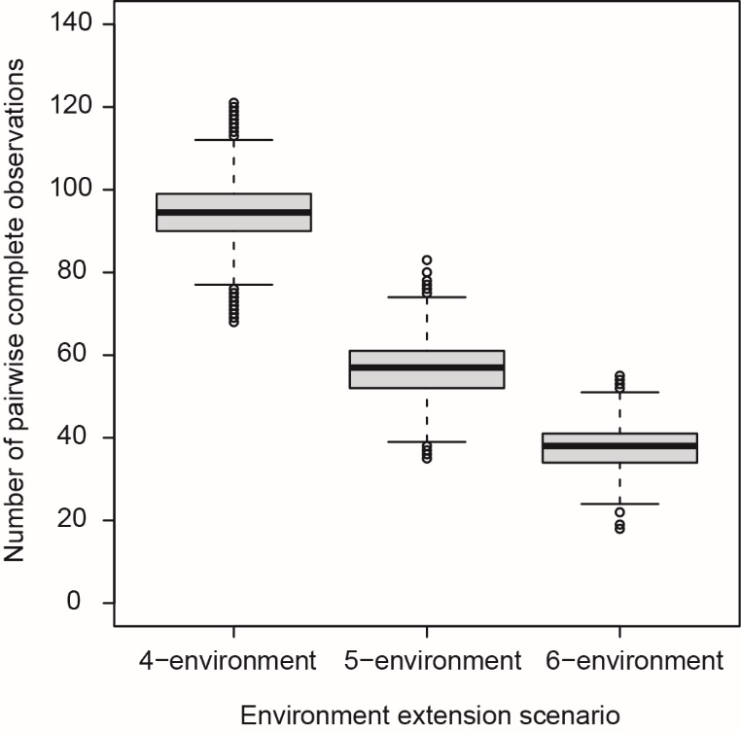
Supplementary Figure 11 Wheat - Number of pairwise complete observations (BLUEs) used for estimating environmental relationship matrix in multi-environment genomic prediction model under different environment extension scenarios.

########################################
### Script of simulating response to selection ###
########################################
rm(list=ls())
library(BGLR) # load BGLR package
Nr_envs <- 4 # Number of environments in sparse phenotyping: 4 means one expansion environment
Nr_rep <- 100 # Number of replications of simulating sparse phenotyping pattern

GRM_ori <- as.matrix(read.table('kinship.txt',as.is = T)) # genotypic relationship matrix
combn_Envs_all <- combn(6,Nr_envs) # generate combinations

for (column in 1:ncol(combn_Envs_all))
{
Res2Sel_all <- c()
Y <- read.table(paste0('combn',column,'/Y.txt'),header = T,as.is = T) # phenotypic data file (3 columns): 1st column is BLUE, 2nd is ID, 3rd is Environment

ones <- rep(1,nrow(Y))
X <- as.matrix(ones)
colnames(X) <- 'intercept'

Envs <- unique(Y$Environment)
nEnv <- length(Envs)
Envs.multiEnv <- Y$Environment
Envs.multiEnv <- factor(Envs.multiEnv,levels=Envs)
Zenv <- as.matrix(model.matrix(~Envs.multiEnv-1))
G.E <- tcrossprod(Zenv)
EVD.E <- eigen(G.E)

IDs <- unique(Y$ID)
nID <- length(IDs)
IDs.multiEnv <- Y$ID
IDs.multiEnv <- factor(IDs.multiEnv,levels=IDs)
Zgeno <- as.matrix(model.matrix(~IDs.multiEnv-1))

GRM <- GRM_ori[IDs,IDs]
EVD <- eigen(GRM)
eigval <- EVD$values
eigvec <- EVD$vectors
eigval[eigval<1e-6] <- 1e-6
GRM <- eigvec %*% diag(eigval) %*% t(eigvec)
GRM_inv <- eigvec %*% diag(1/eigval) %*% t(eigvec)
rownames(GRM) <- IDs
colnames(GRM) <- IDs
rownames(GRM_inv) <- IDs
colnames(GRM_inv) <- IDs
G.G <- tcrossprod(tcrossprod(Zgeno,GRM),Zgeno)
EVD.G<-eigen(G.G)

G.GxE <- G.G*G.E
EVD.GxE <- eigen(G.GxE)
ID.Env.Int <- paste(Y$ID,Y$Environment,sep = ':')
G.GxE_inv <- solve(G.GxE)
rownames(G.GxE_inv) <- ID.Env.Int
colnames(G.GxE_inv) <- ID.Env.Int
Zint <- diag(1:length(ID.Env.Int))

K_E<-list(V=EVD.E$vectors,d=EVD.E$values,model="RKHS")
K_G<-list(V=EVD.G$vectors,d=EVD.G$values,model="RKHS")
K_GxE<-list(V=EVD.GxE$vectors,d=EVD.GxE$values,model="RKHS")
ETA <- list(K_E,K_G,K_GxE)

for (jj in 1:Nr_rep)
{
TestData <- scan(paste0('combn',column,'/sampling/TestData_',jj,'.txt')) # one sample of sparse phenotyping pattern

yNA <- Y$BLUE
yNA[TestData] <- NA

fm <- BGLR(y=yNA,
ETA=ETA,
nIter=30000,
burnIn=5000,
saveAt=paste0("combn",column,"/BGLR/BGLR_",paste(Envs,collapse = "_"),"_rep",jj,""),
verbose=FALSE)

varcomp.env <- fm$ETA[[1]]$varU
varcomp.gen <- fm$ETA[[2]]$varU
varcomp.gxE <- fm$ETA[[3]]$varU
varcomp.err <- fm$varE

Y_shrink <- Y[!is.na(yNA),]

ones_shrink <- rep(1,nrow(Y_shrink))
X_shrink <- as.matrix(ones_shrink)
colnames(X_shrink) <- 'intercept'

Envs_shrink <- unique(Y_shrink$Environment)
nEnv_shrink <- length(Envs_shrink)
Envs_shrink.multiEnv <- Y_shrink$Environment
Envs_shrink.multiEnv <- factor(Envs_shrink.multiEnv,levels=Envs_shrink)
Zenv_shrink <- as.matrix(model.matrix(~Envs_shrink.multiEnv-1))
G.E_shrink <- tcrossprod(Zenv_shrink)

IDs_shrink <- unique(Y_shrink$ID)
nID_shrink <- length(IDs_shrink)
IDs_shrink.multiEnv <- Y_shrink$ID
IDs_shrink.multiEnv <- factor(IDs_shrink.multiEnv,levels=IDs_shrink)
Zgeno_shrink <- as.matrix(model.matrix(~IDs_shrink.multiEnv-1))

GRM_shrink <- GRM_ori[IDs_shrink,IDs_shrink]
EVD_shrink <- eigen(GRM_shrink)
eigval_shrink <- EVD_shrink$values
eigvec_shrink <- EVD_shrink$vectors
eigval_shrink[eigval_shrink<1e-6] <- 1e-6
GRM_shrink <- eigvec_shrink %*% diag(eigval_shrink) %*% t(eigvec_shrink)
GRM_inv_shrink <- eigvec_shrink %*% diag(1/eigval_shrink) %*% t(eigvec_shrink)
rownames(GRM_shrink) <- IDs_shrink
colnames(GRM_shrink) <- IDs_shrink
rownames(GRM_inv_shrink) <- IDs_shrink
colnames(GRM_inv_shrink) <- IDs_shrink
G.G_shrink <- tcrossprod(tcrossprod(Zgeno_shrink,GRM_shrink),Zgeno_shrink)

G.GxE_shrink <- G.G_shrink*G.E_shrink
EVD.GxE_shrink <- eigen(G.GxE_shrink)
ID.Env.Int_shrink <- paste(Y_shrink$ID,Y_shrink$Environment,sep = ':')
G.GxE_inv_shrink <- solve(G.GxE_shrink)
rownames(G.GxE_inv_shrink) <- ID.Env.Int_shrink
colnames(G.GxE_inv_shrink) <- ID.Env.Int_shrink
Zint_shrink <- diag(1:length(ID.Env.Int_shrink))

Zcombine_shrink <- cbind(Zenv_shrink,Zgeno_shrink,Zint_shrink)

ZRZ <- crossprod(Zcombine_shrink)/varcomp.err
Gcombine <- diag(0,nEnv_shrink+nID_shrink+length(ID.Env.Int_shrink))
Gcombine[1:nEnv_shrink,1:nEnv_shrink] <- diag(1,nEnv_shrink)*varcomp.env
Gcombine[(nEnv_shrink+1):(nEnv_shrink+nID_shrink),(nEnv_shrink+1):(nEnv_shrink+nID_shrink)] <- GRM_shrink*varcomp.gen
Gcombine[(nEnv_shrink+nID_shrink+1):nrow(Gcombine),(nEnv_shrink+nID_shrink+1):ncol(Gcombine)] <- G.GxE_shrink*varcomp.gxE
Gcombine_inv <- solve(Gcombine)

leftMat1 <- crossprod(X_shrink)/varcomp.err
leftMat2 <- crossprod(X_shrink,Zcombine_shrink)/varcomp.err
leftMat3 <- crossprod(Zcombine_shrink,X_shrink)/varcomp.err
leftMat4 <- ZRZ + Gcombine_inv

leftMat <- rbind(cbind(leftMat1,leftMat2),
cbind(leftMat3,leftMat4))

leftMat_inv <- solve(leftMat)

C22 <- leftMat_inv[(nEnv_shrink+2):(nEnv_shrink+nID_shrink+1),(nEnv_shrink+2):(nEnv_shrink+nID_shrink+1)]
G <- GRM_shrink*varcomp.gen
Var.gcup<- G - C22
omegaMat <- rbind(cbind(G,Var.gcup),cbind(Var.gcup,Var.gcup))
EVD <- eigen(omegaMat)

if (all(EVD$values > 0))
{
taoMat <- EVD$vectors %*% sqrt(diag(EVD$values))
} else {
eigval <- EVD$values
eigval[eigval<1e-6] <- 1e-6
taoMat <- EVD$vectors %*% sqrt(diag(eigval))
}

Res2Sel <- c()
for (mal in 1:10000)
{
set.seed(12345+mal)
z <- rnorm(nrow(taoMat),mean = 0,sd = 1)
w <- taoMat %*% as.matrix(z)
g <- w[1:length(IDs_shrink)]
gcup <- w[(length(IDs_shrink)+1):length(w)]
names(g) <- IDs_shrink
names(gcup) <- IDs_shrink

gcup_sort <- sort(gcup,decreasing = T)
Rq_mal <- c()
for (perc in seq(0.1,0.9,0.1))
{
fraction <- round(nID_shrink*perc)
gcup_subset <- gcup_sort[1:fraction]
selected_ones <- names(gcup_subset)
g_subset <- g[selected_ones]
Rq <- sum(g_subset)/fraction
Rq_mal <- c(Rq_mal,Rq)
}
Res2Sel <- rbind(Res2Sel,Rq_mal)
}

Res2Sel <- apply(Res2Sel,2,mean)
Res2Sel_all <- rbind(Res2Sel_all,Res2Sel)
}
colnames(Res2Sel_all) <- paste0('Perc_',seq(0.1,0.9,0.1))
write.table(Res2Sel_all,file = paste0('combn',column,'/Res2Sel_EG_GxE_directEsti.txt'),quote = F,row.names = F,sep = '\t') # simulated response to selection
cat ('column:',column,' done\n')
}

