Supplementary Material

Supplementary Tables
Table S1 – Growth rates (GR; cm day⁻¹) were calculated as the coefficient of the significant linear relationship between length (cm) and time (day). Results of the regression (intercept, R², F and p values) are given for each nominal pH and each replicate.
Nominal pH | Replicate | GR (cm day⁻¹) | intercept | R² | Model  (F; p)
pH 8.0 | 1 | 0.053 | 10.74 | 0.68 | 116.78; p<0.0001
 | 2 | 0.050 | 10.26 | 0.65 | 120.86; p<0.0001
 | 3 | 0.057 | 10.69 | 0.74 | 149.15; p<0.0001
pH 7.9 | 1 | 0.051 | 10.47 | 0.62 | 102.28; p<0.0001
 | 2 | 0.066 | 10.15 | 0.86 | 348.87; p<0.0001
 | 3 | 0.045 | 10.89 | 0.71 | 123.30; p<0.0001
pH 7.6 | 1 | 0.050 | 10.50 | 0.67 | 136.33; p<0.0001
 | 2 | 0.062 | 9.76 | 0.77 | 170.01; p<0.0001
 | 3 | 0.063 | 10.59 | 0.73 | 125.99; p<0.0001

Table S2 – Growth rates (GR; g day⁻¹) were calculated as the coefficient of the significant linear relationship between weight (g) and time (day). Results of the regression (intercept, R², F and p values) are given for each nominal pH and each replicate.
Nominal pH | Replicate | GR (g day⁻¹) | intercept | R² | Model  (F; p)
pH 8.0 | 1 | 0.129 | 9.48 | 0.96 | 89.07; p=0.0007
 | 2 | 0.107 | 9.17 | 0.97 | 130.28; p=0.0003
 | 3 | 0.167 | 8.25 | 0.95 | 73.11; p=0.001
pH 7.9 | 1 | 0.111 | 9.06 | 0.97 | 118.41; p=0.0004
 | 2 | 0.170 | 9.01 | 0.95 | 74.27; p=0.001
 | 3 | 0.132 | 8.62 | 0.95 | 81.98; p=0.0008
pH 7.6 | 1 | 0.120 | 9.16 | 0.98 | 215.44; p=0.0001
 | 2 | 0.146 | 8.34 | 0.97 | 155.56; p<0.0002
 | 3 | 0.163 | 8.74 | 0.86 | 23.78; p<0.0008

Table S3 – Allometries between length (cm) and weight (gr) were calculated as the coefficient of the significant exponential between the two parameters. Results of the regression (intercept, R², F and p values) are given for each nominal pH and each replicate.
Nominal pH | Replicate | Allometry | intercept | R² | Model  (F_{1,63}; p)
pH 8.0 | 1 | 0.179 | 1.37 | 0.84 | 279.31; p<0.0001
 | 2 | 0.163 | 1.73 | 0.79 | 249.15; p<0.0001
 | 3 | 0.210 | 0.89 | 0.89 | 432.57; p<0.0001
pH 7.9 | 1 | 0.168 | 1.55 | 0.74 | 172.26; p<0.0001
 | 2 | 0.162 | 1.83 | 0.83 | 270.56; p<0.0001
 | 3 | 0.224 | 0.76 | 0.91 | 526.00; p<0.0001
pH 7.6 | 1 | 0.153 | 1.97 | 0.78 | 237.43; p<0.0001
 | 2 | 0.170 | 1.63 | 0.85 | 305.83; p<0.0001
 | 3 | 0.211 | 0.87 | 0.91 | 460.22; p<0.0001

Supplementary Figures
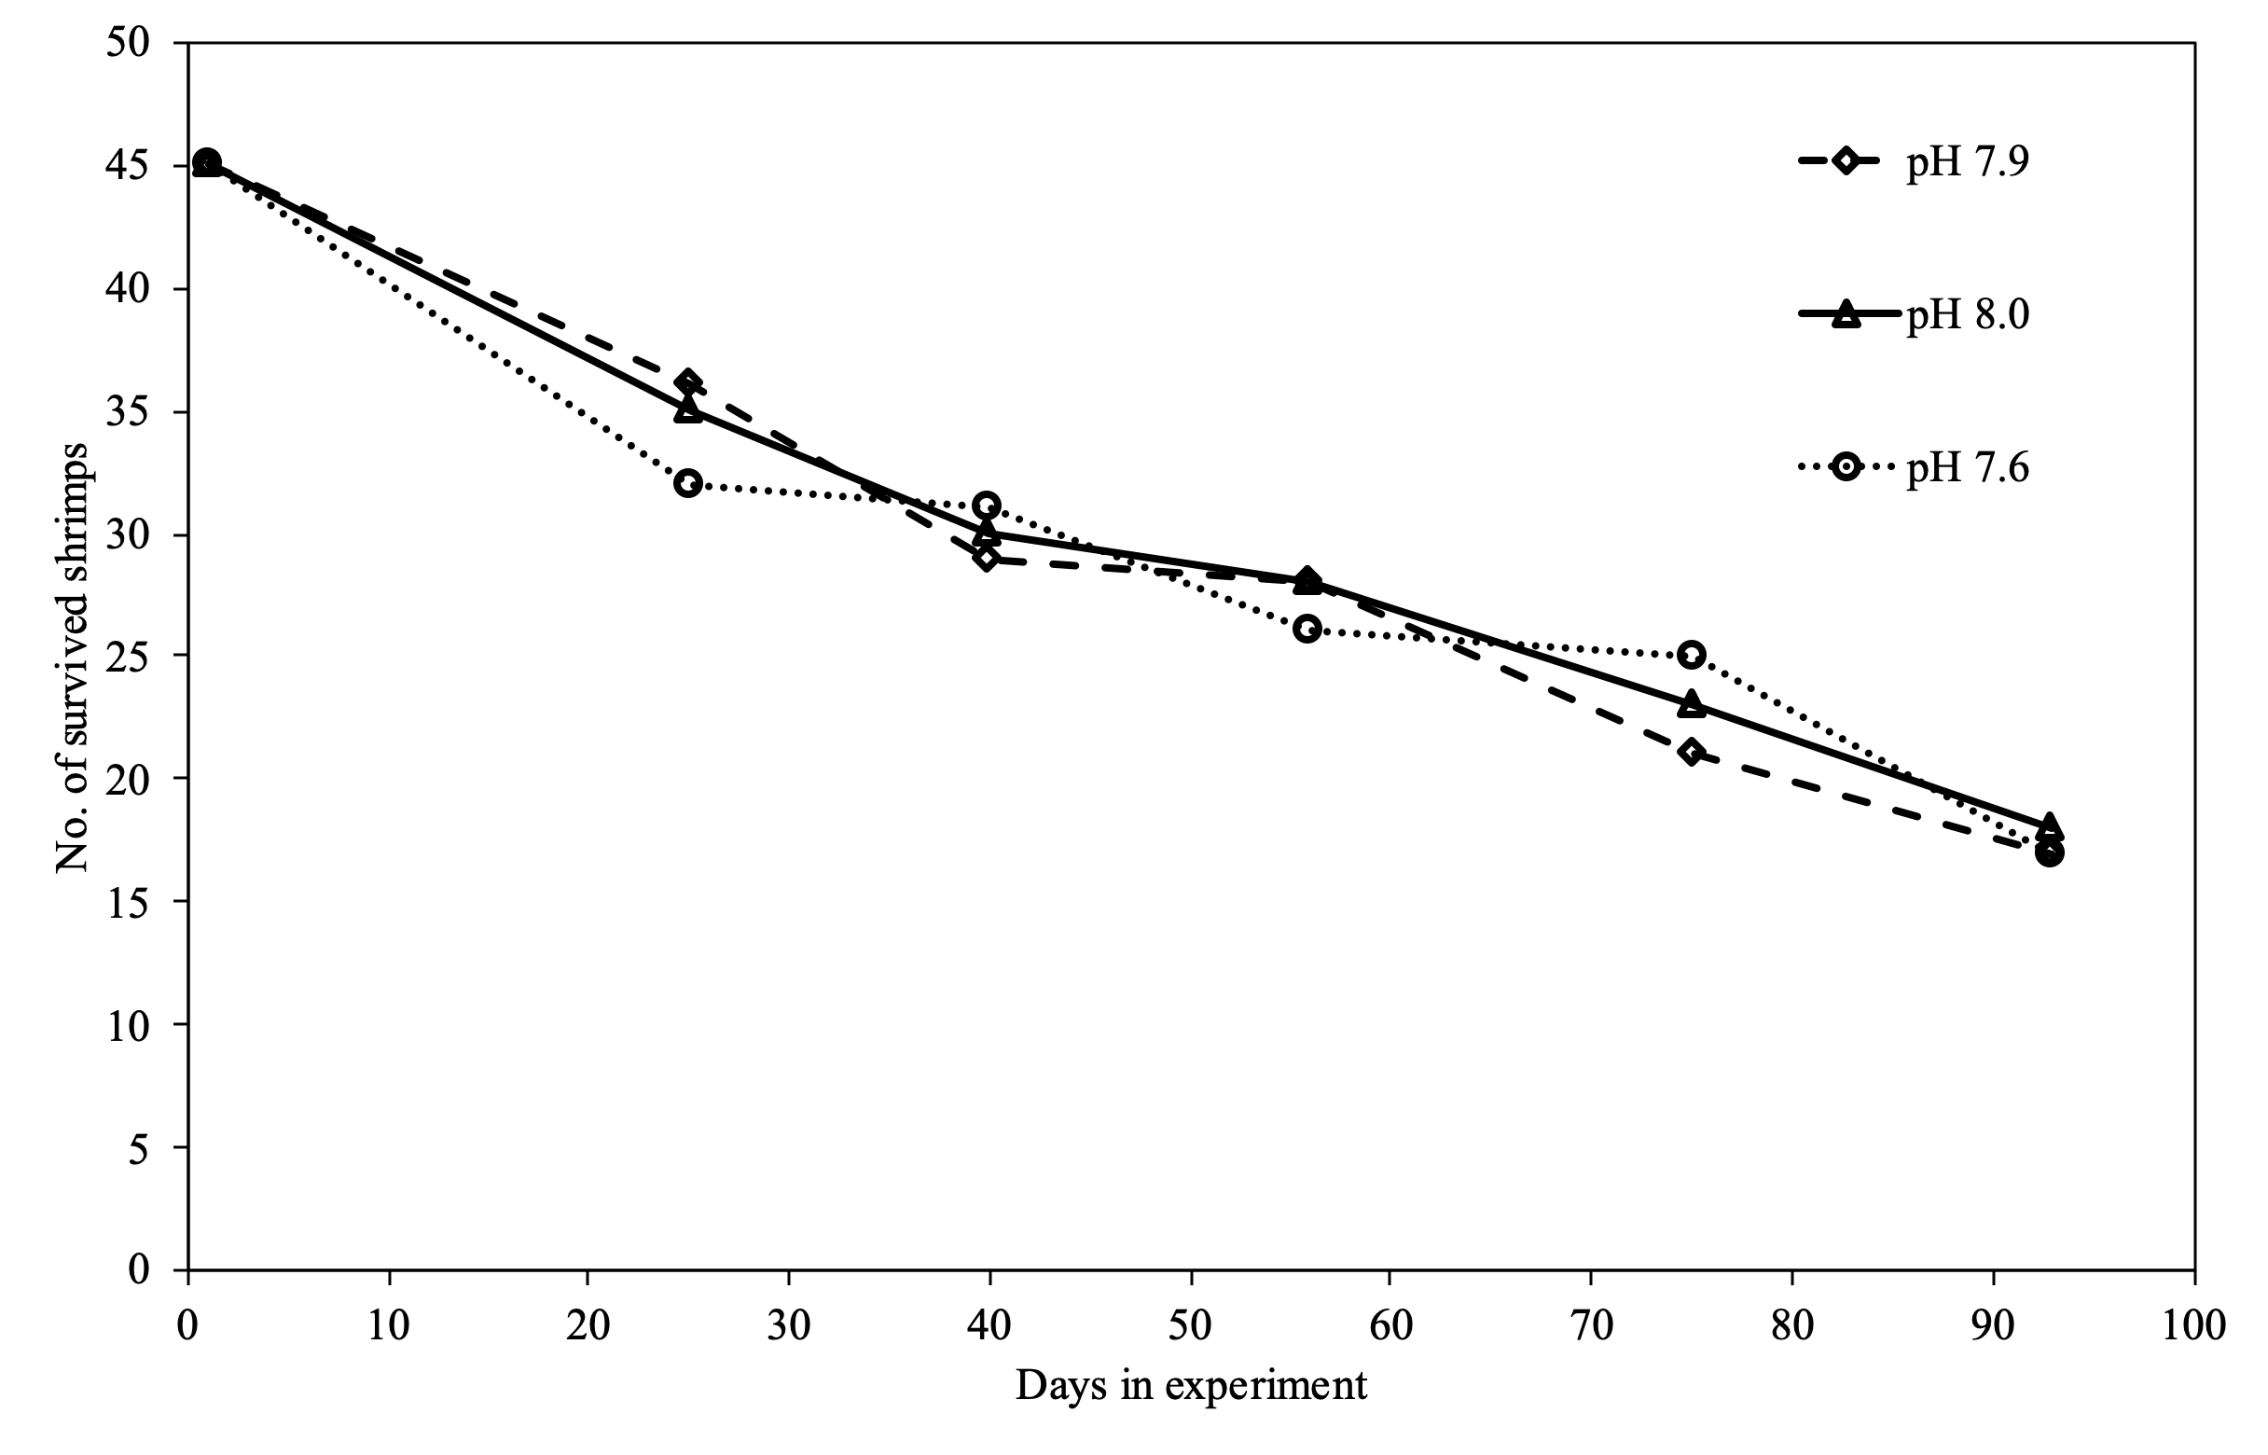
Supplementary Figure S1. Number of survived shrimps with the time (in days) during the experiment in three nominal pH treatments.

