Supplementary Material
Evaluation of oxidative stress markers effects shown by forest plots
- Pro-oxidant Markers
1.1 MDA
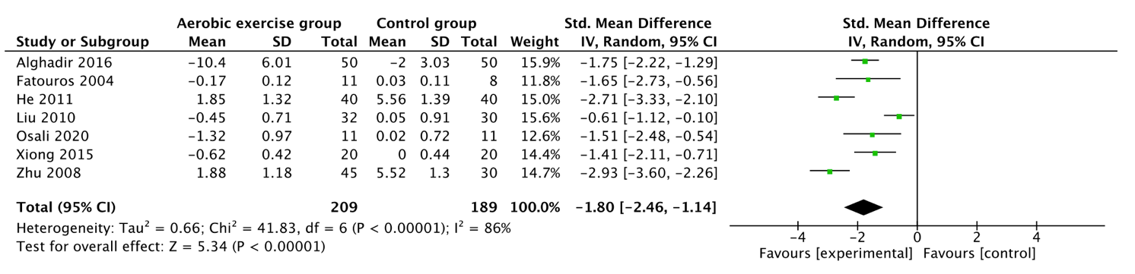
  - 8-OHdG
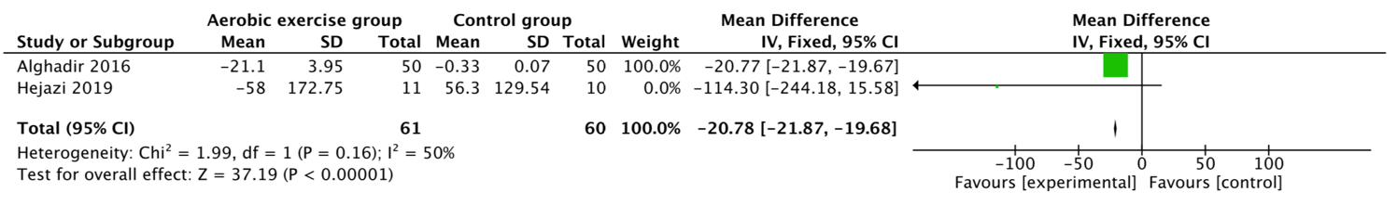
  - LPO
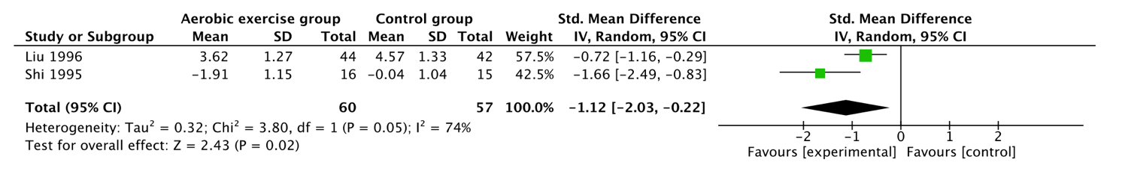
  - 3-NT
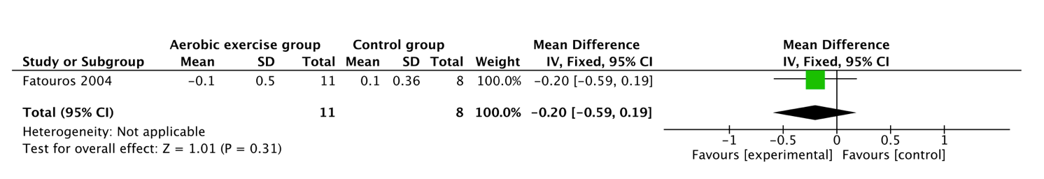
  - Ox-LDL
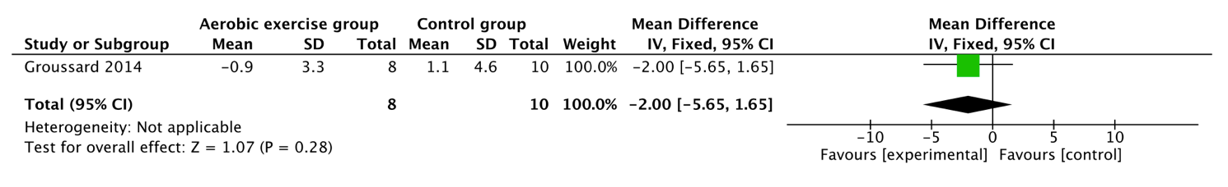
  - 8-isoPGF2
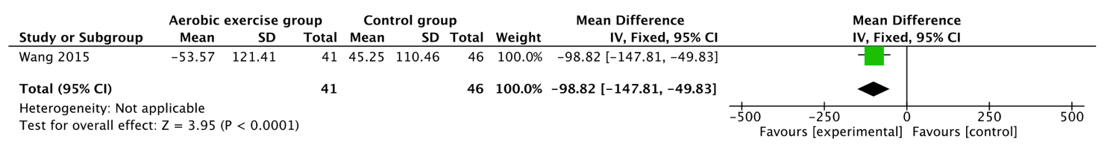

- Antioxidant Markers
2.1 NO
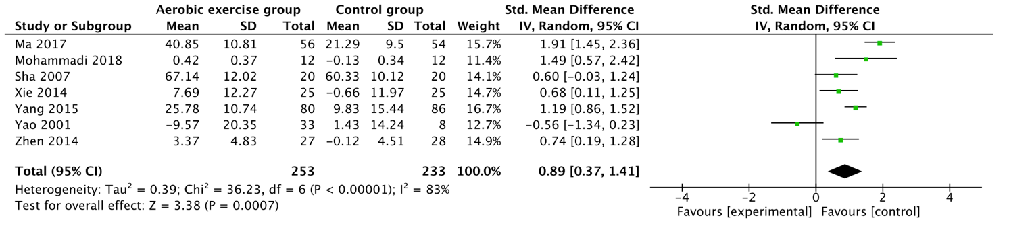
  - SOD
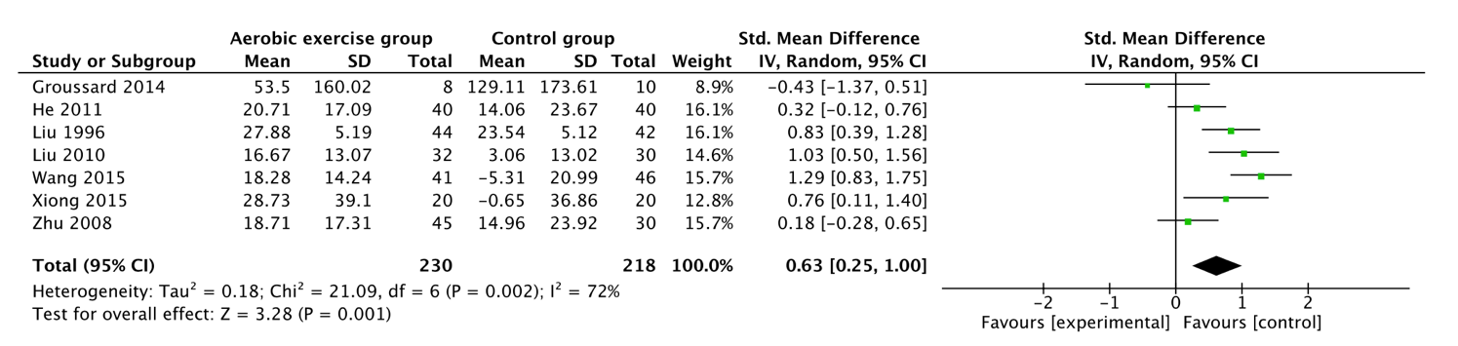
  - TAC
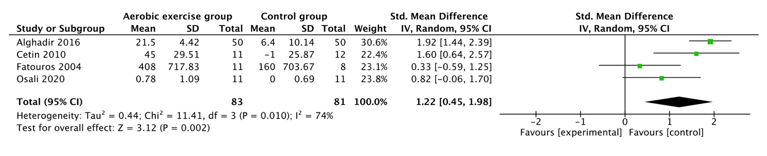
  - GPX
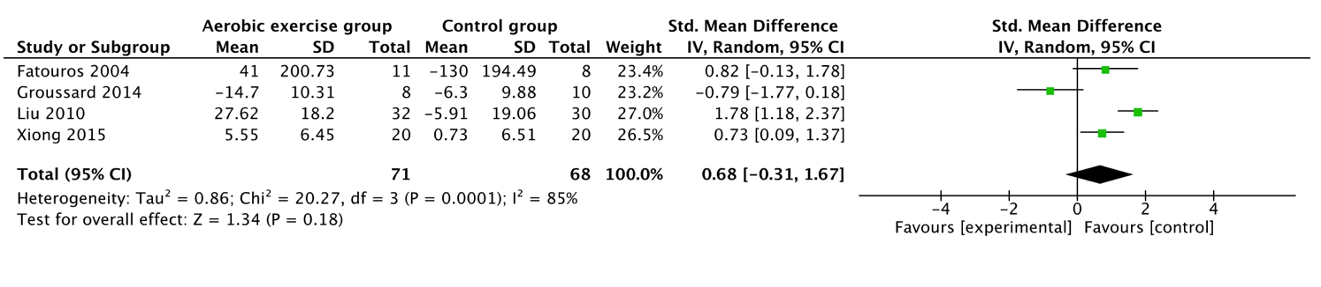
  - GSH
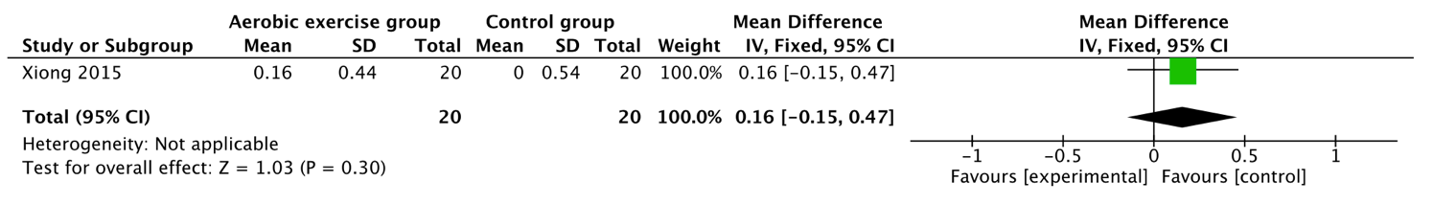
  - Vitamin E
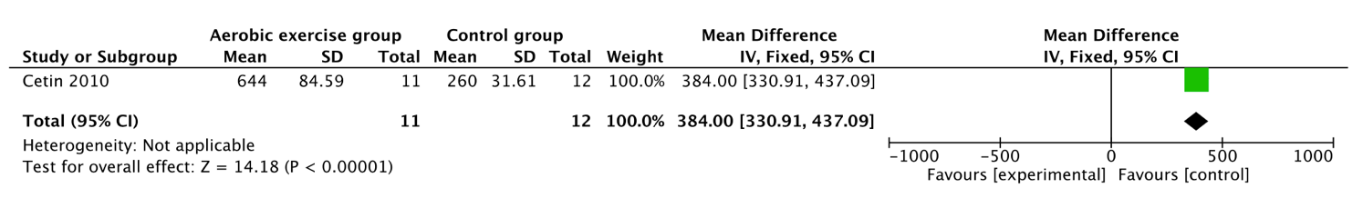
2.7 GSH/GSSG
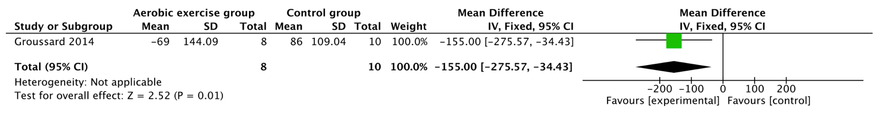

- Subgroup analysis
3.1 MDA
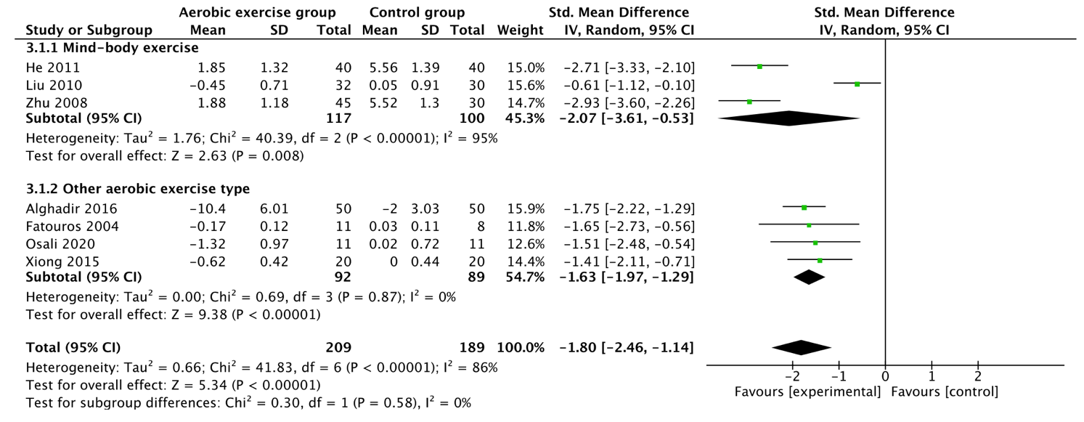

  - NO
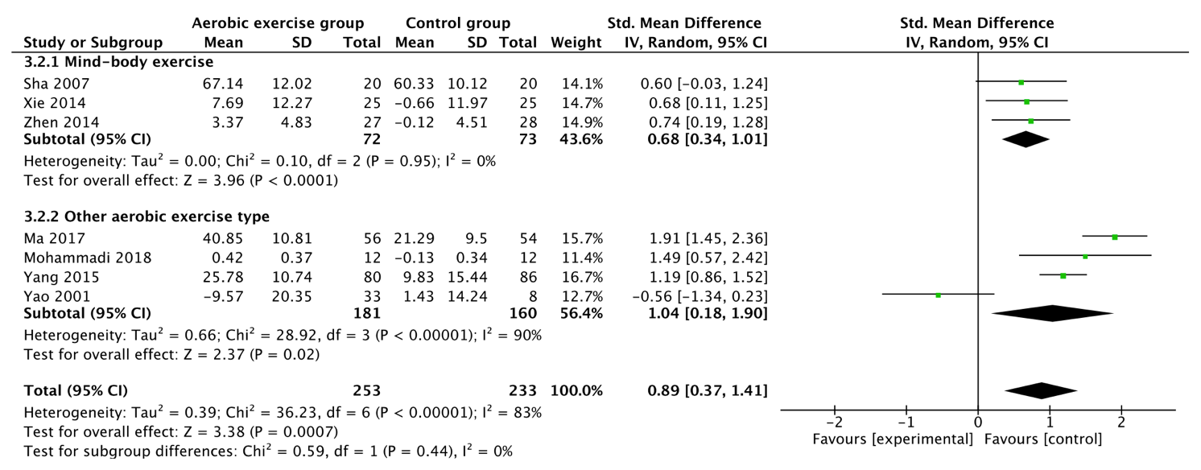
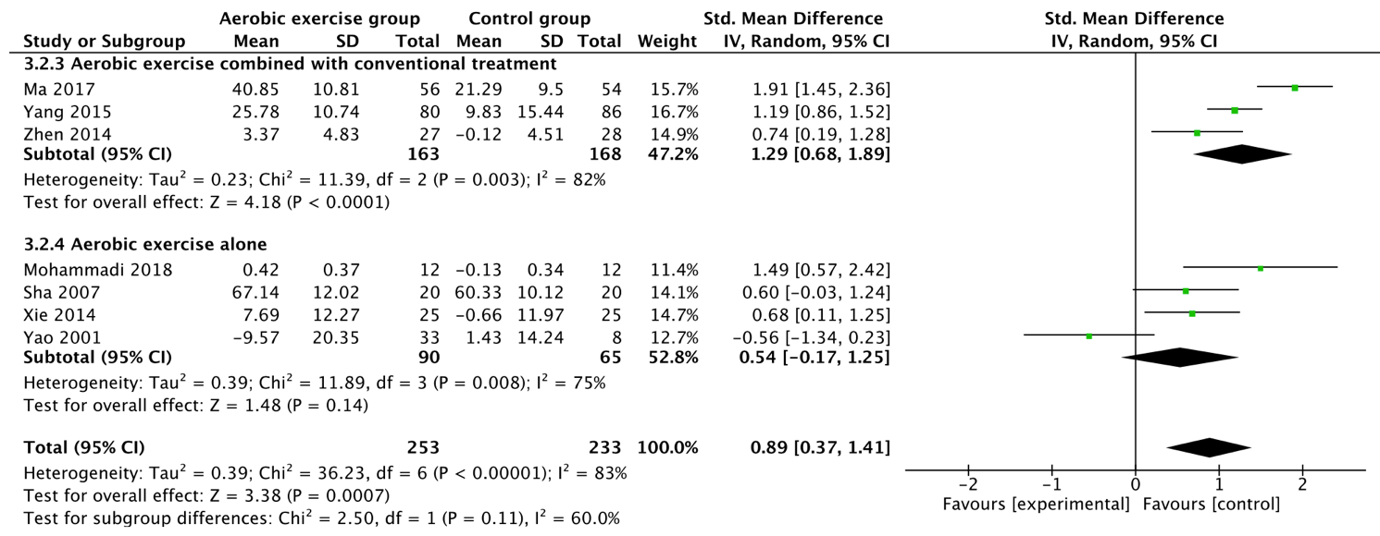

  - SOD
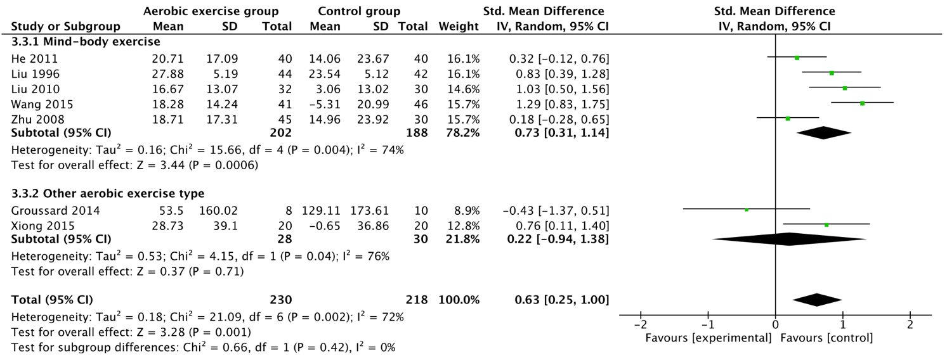

- Sensitivity analysis for the subgroup
4.1 NO
