Supporting Information
Confined Monolayer Ice Between CaF₂ (111) and Graphene: Structure and Stability
Shi-Qi LI, Shi QIU, Hongsheng Liu, Maodu Chen, Junfeng Gao*
Key Laboratory of Materials Modification by Laser, Ion and Electron Beams, Dalian University of Technology, Ministry of Education, Dalian 116024, China

S1 Free standing structures of four ice phases

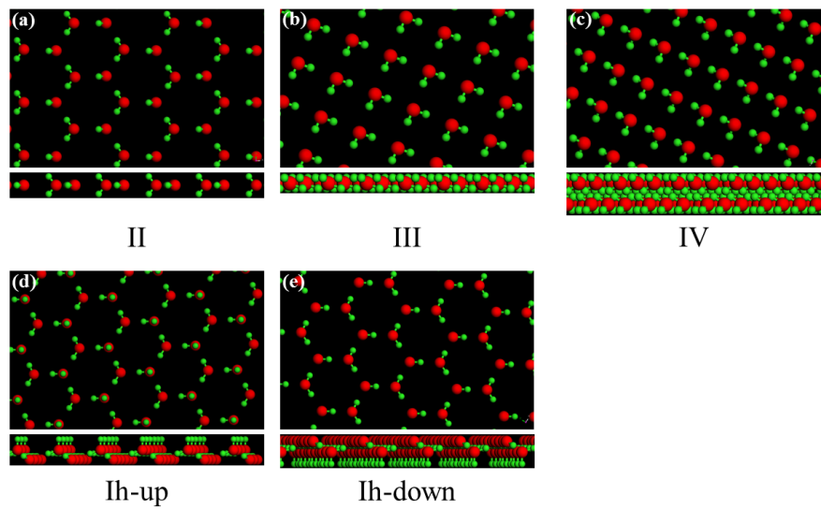
Figure S1 Free standing structures of four ice phases including ice II (a), III (b), IV (c) and Ih (d)-(e). In all figures, the red and green spheres represent the O and H atoms, respectively.

S2 Structures of two amorphous water structures confined between CaF₂ (111) and graphene

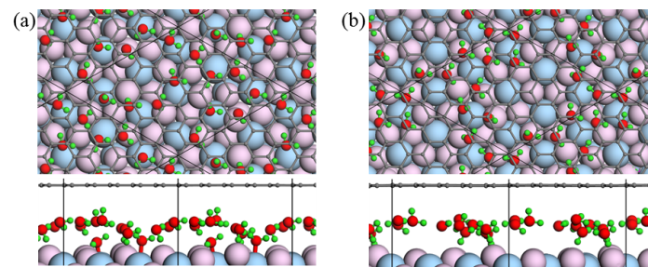
Figure S2 Structures of two amorphous water structures including Amor-1 (a) and Amor-2 (b) confined between CaF₂ (111) and graphene. In all figures, the black, red, green, flesh pink and light blue spheres represent the C, O, H, F and Ca atoms, respectively.

