Supplementary material

Table
Supplementary Table S 1: Final parameter collection and respective VIF values. NS: vertical gradient; WE: horizontal gradient.
Parameter | GVIF
dtNS | 1.98
dtWE | 1.59
Oxygen | 2.16
doNS | 1.84
doWE | 1.57
Salinity | 1.36
dsNS | 1.09
dsWE | 1.07
Chlorophyll_a | 1.17
dcNS | 1.12
dcWE | 1.03
Appendicularia | 1.04
Copepoda | 1.25
Pluteus | 1.13
MarineSnow | 1.30
Dinoflagelattes | 1.02

Figures
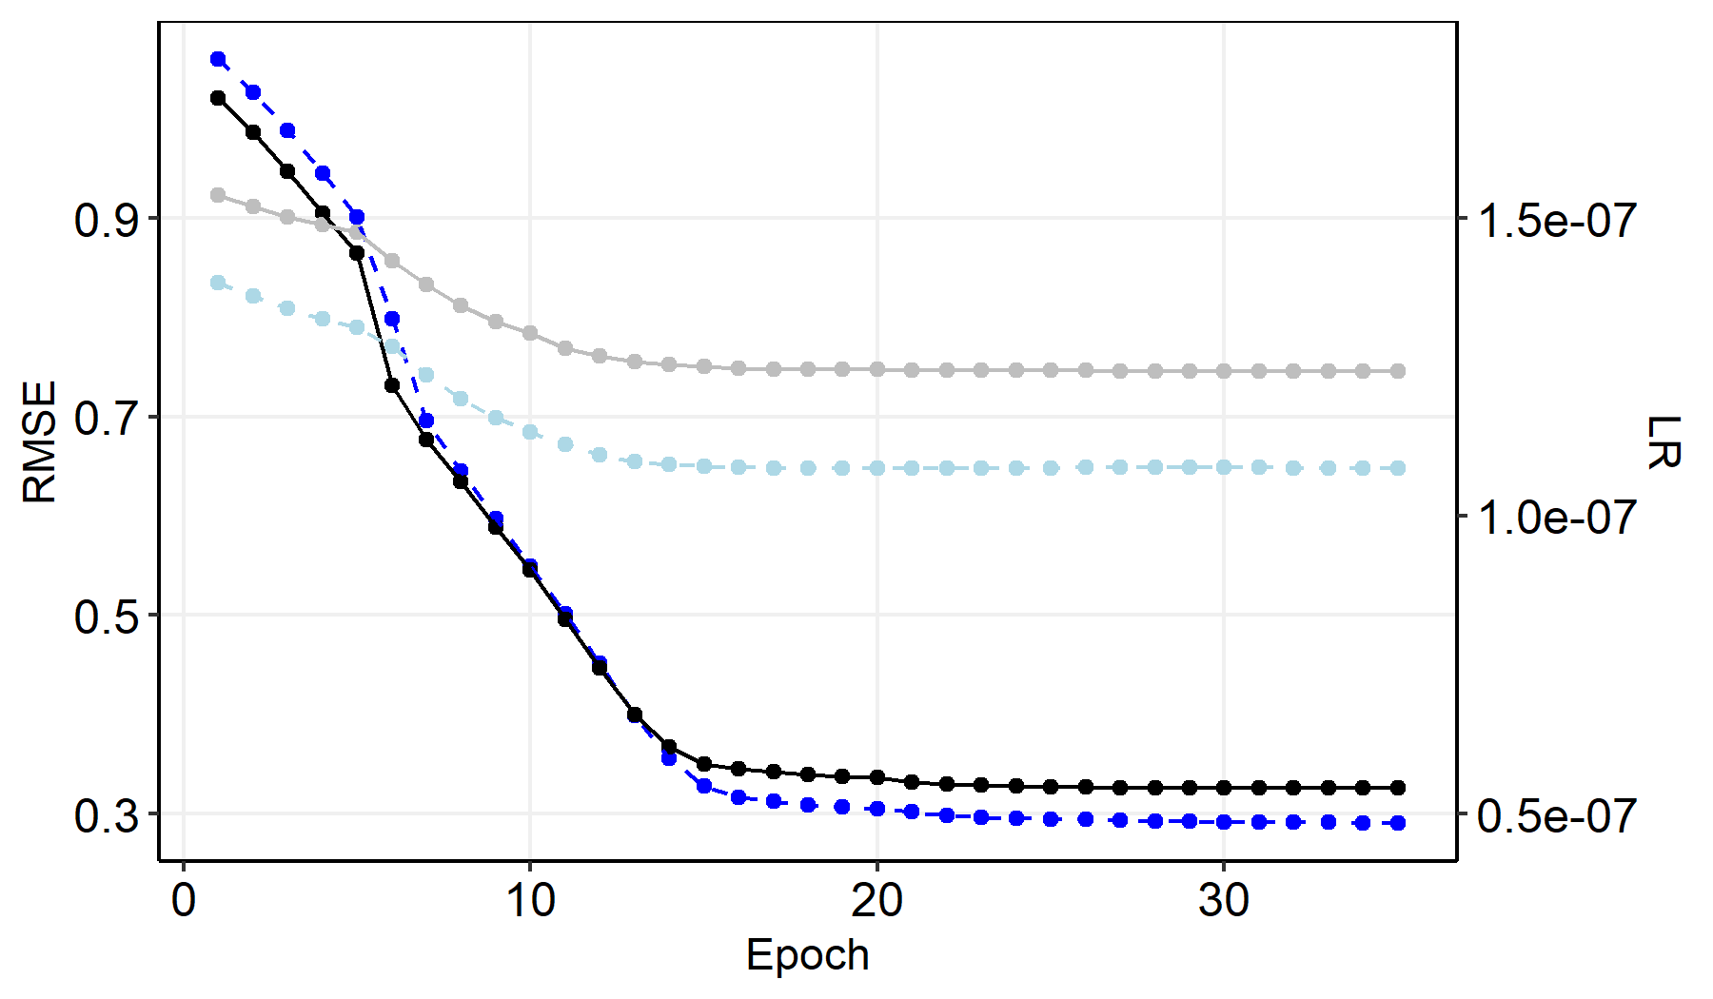
Supplementary Figure S 1: Prolonged history of model training. black: validation, blue: training, light: including density, dark: without density.
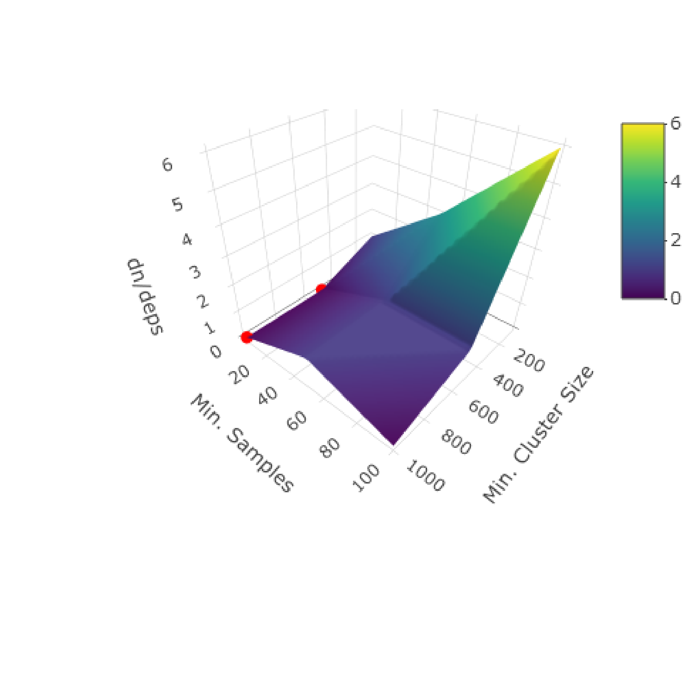
Supplementary Figure S 2: Influence of Epsilon regarding the segregation of macro-habitats. dn/deps is the difference in segregated macro-habitats at a specific range in Epsilon (0.2 - 0.32).
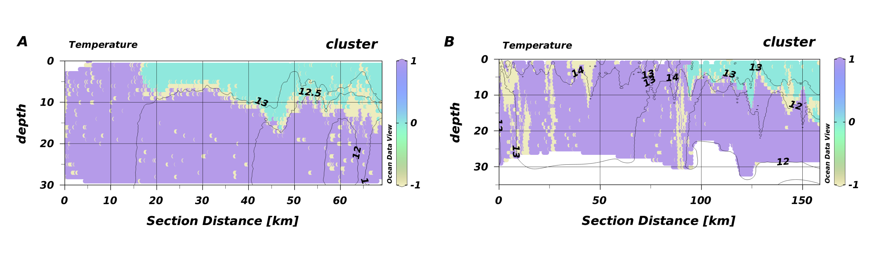
Supplementary Figure S 3: Habitat maps of T1 (A) and T2 (B) from HE534 overlayed by temperature isolines.

