Supplementary Material
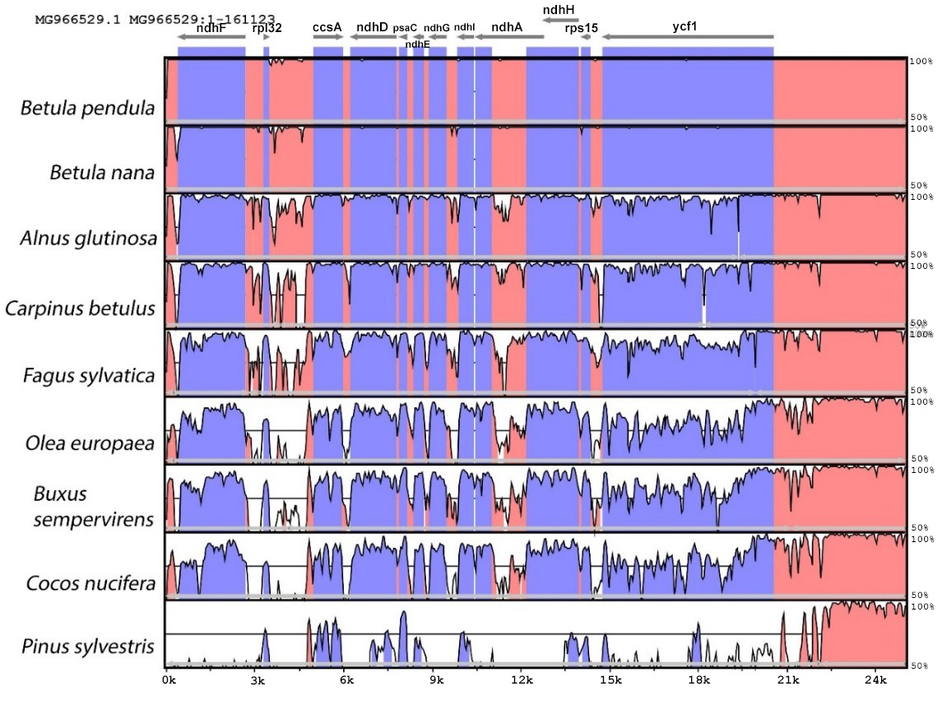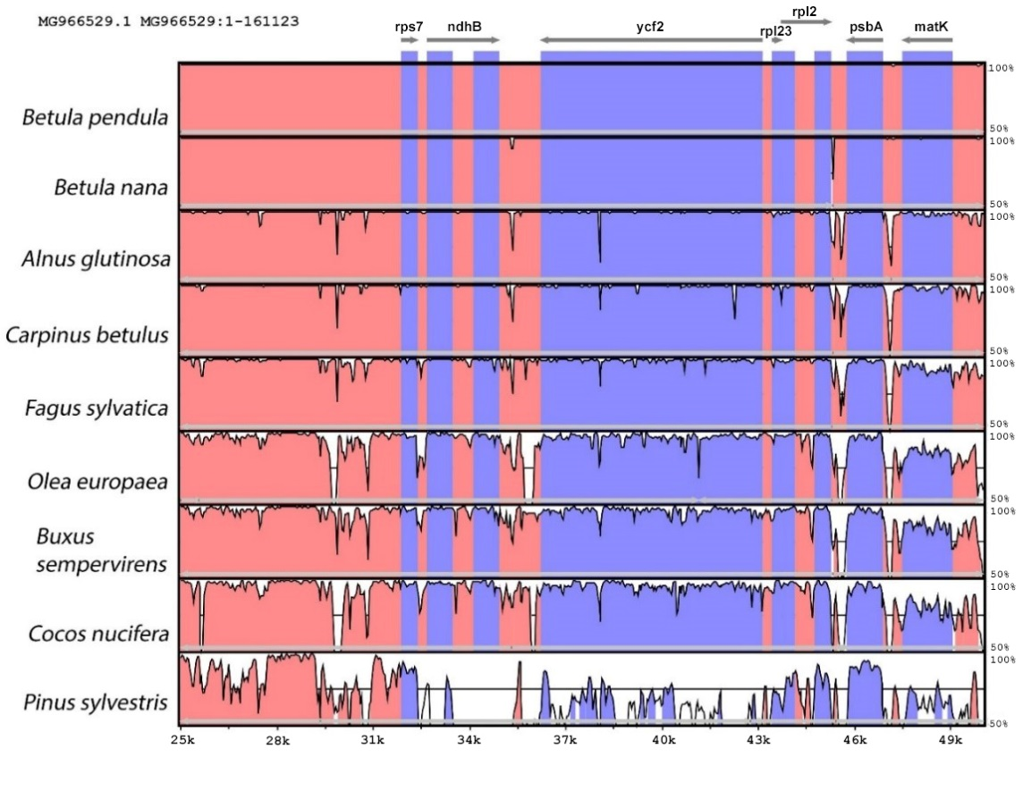
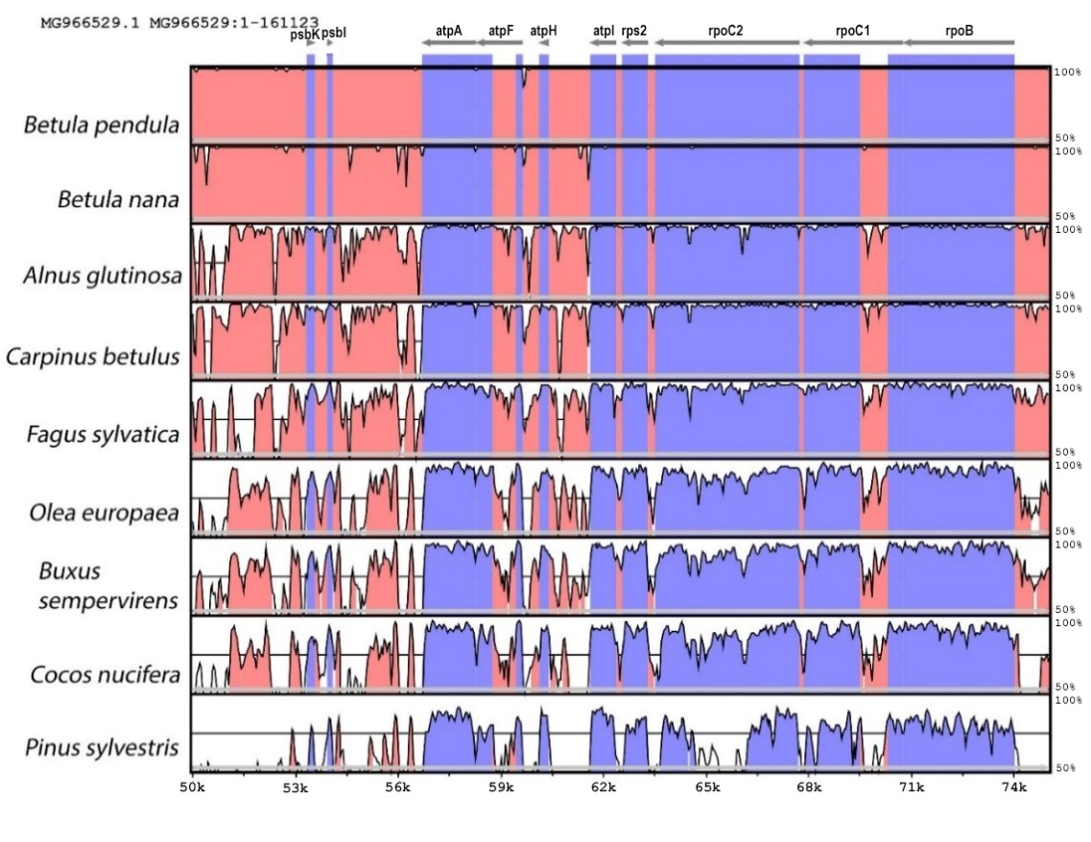
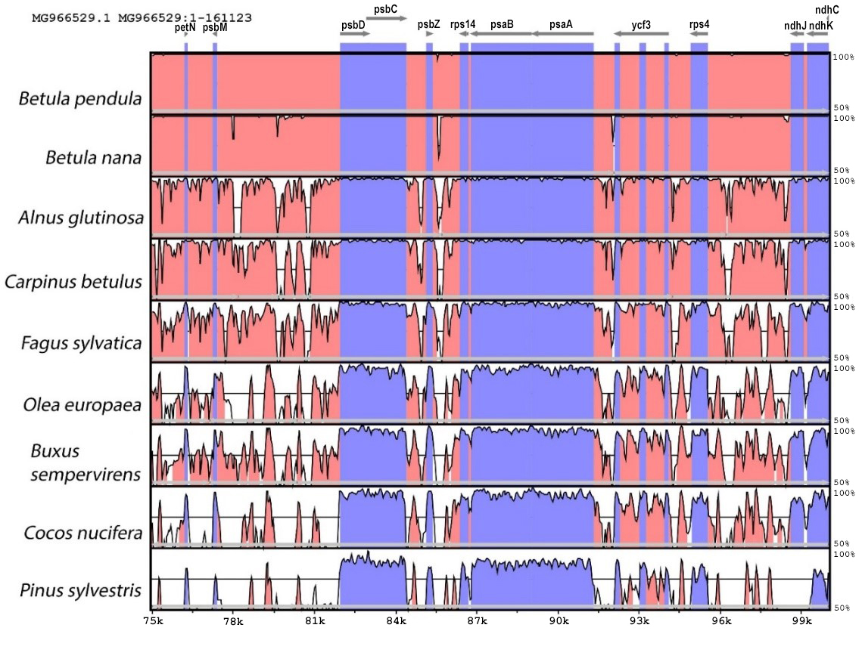
Supplementary Figure S1. Multiple nucleotide sequence alignment of nine woody plant species plastomes from Spermatophyta (mVISTA). B. pendula var. carelica was used as a reference. Grey arrows above the alignment indicate the transcriptional directions of genes. Genome regions are color-coded as exon (violet) and conserved non-coding sequences (CNS) (red). A cut-off of 50% identity was used for the plots. The Y-axis indicates the percent identity between 50 and 100%.

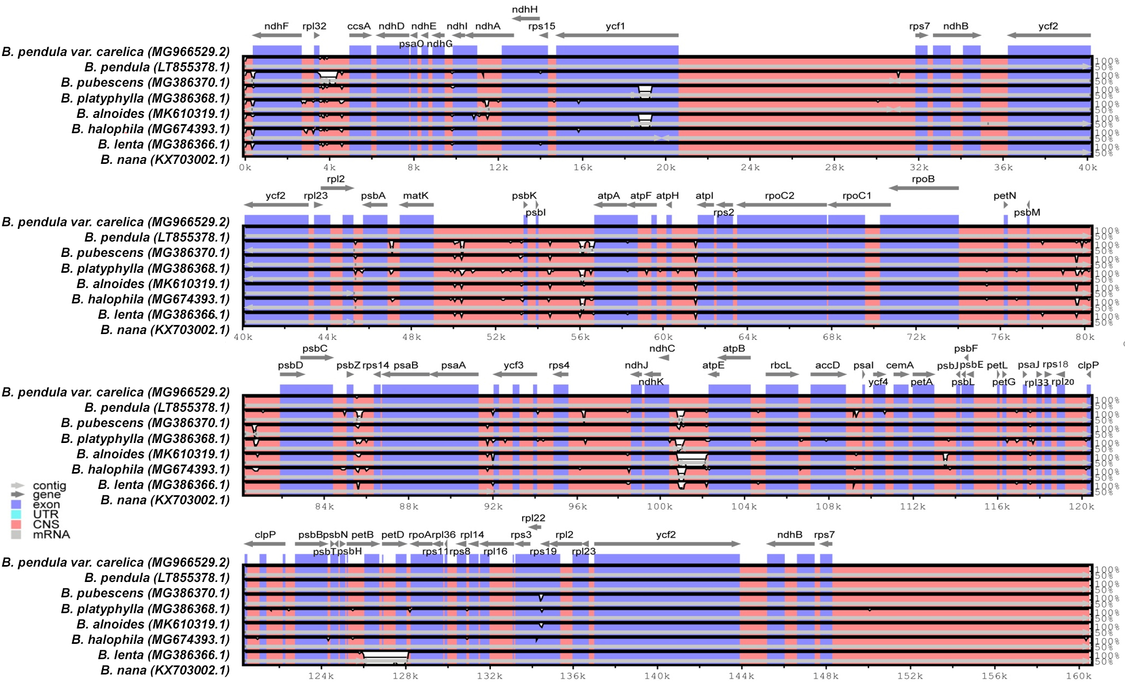Supplementary Figure S2. Multiple whole-plastome sequence alignment of eight birch species. Grey arrows above the alignment indicate the transcriptional directions of genes. Genome regions are color-coded.

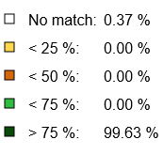
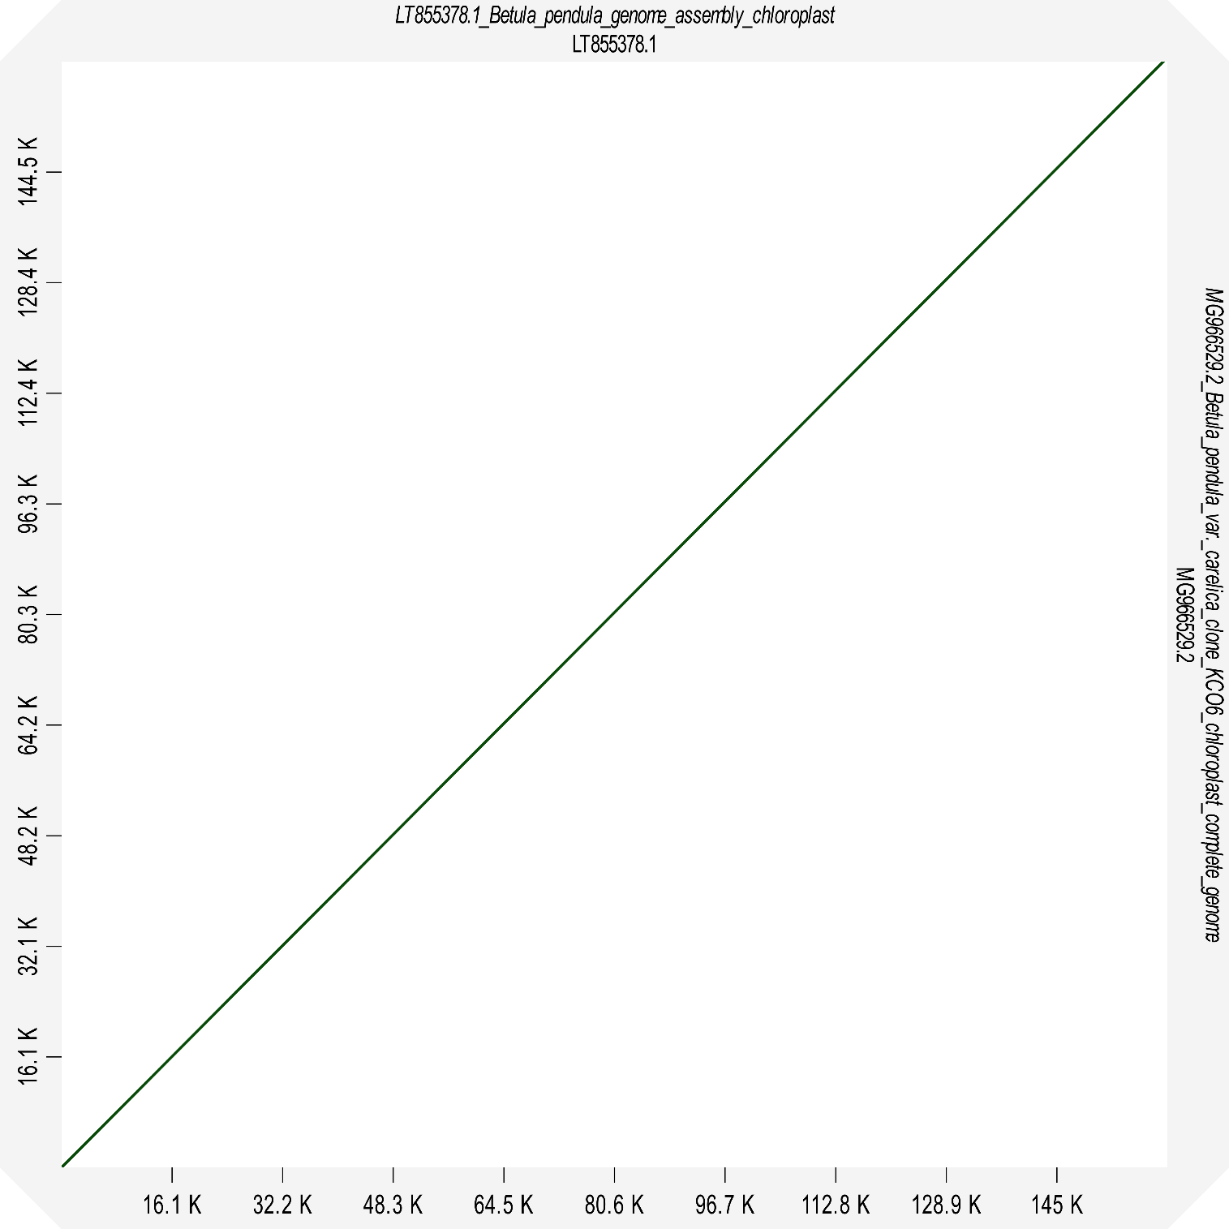

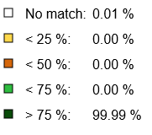
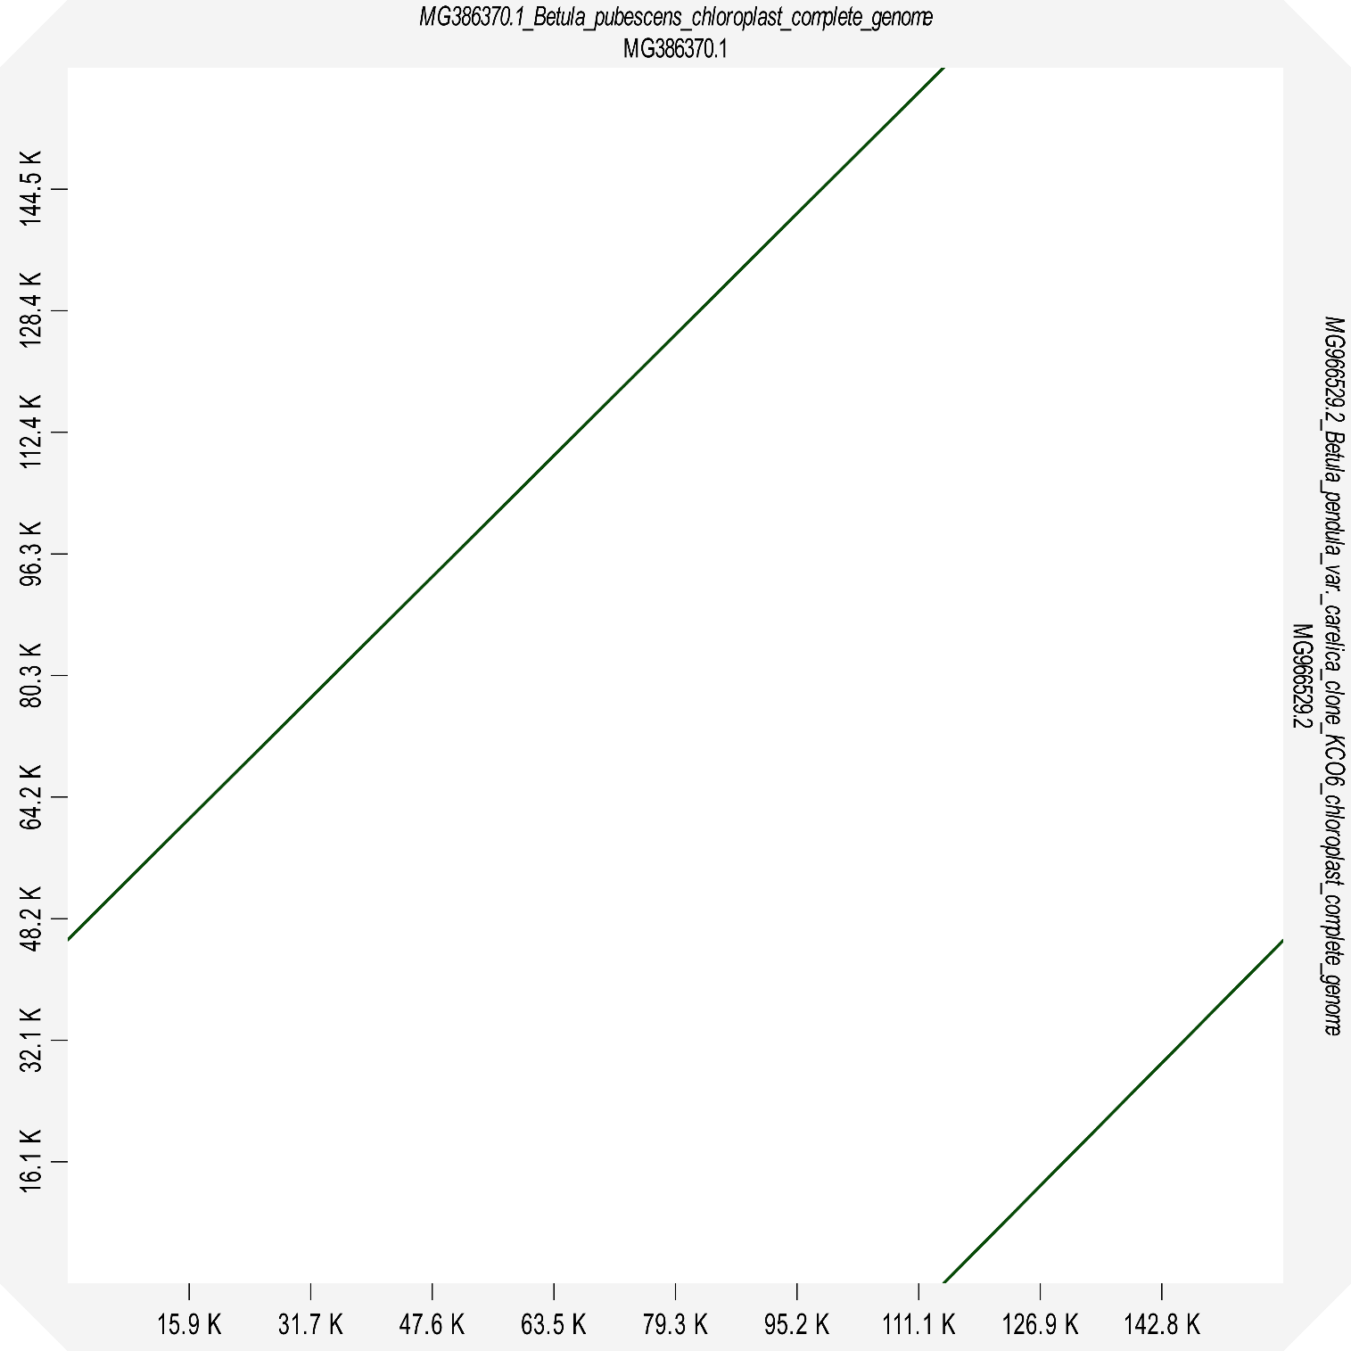

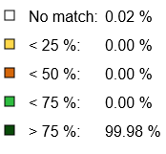
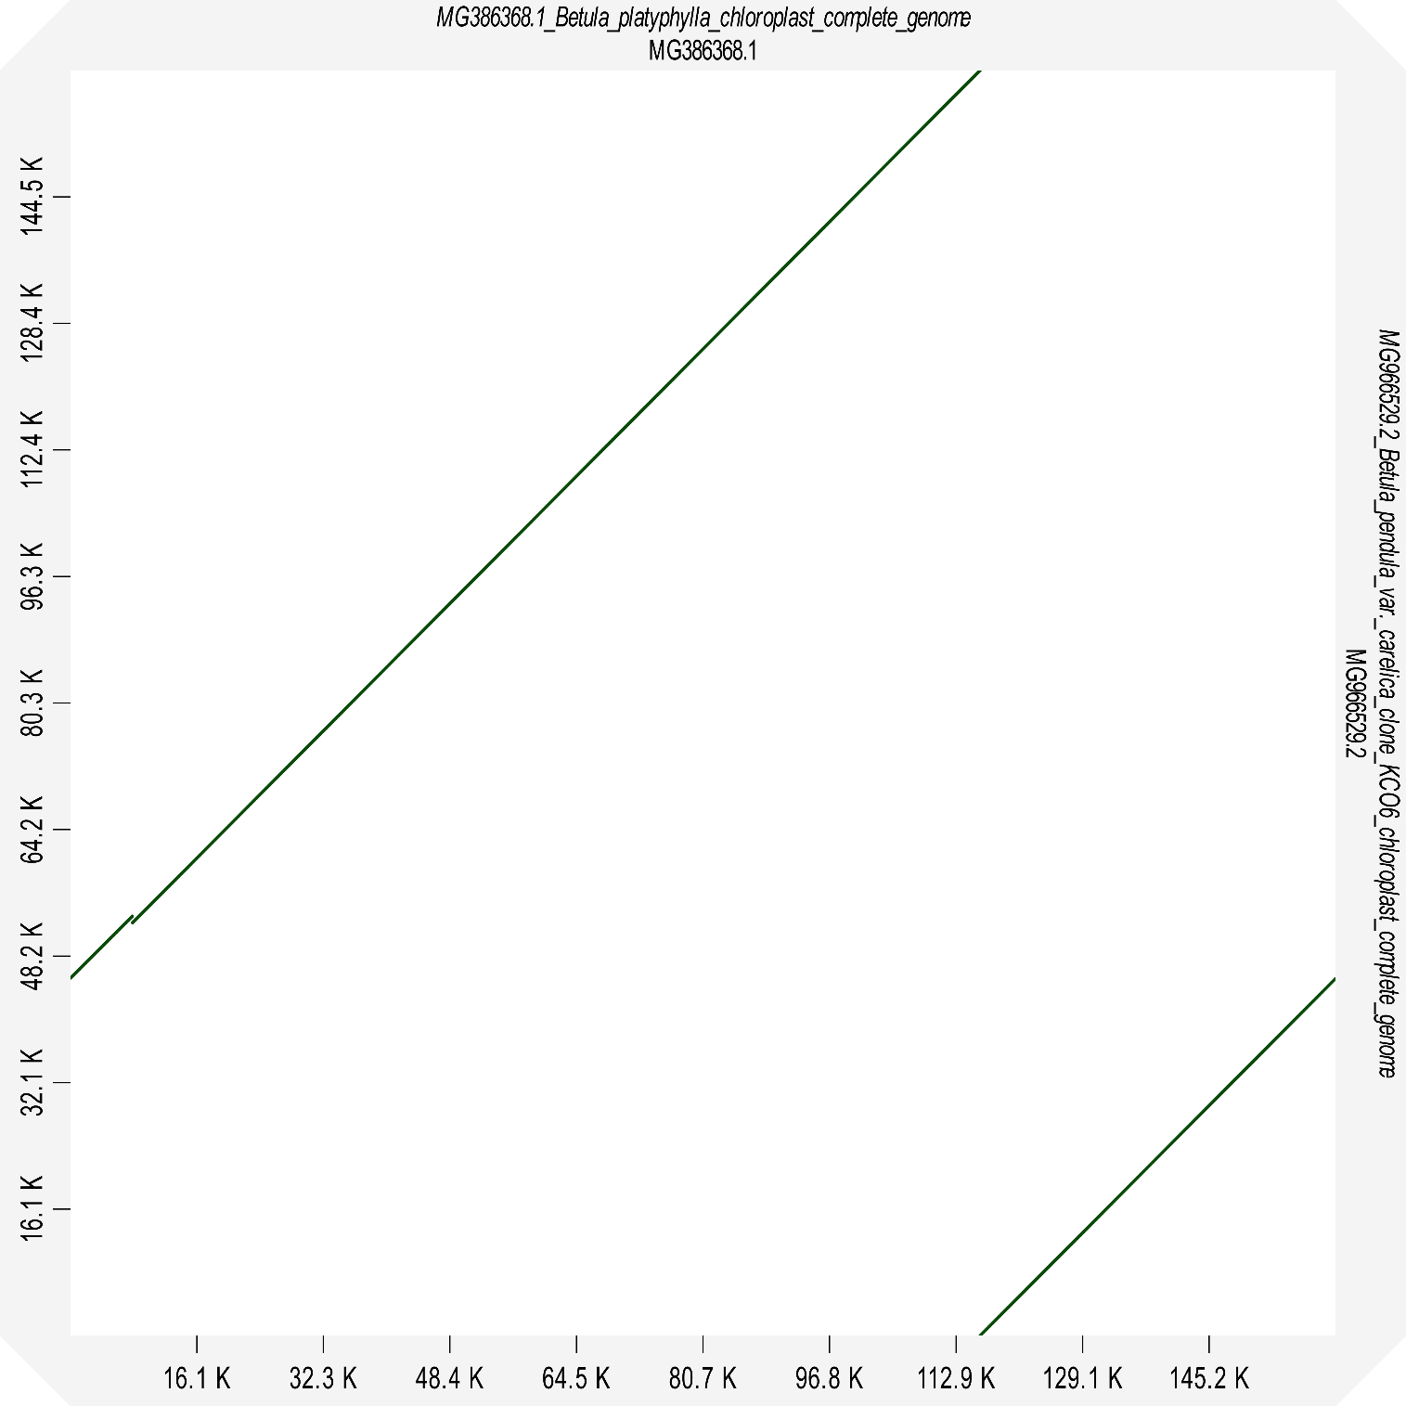

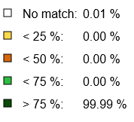
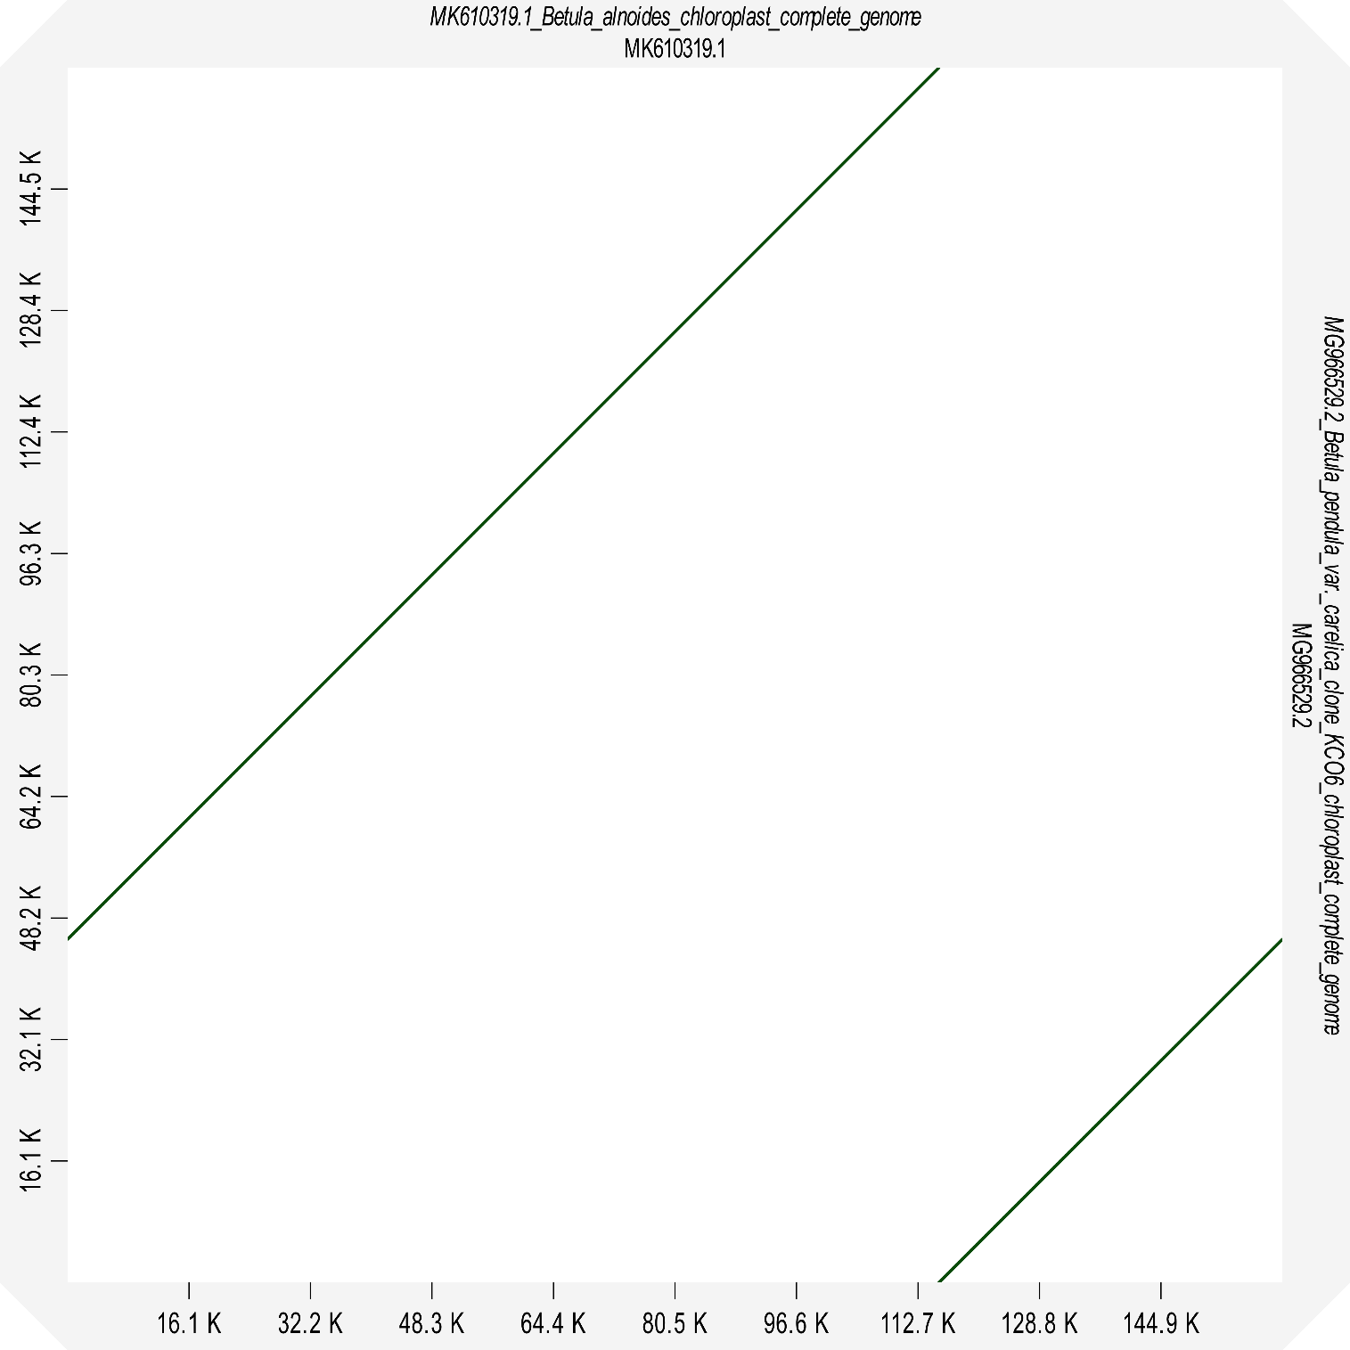

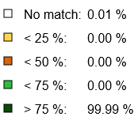
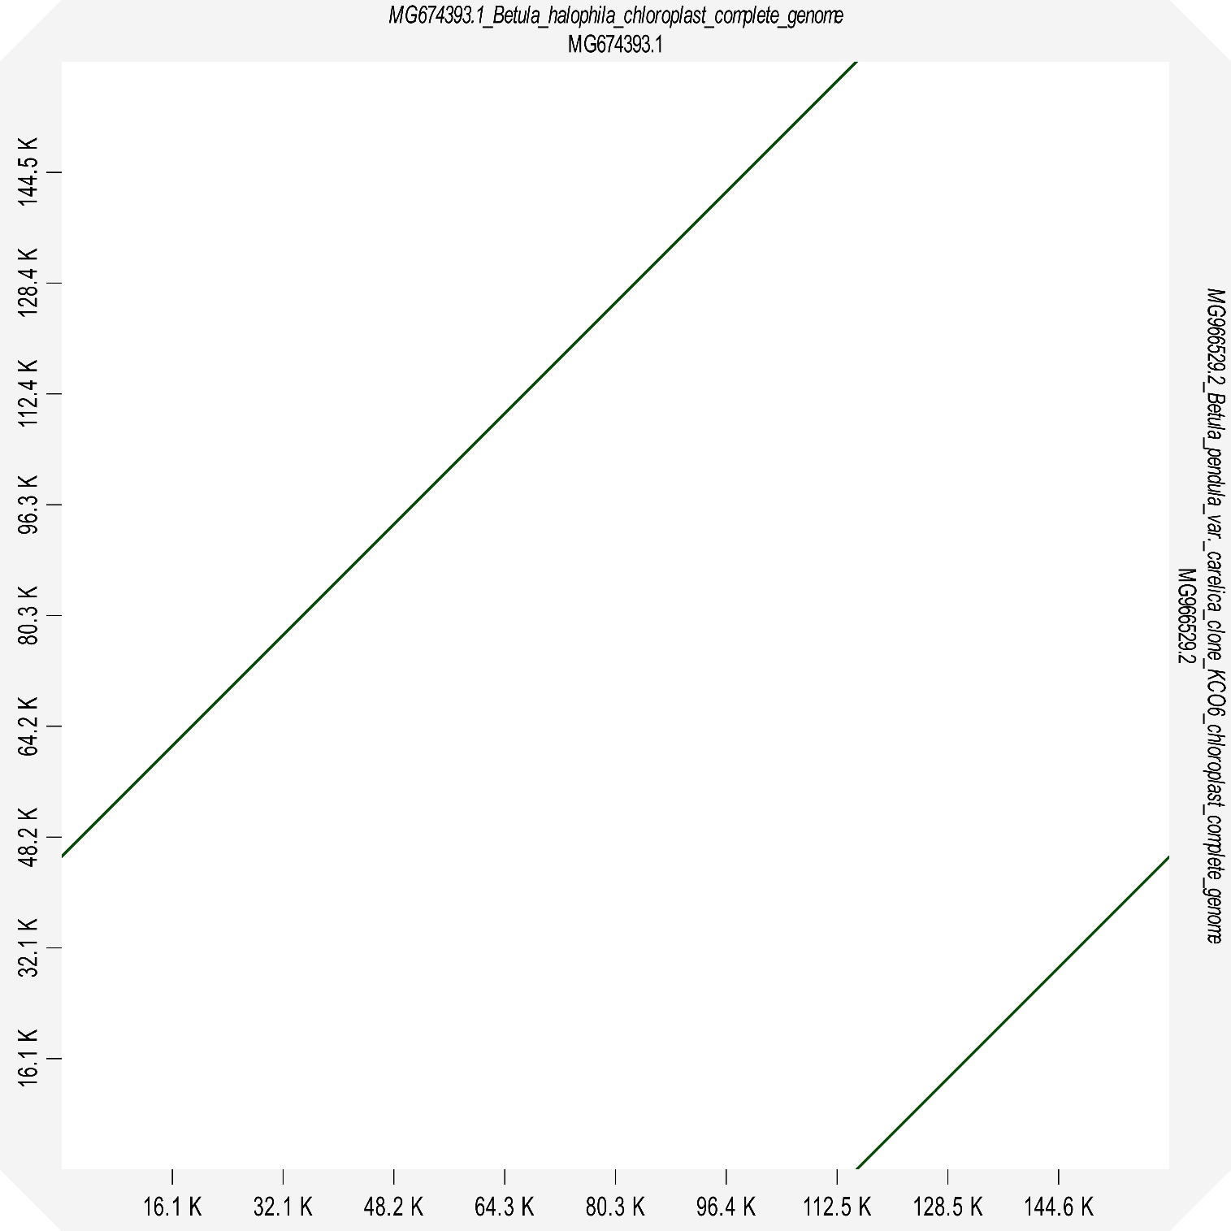

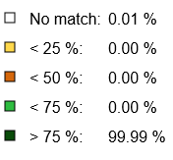
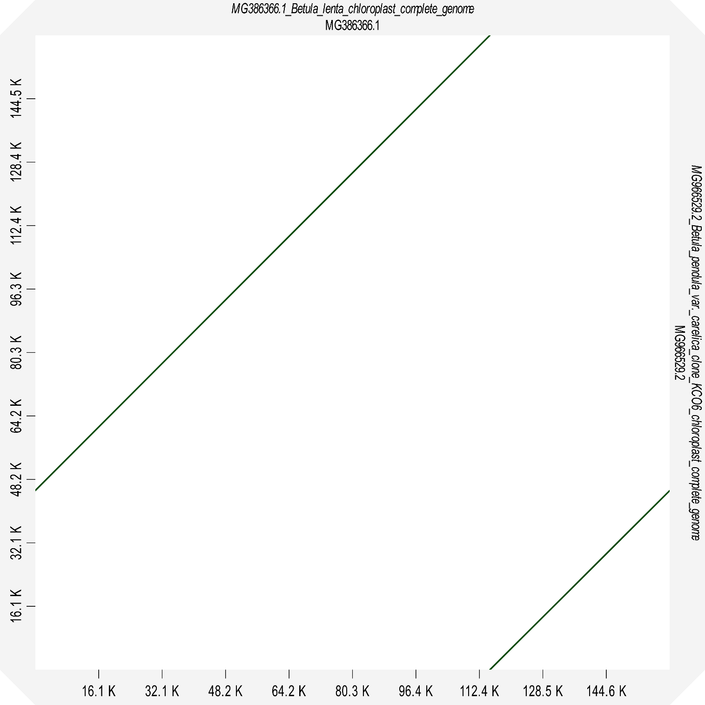

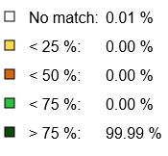
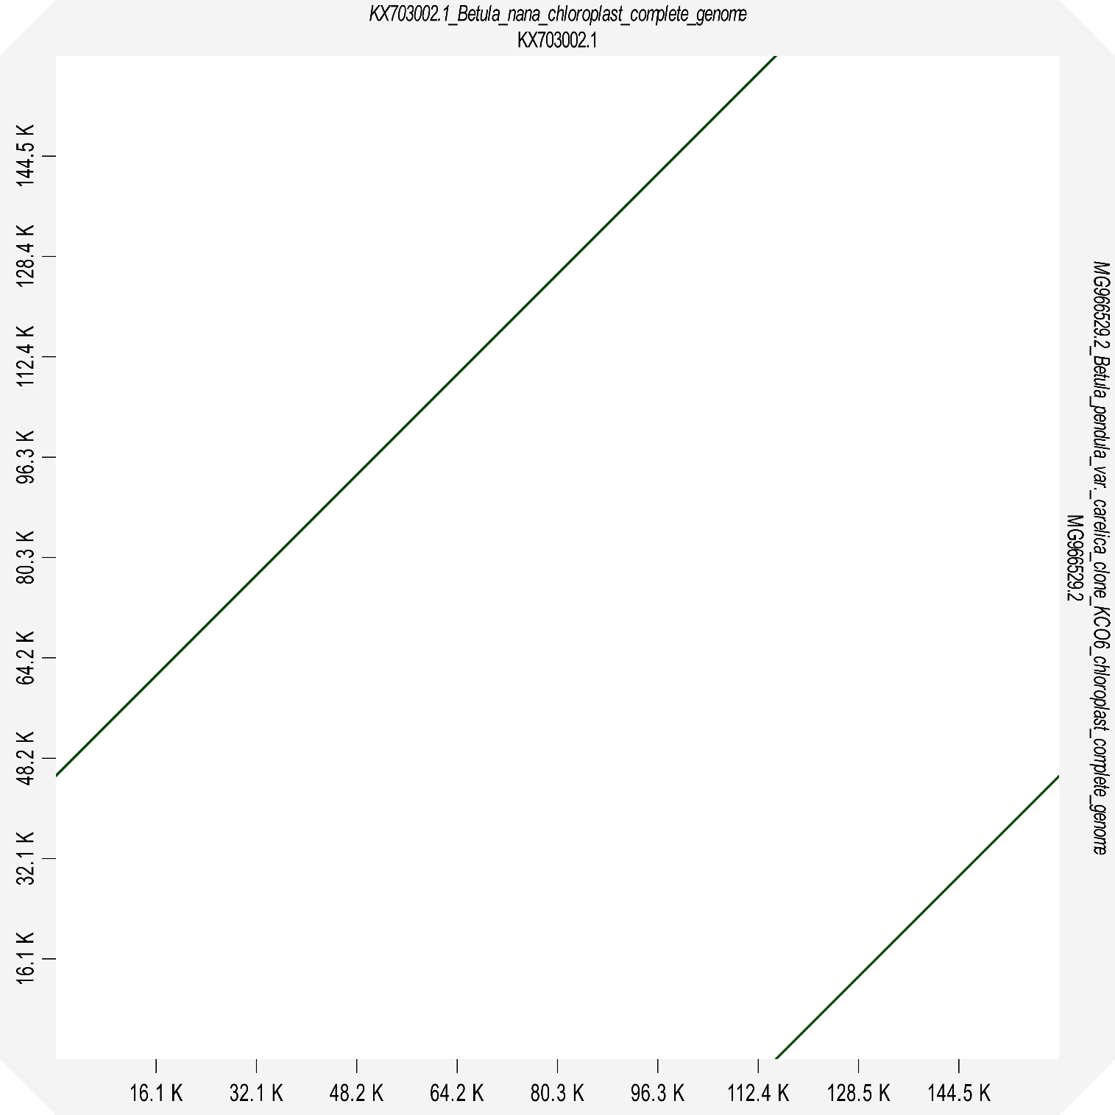
Supplementary Figure S3. Dot plots of pairwise alignments of the B. pendula var. carelica (MG966529.2) complete plastome sequence vs. plastomes of eight birch species.

