Supplement Information
Title: Growth response and recovery of Corynebacterium glutamicum colonies on single-cell level upon defined pH stress pulses
Sarah Täuber^{1,3}, Luisa Blöbaum^{1,3}, Volker F. Wendisch^{2,3} and Alexander Grünberger^{1,3*}

¹Multiscale Bioengineering, Technical Faculty, Bielefeld University, Bielefeld, Germany
²Genetics of Prokaryotes, Faculty of Biology
³CeBiTec, Bielefeld University, Bielefeld, Germany
*Correspondence:
Email: alexander.gruenberger@uni-bielefeld.de

Video S1: C. glutamicum growth before, during and after 2 h stress pulse of pH 5.
Video S2: C. glutamicum growth before, during and after 6 h stress pulse of pH 5.
Video S3: C. glutamicum growth before, during and after 2 h stress pulse of pH 10.
Video S4: C. glutamicum growth before, during and after 6 h stress pulse of pH 10.

Table S1: Single-cell sample size for each single stress pulse.
 | Stress pulse | Single cell sample size | Growing cells | No growth
pH 4 | 30 min | 100 | 0 | 100
 | 25 min | 119 | 5 | 114
 | 20 min | 61 | 3 | 58
 | 15 min | 50 | 6 | 44
 | 10 min | 61 | 13 | 48
 | 5 min | 45 | 41 | 4
pH 5 | 2 h | 117 | 109 | 8
 | 3 h | 94 | 54 | 35
 | 4 h | 59 | 53 | 9
 | 5 h | 117 | 37 | 80
 | 6 h | 113 | 31 | 82
 | 7 h | 128 | 11 | 117
 | 8 h | 164 | 22 | 142
 | 9 h | 152 | 9 | 143
pH 10 | 2 h | 77 | 76 | 1
 | 3 h | 82 | 67 | 15
 | 4 h | 70 | 30 | 40
 | 5 h | 108 | 32 | 76
 | 6 h | 106 | 16 | 90
 | 7 h | 72 | 12 | 52
pH 11 | 5 min | 38 | 38 | 0
 | 10 min | 53 | 44 | 9
 | 15 min | 127 | 82 | 45
 | 20 min | 181 | 146 | 35
 | 25 min | 134 | 36 | 96
 | 30 min | 95 | 0 | 95

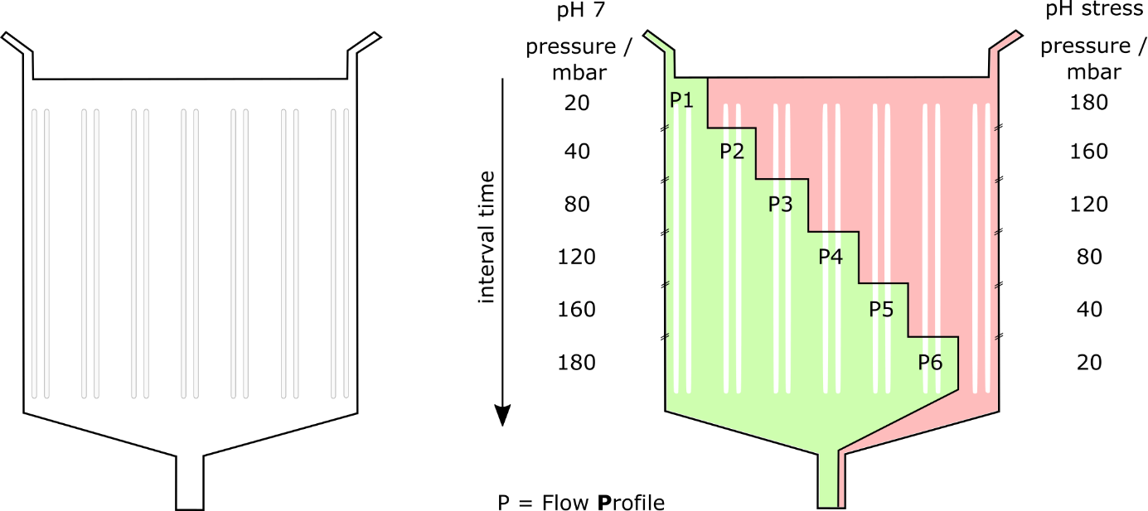
Figure S1: dMSCC with seven array pairs, the distance between these pairs being 400 µm. Six flow profiles were conducted with one control zone of each side.

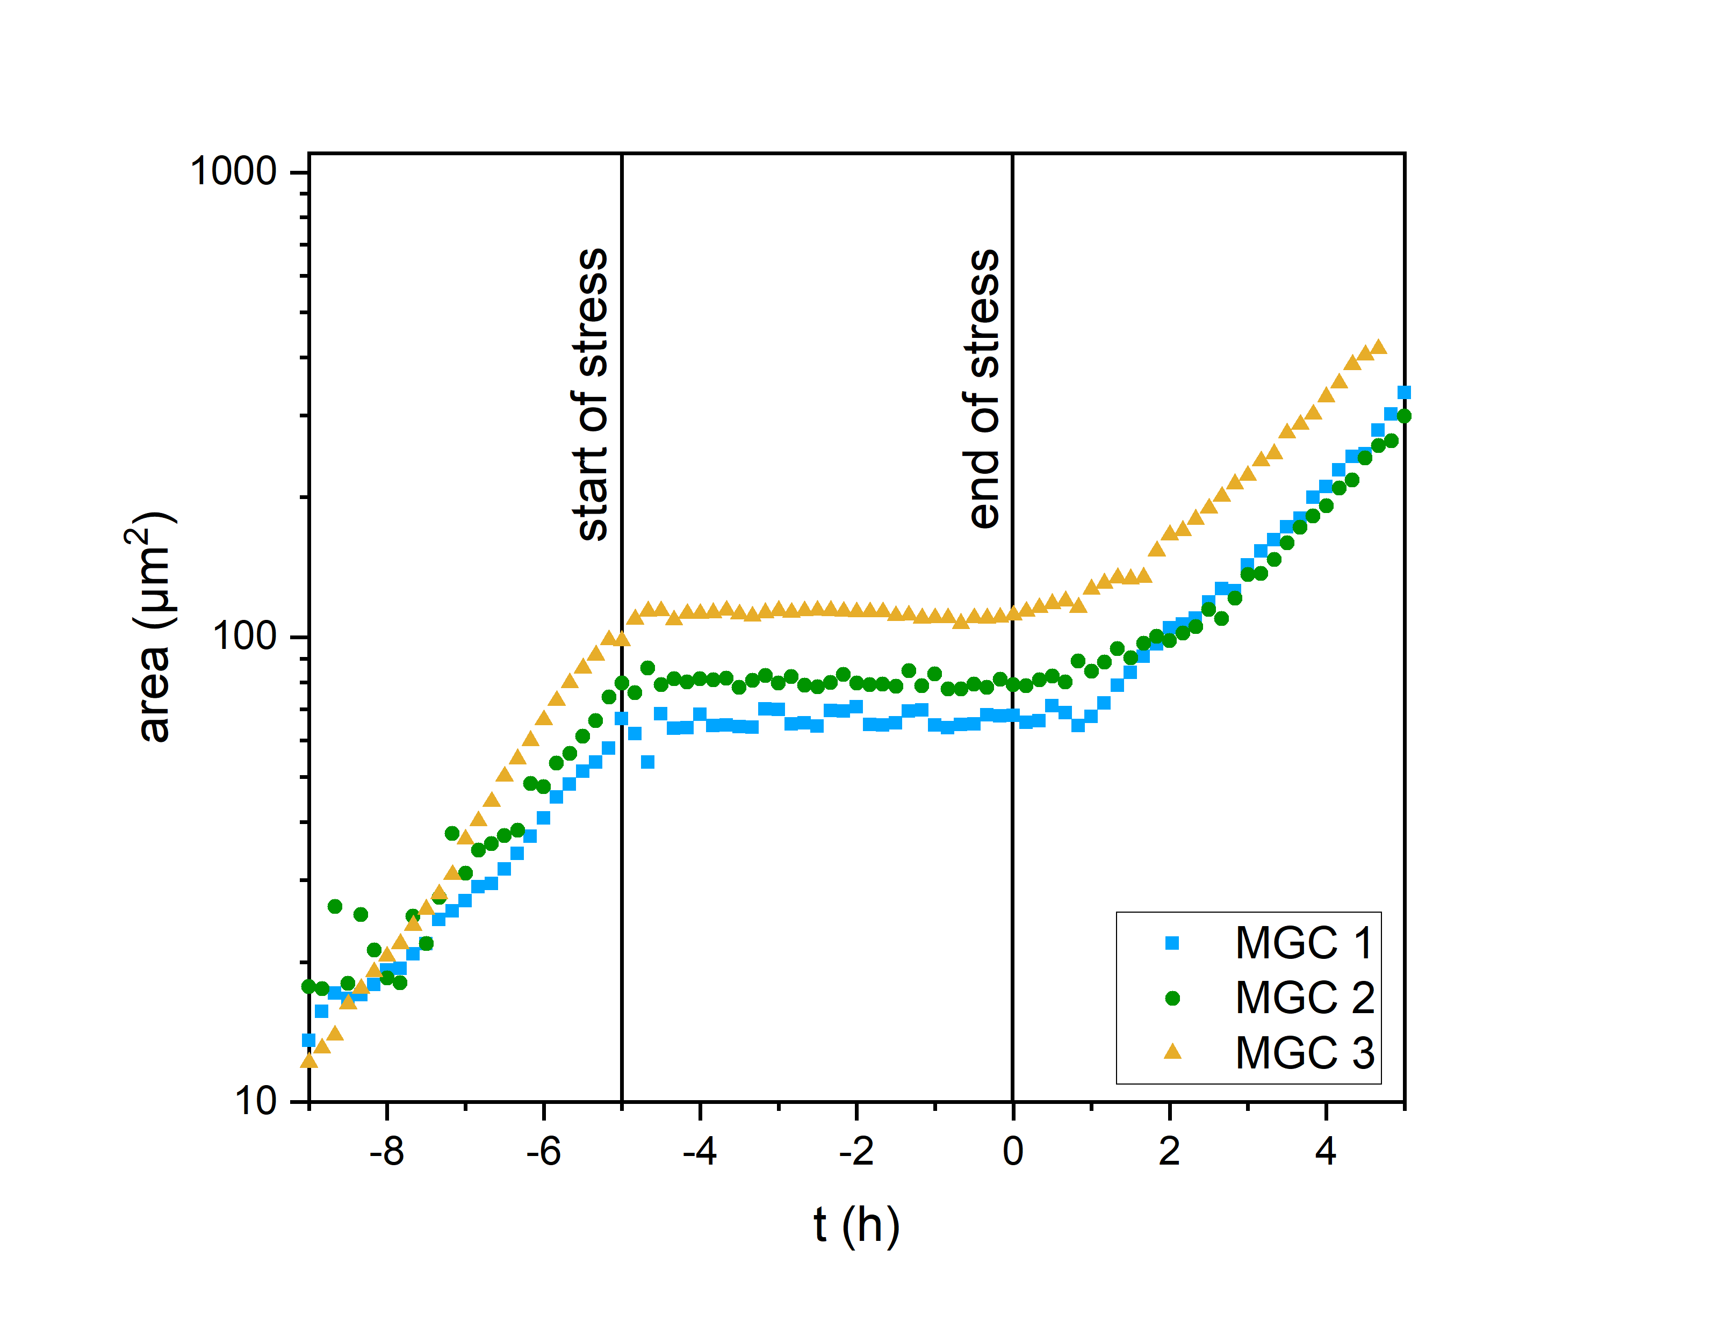
Figure S2: Growth curve at a single stress pulse of pH 5 for 5h. At t = 0h, the stress ends. Three colonies (yellow, green, blue) are shown.

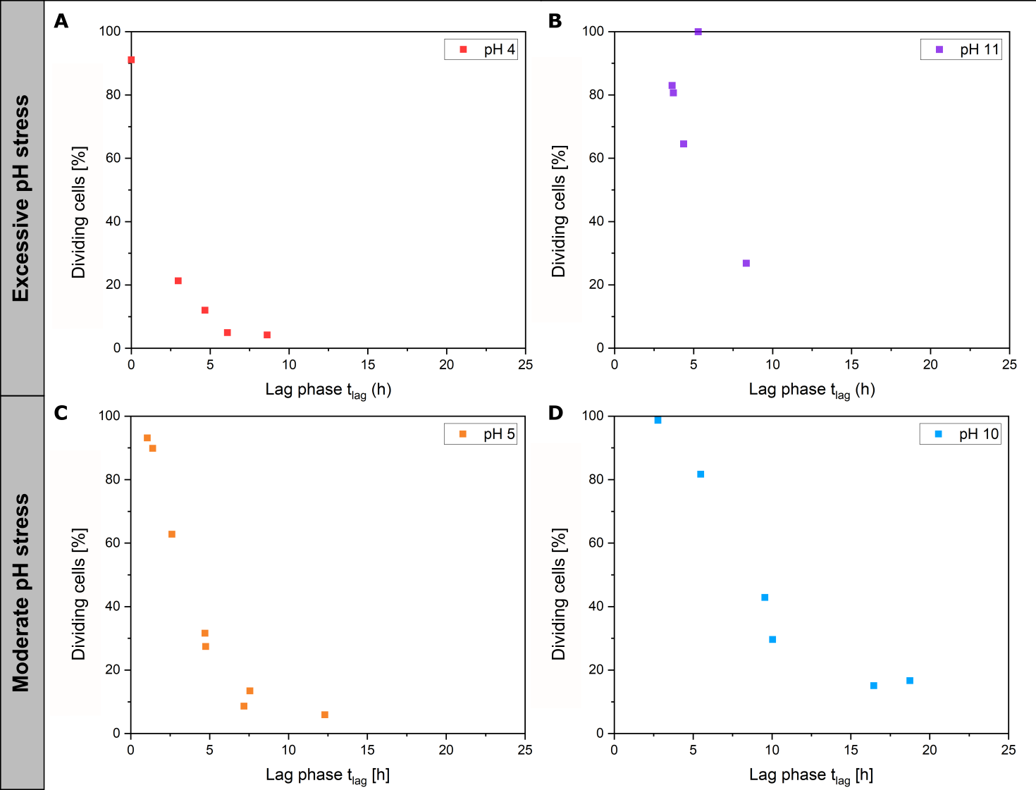
Figure S3: Correlation between dividing cells and lag phase for colony growth of C. glutamicum. With decreasing viability, the lag phase increase for all pH values. A) pH 4. B) pH 11. C) pH 5. D) pH 10.

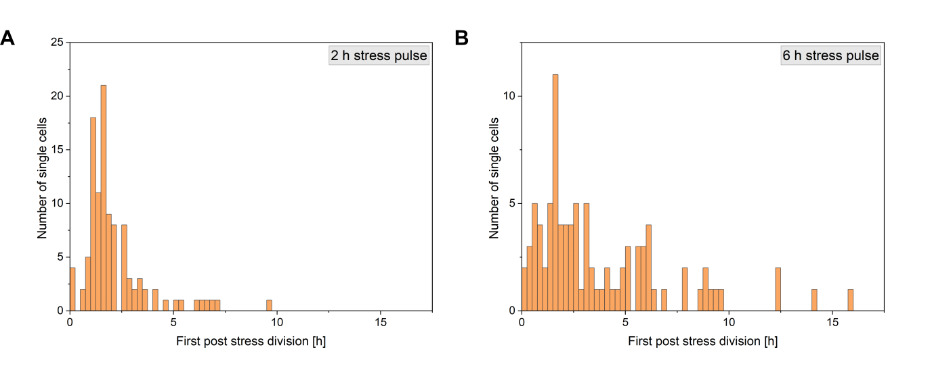
Figure S4: Cell distribution of the first post stress division time after a A) 2 h and B) 6 h pH 5 stress pulse.
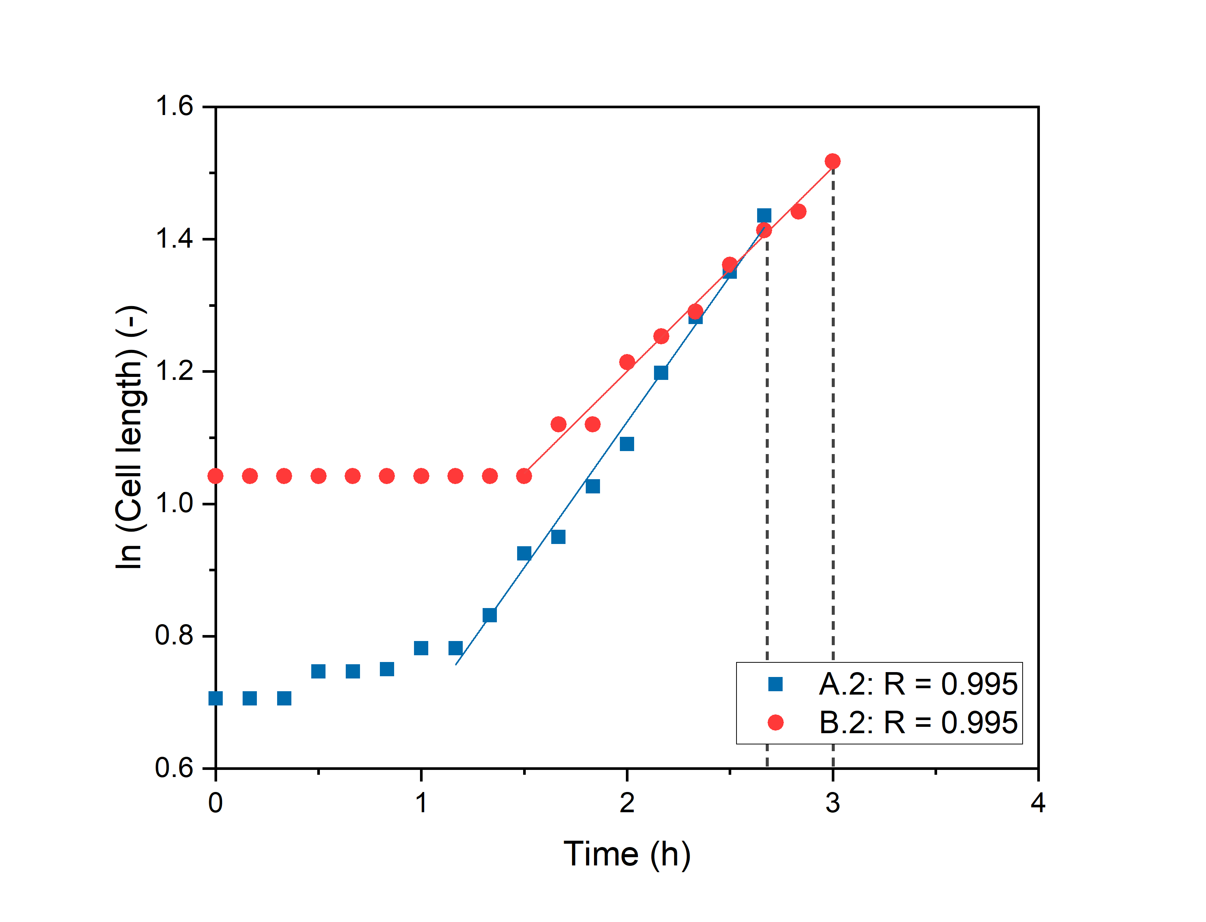
Figure S5: Correlation analysis for the exponential length growth of cell A.2 (2 h stress pulse at pH 5) and cell B.2 (2 h stress pulse of pH 10).
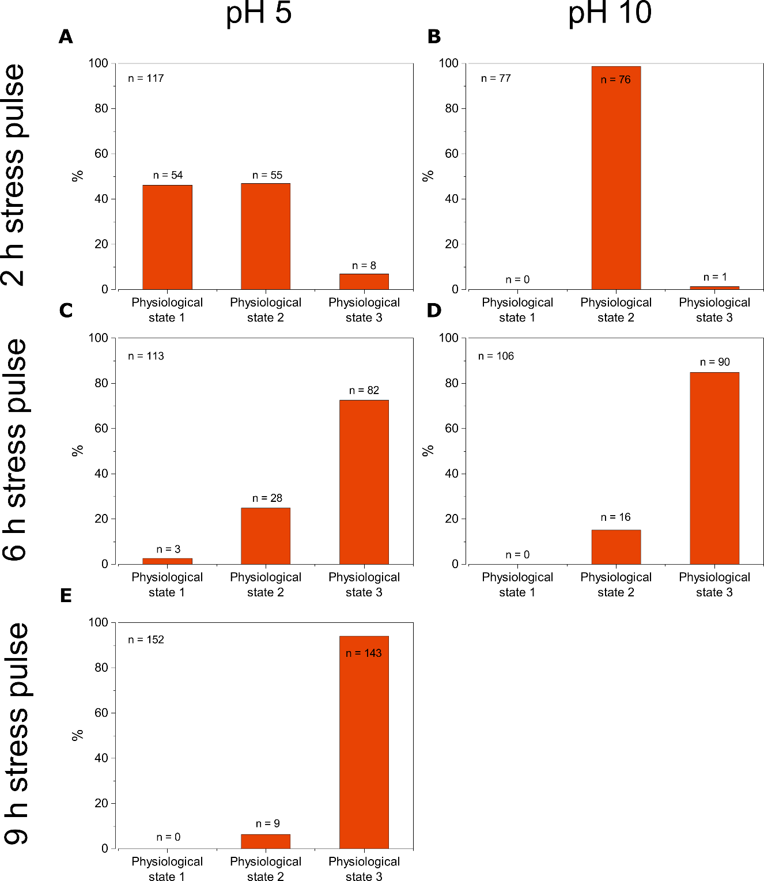
Figure S6: Distribution of regrowth physiological states of C. glutamicum after A) 2 h stress pulse of pH 5. B) 2 h stress pulse of pH 10. C) 6 h stress pulse of pH 5. D) 6 h stress pulse of pH 10. E) 9 h stress pulse of pH 5. Sample sizes are shown in Table 1.
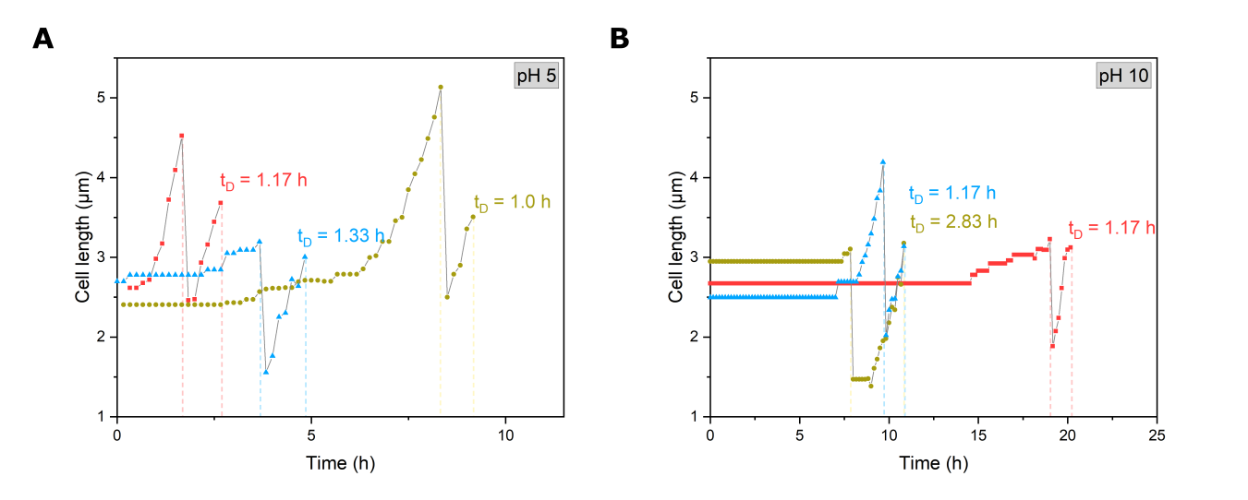
Figure S7: Cell length growth of single C. glutamicum cells after 6 h stress pulses of A) pH 5 and B) 10 stress until the first and second post-stress division. The dashed line marks the division of the cells.

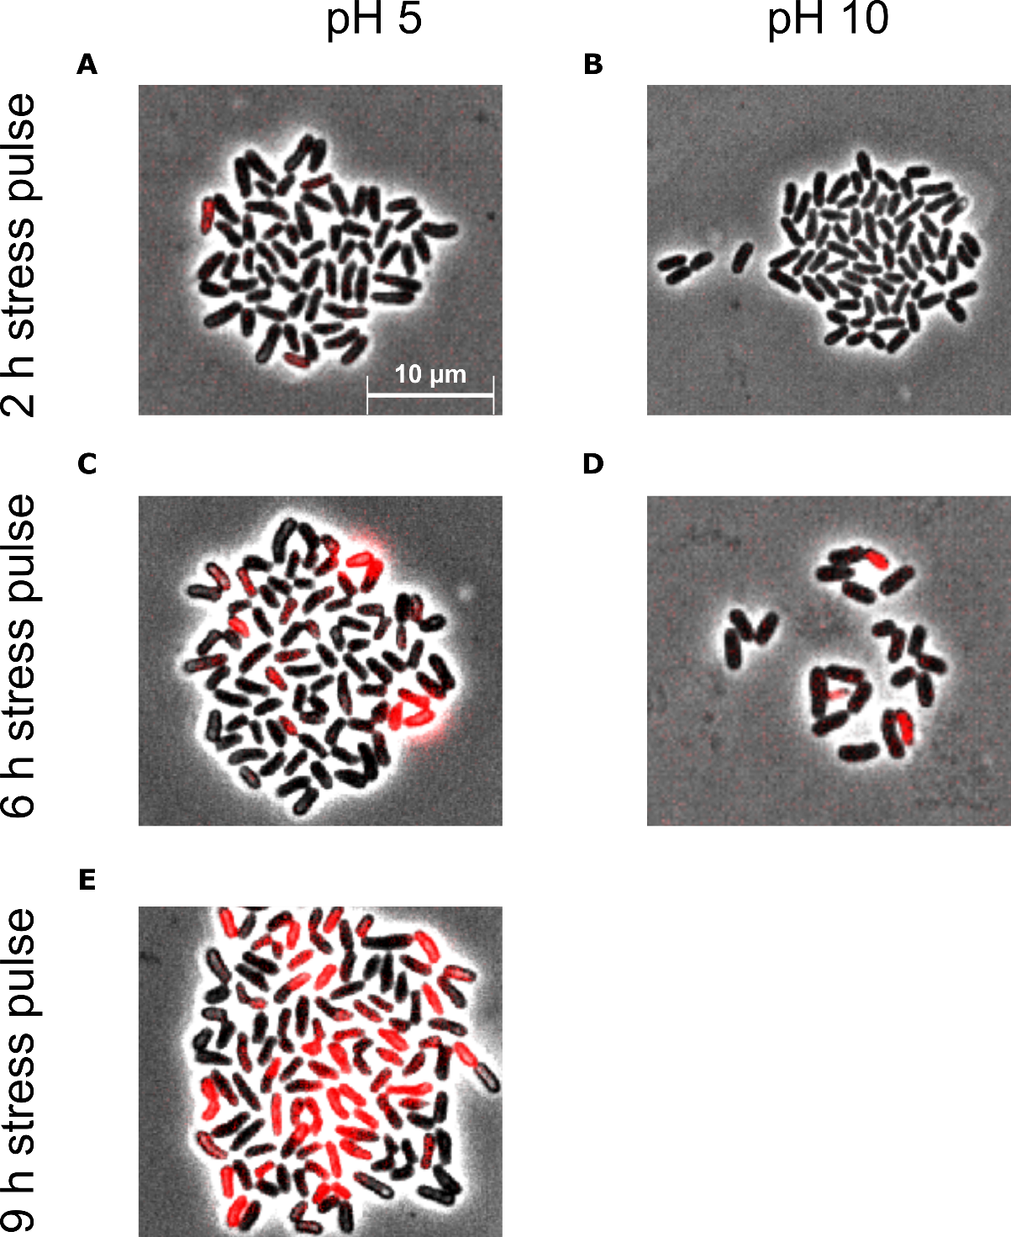
Figure S8: Microscope images of live-dead staining of C. glutamicum at the end of a pH stress pulse. After a pH 5 stress pulse of a duration of A) 2h, B) 6h and C) 8h and after a pH 10 stress pulse of a duration of D) 2h and E) 6h. Scale bar 10 µm.

