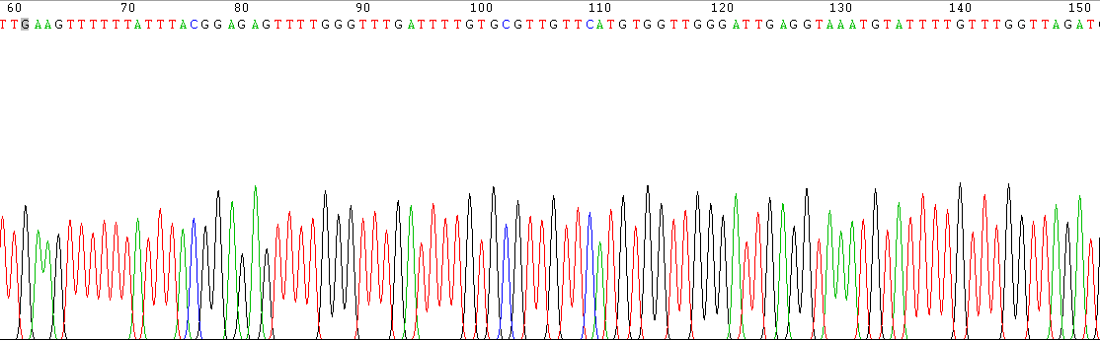
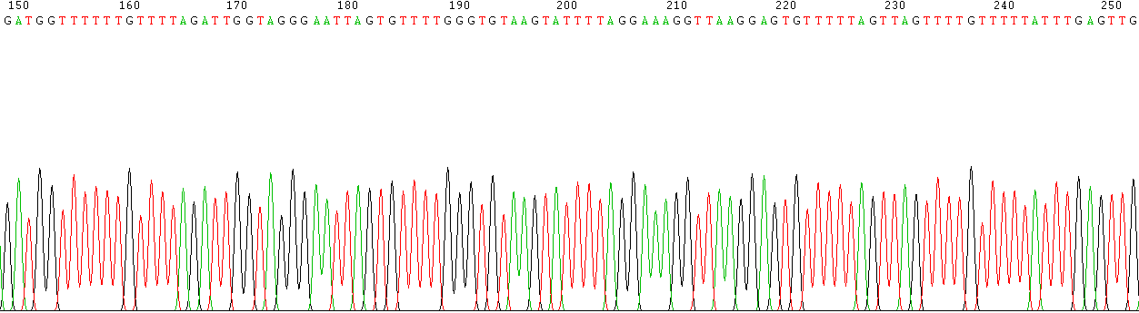
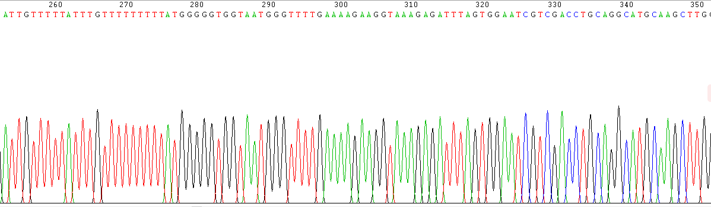
Figure S1. The bisulfite sequencing mode map for DMR in EDN1 gene

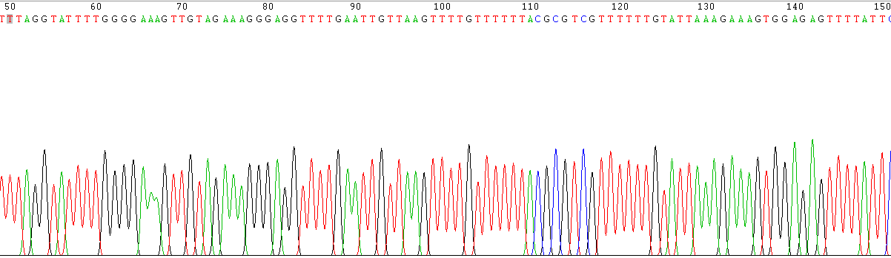
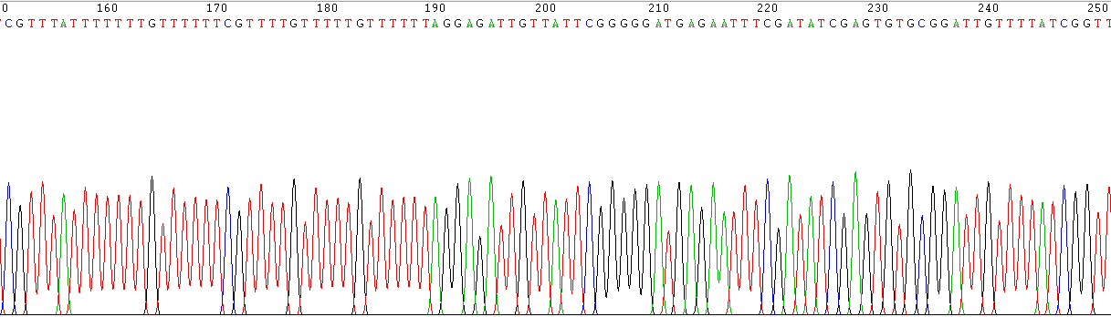
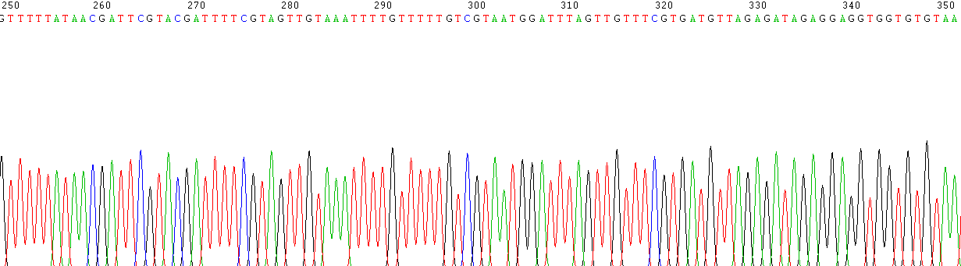
Figure S2. The bisulfite sequencing mode map for DMR in LAMC2 gene
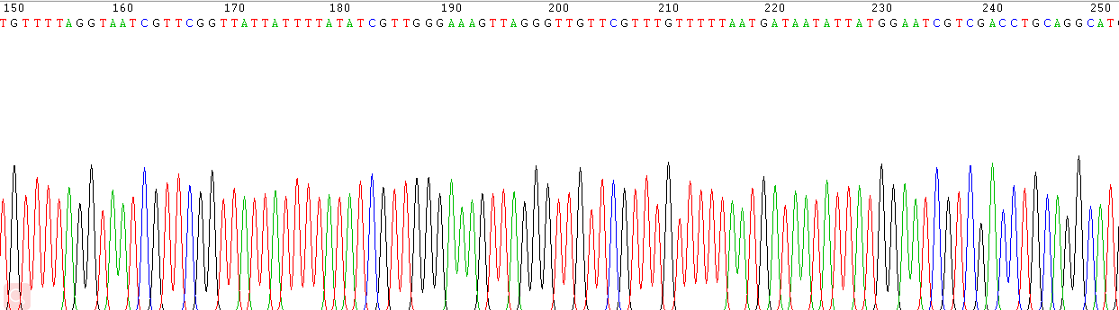
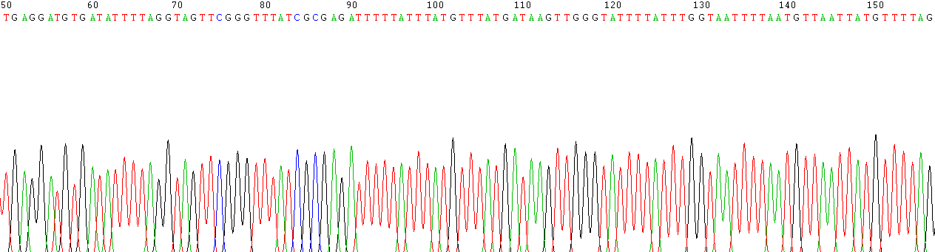
Figure S3. The bisulfite sequencing mode map for DMR in NR1D1 gene

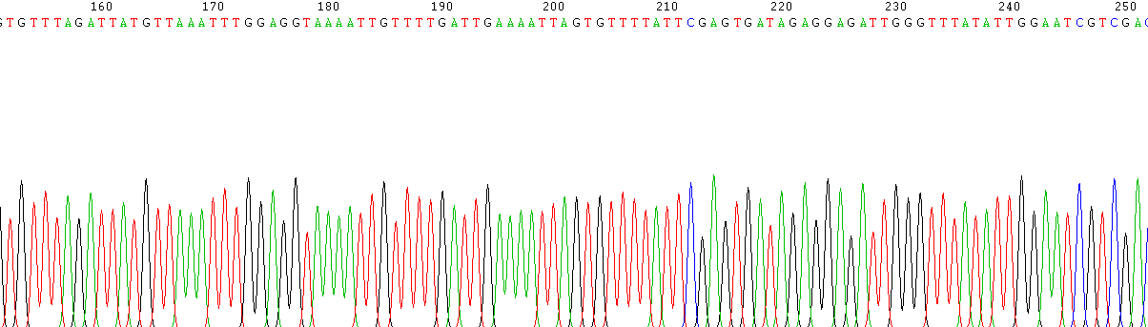
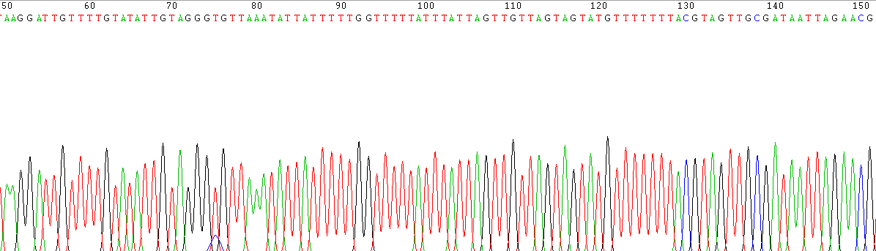

Figure S4. The bisulfite sequencing mode map for DMR in RORB gene

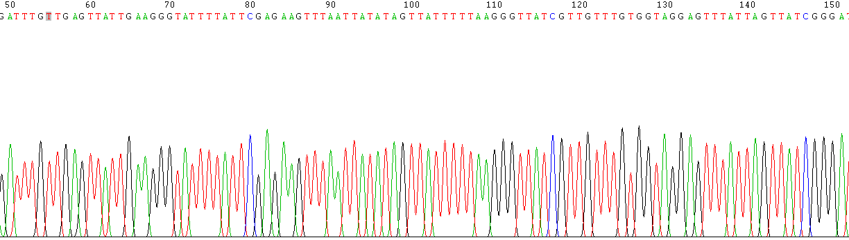
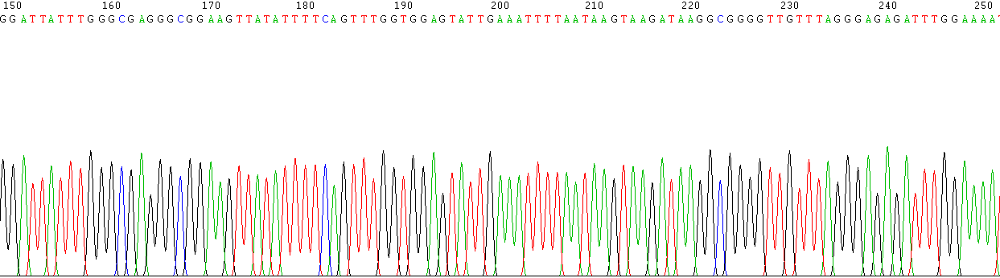
Figure S5. The bisulfite sequencing mode map for DMR in MYOZ3 gene

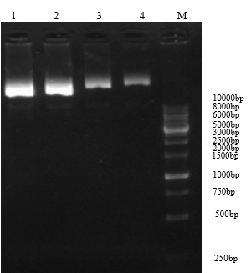
Figure S6. Extraction and identification of recombinant plasmid pLEX-MCS-WNT2
Note: No.1 and No.2 are empty lentiviral plasmids pLEX-MCS; No.3 and No.4 are recombinant plasmids pLEX-MCS-WNT2.

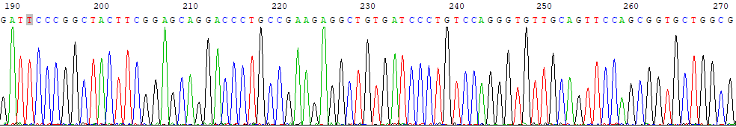
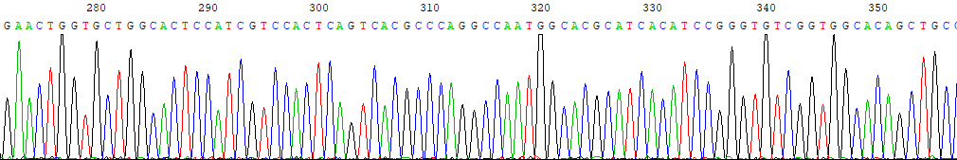
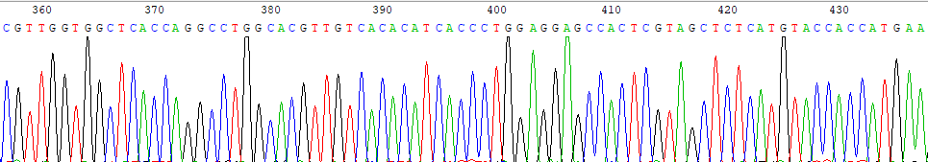
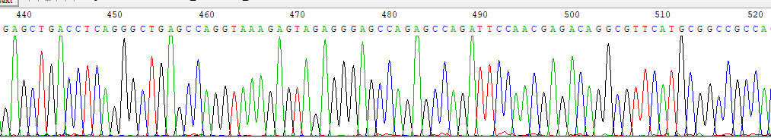
Figure S7. Peak sequencing of recombinant plasmid pLEX-MCS-WNT2

