Supplementary Material

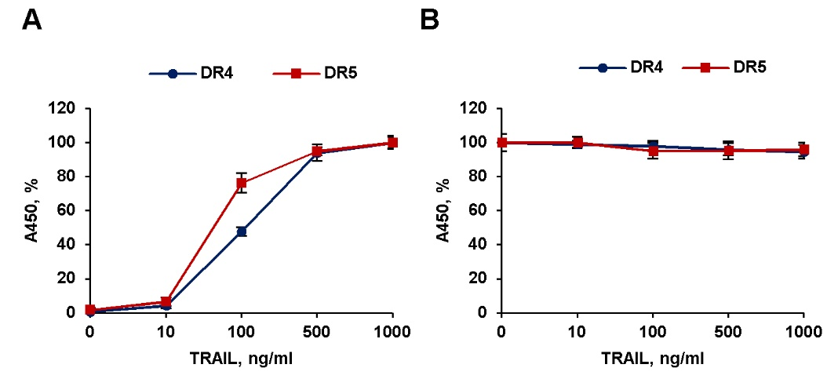
Supplementary Figure 1. TRAIL and anti-DR antibodies did not compete for binding to DR4 and DR5. (A) Binding of TRAIL to DRs. Recombinant extracellular domain of the DR5 and DR4 receptors (R&D Systems Inc., USA) were immobilized on ELISA plates overnight at 4°С at concentration of 1 μg/ml in sodium phosphate buffer (PBS). The plates were washed three times with PBST (PBS+ 0.05% Tween), and wells were blocked by 2% BSA in PBST for 1 h at room temperature. Then TRAIL was added to the wells at indicated concentrations and the plates were incubated for 1 h at 37°C. For detection of bounded TRAIL anti-TRAIL antibodies (MAB375, R&D systems, USA) was used. To evaluate the binding of TRAIL the mouse IgG (HAF007, R&D Systems, USA) conjugated with horseradish peroxidase was added to each well and the plates were incubated for 1 h and color was developed by OPD (o-phenylenediamine dihydrochloride) colorimetric substrate. After 15-minute incubation with substrate, reaction was stopped by 1 N H₂SO₄ solution. The optical density was determined at 450 nm by iMark spectrophotometer (Bio-Rad, USA). (B) The competitive binding of TRAIL and anti-DR antibodies to DR4 and DR5. The plate were captured with recombinant DRs as in (A) and the wells were incubated with TRAIL at concentration 1 μg/ml at 37°C for 1 h. After extensive washing of plates were incubated for 1 h at 37°C with anti-DR4 (DR-4-02) or anti-DR5 (DR5-01-1) monoclonal antibodies (GeneTex, Irvine, CA, USA) at concentration 5 μg/ml. The evaluation of antibody binding to the receptors was carried out as in (A). Data represent means ± SD of three independent experiments. Raw data are available in Table S1.

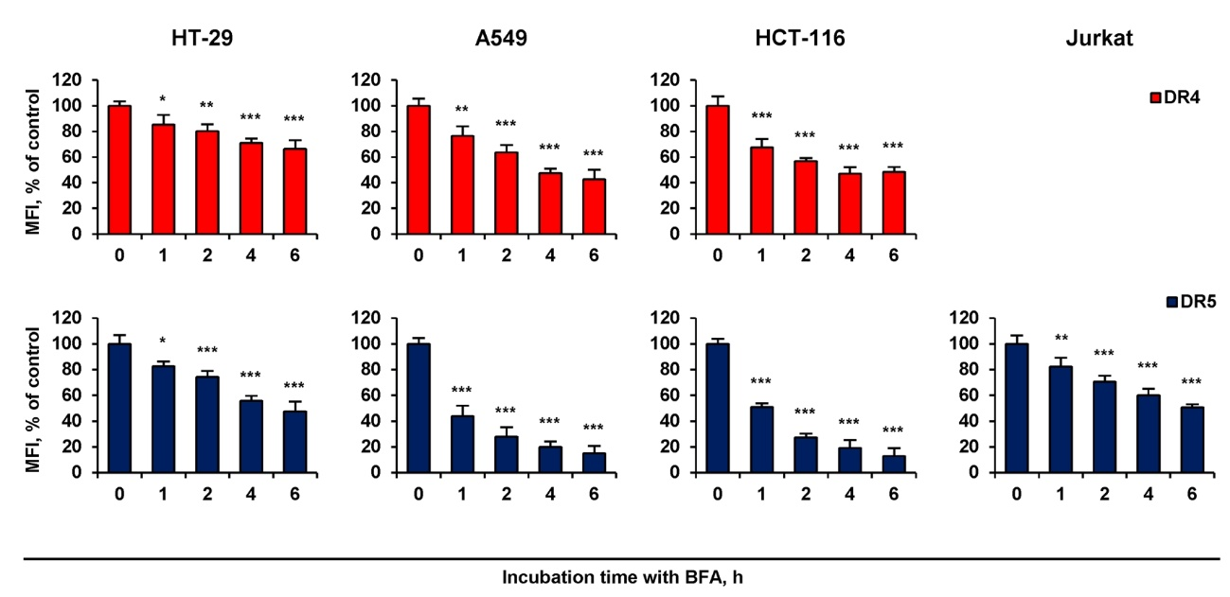
Supplementary Figure 2. Brefeldin A downregulated DR4 and DR5 surface expression in time-dependent manner. HT-29, A549, HCT116 and Jurkat cells were treated with 1.5 µM brefeldin A (BFA) at indicated periods and the surface expression of DR4 and DR5 was determined by flow cytometry. Mean Fluorescence Intensity (MFI) values are presented as a percentage relative to BFA non-treated cells. Data represent means ± SD of three independent experiments. * (p < 0.05), ** (p < 0.01) and *** (p < 0.001) indicated significant difference from the control according to One-way ANOVA followed by Dunnett’s posthoc test. Raw data are available in Table S2.

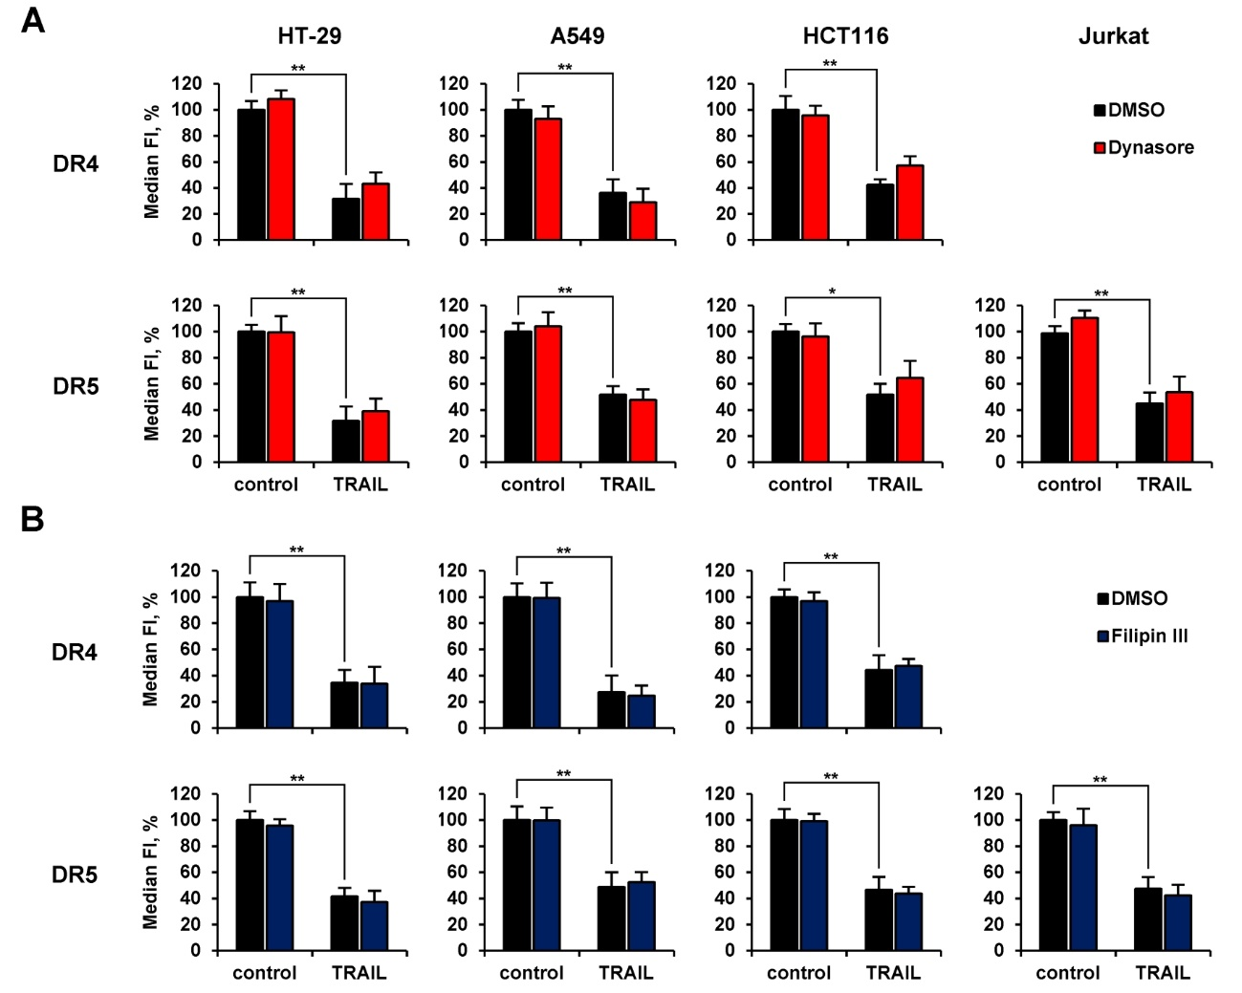
Supplementary Figure 3. Inhibitor of clathrin mediated endocytosis dynasore or cholesterol depleting agent filipin III did not significantly inhibit TRAIL mediated endocytosis of DR4 or DR5. HT-29, A549, HCT116 and Jurkat cells were treated with or without 80 µM dynasore (A) or 5 µM filipin III (B) for 1 h following 100 ng/ml TRAIL for another 1 h. The surface expression of DR4 and DR5 was determined by flow cytometry. Mean Fluorescence Intensity (MFI) values are presented as a percentage relative to non-treated with inhibitors cells. Data represent means ± SD of three independent experiments. * (p < 0.01) and ** (p < 0.001) indicate significant difference between groups according to One-way ANOVA followed by Tukey test. Raw data are available in Table S5.

Supplementary Table 1. Raw data of enzyme-linked immunosorbent assay (ELISA) for Figure S1.
Receptors | TRAIL, ng/ml | A₄₅₀
 |  | Figure S1A |  |  | Figure S1B
DR4 | 0 | 0.012 | 0.007 | 0.008 | 2.000 | 1.953 | 1.937
 | 10 | 0.050 | 0.091 | 0.042 | 1.989 | 1.923 | 1.917
 | 100 | 0.629 | 0.692 | 0.689 | 1.986 | 1.908 | 1.876
 | 500 | 1.254 | 1.301 | 1.390 | 1.877 | 1.957 | 1.819
 | 1000 | 1.376 | 1.461 | 1.361 | 1.910 | 1.763 | 1.891
DR5 | 0 | 0.021 | 0.036 | 0.009 | 1.240 | 1.190 | 1.315
 | 10 | 0.096 | 0.045 | 0.099 | 1.276 | 1.198 | 1.266
 | 100 | 0.894 | 0.888 | 1.014 | 1.127 | 1.193 | 1.240
 | 500 | 1.131 | 1.188 | 1.152 | 1.122 | 1.196 | 1.255
 | 1000 | 1.182 | 1.215 | 1.266 | 1.148 | 1.249 | 1.197

Supplementary Table 2. Raw data of surface death receptors flow cytometry analysis for Figure S2.
Receptors | BFA, h | Median FI
 |  | Cell lines
 |  | HT-29 |  |  | A549 |  |  | HCT116 |  |  | Jurkat
 | isotype | 2961.2 | 2971.8 | 2981.2 | 2000.5 | 2083.0 | 2001.4 | 2214.8 | 2198.4 | 2208.4 | 966.6 | 942.1 | 1046.8
DR5 | control | 10263.8 | 10221.4 | 11131.8 | 10145.3 | 10071.7 | 9464.6 | 15440.3 | 16018.9 | 16491.3 | 3024.2 | 3058.0 | 2913.6
 | 1 | 9534.1 | 9159.4 | 8998.4 | 5275.4 | 5046.8 | 6171.2 | 8803.3 | 9409.6 | 9527.1 | 2478.5 | 2732.8 | 2724.9
 | 2 | 9001.6 | 8332.9 | 8458.3 | 3532.9 | 4558.9 | 4556.6 | 5513.8 | 6300.4 | 6050.0 | 2261.2 | 2414.7 | 2479.7
 | 4 | 7448.2 | 7219.4 | 6887.7 | 3495.9 | 3363.4 | 3919.4 | 3939.9 | 5600.0 | 4939.2 | 2247.7 | 2112.7 | 2136.0
 | 6 | 7064.0 | 5934.7 | 6726.2 | 3200.9 | 2819.5 | 3648.9 | 3562.7 | 4983.1 | 3546.9 | 2078.6 | 1989.1 | 2061.1
DR4 | control | 12295.8 | 11988.4 | 11715.5 | 21177.7 | 19292.0 | 20484.2 | 20506.8 | 22036.2 | 23365.3 | – | – | –
 | 1 | 11450.9 | 10246.5 | 10328.4 | 16267.5 | 14561.9 | 17161.3 | 14173.8 | 16772.7 | 15599.8 | – | – | –
 | 2 | 9889.6 | 9919.0 | 10678.0 | 12489.7 | 13849.0 | 14580.5 | 13252.1 | 14014.7 | 13150.4 | – | – | –
 | 4 | 9803.5 | 9180.9 | 9365.6 | 10657.4 | 10185.7 | 11364.8 | 12137.6 | 10388.7 | 11985.7 | – | – | –
 | 6 | 9670.2 | 8601.5 | 8679.1 | 9900.3 | 8545.5 | 11128.5 | 11971.8 | 10951.8 | 12385.3 | – | – | –
–, not investigated

Supplementary Table 3. Raw data of surface death receptors flow cytometry analysis for Figures 5B and 5C.
Receptors | Samples |  | Median FI
 |  |  | Cell lines
 |  |  | HT-29 |  |  | A549 |  |  | HCT116 |  |  | Jurkat
DR5 | BFA, μM,  6 h | isotype | 2856.8 | 2854.2 | 2956.3 | 2157.8 | 1968.5 | 2015.2 | 2420.2 | 2466.4 | 2301.3 | 1015.0 | 996.0 | 1026.9
 |  | control | 12300.8 | 11403.8 | 12559.5 | 8817.7 | 9137.9 | 8954.5 | 16187.2 | 15105.5 | 16411.6 | 2339.3 | 2134.6 | 2251.0
 |  | 0.1 | 7367.2 | 7736.6 | 8227.5 | 4857.5 | 4826.0 | 4031.6 | 14593.2 | 13604.7 | 14690.9 | 2315.5 | 2210.6 | 2258.3
 |  | 0.5 | 6962.4 | 7091.0 | 7836.3 | 4460.8 | 4188.1 | 3876.2 | 6104.8 | 6683.6 | 5397.0 | 1457.3 | 1536.8 | 1489.1
 |  | 1.0 | 6567.2 | 6759.0 | 7682.7 | 4201.1 | 3690.2 | 3511.7 | 5992.7 | 6364.7 | 4948.3 | 1472.6 | 1459.5 | 1378.8
 | BFA, μM,  6 h after TRAIL washing | isotype | 2880.7 | 2878.4 | 3154.4 | 2221.0 | 2208.8 | 2277.7 | 2396.8 | 2362.2 | 2198.7 | 1086.7 | 1067.2 | 957.2
 |  | control | 12645.8 | 14322.4 | 13799.0 | 10524.8 | 11373.8 | 11423.1 | 17785.2 | 18912.9 | 18776.2 | 2264.0 | 2286.0 | 2298.4
 |  | TRAIL, 1 h | 3773.8 | 4438.8 | 4401.2 | 4316.2 | 4732.9 | 4594.3 | 6421.5 | 7219.5 | 6288.9 | 1402.6 | 1293.9 | 1232.7
 |  | 0 | 15911.3 | 17216.9 | 16409.4 | 10904.6 | 11376.8 | 11088.6 | 16249.6 | 17471.1 | 16802.7 | 2423.6 | 2575.4 | 2467.2
 |  | 0.1 | 5378.0 | 6098.8 | 5668.5 | 4190.1 | 4614.5 | 4177.5 | 14686.3 | 16995.5 | 16246.4 | 2174.5 | 2064.7 | 2032.4
 |  | 0.5 | 3941.8 | 5438.7 | 5023.6 | 3591.6 | 3301.4 | 4155.6 | 7913.4 | 7953.1 | 9443.2 | 1833.3 | 1866.3 | 1804.9
 |  | 1.0 | 3972.6 | 5072.8 | 4842.7 | 3405.1 | 3165.0 | 4127.2 | 8083.1 | 8425.0 | 9550.8 | 1942.8 | 1887.4 | 1880.3
DR4 | BFA, μM,  6 h | isotype | 2914.9 | 3065.3 | 2896.1 | 2140.1 | 2091.2 | 2199.3 | 2624.6 | 2347.1 | 2242.2 | – | – | –
 |  | control | 9515.3 | 10141.3 | 10050.9 | 21866.7 | 23390.1 | 21242.3 | 28275.8 | 28828.3 | 26157.1 | – | – | –
 |  | 0.1 | 7861.7 | 8567.7 | 7982.1 | 16615.6 | 16714.5 | 15656.6 | 23496.5 | 24462.4 | 23305.4 | – | – | –
 |  | 0.5 | 7897.3 | 8393.3 | 7971.7 | 13379.1 | 16289.2 | 13972.9 | 20028.4 | 20926.2 | 19998.5 | – | – | –
 |  | 1.0 | 7824.9 | 7828.1 | 7369.7 | 16396.7 | 16316.7 | 14782.6 | 19099.8 | 21424.1 | 19199.3 | – | – | –
 | BFA, μM,  6 h after TRAIL washing | isotype | 3017.5 | 3113.1 | 2846.7 | 2005.2 | 2122.6 | 2249.4 | 2253.8 | 2056.5 | 2227.3 | – | – | –
 |  | control | 10533.8 | 11190.6 | 11109.7 | 22185.7 | 21974.8 | 24683.1 | 29327.6 | 26307.1 | 26434.7 | – | – | –
 |  | TRAIL, 1 h | 3824.2 | 3829.1 | 4046.0 | 4751.4 | 5326.1 | 4273.6 | 5128.1 | 6147.4 | 4668.0 | – | – | –
 |  | 0 | 10526.8 | 10771.7 | 11069.2 | 25267.5 | 24680.0 | 24584.8 | 22037.4 | 24327.9 | 23662.0 | – | – | –
 |  | 0.1 | 4043.6 | 4580.2 | 4129.0 | 15425.1 | 15251.7 | 18164.1 | 14713.9 | 16904.1 | 15001.0 | – | – | –
 |  | 0.5 | 3569.9 | 4543.6 | 3822.9 | 15132.3 | 13988.1 | 17033.0 | 9346.9 | 11100.9 | 9913.9 | – | – | –
 |  | 1.0 | 3690.2 | 4261.0 | 3704.6 | 15562.7 | 14327.1 | 16373.6 | 10154.2 | 11547.3 | 9181.7 | – | – | –
–, not investigated
Supplementary Table 4. Raw data of surface death receptors flow cytometry analysis for Figures 6A and 6D.
Receptors | Samples |  | Median FI
 |  |  | Cell lines
 |  |  | HT-29 |  |  | A549 |  |  | HCT116 |  |  | Jurkat
DR5 | CHX, μg/ml,  6 h | isotype | 2942.3 | 3155.1 | 2990.9 | 2283.2 | 2300.1 | 2221.8 | 2292.7 | 2520.6 | 2260.5 | 1016.7 | 1027.2 | 927.2
 |  | control | 12420.2 | 13842.7 | 12805.8 | 8566.7 | 9107.2 | 8512.8 | 16516.9 | 17235.1 | 18103.8 | 2381.3 | 2466.8 | 2388.7
 |  | 2 | 12381.3 | 13552.8 | 13848.2 | 7721.1 | 8395.7 | 8316.8 | 12699.1 | 14866.2 | 14488.4 | 2334.1 | 2434.1 | 2344.1
 |  | 20 | 12428.6 | 13232.8 | 12532.3 | 6119.6 | 6411.5 | 5413.7 | 9117.3 | 9936.1 | 9549.2 | 2232.2 | 2245.5 | 2197.8
 |  | 50 | 11312.3 | 11754.7 | 11856.5 | 5618.0 | 6071.2 | 5176.0 | 8546.4 | 9973.9 | 9588.3 | 2218.1 | 2285.3 | 2278.4
 | CHX, μg/ml,  6 h after TRAIL washing | isotype | 2802.3 | 3034.4 | 3067.9 | 2248.6 | 2273.6 | 2236.9 | 2085.3 | 1916.2 | 1931.6 | 947.5 | 996.7 | 939.5
 |  | control | 10396.2 | 10391.6 | 11068.1 | 9265.7 | 10229.3 | 10207.1 | 15618.8 | 15058.8 | 16507.7 | 2824.5 | 3034.6 | 2970.4
 |  | TRAIL, 1 h | 3846.0 | 3769.9 | 4270.8 | 4221.8 | 4294.5 | 3839.8 | 6066.0 | 6619.4 | 5833.9 | 1500.2 | 1602.9 | 1584.8
 |  | 0 | 12024.6 | 12109.4 | 13233.5 | 9988.2 | 10152.4 | 10306.5 | 14296.1 | 13847.4 | 15819.5 | 2930.7 | 3241.3 | 3039.0
 |  | 2 | 10281.9 | 10000.2 | 10975.3 | 6688.7 | 6326.7 | 7197.3 | 9867.8 | 10303.9 | 10487.2 | 2317.2 | 2287.8 | 2501.2
 |  | 20 | 7852.1 | 7883.9 | 8659.8 | 4903.4 | 4468.5 | 4644.7 | 5708.4 | 6606.8 | 7561.2 | 2007.3 | 2128.3 | 2215.5
 |  | 50 | 8031.4 | 7412.8 | 8323.8 | 3918.8 | 3960.5 | 4678.0 | 7216.6 | 6226.0 | 7226.5 | 2161.6 | 2385.2 | 2143.3
DR4 | CHX, μg/ml,  6 h | isotype | 3149.0 | 3120.6 | 3048.9 | 2103.3 | 2008.1 | 2078.0 | 2305.9 | 2222.5 | 2437.1 | – | – | –
 |  | control | 11474.9 | 10553.3 | 11127.4 | 21873.2 | 22103.5 | 24140.2 | 26201.8 | 25716.4 | 27635.3 | – | – | –
 |  | 2 | 9236.5 | 8970.8 | 9969.4 | 21311.1 | 22232.1 | 22747.2 | 25917.4 | 27275.0 | 27560.4 | – | – | –
 |  | 20 | 8466.2 | 8958.6 | 8774.5 | 21428.7 | 22228.1 | 22853.5 | 26154.4 | 27508.5 | 27722.1 | – | – | –
 |  | 50 | 8767.5 | 9344.7 | 9421.3 | 20349.8 | 21076.7 | 21328.2 | 27418.8 | 28246.3 | 24970.9 | – | – | –
 | CHX, μg/ml,  6 h after TRAIL washing | isotype | 3014.2 | 2889.4 | 2853.3 | 2212.6 | 2228.1 | 2251.8 | 1960.7 | 2141.1 | 2124.2 | – | – | –
 |  | control | 10255.2 | 10774.3 | 10762.6 | 22995.7 | 25589.1 | 25610.8 | 20331.6 | 22763.2 | 22744.4 | – | – | –
 |  | TRAIL, 1 h | 3410.0 | 3672.0 | 3963.1 | 5371.3 | 5434.7 | 6669.6 | 5497.3 | 4989.1 | 4596.6 | – | – | –
 |  | 0 | 9383.0 | 10175.2 | 10342.6 | 24806.7 | 25727.5 | 25906.1 | 18724.3 | 18270.1 | 16730.3 | – | – | –
 |  | 2 | 5704.8 | 5098.9 | 5010.1 | 23553.4 | 22767.5 | 25110.5 | 13592.0 | 11582.1 | 10745.1 | – | – | –
 |  | 20 | 4729.6 | 4496.2 | 5152.3 | 23967.7 | 23236.0 | 24760.5 | 9341.5 | 8553.9 | 7875.2 | – | – | –
 |  | 50 | 4114.6 | 3870.3 | 4431.0 | 21328.0 | 23466.2 | 23717.5 | 9949.7 | 8178.1 | 7618.3 | – | – | –
–, not investigated
Supplementary Table 5. Raw data of surface death receptors flow cytometry analysis for Figure S3.
Figures | Receptors | Samples | Median FI
 |  |  | Cell lines
 |  |  | HT-29 |  |  | A549 |  |  | HCT116 |  |  | Jurkat
S3A |  | isotype | 3084.9 | 3166.3 | 3175.9 | 2286.4 | 2242.3 | 2242.5 | 2287.3 | 2235.5 | 2246.1 | 1210.9 | 959.5 | 909.8
 | DR5 | control | 13530.6 | 12776.8 | 12687.9 | 11071.9 | 10976.4 | 10058.6 | 14519.5 | 13783.0 | 15210.2 | 2879.0 | 2776.6 | 2756.3
 |  | TRAIL | 4960.8 | 6828.1 | 7051.0 | 6718.3 | 7106.8 | 6007.7 | 8874.0 | 7454.3 | 9430.2 | 1863.8 | 1780.1 | 1853.1
 |  | Dynasore | 11538.0 | 13798.9 | 13601.1 | 10158.2 | 11144.8 | 11911.8 | 14592.5 | 12590.5 | 14919.0 | 3010.2 | 2934.0 | 2887.7
 |  | Dynasore + TRAIL | 5879.8 | 7490.5 | 7700.1 | 6622.5 | 6772.3 | 5510.2 | 10437.5 | 8424.6 | 11579.2 | 1920.4 | 2030.2 | 1993.4
 | DR4 | control | 10999.2 | 10999.0 | 12001.6 | 19794.1 | 20506.4 | 17923.8 | 25280.1 | 22189.8 | 26925.7 | – | – | –
 |  | TRAIL | 5539.1 | 4882.1 | 6746.6 | 8920.9 | 9985.9 | 6563.7 | 12117.8 | 10736.6 | 12541.0 | – | – | –
 |  | Dynasore | 12252.8 | 11413.0 | 12358.9 | 19501.1 | 18866.6 | 16289.7 | 25489.2 | 22060.1 | 24007.8 | – | – | –
 |  | Dynasore + TRAIL | 6891.3 | 5901.0 | 7286.1 | 7298.4 | 8992.1 | 5419.9 | 15475.1 | 13397.3 | 16566.2 | – | – | –
S3B |  | isotype | 3257.8 | 3169.1 | 3173.0 | 2274.2 | 2214.1 | 2383.6 | 2368.9 | 2481.4 | 2824.1 | 957.0 | 943.4 | 1003.8
 | DR5 | control | 12945.5 | 14279.8 | 13553.6 | 7935.3 | 7081.2 | 7034.7 | 14544.4 | 13245.5 | 13185.8 | 3119.0 | 3007.9 | 2916.8
 |  | TRAIL | 7025.4 | 8253.5 | 7238.9 | 4512.1 | 5220.8 | 4262.7 | 7184.7 | 8909.8 | 7148.4 | 2069.9 | 1990.4 | 1773.1
 |  | Filipin III | 12964.5 | 13731.9 | 12784.2 | 7889.0 | 6908.6 | 7261.7 | 14113.0 | 13253.8 | 13377.8 | 2991.4 | 3122.4 | 2680.1
 |  | Filipin III + TRAIL | 7048.2 | 7995.4 | 6234.7 | 4844.9 | 5301.4 | 4723.1 | 7430.4 | 7808.9 | 7017.5 | 1953.3 | 1868.6 | 1682.0
 | DR4 | control | 9964.4 | 11178.7 | 9751.6 | 27677.6 | 28697.3 | 24038.7 | 25171.7 | 22809.5 | 24012.6 | – | – | –
 |  | TRAIL | 5299.2 | 6436.5 | 5294.5 | 11674.9 | 9713.2 | 5651.1 | 11865.9 | 9555.7 | 14822.0 | – | – | –
 |  | Filipin III | 9294.5 | 11022.4 | 9914.2 | 28765.1 | 27695.7 | 23541.3 | 24283.8 | 21610.0 | 23983.5 | – | – | –
 |  | Filipin III + TRAIL | 4739.4 | 6479.0 | 5580.1 | 9698.4 | 9169.0 | 6302.6 | 13292.9 | 11279.2 | 13519.6 | – | – | –
–, not investigated

Supplementary Table 6. Raw data of surface death receptors flow cytometry analysis for Figures 7A and 7B.
Receptors | Samples | Median FI
 |  | Cell lines
 |  | HT-29 |  |  | A549 |  |  | HCT116 |  |  | Jurkat
 | isotype | 2962.3 | 3074.6 | 2937.1 | 2075.4 | 2074.8 | 2102.8 | 2168.3 | 2059.7 | 2043.5 | 1171.3 | 1096.6 | 1175.7
DR5 | control | 12396.1 | 13067.9 | 13488.9 | 10802.7 | 10803.6 | 10327.6 | 15314.0 | 16663.0 | 15923.9 | 3386.7 | 3006.1 | 3148.3
 | TRAIL | 6385.7 | 5024.7 | 6053.2 | 4616.7 | 4977.6 | 5658.2 | 8581.3 | 8036.9 | 9711.7 | 2137.6 | 2261.9 | 2187.6
 | sucrose | 13830.0 | 13681.4 | 13961.3 | 10141.7 | 10771.2 | 11421.8 | 17080.1 | 16527.6 | 17284.0 | 3564.7 | 3647.8 | 3518.8
 | sucrose + TRAIL | 8390.5 | 10261.4 | 8943.5 | 8729.6 | 8527.3 | 9528.3 | 12192.7 | 11215.4 | 12714.9 | 2462.5 | 2619.8 | 2513.3
DR4 | control | 10296.4 | 11131.5 | 11549.7 | 21191.7 | 20910.1 | 22594.5 | 24586.7 | 26113.2 | 26099.0 | – | – | –
 | TRAIL | 5299.0 | 5850.9 | 6124.5 | 8607.4 | 9095.1 | 10033.5 | 13358.2 | 15542.6 | 13457.8 | – | – | –
 | sucrose | 11415.7 | 11835.5 | 10800.1 | 20361.3 | 20962.4 | 21566.4 | 32512.2 | 31595.0 | 30486.5 | – | – | –
 | sucrose + TRAIL | 8536.7 | 9485.1 | 8764.3 | 15191.0 | 15226.5 | 16423.1 | 25305.8 | 22378.6 | 25787.8 | – | – | –
–, not investigated

Supplementary Table 7. Raw data of WST-1 assay for Figure 7C.
Samples | A₄₅₀ - A₆₅₅
 | Cell lines
 | HT-29 |  |  | A549 |  |  | HCT116 |  |  | Jurkat
control | 1.470 | 1.457 | 1.452 | 1.792 | 1.748 | 1.713 | 1.046 | 1.093 | 1.118 | 1.451 | 1.550 | 1.596
sucrose | 1.003 | 0.987 | 1.061 | 1.414 | 1.420 | 1.455 | 0.876 | 0.913 | 0.871 | 1.237 | 1.220 | 1.226
sucrose + Z-VAD-FMK | 0.983 | 1.078 | 0.867 | 1.282 | 1.365 | 1.310 | 0.933 | 0.928 | 0.941 | 1.139 | 1.146 | 1.192
TRAIL | 1.490 | 1.444 | 1.431 | 1.665 | 1.572 | 1.695 | 0.683 | 0.697 | 0.710 | 1.521 | 1.495 | 1.486
sucrose + TRAIL | 0.462 | 0.405 | 0.356 | 0.724 | 0.766 | 0.634 | 0.463 | 0.464 | 0.461 | 0.885 | 0.868 | 0.816
sucrose + Z-VAD-FMK + TRAIL | 1.018 | 0.993 | 1.085 | 1.163 | 1.157 | 1.148 | 0.943 | 0.934 | 0.903 | 1.156 | 0.985 | 1.017

