Table S1. The re-matched participants’ demographic and clinical information.
 | ADHD (n = 20) | HC (n = 20) | P-values
Age (Mean ± SD) | 8.63±0.48 | 8.93±0.68 | 0.16
Grade (Mean ± SD) | 2.90±0.72 | 2.63±0.77 | 0.21
FSIQ (Mean ± SD) | 96.02±5.34 | 95.85±10.20 | 0.26
Mean FD (Mean ± SD) | 0.07±0.01 | 0.10±0.06 | 0.82
Anxiety scores (Mean ± SD) | 0.74±0.58 | 0.14±0.19 | <0.01
Behavioral problems(Mean ± SD) | 1.04±0.55 | 0.41±0.35 | <0.01
Learning problems(Mean ± SD) | 1.79±0.57 | 0.57±0.45 | <0.01
Psychosomatic disorders(Mean ± SD) | 0.47±0.39 | 0.23±0.30 | 0.04
Hyperactivity impulsescores (Mean ± SD) | 1.54±0.60 | 0.39±0.43 | <0.01
IS (Time; Mean ± SD) | 17.91±9.56 | 11.08±4.00 | 0.02
IS (Error; Mean ± SD) | 1.80±1.82 | 1.20±1.61 | 0.06
Correct rate of working memory (Mean ± SD)
0-back | 0.89±0.15 | 0.94±0.08 | 0.30
1-back | 0.60±0.21 | 0.80±0.17 | <0.01
2-back | 0.39±0.18 | 0.56±0.14 | <0.01
Notes: ADHD means attention deficit hyperactivity disorder; HC, health control; FSIQ, Full-Scale Intelligence Quotient; FD, framewise displacement; and IS, interference score.
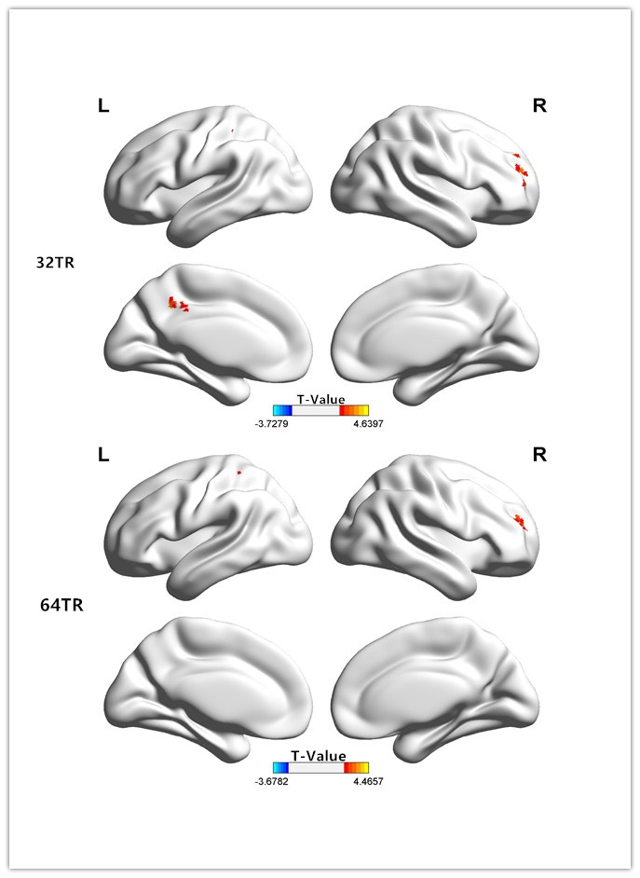
Figure S1. Brain areas with significant dFC differences between children in the ADHD and HC groups(The window width was set as 32/64 TR).
Notes:ADHD means attention deficit hyperactivity disorder; HC, health control; and TR,repetition time.
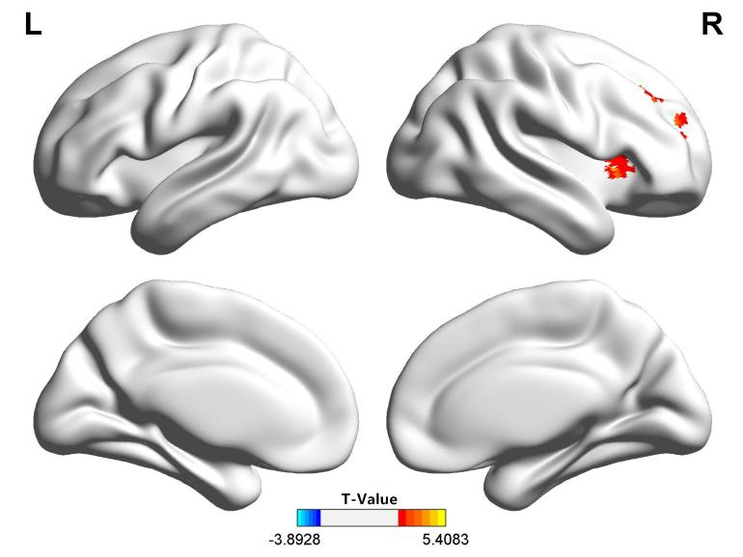
Figure S2. Compared with the HC group, the dFC in the right SFA of the children in the ADHD group (re-matched) was significantly higher.
Notes:ADHD means attention deficit hyperactivity disorder; HC, health control; and dFC, dynamic functional connectivity.

