Supplementary Data
Optimization of Pichia pastoris expression system for high-level production of Margatoxin
Muhammad Umair Naseem¹, Gabor Tajti¹, Attila Gaspar², Tibor G. Szanto¹, Jesús Borrego¹, Gyorgy Panyi^{1,*}
¹University of Debrecen, Faculty of Medicine, Department of Biophysics and Cell Biology
²University of Debrecen, Faculty of Science and Technology, Institute of Chemistry, Department of Inorganic and Analytical Chemistry

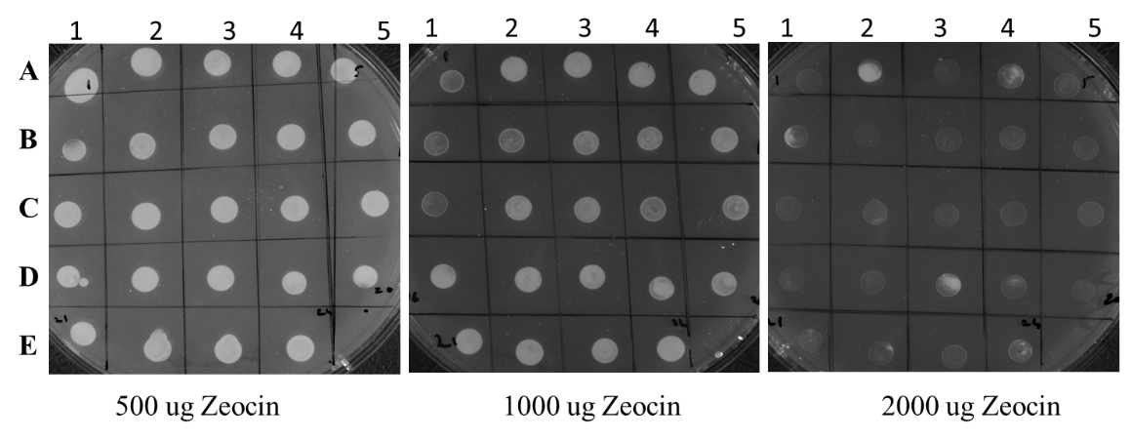
Suppl. Figure 1: Growth of Pichia X-33 clones on different concentration of Zeocin after 2 days

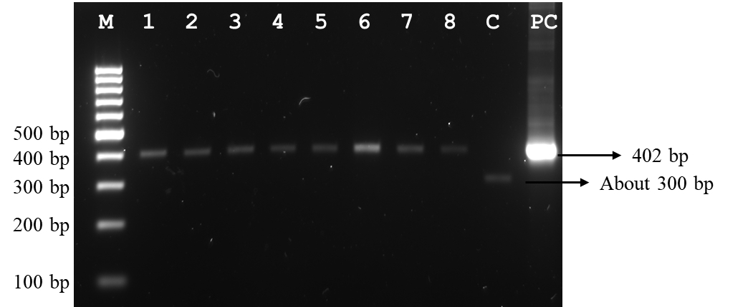
Suppl. Figure 2: 2% agarose gel showing the results of colony PCR of Pichia X-33 clones transformed with TrMgTx- pPICZαA. M: 100bp DNA marker, Lane 1-8: X-33 clones, C: Clone with empty plasmid, PC: positive control TrMgTx- pPICZαA plasmid.

