**The use of a length-structured multispecies model fitted directly to data in near-real time as a viable tool for advice.**

Michael Spence1*, Paul Dolder1, Richard Nash1, Robert Thorpe1**

04/03/2021

1 Centre for Fisheries Ecology and Aquaculture Science, CEFAS Laboratory, Lowestoft, Suffolk, NR33 0HT, UK

*First Author ** Corresponding Author: robert.thorpe@cefas.co.uk

**Supplementary Material**

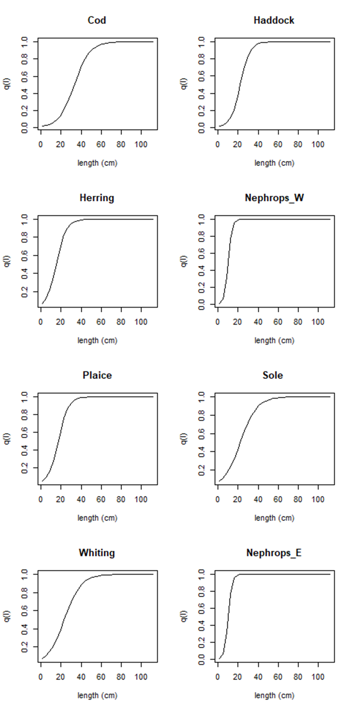

Figure S1: Catchability curves for the 8 model stocks.

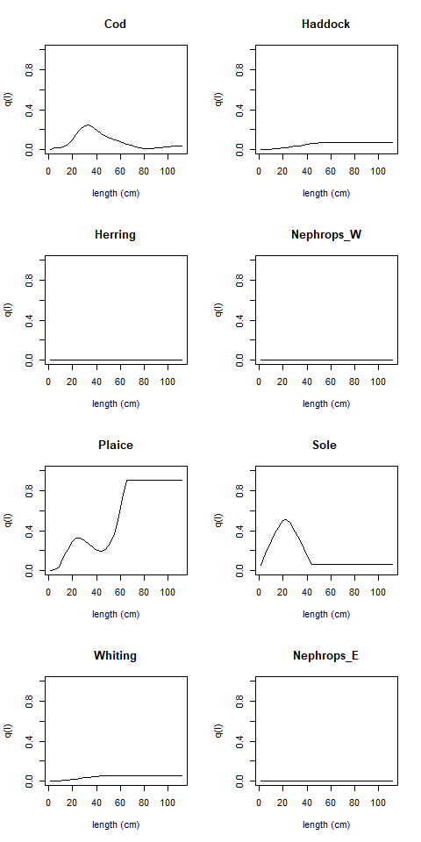

Figure S2: Catchability for the beam trawl survey

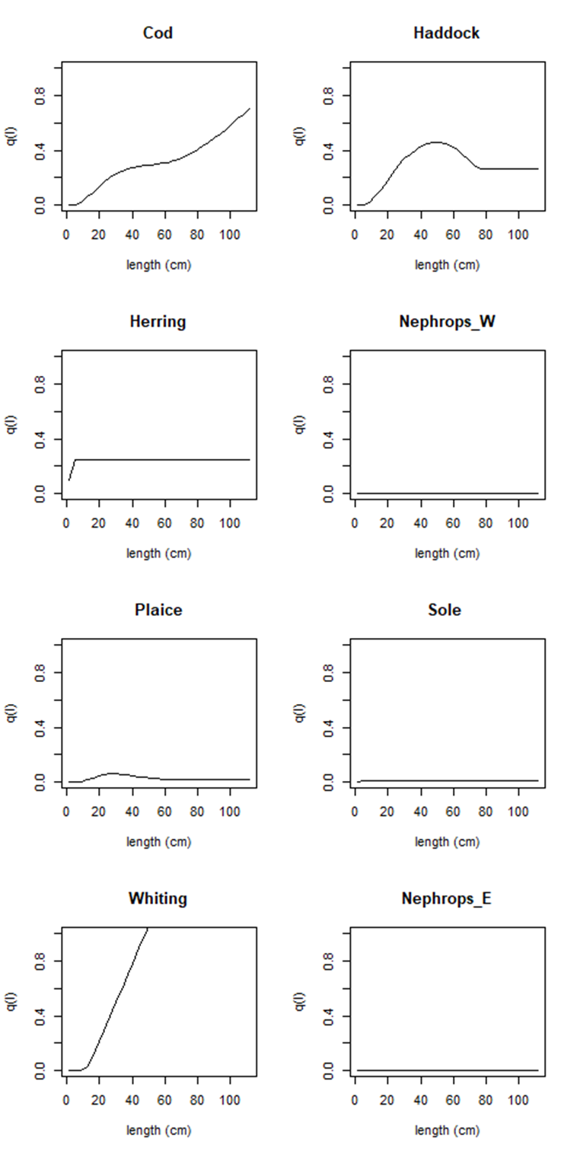

Figure S3: Catchability for the GOV trawl survey.



Figure S4: Catchability for the otter trawl survey



Figure S5. Haddock fits to commercial catch (CV=0.1), beam trawl, GOV trawl and ROT trawl (CV=0.5) [top 4 panels], and projections of F and SSB compared with single species assessment. The multispecies outputs are shown in the solid line. We were able to fit the catches well, but we struggled with the ROT and GOV trawl surveys. In we under-estimate the surveyed catch. We suggest that the haddock recovery happened earlier than the single-species assessment did. We also predict a lower F, consistent with the higher biomass. The low abundance relative to the survey may suggest that we under-estimate the catchability or relative effort of the survey.



Figure S6: Fits to commercial catches and acoustic survey (top 2 panels) and comparison of estimates of F and SSB with single species assessments for herring. In each case the model is the solid line. We were able to fit the catches well, and captured the magnitude of the acoustic survey, however we were not able to fit to the trend. This is reflected in the multispecies assessment, where we do not predict the recovery in SSB that the single-species assessment does.



Figure S7: Fits to commercial catches and the TV survey (top 2 panels) and comparison of estimates of F and SSB with single species assessments for Nephrops west. In each case the model is the solid line. The LeMans model fits the catches and the TV survey well. The Fs are quite different, but the abundance estimates are similar.



Figure S8: Fits to commercial catches and the three surveys (top 4 panels) and comparison of estimates of F and SSB with single species assessments for plaice. In each case the model is the solid line. We over-estimate the catches and fit the beam trawl survey well. The SSB in our assessment is similar during the middle phase of the model to that of the single-species assessment however we predict more SSB at the beginning and end of the model.



Figure S9: Fits to commercial catches and the three surveys (top 4 panels) and comparison of estimates of F and SSB with single species assessments for sole. In each case the model is the solid line. We fit the cates well, as well as the absolute values of the surveys, however we do not fit the trend in the beam trawl survey very well. The F time series is similar in both assessments; however we predict higher SSB.



Figure S10: Fits to commercial catches and the TV survey (top 2 panels) and comparison of estimates of F and SSB with single species assessments for Nephrops east. In each case the model is the solid line. The LeMans model fits the catches and the TV survey well. The Fs are quite different, but the abundance estimates are similar.

Table S1: Length discretization of the Irish Sea LeMans model.

|  |  |  |
| --- | --- | --- |
| Lower boundary | Mid point | Upper boundary |
| 0.00 | 1.00 | 2.00 |
| 2.00 | 3.00 | 4.00 |
| 4.00 | 5.00 | 6.00 |
| 6.00 | 7.01 | 8.01 |
| 8.01 | 9.02 | 10.03 |
| 10.03 | 11.05 | 12.06 |
| 12.06 | 13.90 | 14.12 |
| 14.12 | 15.16 | 16.20 |
| 16.20 | 17.26 | 18.32 |
| 18.32 | 19.40 | 20.49 |
| 20.49 | 21.60 | 22.71 |
| 22.71 | 23.86 | 25.01 |
| 25.01 | 26.20 | 27.39 |
| 27.39 | 28.63 | 29.87 |
| 29.87 | 31.17 | 32.46 |
| 32.46 | 33.82 | 35.18 |
| 35.18 | 36.62 | 38.06 |
| 38.06 | 39.58 | 41.10 |
| 41.10 | 42.72 | 44.33 |
| 44.33 | 46.06 | 47.78 |
| 47.78 | 49.62 | 51.46 |
| 51.46 | 53.42 | 55.39 |
| 55.39 | 57.50 | 59.61 |
| 59.61 | 61.87 | 64.14 |
| 64.14 | 66.57 | 69.00 |
| 69.00 | 71.61 | 74.22 |
| 74.22 | 77.04 | 79.85 |
| 79.85 | 82.87 | 85.90 |
| 85.89 | 89.15 | 92.40 |
| 92.40 | 95.90 | 99.40 |
| 99.40 | 103.16 | 106.92 |
| 106.92 | 110.96 | 115.00 |

Table S2: Annual proportion of Irish Sea surveyed by each survey gear (annual effort per survey gear).

|  |  |  |  |
| --- | --- | --- | --- |
| Year | Beam Trawl Survey (BT4A) | GOV Trawl Survey  (GOV) | Otter Trawl Survey (ROT) |
| 1980 | 0 | 0 | 0 |
| 1981 | 0 | 0 | 0 |
| 1982 | 0 | 0 | 0 |
| 1983 | 0 | 0 | 0 |
| 1984 | 0 | 0 | 0 |
| 1985 | 0 | 0 | 0 |
| 1986 | 0 | 0 | 0 |
| 1987 | 0 | 0 | 0 |
| 1988 | 0 | 0 | 0 |
| 1989 | 0 | 0 | 0 |
| 1990 | 0 | 0 | 0 |
| 1991 | 0 | 0 | 0 |
| 1992 | 0 | 0 | 1.434 e-4 |
| 1993 | 3.176 e-5 | 0 | 1.613 e-4 |
| 1994 | 2.359 e-5 | 0 | 1.416 e-4 |
| 1995 | 2.306 e-5 | 0 | 1.370 e-4 |
| 1996 | 2.336 e-5 | 0 | 1.494 e-4 |
| 1997 | 2.478 e-5 | 0 | 1.556 e-4 |
| 1998 | 2.434 e-5 | 0 | 1.616 e-4 |
| 1999 | 2.383 e-5 | 0 | 1.589 e-4 |
| 2000 | 2.168 e-5 | 0 | 1.549 e-4 |
| 2001 | 2.160 e-5 | 0 | 1.675 e-4 |
| 2002 | 2.164 e-5 | 0 | 1.257 e-4 |
| 2003 | 2.141 e-5 | 2.907 e-6 | 1.281 e-4 |
| 2004 | 2.095 e-5 | 4.900 e-6 | 1.185 e-4 |
| 2005 | 1.985 e-5 | 3.194 e-6 | 1.278 e-4 |
| 2006 | 2.025 e-5 | 1.596 e-6 | 1.240 e-4 |
| 2007 | 1.960 e-5 | 1.728 e-6 | 1.155 e-4 |
| 2008 | 1.797 e-5 | 5.058 e-6 | 8.637 e-5 |
| 2009 | 2.008 e-5 | 4.604 e-6 | 1.152 e-4 |
| 2010 | 1.985 e-5 | 3.050 e-6 | 1.182 e-4 |
| 2011 | 1.979 e-5 | 4.628 e-6 | 1.119 e-4 |
| 2012 | 1.997 e-5 | 4.564 e-6 | 1.158 e-4 |
| 2013 | 1.997 e-5 | 4.697 e-6 | 1.200 e-4 |
| 2014 | 1.892 e-5 | 3.158 e-6 | 1.209 e-4 |
| 2015 | 1.884 e-5 | 4.498 e-6 | 1.199 e-4 |
| 2016 | 0 | 3.615 e-6 | 1.235 e-4 |