Supplementary Material

OVERDOSE RISK ASSESSMENT QUESTIONNAIRE

Instructions:
1. Complete the pro-forma with your patient;
2. If the answer to a question is (yes) circle the score; if answer is (no) record no
score for that question;
3. Make any notes related to the answer as required e.g. mode of use, high risk
injecting, number of units of alcohol, prescription or illicit use etc
4. Add up the total score to establish the level of risk;
5. Complete management of risk plan in patient notes.

Item number | RISK FACTOR | Score  (1=Yes/0=No) | ADDITIONAL INFORMATION
1 | Current heroin user  (smoke, snort)
2 | Current intravenous drug use
3 | Current Prescription for opiate dependence  (methadone, buprenorphine, suboxone)
4 | Is not on supervised consumption of prescribed  substitute medication.
5 | Also drinks alcohol (please detail amounts)
6 | Current use of benzodiazepines  (mode of use, amounts whether prescribed or illicit)
7 | Poly use of CNS Depressants  (include prescription psychotropic medication, i.e  antidepressants, anti psychotics)
8 | Has been in prison, hospital or residential detox in  preceding month, or currently on detox prescription
9 | Has overdosed accidentally/intentionally (ever)
10 | Has overdosed accidentally/intentionally once in past  year
11 | Has overdosed accidentally/intentionally two or more times in past year
12 | Has been using drugs for more than 5 years
13 | Having to use increasing amounts of drugs to become intoxicated
14 | Enjoys or wants to feel heavily intoxicated
15 | Currently experiencing severe low mood, depression or  suicidal thoughts
16 | Tends to use alone
17 | Recent Bereavement ( in past year)
18 | Domestic Abuse past or present
19 | Emotional/sexual abuse past or present
20 | Past termination or miscarriage (women only)
21 | Has physical health problems (e.g hepatitis, cirrhosis,  respiratory problems)
22 | Mental health diagnosis
23 | Homeless/roofless
24 | Sporadic attendance at appointments
25 | At beginning of treatment (titration prescription)
Total score

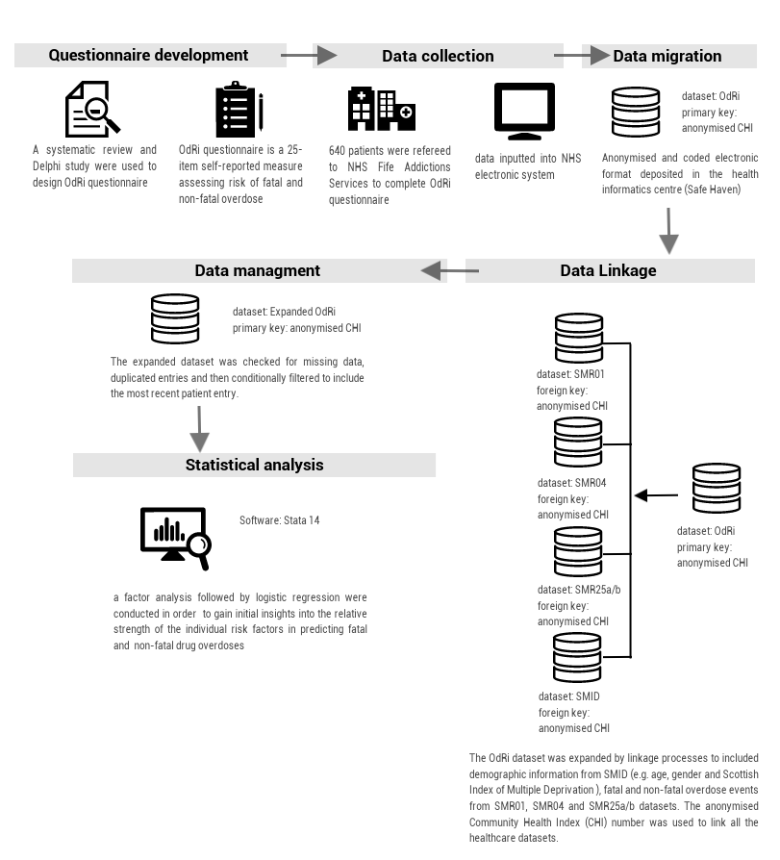
Figure S1. flow diagram for all the steps that were undertaken to develop and validate the questionnaire.

