Supplementary Information
Contents

Supplementary Figures
Figure S1. Staining image of L. acidophilus EG004 and EG008 strains. 2
Figure S2. Antibacterial-related genes found in the genome of L. acidophilus EG004 and EG008 strains 3
Figure S3. Genomic features of L. acidophilus EG004 and EG008 strains. 4
Figure S4. Physiological activities of L. acidophilus EG004 and EG008 strains. 5

Supplementary Tables
Table S1. Assembly statistic for complete genome of L. acidophilus EG004 strain and EG008 strain. 6
Table S2. Microbial kinetics for L. acidophilus EG004 and EG008 strains. 7

Supplementary Figures
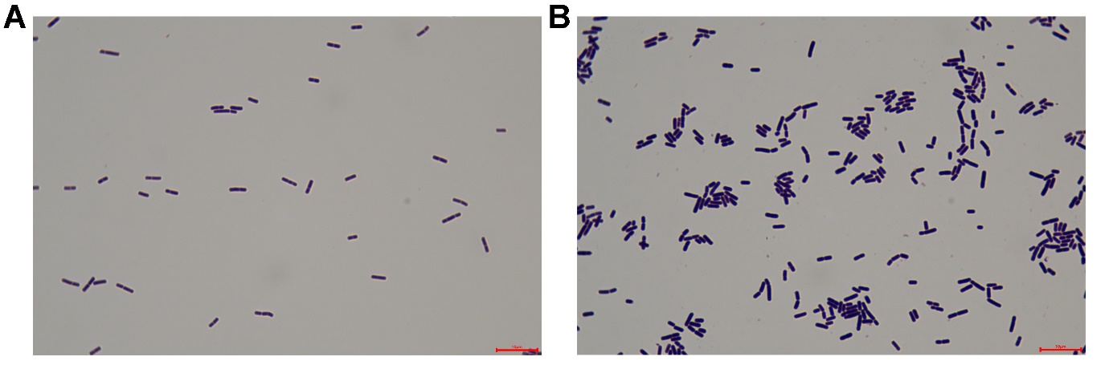
Figure S1. Staining image of L. acidophilus EG004 and EG008 strains.
We observed bacterial morphology of L. acidophilus (A) EG004 and (B) EG008 strains. After 16 hours of incubation, two strains were prepared for microscopic observation. Bacterial morphology was examined under a light microscope at 1000x magnification after gram staining. We verified that both strains are rod-shaped and gram-positive bacteria. The length of the red bar at the bottom represents 10 μm.
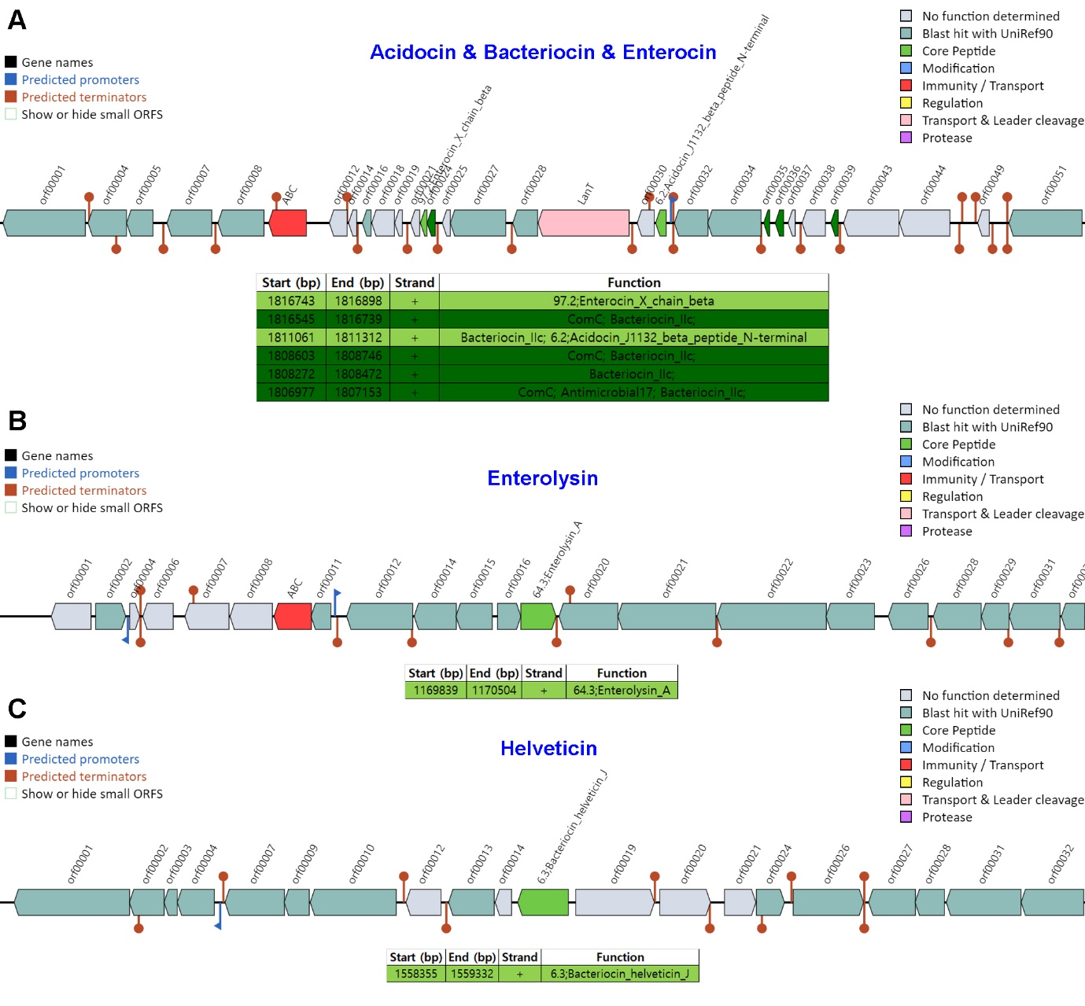
Figure S2. Antibacterial-related genes found in the genome of L. acidophilus EG004 and EG008 strains
We identified that all genes related to antibacterial action, such as Acidocin, Bacteriocin, Enterocin, Enterolysin, and Helveticin, are maintained on the genome of the L. acidophilus EG004 using BAGLE4 software. There were no differences between the EG004 and EG008 strains.

Figure S3. Genomic features of L. acidophilus EG004 and EG008 strains.
(A) Seven predicted genomic islands on the L. acidophilus EG004 and EG008 strains. (B) Two complete prophage regions identified by PHASTER tool. (C) Result of pan and core genome analysis. The results demonstrated that the pan-genome of L. acidophilus EG004 and EG008 strains is open, given the pattern of influx of new genes while the number of core genes is about half of that of the pan genes. There was no difference between EG004 and EG008 strains in all annotations.

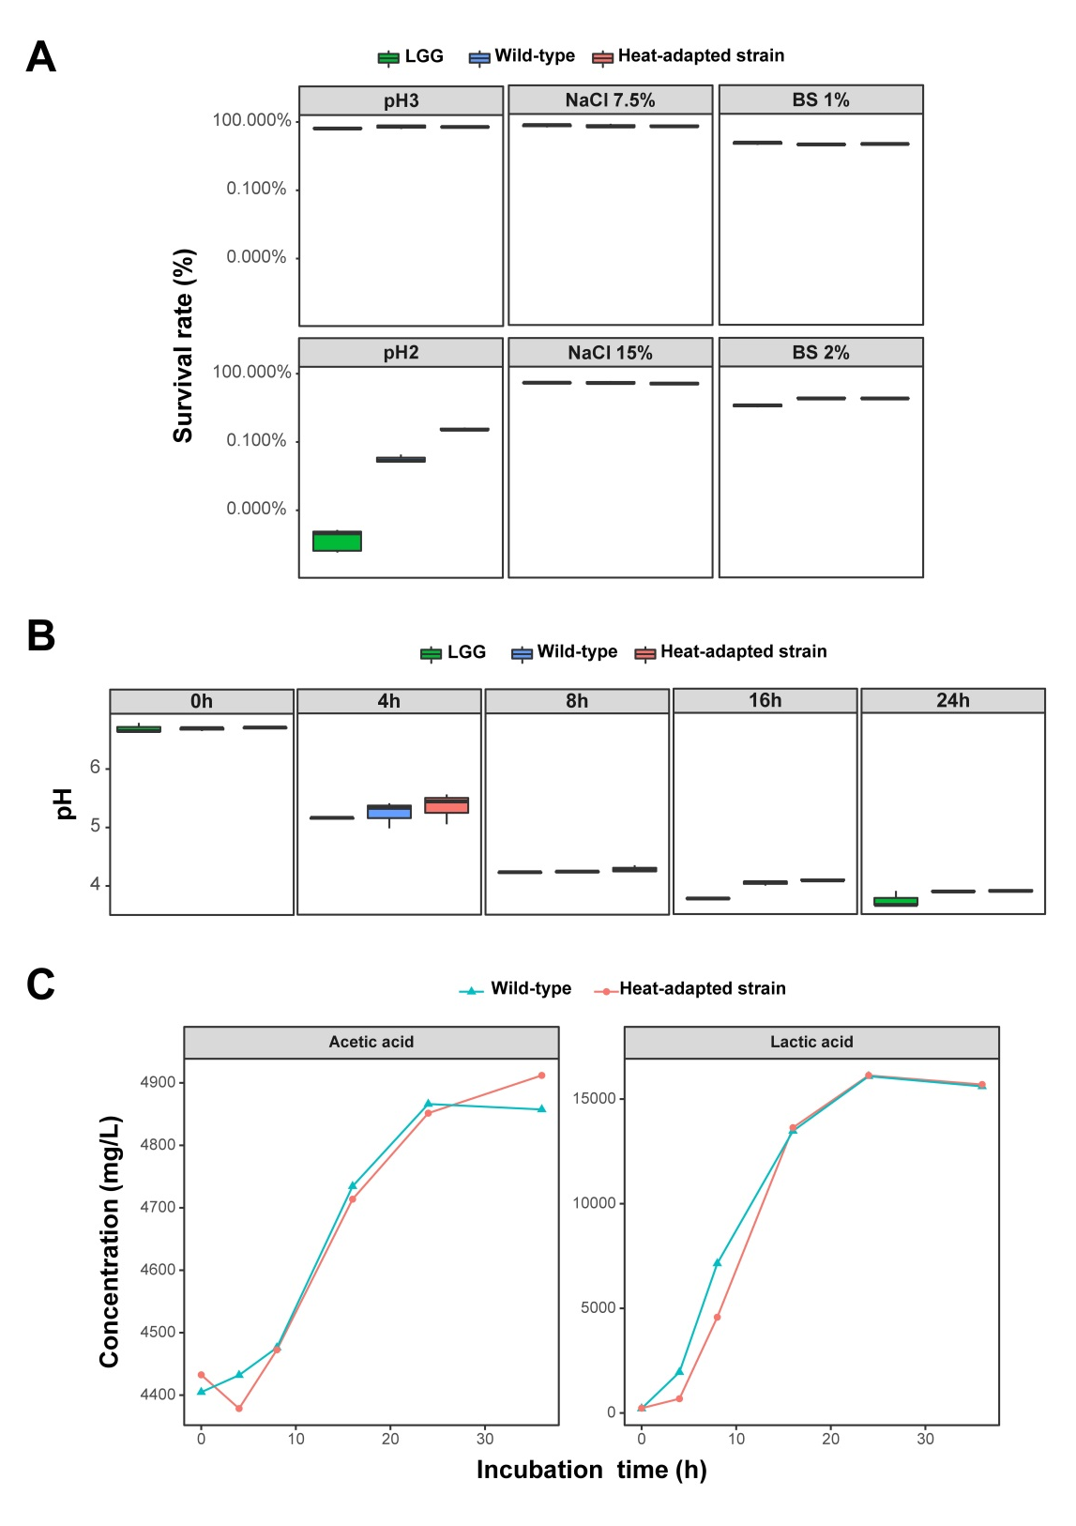
Figure S4. Physiological activities of L. acidophilus EG004 and EG008 strains.
(A) Resistance comparison to external stresses with LGG strain. Resistance was assessed to acid, salt, and bile salt stresses. (B) pH change according to bacterial culture time. (C) Changes in acetic acid and lactic acid concentration.

Supplementary Tables
Table S1. Assembly statistic for complete genome of L. acidophilus EG004 strain and EG008 strain.
Assembly statistic | L. acidophilus  EG004 | L. acidophilus  EG008
# of subreads | 85,438 | 1,003,160
Avg. alignment length | 5,000 | 3,388
N50 of contig | 1,991,561 | 4,036
Genome coverage | > 100x | > 100x
Maximum contig length (bp) | 1,991,559 | 2,001,616

Table S2. Microbial kinetics for L. acidophilus EG004 and EG008 strains.
Factor | L. acidophilus  EG004 | L. acidophilus  EG008
μ_{max} (-h) | 0.0238 | 0.0237
Y_{X/S} (cell/substrate) | 0.0911 | 0.0825
t_{d} (h) | 29.08 | 29.31
K_{s} (g/L) | 2.076 | 2.079
q (g/h) | 0.2616 | 0.2866
μ: the specific growth rate of the bacteria, μ_{max}: the maximum specific growth rate, S: the concentration of the limiting substrate for bacterial growth, Ks: the half-velocity constant, X: the total biomass, Y_{X⁄S}: fermentation growth yield, t: cultural time, and q: substrate consumption ratio

