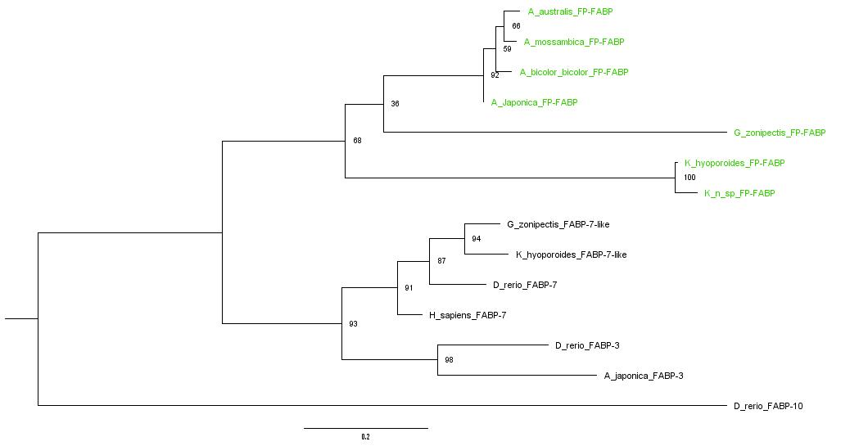
A

B
A. japonica FP-FABP --MVEKFVGTWKIADSHNFGEYLKAIGAPKELSDGGDATTPTLYISQKDGDKMTVKIENG
A. bicolor bicolor FP-FABP --MVEKFVGTWKIAESHNFGEYLKAIGAPKELSDGGDATKPTLYISQKDGDKMTVKIENG
A. australis FP-FABP --MVEKFVGTWKIADSHNFGEYLKAIGAPKELSDGGDATTPTLYISQKDGDKMTVKIENG
A. mossambica FP-FABP --MVEKFVGTWKIADSHNFGEYLKAIGAPKELSDGGDATTPTLYISQKDRDKMTVKIENG
G. zonipectis FP-FABP --MLEQFVGKWTIAESKDFGKYLEAIGAPTSLSEAGDNTQPKLEISQKDGNKMTVDIDNG
K. hyoproroides FP-FABP --MFEDFLGTWKCIDSQNFGAYLAAIGAPPVLSERADATRPTVHFN-RDGDKLSLKVEHG
K. n. sp. FP-FABP --MFEDFLGTWECIDSQNFGAYLAAVGAPPVLSDRADATRPTVYFN-RDGDKLSLKVEHG
H. sapiens FABP-7 --MVEAFCATWKLTNSQNFDEYMKALGVGFATRQVGNVTKPTVIIS-QEGDKVVIRTLS-
G. zonipectis FABP-7 like --MVDAFCATWKLLDSQNFDDYMKAIGVGFATRQVGNVTKPTIIIG-KDGDKMFVKTLS-
D. rerio FABP-7 --MVDAFCATWKLVDSQNFDEYMKSLGVGFATRQVGNVTKPTIVIS-HEGDKVVIKTLS-
K. hyoporoides FABP-7 like --MVDAFFGTWKLVDSQNFDEYMKALGVGFATRQVGNVTKPTVIIG-QDGDKVFVKT-Q-
D. rerio FABP-3 --MADAFIGTWNLKESKNFDEYMKGIGVGFATRQVANMTKPTTIIS-KEGDVFTLKTVS-
A. japonica FABP-3 MVIMEPFLGTWHLKTSENFDEYMKELGVGFATRKIGNTTKPTLIIA-ADGDKFQVKTQS-
D. rerio FABP-10 --M--AFSGTWQVYAQENYEEFLRAISLPEEVIKLAKDVKPVTEIQ-QNGSDFTITSKT-

A. japonica FP-FABP PPTFLDTQVKFKLGEEFDEFPSDRRKGVKSVVNLVGEKLVYVQKWDGKETTYVREIKDGK
A. bicolor bicolor FP-FABP PPTFLDTEVKFKLGEEFDEFPSDRRKGVRSVVNLVGEKLVYAQKWDGKETTYVREIKDGK
A. australis FP-FABP PPTFLDTQVKFTLGEEFDEFPSDRRKGVRSVVNLVGEKLVYLQKWDGKETTLVREIKDGK
A. mossambica FP-FABP PPTFLDTEVKFKLGEEFDEFPSDRRKGVRSVVNLVGEKLVYLQKWDGKKTTLVREIKDGK
G. zonipectis FP-FABP PPTNYQVQVKFTLGEEFDEKTSDGRKGIKTTVTYEDNKLVYTQRWDGKKAVTYRQVVDGT
K. hyoporoides FP-FABP PPPLKDVLLSFKLGEEFDEHPTDGRK-CKTLVTFEGDKLLYLQKWDGKETVVVREIRDGN
K. n. sp. FP-FABP PPPLKDVILSFKLGEEFDEHPTDGRK-CKTLVTFEGDKLLYLQKWDGKETVVVREIRDGN
H. sapiens FABP-7 --TFKNTEISFQLGEEFDETTADDRN-CKSVVSLDGDKLVHIQKWDGKETNFVREIKDGK
G. zonipectis FABP-7 like --TFKNTEISFKLGEEFDETTADDRN-CKSVISMEGDKLVHVQKWDGKETKFVREIQDGK
D. rerio FABP-7 --TFKNTEISFKLGEEFDETTADDRH-VKSTVSLEGDNLVQVQRWDGKETKFVREIKDGK
K. hyoporoides FABP-7 like --TF-NTEISFKLGEEFDETTADDRN-CKSVV-MEGNSLVHVQ-WDGKETKFVREVQDGK
D. rerio FABP-3 --TFKSTEINFKLGEEFDETTADDRK-VKSVITLDGGKLLHVQKWDGKETTLLREVSDNN
A. japonica FABP-3 --LLKSTEINFKLGEEFDETTADDRK-VKSVVKLEDGKLVHLQKWDSKETSLVRAVDGNK
D. rerio FABP-10 --PGKTVTNSFTIGKEAEITTMDGKK-LKCIVKLDGGKLVCRT----DRFSHIQEIKAGE

A. japonica FP-FABP LVVTLTMGDVVAVRSYRRATE-----
A. bicolor bicolor FP-FABP LVVTLTMGDVVSVRSYRRATE-----
A. australis FP-FABP LFVTLTMGDVVSVRSYRRASE-----
A. mossambica FP-FABP LVVTLTMGDVVSVRSYRRATE-----
G. zonipectis FP-FABP LVTKLTYGDVVSVRKYKRINV-----
K. hyoporoides FP-FABP VVATLSHEGVVALRVYKKVAGPTALE
K. n. sp. FP-FABP VVATLSHEGVVALRVYKKVAGPTA--
H. sapiens FABP-7 MVMTLTFGDVVAVRHYEKA-------
G. zonipectis FABP-7 like MVMKLTFEDILAVRTYEKA-------
D. rerio FABP-7 MVMTLTFEGVQAVRTYEKA-------
K. hyoporoides FABP-7 like LVMKLTFEDVLSVRTYEKA-------
D. rerio FABP-3 LTLTLTLGDIVSTRHYVKAE------
A. japonica FABP-3 LTLTLTFGNVVSTRHYEKAE------
D. rerio FABP-10 MVETLTVGGTTMIRKSKKI-------

S2 Figure. (A) Phylogenetic tree of fluorescent and nonfluorescent FABPs, rooted to the midpoint. Fluorescent proteins are shown in green. Input data statistics: 14 sequences with 146 amino-acid sites. Number of constant sites: 24 (= 16.4384% of all sites). Number of invariant (constant or ambiguous constant) sites: 24 (= 16.4384% of all sites). Number of parsimony informative sites: 91. Number of distinct site patterns: 143.

The consensus tree was constructed from 1000 ultrafast bootstrap trees (Hoang et al., 2017).

(B) Alignment of all sequences shown in the phylogenetic tree. Amino acid sequences were aligned using MAFFT v7.487 with the L-INS-i Iterative refinement method and default parameters (Hofacker et al., 2002; Katoh et al., 2002, 2005; Katoh and Toh, 2008; Tabei et al., 2008; Katoh and Frith, 2012; Kuraku et al., 2013; Katoh and Standley, 2016; Yamada et al., 2016; Rozewicki et al., 2019). The best model of substitution was selected using ModelFinder (Kalyaanamoorthy et al., 2017).

Sequences used for the tree and alignment are as follows: Anguilla japonica FP-FABP (UnaG, Accession P0DM59.1), Anguilla australis FP-FABP (Accession BAP76194.1), Anguilla bicolor bicolor FP-FABP (Accession BAP76195.1), Anguilla mossambica FP-FABP (Accession BAP76197.1), Gymnothorax zonipectis FP-FABP (GymFP, Accession PRJNA718586), Kaupichthys hyoproroides FP-FABP (Chlopsid FP I, Accession PRJNA192511), Kaupichthys n. sp. FP-FABP (Chlopsid FP II, Accession PRJNA223153), Homo sapiens FABP-7 (Accession NP_001437.1), Danio rerio FABP-3 (Accession NP_694493.1), Danio rerio FABP-7 (Accession NP_571680.1), Danio rerio FABP-10 (Accession NP_694492.1), Anguilla japonica FABP-3 (Accession BAA92241.3), Kaupichthys hyoproroides FABP-7 like (Accession PRJNA192511), Gymnothorax zonipectis FABP-7 like (Accession PRJNA718586).

