Supporting Information for
Stability and Thermoelasticity of Diaspore by Synchrotron X-ray Diffraction and Raman Spectroscopy
Shijie Huang ^{1,2}, Jingui Xu ³, Daorong Liu ⁴, Bo Li ^{1,2}, Zhilin Ye ^{1,2}, Wei Chen ^{1,2,5}, Yunqian Kuang ^{1,2,6}, Fangli Chi ⁷, Dawei Fan ^{1*}, Maining Ma ^{8*}, Wenge Zhou ¹
¹Key Laboratory of High-Temperature and High-Pressure Laboratory for High Temperature and High Pressure Study of the Earth’s Interior, Institute of Geochemistry, Chinese Academy of Sciences, Guiyang 550002, China
²University of Chinese Academy of Sciences, Beijing 100049, China
³Hawai'i Institute of Geophysics and Planetology, School of Ocean and Earth Science and Technology, University of Hawai'i at Manoa, Honolulu, HI, USA
⁴Zhejiang Geological Prospecting Institute of China Chemical Geology and Mine Bureau, Hangzhou 310002, China
⁵Guizhou Polytechnic of Construction, Guiyang 551400, China
⁶Bureau of natural resources and planning of Yongzhou, Yongzhou 425000, China
⁷Key Laboratory of Urban Sewage Treatment of Jilin Province, Changchun Institute of Technology, Changchun 130012, China
⁸Key Laboratory of Computational Geodynamics, College of Earth and Planetary Sciences, University of Chinese Academy of Sciences, Beijing 100049, China
* Corresponding author: Dawei Fan (fandawei@vip.gyig.ac.cn ) or Maining Ma (mamn@ucas.ac.cn)

Contents of this file
Table S1 to S3
Figure S1 to S2

TABLE S1 The chemical composition of diaspore (wt. %)
 | Na₂O | FeO | P₂O₅ | SiO₂ | Cr₂O₃ | K₂O | MgO | MnO | CaO | Al₂O₃ | NiO | TiO₂ | Total
diaspore | 0.01 | 0.511 | - | - | 0.027 | - | - | - | 0.001 | 85.81 | 0.005 | 0.055 | 86.419
 | - | 0.562 | 0.009 | - | 0.066 | - | 0.021 | 0.052 | 0.02 | 86.745 | 0.002 | - | 87.477
 | 0.028 | 0.56 | - | - | - | - | - | 0.015 | - | 86.078 | - | 0.062 | 86.743
 | - | 0.501 | 0.037 | 0.036 | 0.067 | 0.008 | - | - | - | 86.727 | - | 0.051 | 87.427
-: none

TABLE S2 The unit-cell parameters of diaspore at high pressures
Pressure (GPa) | a (Å) | b (Å) | c (Å) | V (Å³)
0.26 (1) | 4.3968 (7) | 9.418 (2) | 2.8458 (12) | 117.85 (3)
0.59 (2) | 4.3929 (7) | 9.413 (2) | 2.8433 (12) | 117.57 (3)
1.23 (5) | 4.3872 (7) | 9.398 (2) | 2.8403 (12) | 117.11 (3)
3.77 (15) | 4.3589 (7) | 9.351 (1) | 2.8279 (6) | 115.27 (3)
4.57 (18) | 4.3511 (7) | 9.342 (1) | 2.8233 (6) | 114.76 (3)
5.53 (22) | 4.3390 (7) | 9.321 (1) | 2.8195 (6) | 114.03 (3)
6.67 (27) | 4.3294 (7) | 9.298 (1) | 2.8138 (6) | 113.27 (3)
7.64 (31) | 4.3202 (6) | 9.280 (1) | 2.8088 (6) | 112.60 (3)
8.56 (34) | 4.3105 (6) | 9.264 (1) | 2.8045 (6) | 111.99 (3)
9.88 (39) | 4.2963 (7) | 9.249 (1) | 2.7965 (6) | 111.12 (3)
11.23 (45) | 4.2866 (7) | 9.225 (1) | 2.7896 (6) | 110.31 (3)
13.42 (51) | 4.2681 (7) | 9.191 (1) | 2.7794 (6) | 109.02 (3)
The numbers in parentheses represent the error, for example, 0.26 (1) means 0.26 ± 0.01

TABLE S3 The unit-cell parameters of diaspore at high temperature and room pressure
Temperature (K) | a (Å) | b (Å) | c (Å) | V (Å³)
297 | 4.3981 (1) | 9.4137 (4) | 2.84137 (7) | 117.640 (7)
323 | 4.3982 (1) | 9.4151 (4) | 2.84175 (6) | 117.675 (6)
353 | 4.3984 (1) | 9.4164 (4) | 2.84210 (6) | 117.713 (6)
383 | 4.39918 (9) | 9.4177 (3) | 2.84252 (5) | 117.766 (5)
413 | 4.3997 (1) | 9.4191 (4) | 2.84276 (5) | 117.808 (6)
443 | 4.4005 (1) | 9.4208 (4) | 2.84319 (5) | 117.869 (5)
473 | 4.40151 (9) | 9.4228 (3) | 2.84379 (5) | 117.946 (5)
503 | 4.4024 (1) | 9.4237 (2) | 2.84426 (5) | 117.998 (4)
533 | 4.4034 (1) | 9.4263 (3) | 2.84492 (5) | 118.088 (5)
563 | 4.40437 (9) | 9.4275 (3) | 2.84539 (5) | 118.146 (5)
593 | 4.4054 (1) | 9.4299 (4) | 2.84610 (5) | 118.235 (6)
623 | 4.4064 (1) | 9.4315 (4) | 2.84673 (5) | 118.307 (6)
653 | 4.40850 (9) | 9.4347 (3) | 2.84766 (5) | 118.442 (5)
683 | 4.4093 (1) | 9.4354 (4) | 2.84804 (6) | 118.488 (6)
713 | 4.4105 (1) | 9.4378 (4) | 2.84844 (5) | 118.568 (6)

(a) | (b)
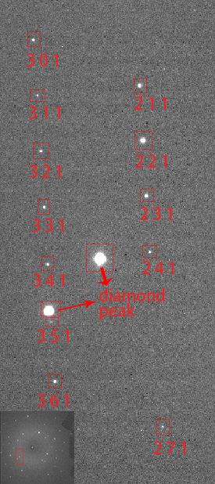 | 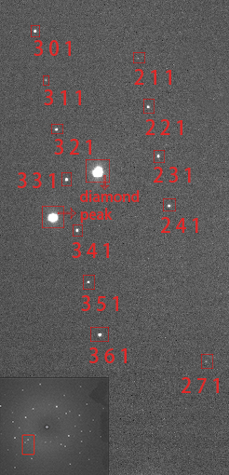
FIGURE S1. Single crystal X-ray diffraction patterns of diaspore at 0.26 GPa (a) and 13.42 GPa (b).

FIGURE S2. The representative Le Bail profile fitting patterns of diaspore at 298 K (a), 413 K (b), 533 K (c), and 713 K (d). Observed spectra (black lines), fitted spectra (red solid lines), difference plots (blue solid lines), and Bragg peak positions (tick marks) are shown.

