Supplementary Table 1 – Physiological recordings and EDA and IBI quality
 |  | No. VR sessions | Duration  (hh:mm) | High quality EDA  (hh:mm) | High quality IBI  (hh:mm)
Day 1 | Tot | 12 | 02:31 | 02:09 | 00:46
 | Mean | 0.86 (1.10) | 00:10 (00:17) | 00:09 (00:15) | 00:03 (00:06)
Day 2 | Tot | 22 | 04:43 | 04:28 | 01:46
 | Mean | 1.57 (1.45) | 00:20 (00:23) | 00:19 (00:23) | 00:07 (00:09)
Day 3 | Tot | 14 | 02:26 | 01:40 | 00:45
 | Mean | 1 (0.78) | 00:10 (00:08) | 00:07 (00:07) | 00:03 (00:04)
Day 4 | Tot | 9 | 01:15 | 01:10 | 00:31
 | Mean | 0.64 (1.28) | 00:05 (00:13) | 00:05 (00:12) | 00:02 (00:06)
Total | Tot | 73 | 10:39 | 09:22 | 03:51
 | Mean | 5.21 (2.99) | 00:45 (00:50) | 00:40 (00:49) | 00:16 (00:21)

Supplementary Table 2 – VR usage time for each patient
# P | Complete VR sessions |  |  |  |  |  | Day 1 |  |  |  |  |  | Day 2 |  |  |  |  |  | Day 3 |  |  |  |  |  | Day 4
 | #S | UT | NI | UT | I | UT | #S | UT | NI | UT | I | UT | #S | UT | NI | UT | I | UT | #S | UT | NI | UT | I | UT | #S | UT | NI | UT | I | UT
1 | 3 | 0:20 | 2 | 0:11 | 1 | 0:09 | 2 | 0:13 | 2 | 0:11 | 0 | 0:00 | 0 | 0:00 | 0 | 0:00 | 0 | 0:00 | 1 | 0:09 | 0 | 0:00 | 1 | 0:09 | 0 | 0:00 | 0 | 0:00 | 0 | 0:00
2 | 5 | 1:10 | 3 | 0:24 | 2 | 0:45 | 1 | 0:04 | 1 | 0:04 | 0 | 0:00 | 2 | 0:43 | 1 | 0:10 | 1 | 0:32 | 2 | 0:23 | 1 | 0:10 | 1 | 0:12 | 0 | 0:00 | 0 | 0:00 | 0 | 0:00
3 | 5 | 0:45 | 5 | 0:45 | 0 | 0:00 | 3 | 0:30 | 3 | 0:30 | 0 | 0:00 | 1 | 0:04 | 1 | 0:04 | 0 | 0:00 | 1 | 0:10 | 1 | 0:10 | 0 | 0:00 | 0 | 0:00 | 0 | 0:00 | 0 | 0:00
4 | 5 | 0:42 | 3 | 0:20 | 2 | 0:21 | 2 | 0:11 | 2 | 0:11 | 0 | 0:00 | 2 | 0:08 | 1 | 0:12 | 1 | 0:12 | 1 | 0:09 | 0 | 0:00 | 1 | 0:09 | 0 | 0:00 | 0 | 0:00 | 0 | 0:00
5 | 12 | 2:07 | 5 | 0:41 | 7 | 1:26 | 3 | 0:34 | 3 | 0:34 | 0 | 0:00 | 5 | 0:44 | 2 | 0:07 | 3 | 0:36 | 1 | 0:15 | 0 | 0:00 | 1 | 0:15 | 3 | 0:34 | 0 | 0:00 | 3 | 0:34
6 | 7 | 1:02 | 5 | 0:40 | 2 | 0:26 | 2 | 0:19 | 2 | 0:19 | 0 | 0:00 | 2 | 0:20 | 1 | 0:08 | 1 | 0:12 | 3 | 0:25 | 2 | 0:11 | 1 | 0:14 | 0 | 0:00 | 0 | 0:00 | 0 | 0:00
7 | 2 | 0:18 | 1 | 0:05 | 1 | 0:12 | 1 | 0:05 | 1 | 0:05 | 0 | 0:00 | 0 | 0:00 | 0 | 0:00 | 0 | 0:00 | 1 | 0:12 | 0 | 0:00 | 1 | 0:12 | 0 | 0:00 | 0 | 0:00 | 0 | 0:00
8 | 3 | 0:31 | 2 | 0:15 | 1 | 0:16 | 2 | 0:15 | 2 | 0:15 | 0 | 0:00 | 1 | 0:16 | 0 | 0:00 | 1 | 0:16 | 0 | 0:00 | 0 | 0:00 | 0 | 0:00 | 0 | 0:00 | 0 | 0:00 | 0 | 0:00
9 | 10 | 3:11 | 7 | 2:33 | 3 | 0:38 | 4 | 1:09 | 4 | 1:09 | 0 | 0:00 | 3 | 1:21 | 1 | 0:57 | 2 | 0:24 | 0 | 0:00 | 0 | 0:00 | 0 | 0:00 | 3 | 0:41 | 2 | 0:27 | 1 | 0:14
10 | 4 | 0:48 | 2 | 0:12 | 2 | 0:36 | 1 | 0:05 | 1 | 0:05 | 0 | 0:00 | 2 | 0:23 | 1 | 0:06 | 1 | 0:17 | 1 | 0:18 | 0 | 0:00 | 1 | 0:18 | 0 | 0:00 | 0 | 0:00 | 0 | 0:00
11 | 4 | 0:39 | 2 | 0:12 | 2 | 0:27 | 2 | 0:12 | 2 | 0:12 | 0 | 0:00 | 1 | 0:16 | 0 | 0:00 | 1 | 0:16 | 1 | 0:10 | 0 | 0:00 | 1 | 0:10 | 0 | 0:00 | 0 | 0:00 | 0 | 0:00
12 | 7 | 0:57 | 5 | 0:27 | 2 | 0:29 | 3 | 0:18 | 3 | 0:18 | 0 | 0:00 | 3 | 0:28 | 2 | 0:09 | 1 | 0:18 | 1 | 0:10 | 0 | 0:00 | 1 | 0:10 | 0 | 0:00 | 0 | 0:00 | 0 | 0:00
13 | 1 | 0:03 | 1 | 0:03 | 0 | 0:00 | 1 | 0:03 | 1 | 0:03 | 0 | 0:00 | 0 | 0:00 | 0 | 0:00 | 0 | 0:00 | 0 | 0:00 | 0 | 0:00 | 0 | 0:00 | 0 | 0:00 | 0 | 0:00 | 0 | 0:00
14 | 5 | 0:22 | 2 | 0:04 | 3 | 0:22 | 1 | 0:03 | 1 | 0:03 | 0 | 0:00 | 0 | 0:00 | 0 | 0:00 | 0 | 0:00 | 1 | 0:09 | 0 | 0:00 | 1 | 0:09 | 3 | 0:10 | 1 | 0:01 | 2 | 0:08
Tot | 73 | 13:02 | 45 | 6:58 | 28 | 6:12 | 28 | 4:07 | 28 | 4:07 | 0 | 0:00 | 22 | 4:48 | 10 | 1:56 | 12 | 3:07 | 14 | 2:35 | 4 | 0:32 | 10 | 2:03 | 9 | 1:25 | 3 | 0:28 | 6 | 0:57
Mean | 5,21 | 0:55 | 3,21 | 0:29 | 2,00 | 0:26 | 2 | 0:17 | 2,00 | 0:17 | 0,00 | 0:00 | 1,57 | 0:20 | 0,71 | 0:08 | 0,86 | 0:13 | 1,00 | 0:11 | 0,29 | 0:02 | 0,71 | 0:08 | 0,64 | 0:06 | 0,21 | 0:02 | 0,43 | 0:04
Std | 2,99 | 0:49 | 1,85 | 0:38 | 1,71 | 0:21 | 0,96 | 0:17 | 0,96 | 0:17 | 0,00 | 0:00 | 1,45 | 0:23 | 0,73 | 0:14 | 0,86 | 0:12 | 0,78 | 0:07 | 0,61 | 0:04 | 0,47 | 0:06 | 1,28 | 0:13 | 0,58 | 0:07 | 0,94 | 0:09
#P = patient code, #S = sessions, UT = usage time [hh:mm], NI = non-interactive, I = interactive

Supplementary Table 3 – Results from the statistical analysis on the impact of non-interactive and interactive content on the differences (Post-Pre) of the ESAS items
(Post-Pre) ESAS item | Non-interactive (S.D. error) | Interactive (S.D. error) |  | p value
Pain | 0.35 (0.14) | 0.51 (0.21) |  | 0.42
Tiredness | -0.4 (0.3) | 0.28 (0.48) |  | 0.15
Nausea | -0.02 (0.11) | 0.08 (0.13) |  | 0.43
Depression | -0.67 (0.22) | -0.30 (0.22) |  | 0.09
Anxiety | -1.13 (0.24) | -0.84 (0.3) |  | 0.33
Drowsiness | -0.3 (0.20) | -0.35 (0.0.31) |  | 0.85
Appetite | -0.53 (0.25) | 0.18 (0.41) |  | 0.08
Well-being | -1.22 (0.28) | -0.71(0.45) |  | 0.25
Short of breath | -0.8 (0.25) | -0.61 (0.41) |  | 0.63

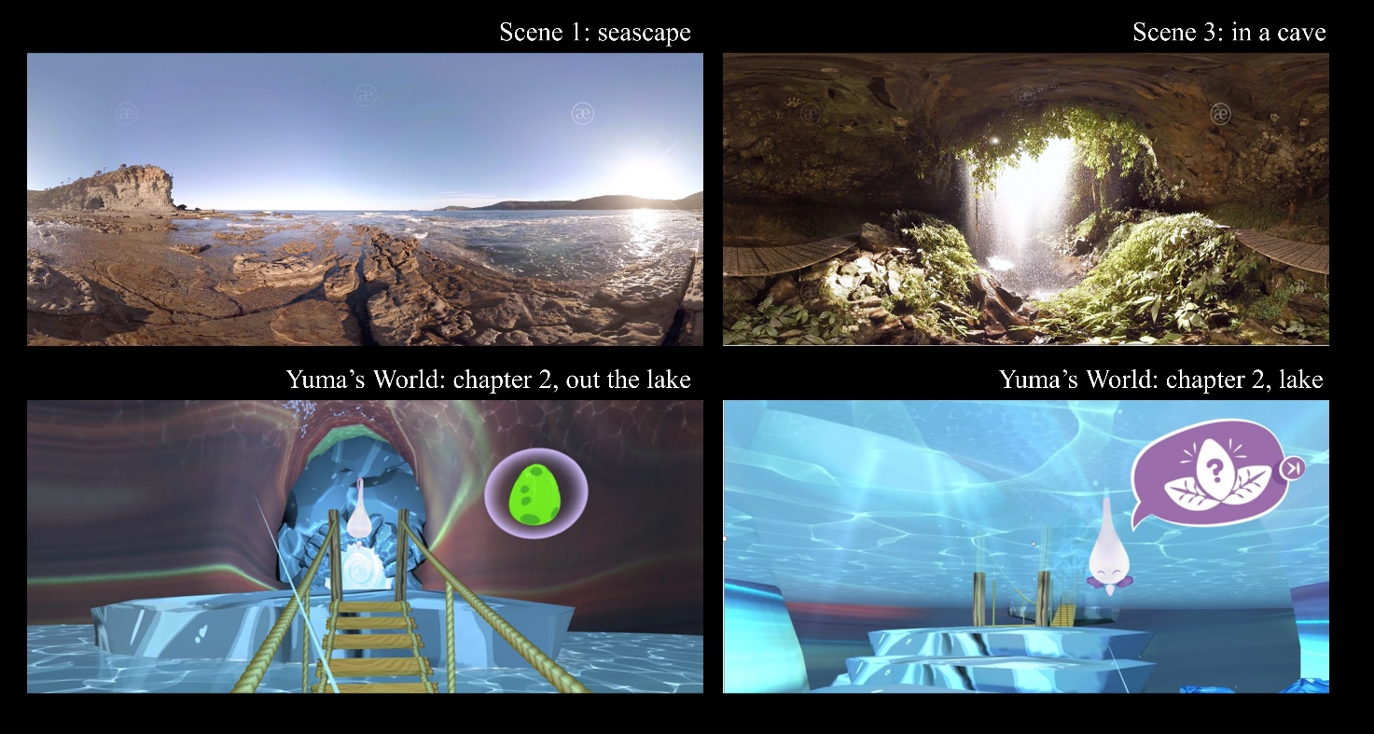
Supplementary Figure 1 - Upper panel: examples of non-interactive contents; Lower panel: examples of interactive content specifically developed for ANT patients

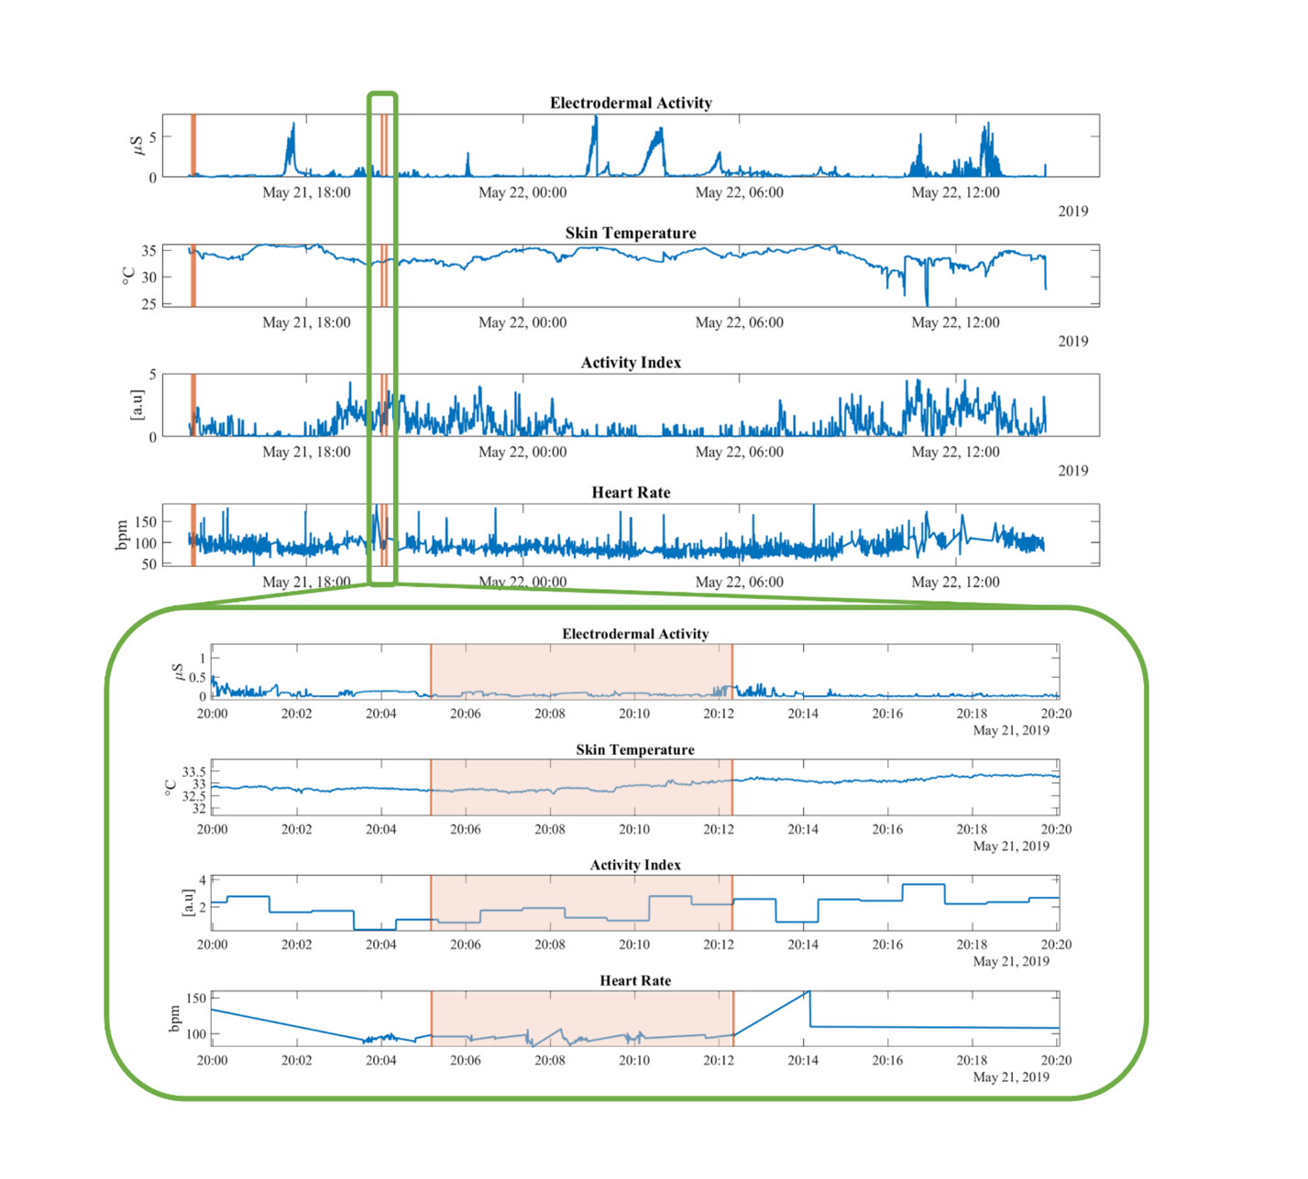
Supplementary Figure 2 – Upper panel: example of physiological recordings (blue lines), highlighting the VR sessions (orange lines). Lower pane: zoom-in of a single VR session (orange-shaded window, first orange line: session’s start, last orange line: session’s end). NB: The quick rise of the Heart Rate is likely to be due to a motion artifact

