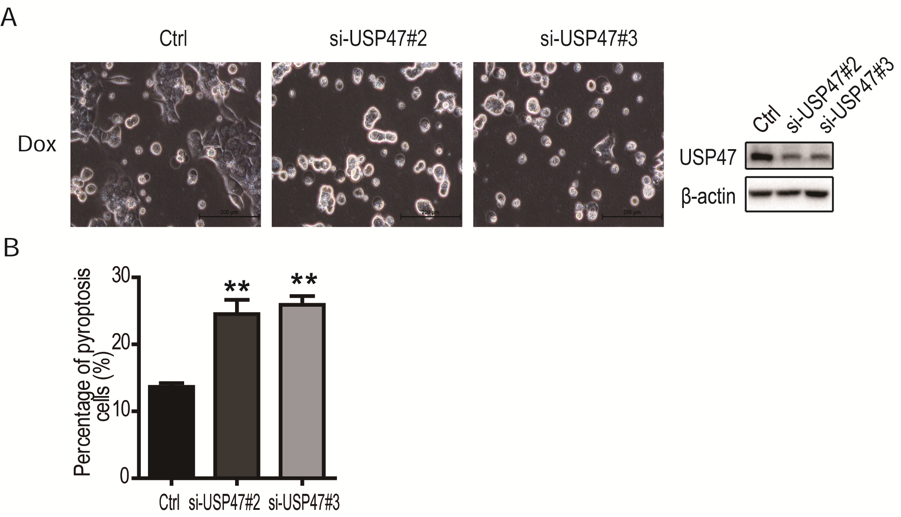
Supplementary Figure 1. Silencing of USP47 increased the pyroptosis by Doxorubicin in CRC cells. (A) USP47 in HCT116 cells was knockdown effectively with our siRNA#2 and #3. After transfected with the siRNA for 1 day, HCT116 cells were treated with 1 μΜ of doxorubicin for 24 hours. Photos taken under microscope indicated the presence of pyroptotic cells, especially in culture treated with. USP47 –targeting siRNA and doxorubicin. (B) The percentages of pyroptotic cells in USP47 knockdown HCT116 treated with doxorubicin. After siRNA transfection for 1 day, HCT116 cells were treated with 1 μΜ of doxorubicin for 24 hours. The “bubble-like” cells were counted as pyroptotic cells in 5 fields under microscope and normalized to the total cells in the fields.

