Supplementary Materials

Table S1. Primer sequences for Real-time PCR
Genes | Accession No. | Primes（5'-3'）
IL-1β | NM_001009465.2 | F: GAAGAGCTGCACCCAACACCTG
 |  | R: CGACACTGCCTGCCTGAAGC
IL-6 | NM_001009392.1 | F: GCTGCTCCTGGTGATGACTTCTG
 |  | R: AGTAGTCTGCTTGGGGTGGTGTC
NFKB | XM_027960471.1 | F: GCCTGCTGAATGCCCTGTCTG
 |  | R: CTCTGTTTCCTGTTCCACCGACTG
NOD-2 | XM_015100434.2 | F: TGCCATCCTCGCTCAGACATCTC
 |  | R: CAGCCACACTGCCCTCTTTGC
TLR-2 | NM_001048231.1 | F: TGCCCGCCTCTCCCTTTCTG  R: CGTGAGCAGGAGCAACAGGAAG
TLR-3 | NM_001135928.1 | F: ACACAATCAGCCACACGACCTTC  R: GCCAGGCAAAGGAGTCATTACCC
TLR-4 | NM_001135930.1 | F: TGGGTGCGGAATGAACTGGTAAA  R: CTGGATGATATTGGCGGCGATGG
TNF-α | NM_001024860.1 | F: CTGGCGGAGGAGGTGCTCTC  R: GGAGGAAGGAGAAGAGGCTGAGG
GAPDH | NM_001190390.1 | F: CGGCACAGTCAAGGCAGAGAAC  R: CACGTACTCAGCACCAGCATCAC
IL-1β interleukin-1β, IL-6 interleukin-1β, NFKB nuclear factor-k-gene binding, NOD2 nucleotide-binding oligomerization domain, TLR2 Toll-like receptors2, TLR3 Toll-like receptors3, TLR4 Toll-like receptors4, TNF-α tumor necrosis factor alpha, GAPDH glyceraldehyde-3-phosphate dehydrogenase..
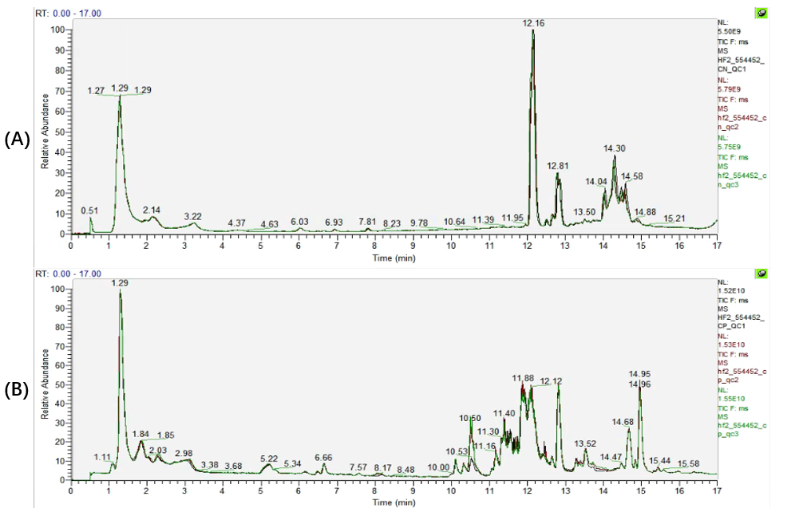
Figure S1. Total Ion Chromatography of Quality control samples in positive (A) and negative (B) modes.

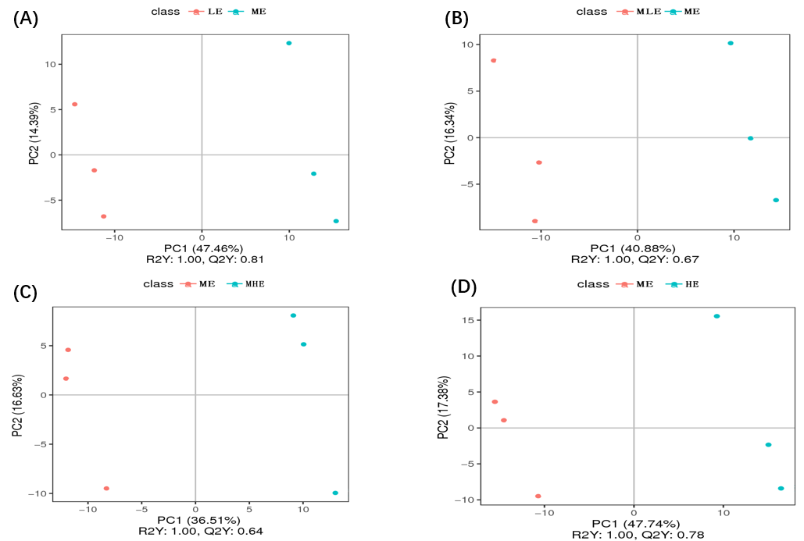
Figure S2. . PLS-DA loading plots based on the liver metabolic profilings in positive mode. A: LE Group VS ME group. B: MLE Group VS ME group. C: MHE Group VS ME group. D: HE Group VS ME group.
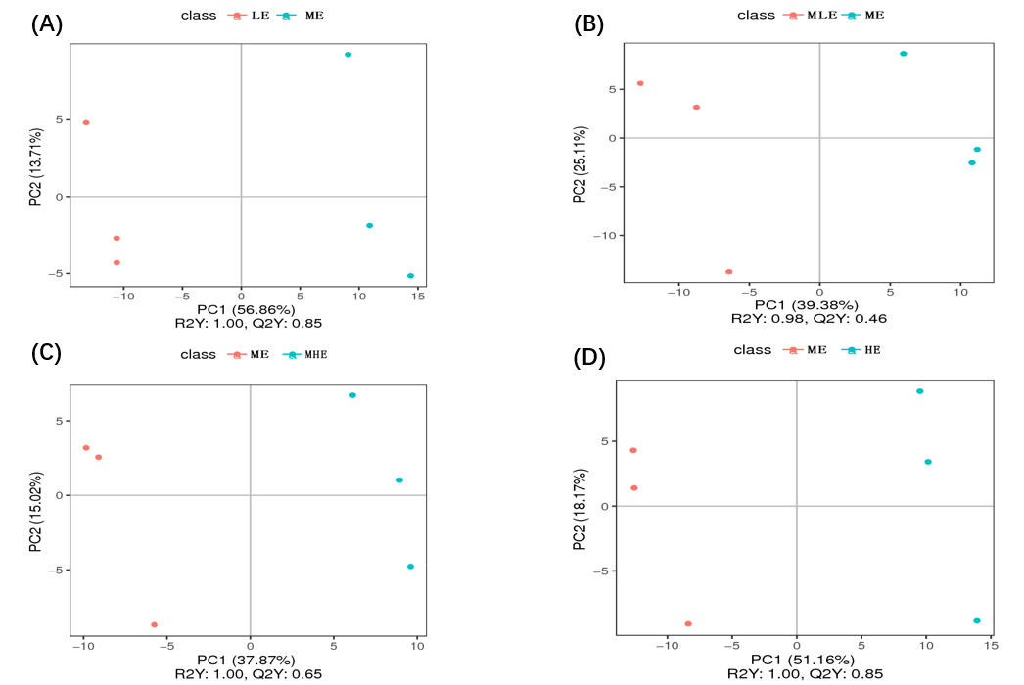
Figure S3. PLS-DA loading plots based on the liver metabolic profilings in negative mode. A: LE Group VS ME group. B: MLE Group VS ME group. C: MHE Group VS ME group. D: HE Group VS ME group.

