Supplementary Material

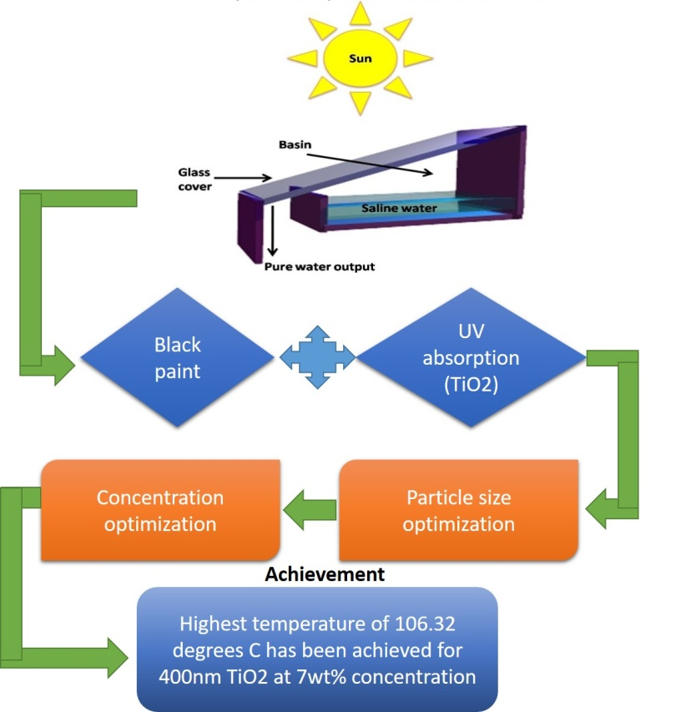

Supplementary Figure 1s. A research design approach

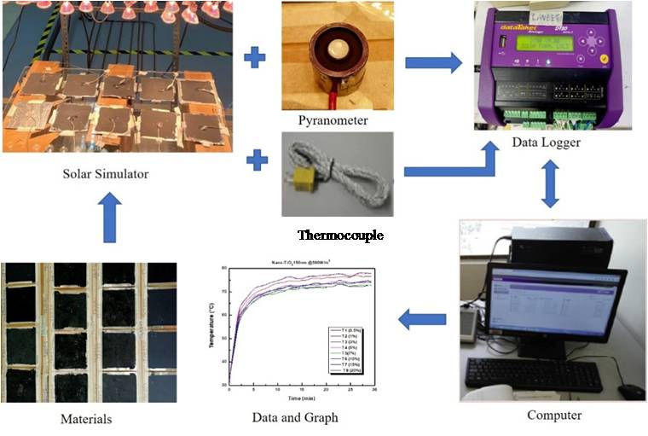

Supplementary Figure 2s. Indoor experimental setup

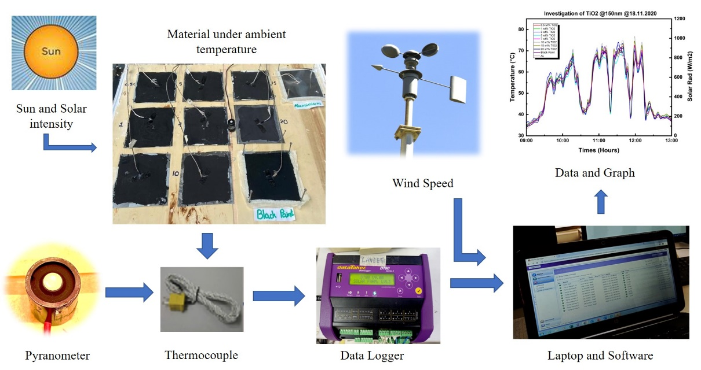

Supplementary Figure 3s. Outdoor experimental setup

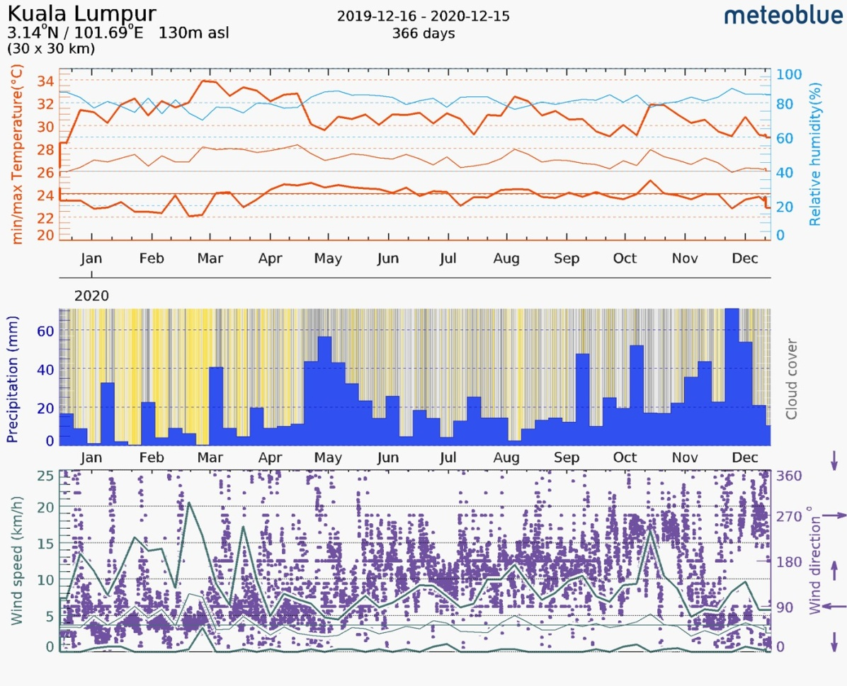
Supplementary Figure 4s. Historical weather data of Kuala Lumpur starting from December 2019 to 2020

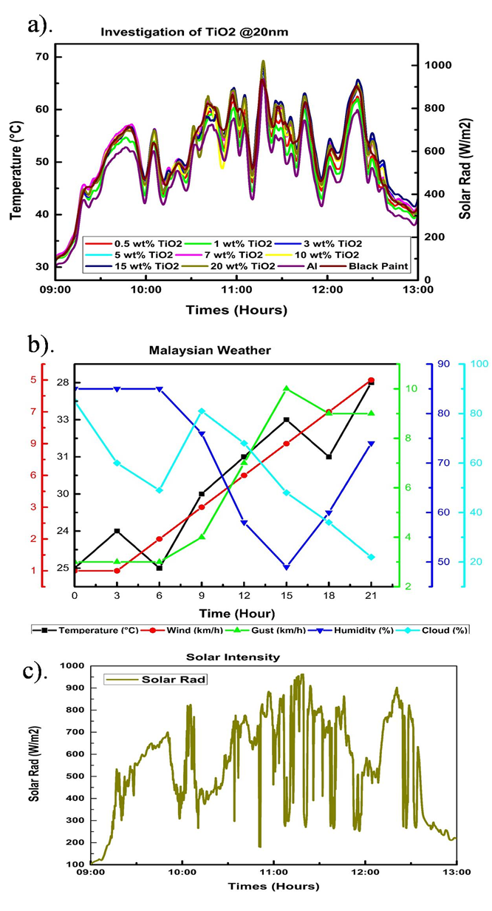
Supplementary Figure 5s. Outdoor (a) temperature variations, (b) weather condition and (c) solar irradiation for TiO₂- 20nm size (12th December 2020)
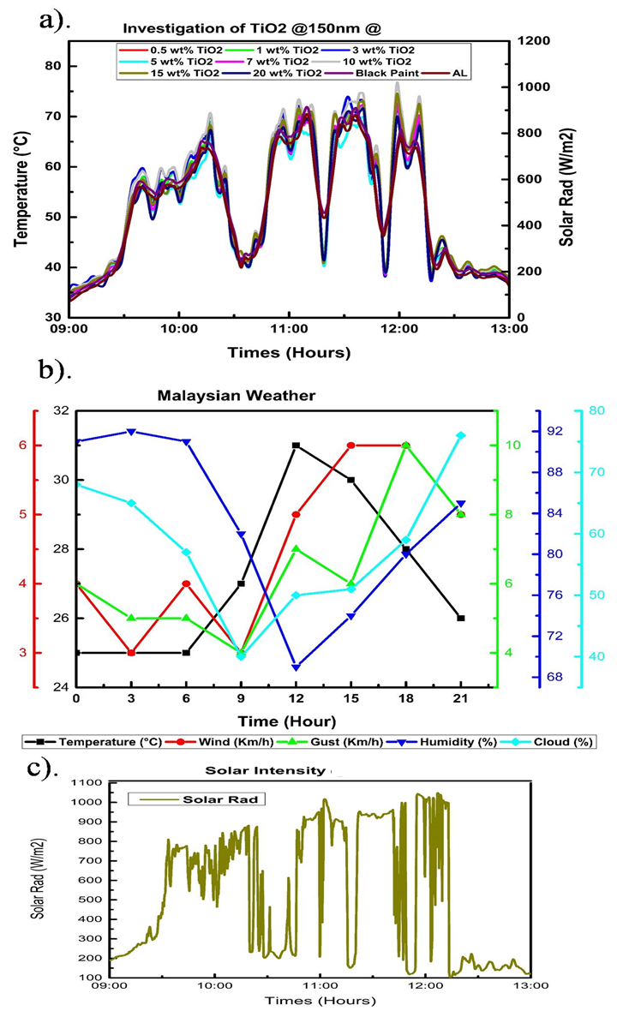
Supplementary Figure 6s. Outdoor (a) temperature variations, (b) weather condition and (c) solar irradiation for TiO₂ – 150nm size (18th December 2020)
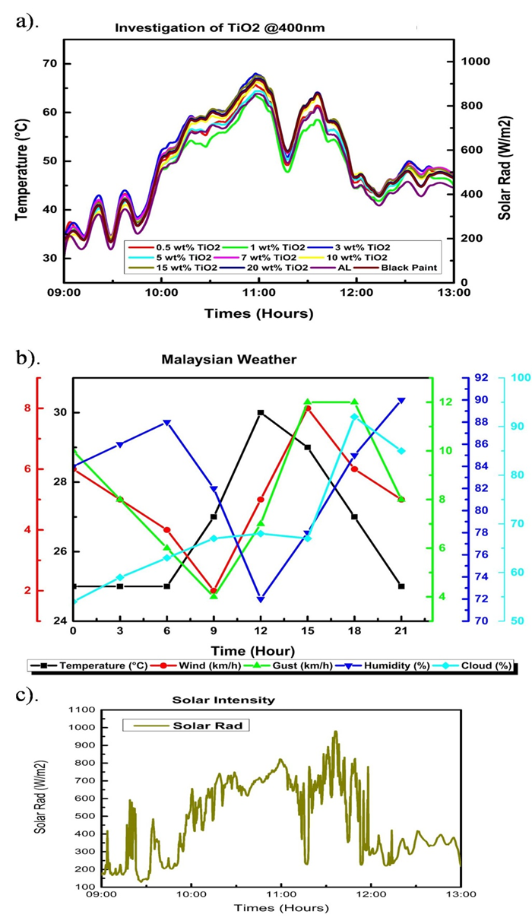
Supplementary Figure 7s. Outdoor (a) temperature variations, (b) weather condition and (c) solar irradiation for TiO₂ – 400nm size (23rd December 2020)

Supplementary Table 1s. Measurement ranges and accuracy of the instruments and sensors
Instrument | Measuring Range | Accuracy
Pyranometer (Model: LI-COR, LI200R) | 0 to 2000 W/m² | ±5%
Data Logger (Model: Data Taker DT80) | - 270 to 1372°C | ±2%
Thermocouple (K-Type) | -200 to 1000°C | ±1.5⁰C

