Supplementary Material
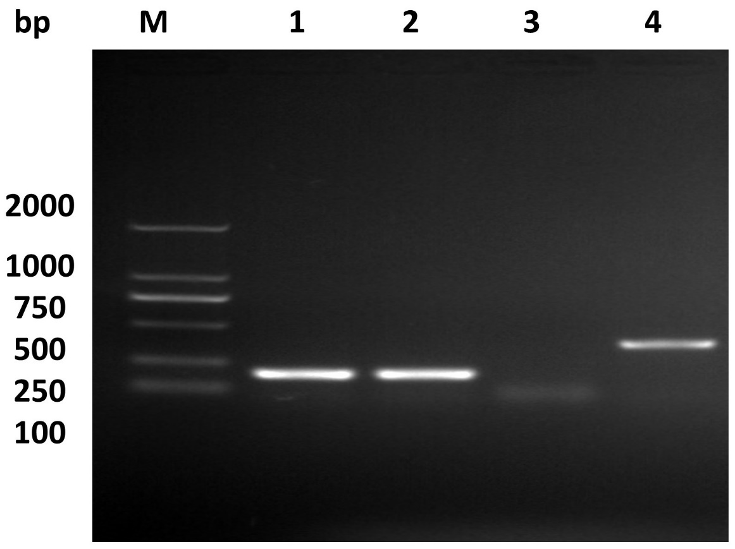
Figure S1. PCR confirmation of B739_0832 deletion in R. anatipestifer. Lanes 1 and 2 were PCR amplification of 16s RNA as positive control. Lanes 3 and 4 were PCR amplification of B739_0832 gene from ΔB739_0832 strain and wild-type, respectively. B739_0832 gene is 501 bps long, and the primers pair with 50bps upstream and downstream of the gene.

A.
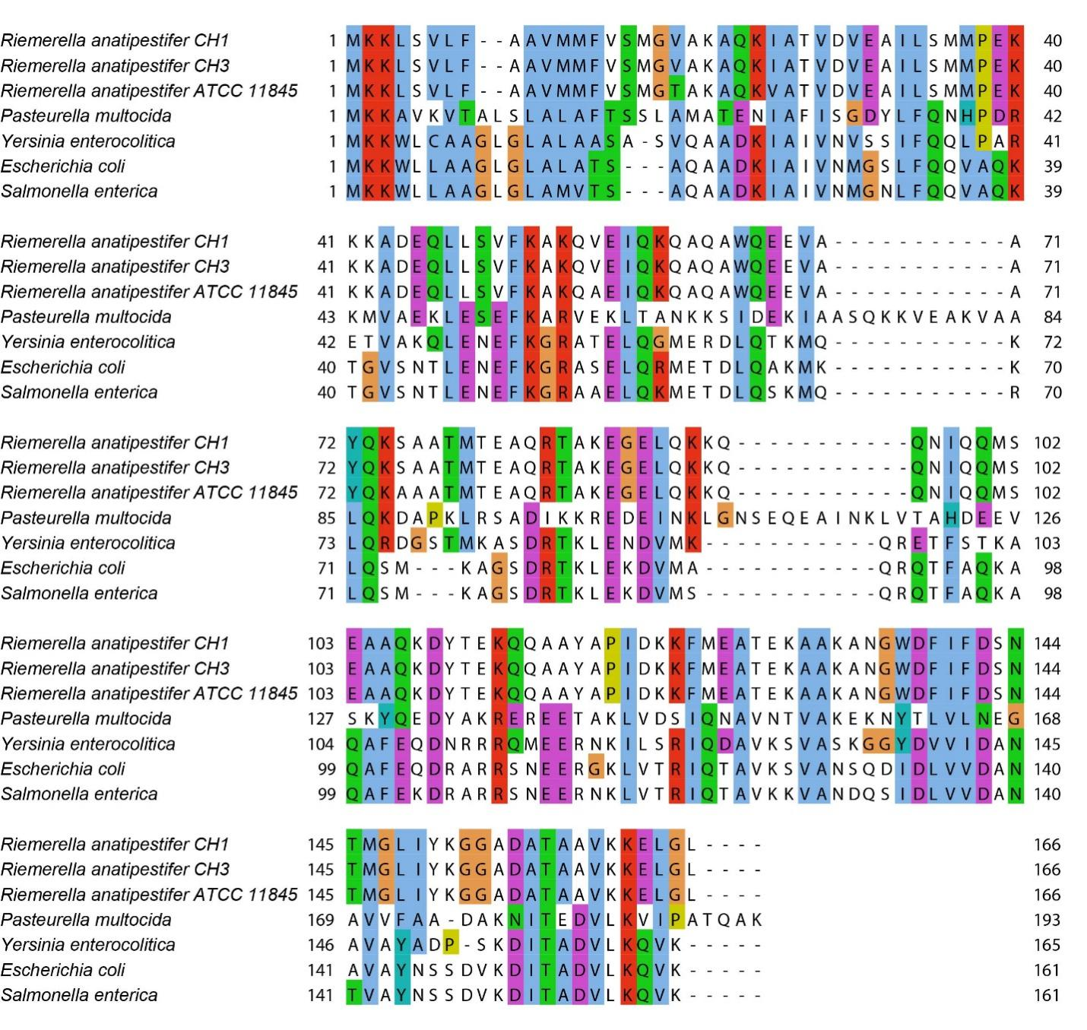

B.
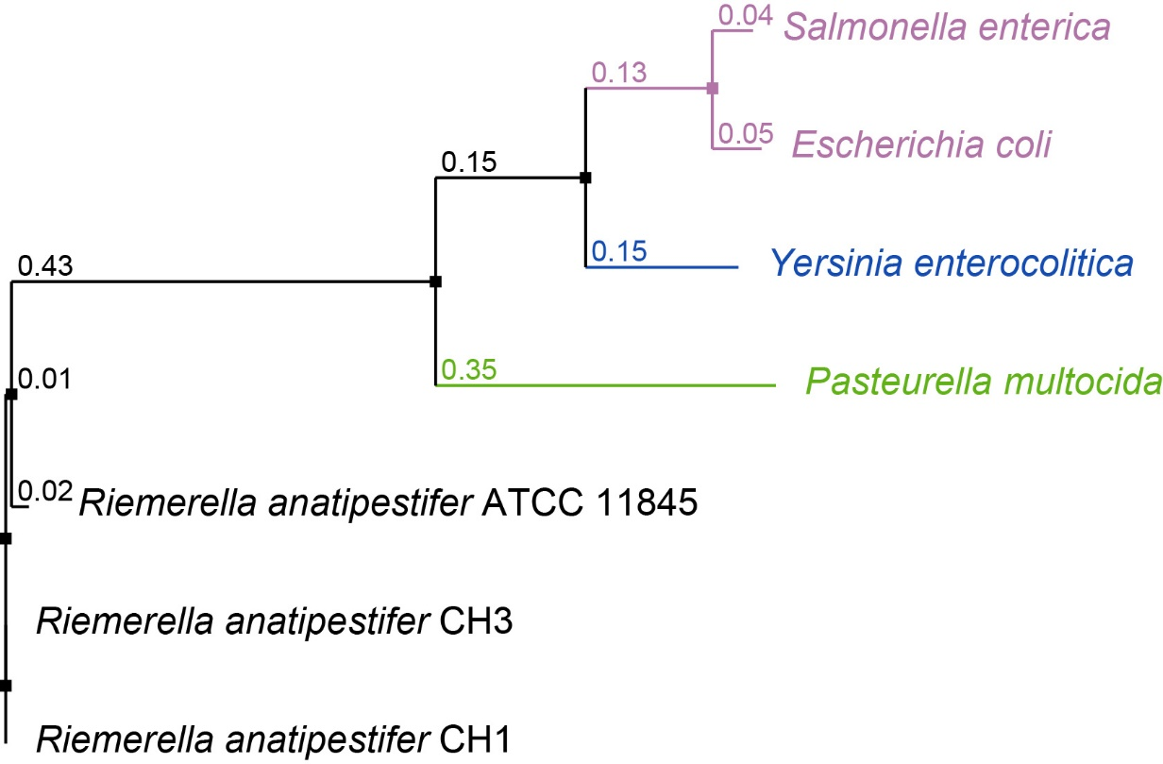

Figure S2. A. Sequence alignments of B739_0832 from R. anatipestifer CH-1, R. anatipestifer CH-2, R. anatipestifer ATCC, E. coli, P. multocida, S. enterica and Y. enterocolitica using EMBL-EBI Clustal Omega. B. Phylogenetic tree illustrating evolutionary distance among these OmpH/Skp proteins. Phylogenetic tree was also generated using EMBL-EBI Clustal Omega.

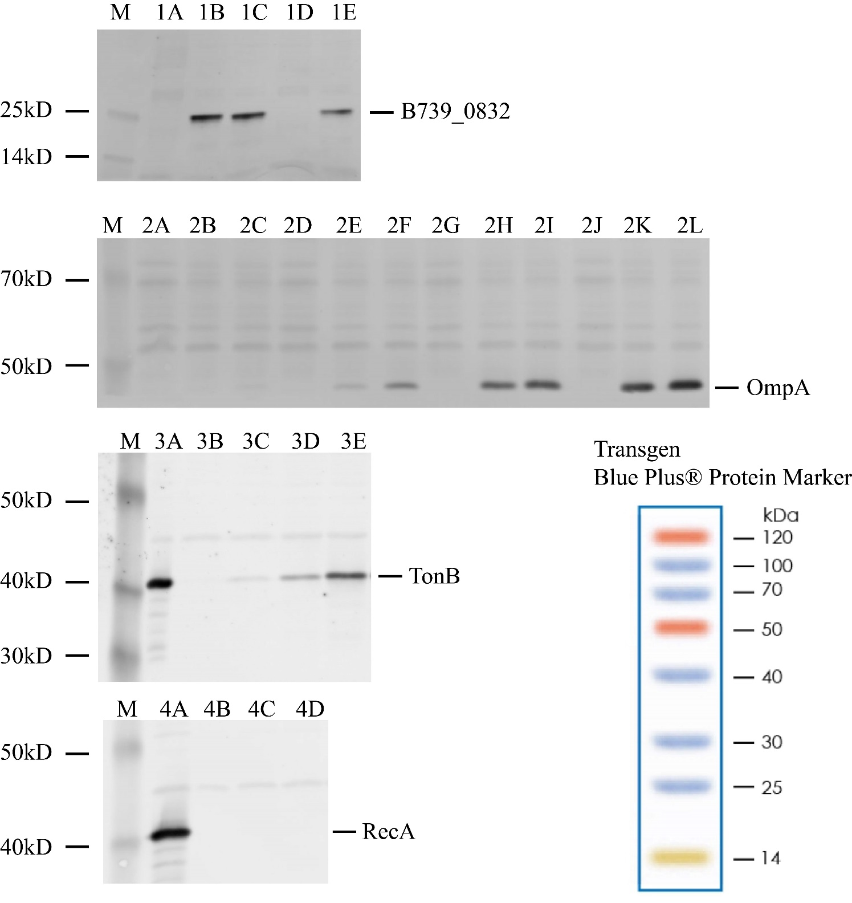
Figure S3. Membrane localization of R. anatipestfer CH-1 B739_0832 protein. Data correspond to Figure 2 in the main text with protein markers. Lane M is protein marker – Blue Plus® 14-120 kDa protein marker from Transgen (right bottom corner). Lanes 1A-1E are: inner membrane, whole cell, total membrane, inner membrane, and outer membrane samples, respectively. Lanes 2A-2L are: inner membrane, outer membrane, whole cell, total membrane, total membrane, whole cell, inner membrane, outer membrane, outer membrane, inner membrane, total membrane, and whole cell, respectively. Whereas 2A-2D were loaded with 1 µL sample in each lane; 2E-2H were loaded with 5 µL sample in each lane; and 2I-2L were loaded with 15 µL sample in each lane. Lanes 3A-3E are: TonB positive control sample, outer membrane, inner membrane, total membrane, and whole cell, respectively. Lanes 4A-4D are: whole cell, total membrane, inner membrane, and outer membrane, respectively. Protein sizes are approximation based on amino acid sequences.

