**List of Supplementary Material**

**Supplementary Tables.**

**Table S1.** Summary of the variance inflation factor (VIF), cut-off <3 for measuring the amount of multicollinearity in the set of environmental conditions analysed. All environmental conditions were retained for performing the analyses.

|  |  |
| --- | --- |
| Variable | VIF |
| Chlorophyll *a* (mg.m3) | 1.15 |
| Organic matter (%) | 1.52 |
| D50 (µm) | 1.61 |
| Sorting (σG) | 1.66 |
| pH | 1.51 |
| Salinity | 1.14 |
| Temperature (°C) | 1.19 |
| Nitrate (mg/L) | 1.12 |
| Nitrite (mg/L) | 1.35 |
| Ammonia (mg/L) | 2.83 |
| Phosphate (mg/L) | 2.59 |

**Table S2.** Summary of the different generalized linear latent variable models (GLLVMs) performed. Four models were tested (Mod_1 – Mod_4), resulting in the Negative Binomial as the best fit model. Individual GLLVMs Negative Binomial were performed for each of the combinations: all dataset, summer dataset, winter dataset, datasets by site, and by site and season.

|  |  |  |  |  |  |  |  |
| --- | --- | --- | --- | --- | --- | --- | --- |
| **ID** | **Variables** | **Season** | **Family** | **AIC** | **AICc** | **BIC** | **Time elapsed** |
| Mod_1 | Species+enviromental+traits | Both | Poisson | 20230.18 | 18280.49 | 22148.01 | 14.28 min |
| Mod_2 | Species+enviromental+traits | Both | ZIP | 17405.37 | 15378.17 | 19580.77 | 1.12 hours |
| Mod_3 | Species+enviromental+traits | Both | Gaussian | 32924.89 | 30897.68 | 35100.29 | 16.31 min |
| Mod_4 | Species+enviromental+traits | Both | Negative Binomial | 15672.30 | 13645.09 | 17847.69 | 10.10 min |
|  |  |  |  |  |  |  |  |
| Mod_all | Species+enviromental+traits | Both | Negative Binomial | 15672.30 | 13645.09 | 17847.69 | 10.10 min |
| Mod_all_s | Species+enviromental+traits | Summer | Negative binomial | 8818.64 | 7377.17 | 10404.73 | 3.10 min |
| Mod_all_w | Species+enviromental+traits | Winter | Negative binomial | 6482.08 | 5107.09 | 7967.81 | 2.18 min |
|  |  |  |  |  |  |  |  |
| Mod_LB_both | Species+envi+traits | Both | Negative binomial | 1831.74 | 893.48 | 2444.06 | 15 sec |
| Mod_KB_both | Species+envi+traits | Both | Negative binomial | 2579.34 | 1593.31 | 3225.29 | 11 sec |
| Mod_PG_both | Species+envi+traits | Both | Negative binomial | 1401.12 | 526.49 | 1968.61 | 6 sec |
| Mod_FB_both | Species+envi+traits | Both | Negative binomial | 1737.40 | 823.01 | 2332.91 | 7 sec |
| Mod_PPa_both | Species+envi+traits | Both | Negative binomial | 1666.96 | 736.65 | 2273.67 | 7 sec |
| Mod_MB_both | Species+envi+traits | Both | Negative binomial | 2044.87 | 1034.96 | 2707.64 | 13 sec |
| Mod_PP_both | Species+envi+traits | Both | Negative binomial | 2146.30 | 1335.24 | 2668.95 | 9 sec |
| Mod_N_both | Species+envi+traits | Both | Negative binomial | 1823.67 | 1004.67 | 2351.92 | 5 sec |
|  |  |  |  |  |  |  |  |
| Mod_LB_s | Species+envi+traits | Summer | Negative binomial | 1118.91 | 293.86 | 1400.05 | 5 sec |
| Mod_KB_s | Species+envi+traits | Summer | Negative binomial | 1497.97 | 592.97 | 1807.38 | 5 sec |
| Mod_PG_s | Species+envi+traits | Summer | Negative binomial | 1081.14 | 272.02 | 1356.57 | 5 sec |
| Mod_FB_s | Species+envi+traits | Summer | Negative binomial | 1223.97 | 406.86 | 1502.24 | 5 sec |
| Mod_PPa_s | Species+envi+traits | Summer | Negative binomial | 1174.56 | 349.46 | 1455.66 | 5 sec |
| Mod_MB_s | Species+envi+traits | Summer | Negative binomial | 1328.92 | 407.94 | 1644.00 | 5 sec |
| Mod_PP_s | Species+envi+traits | Summer | Negative binomial | 1274.99 | 505.80 | 1536.26 | 5 sec |
| Mod_N_s | Species+envi+traits | Summer | Negative binomial | 1367.93 | 598.75 | 1629.20 | 5 sec |
|  |  |  |  |  |  |  |  |
| Mod_LB_w | Species+envi+traits | winter | Negative binomial | 1178.47 | 289.45 | 1482.22 | 5 sec |
| Mod_KB_w | Species+envi+traits | winter | Negative binomial | 1408.16 | 511.16 | 1714.75 | 5 sec |
| Mod_PG_w | Species+envi+traits | winter | Negative binomial | 898.20 | 129.02 | 1159.47 | 5 sec |
| Mod_FB_w | Species+envi+traits | winter | Negative binomial | 1026.50 | 209.40 | 1304.72 | 5 sec |
| Mod_PPa_w | Species+envi+traits | winter | Negative binomial | 1024.26 | 199.16 | 1305.35 | 5 sec |
| Mod_MB_w | Species+envi+traits | winter | Negative binomial | 1130.03 | 264.98 | 1425.28 | 5 sec |
| Mod_PP_w | Species+envi+traits | winter | Negative binomial | 1286.84 | 533.63 | 1542.45 | 5 sec |
| Mod_N_w | Species+envi+traits | winter | Negative binomial | 898.71 | 153.49 | 1151.48 | 5 sec |

**Table S3.** Summary of the environmental conditions recorded in the eight sites along the southern Australian coast in two seasons. Mean values and standard deviations are shown. Chl *a*: chlorophyll *a*; OM: organic matter; D50: median grain size.

|  |  |  |  |  |  |  |  |  |  |  |  |  |  |  |  |
| --- | --- | --- | --- | --- | --- | --- | --- | --- | --- | --- | --- | --- | --- | --- | --- |
| Site | Season | Chl *a* (mg.m3) | | OM (%) | | D50 (µm) | | Sorting (σG) | | pH | | Salinity | | Temperature (°C) | |
| Mean | ± SE | Mean | ± SE | Mean | ± SE | Mean | ± SE | Mean | ± SE | Mean | ± SE | Mean | ± SE |
| Long Beach | Summer | 1.20 | 0.15 | 1.99 | 0.13 | 245.89 | 1.52 | 1.59 | 0.03 | 7.86 | 0.03 | 43.33 | 0.44 | 24.81 | 0.40 |
| Winter | 0.71 | 0.08 | 2.17 | 0.08 | 248.04 | 2.96 | 1.77 | 0.08 | 7.73 | 0.07 | 36.11 | 0.97 | 13.10 | 0.17 |
| Kellidie Bay | Summer | 1.49 | 0.11 | 2.91 | 0.31 | 215.88 | 8.03 | 2.16 | 0.22 | 7.88 | 0.09 | 34.58 | 2.37 | 24.15 | 0.42 |
| Winter | 0.70 | 0.08 | 2.94 | 0.22 | 254.06 | 28.89 | 2.80 | 0.34 | 8.37 | 0.06 | 34.54 | 0.89 | 16.10 | 0.20 |
| Port Germein | Summer | 0.52 | 0.06 | 1.77 | 0.06 | 224.27 | 6.70 | 2.05 | 0.11 | 7.46 | 0.06 | 45.17 | 0.76 | 26.43 | 0.35 |
| Winter | 0.31 | 0.02 | 2.18 | 0.05 | 167.46 | 8.04 | 2.25 | 0.05 | 7.88 | 0.11 | 56.91 | 1.06 | 13.83 | 0.38 |
| Fisherman Bay | Summer | 0.83 | 0.10 | 3.08 | 0.07 | 384.02 | 8.74 | 3.75 | 0.17 | 7.90 | 0.10 | 51.40 | 5.61 | 22.90 | 0.31 |
| Winter | 0.57 | 0.04 | 3.17 | 0.10 | 378.08 | 11.19 | 2.28 | 0.17 | 8.16 | 0.04 | 43.44 | 0.10 | 6.23 | 0.33 |
| Port Parham | Summer | 0.51 | 0.04 | 2.26 | 0.06 | 197.29 | 10.39 | 2.18 | 0.11 | 8.04 | 0.11 | 46.32 | 1.46 | 30.44 | 0.88 |
| Winter | 0.21 | 0.02 | 2.30 | 0.12 | 240.07 | 11.33 | 2.25 | 0.12 | 8.11 | 0.03 | 40.68 | 0.45 | 11.65 | 0.31 |
| Middle Beach | Summer | 1.23 | 0.21 | 3.33 | 0.13 | 438.69 | 25.69 | 2.81 | 0.22 | 7.97 | 0.12 | 41.93 | 0.28 | 30.63 | 0.60 |
| Winter | 0.78 | 0.14 | 2.96 | 0.12 | 652.66 | 38.97 | 3.48 | 0.25 | 7.87 | 0.04 | 40.31 | 0.19 | 13.89 | 0.22 |
| Pelican Point | Summer | 2.10 | 0.27 | 1.41 | 0.09 | 320.12 | 4.96 | 2.36 | 0.09 | 7.93 | 0.12 | 27.49 | 0.48 | 18.95 | 0.43 |
| Winter | 0.97 | 0.10 | 0.91 | 0.12 | 346.66 | 16.32 | 1.79 | 0.07 | 7.53 | 0.10 | 35.65 | 2.67 | 11.01 | 0.14 |
| Noonameena | Summer | 1.85 | 0.16 | 0.99 | 0.04 | 227.82 | 5.42 | 1.69 | 0.01 | 8.08 | 0.01 | 65.86 | 0.63 | 24.96 | 0.17 |
| Winter | 0.62 | 0.06 | 0.82 | 0.04 | 198.06 | 2.92 | 1.58 | 0.01 | 8.18 | 0.03 | 34.10 | 0.64 | 11.74 | 0.18 |

**Table S3.** Continued

|  |  |  |  |  |  |  |  |  |  |
| --- | --- | --- | --- | --- | --- | --- | --- | --- | --- |
| Site | Season | Nitrate (mg/L) | | Nitrite (mg/L) | | Ammonia (mg/L) | | Phosphate (mg/L) | |
| Mean | ± SE | Mean | ± SE | Mean | ± SE | Mean | ± SE |
| Long Beach | Summer | 0.07 | 0.02 | 0.12 | 0.01 | 0.47 | 0.04 | 0.19 | 0.04 |
| Winter | 0.04 | 0.02 | 0.41 | 0.19 | 0.46 | 0.13 | 0.18 | 0.03 |
| Kellidie Bay | Summer | 0.02 | 0.01 | 0.17 | 0.01 | 0.27 | 0.01 | 0.00 | 0.00 |
| Winter | 0.20 | 0.14 | 0.66 | 0.21 | 0.19 | 0.02 | 0.09 | 0.01 |
| Port Germein | Summer | 0.01 | 0.01 | 0.28 | 0.01 | 1.34 | 0.47 | 0.02 | 0.01 |
| Winter | 1.04 | 0.64 | 0.68 | 0.03 | 1.21 | 0.22 | 0.29 | 0.02 |
| Fisherman Bay | Summer | 0.09 | 0.02 | 0.28 | 0.01 | 0.01 | 0.00 | 0.00 | 0.00 |
| Winter | 0.07 | 0.02 | 0.73 | 0.05 | 0.46 | 0.02 | 0.27 | 0.02 |
| Port Parham | Summer | 0.05 | 0.01 | 0.26 | 0.01 | 0.35 | 0.03 | 0.01 | 0.00 |
| Winter | 0.02 | 0.01 | 0.64 | 0.06 | 0.37 | 0.03 | 0.20 | 0.01 |
| Middle Beach | Summer | 0.00 | 0.00 | 0.11 | 0.01 | 0.84 | 0.41 | 0.12 | 0.08 |
| Winter | 0.02 | 0.01 | 0.53 | 0.03 | 0.26 | 0.03 | 0.18 | 0.02 |
| Pelican Point | Summer | 0.13 | 0.01 | 0.42 | 0.01 | 0.61 | 0.20 | 0.05 | 0.04 |
| Winter | 0.94 | 0.80 | 1.00 | 0.25 | 5.23 | 1.97 | 2.17 | 0.97 |
| Noonameena | Summer | 0.01 | 0.01 | 0.36 | 0.01 | 0.49 | 0.00 | 0.03 | 0.01 |
| Winter | 0.18 | 0.04 | 0.75 | 0.01 | 0.51 | 0.08 | 0.35 | 0.05 |

**Table S4.** Macrobenthic fauna abundances recorded in the eight sites surveyed across the southern Australian coast in two seasons. Major taxonomical groups, mean and error standard values are shown.

|  |  |  |  |  |  |  |  |  |  |
| --- | --- | --- | --- | --- | --- | --- | --- | --- | --- |
| Site | Season | Total number of species | Mean total abundance (ind.m2) | Annelida | | Arthropoda | | Bivalvia | |
| Mean (ind.m2) | ± SE | Mean (ind.m2) | ± SE | Mean (ind.m2) | ± SE |
| Long Beach | Summer | 17 | 2496.40 | 1416.23 | 256.67 | 72.01 | 15.71 | 480.08 | 85.27 |
| Winter | 25 | 3592.57 | 1736.28 | 419.51 | 208.03 | 76.33 | 184.03 | 38.61 |
| Kellidie Bay | Summer | 27 | 14330.29 | 3120.50 | 1130.93 | 2224.36 | 1178.50 | 3968.63 | 756.85 |
| Winter | 26 | 14210.27 | 1400.22 | 93.46 | 152.02 | 32.01 | 3928.63 | 502.48 |
| Port Germein | Summer | 15 | 4632.74 | 1352.22 | 286.77 | 232.04 | 86.44 | 2816.45 | 587.49 |
| Winter | 10 | 2320.37 | 128.02 | 27.39 | 32.01 | 18.40 | 480.08 | 136.09 |
| Fisherman Bay | Summer | 16 | 15818.53 | 1256.20 | 409.42 | 312.05 | 55.93 | 1696.27 | 314.91 |
| Winter | 16 | 1904.30 | 480.08 | 49.69 | 144.02 | 42.55 | 64.01 | 28.37 |
| Port Parham | Summer | 17 | 13194.11 | 1280.20 | 244.47 | 56.01 | 19.83 | 640.10 | 156.56 |
| Winter | 17 | 2152.34 | 920.15 | 127.05 | 32.01 | 14.18 | 112.02 | 34.08 |
| Middle Beach | Summer | 29 | 13498.16 | 5480.88 | 1198.51 | 216.03 | 56.42 | 680.11 | 230.61 |
| Winter | 22 | 3872.62 | 1648.26 | 741.65 | 1128.18 | 445.20 | 432.07 | 143.83 |
| Pelican Point | Summer | 10 | 49399.90 | 17858.86 | 1356.66 | 1472.24 | 301.01 | 27452.39 | 4588.10 |
| Winter | 8 | 52592.41 | 13234.12 | 2919.97 | 16794.69 | 6394.36 | 21707.47 | 3221.71 |
| Noonameena | Summer | 11 | 87486.00 | 68626.98 | 4455.75 | 18122.90 | 1732.13 | 600.10 | 143.93 |
| Winter | 7 | 10489.68 | 8905.42 | 1142.94 | 1568.25 | 491.44 | 8.00 | 8.00 |

**Table S4.** Continued.

|  |  |  |  |  |  |  |  |  |  |
| --- | --- | --- | --- | --- | --- | --- | --- | --- | --- |
| Site | Season | Cnidaria | | Echinodermata | | Gastropoda | | Nemertea | |
| Mean (ind.m2) | ± SE | Mean (ind.m2) | ± SE | Mean (ind.m2) | ± SE | Mean (ind.m2) | ± SE |
| Long Beach | Summer | 0.00 | 0.00 | 0.00 | 0.00 | 528.08 | 115.24 | 0.00 | 0.00 |
| Winter | 0.00 | 0.00 | 0.00 | 0.00 | 1464.23 | 511.91 | 0.00 | 0.00 |
| Kellidie Bay | Summer | 0.00 | 0.00 | 24.00 | 12.83 | 4992.80 | 830.51 | 0.00 | 0.00 |
| Winter | 0.00 | 0.00 | 0.00 | 0.00 | 8729.40 | 1737.72 | 8.00 | 8.00 |
| Port Germein | Summer | 0.00 | 0.00 | 0.00 | 0.00 | 232.04 | 78.10 | 16.00 | 10.90 |
| Winter | 0.00 | 0.00 | 0.00 | 0.00 | 1680.27 | 285.22 | 0.00 | 0.00 |
| Fisherman Bay | Summer | 0.00 | 0.00 | 0.00 | 0.00 | 12554.01 | 2208.26 | 0.00 | 0.00 |
| Winter | 8.00 | 8.00 | 0.00 | 0.00 | 1208.19 | 169.52 | 8.00 | 8.00 |
| Port Parham | Summer | 0.00 | 0.00 | 0.00 | 0.00 | 11217.79 | 2656.55 | 24.00 | 17.37 |
| Winter | 0.00 | 0.00 | 0.00 | 0.00 | 1088.17 | 165.42 | 0.00 | 0.00 |
| Middle Beach | Summer | 64.01 | 25.84 | 0.00 | 0.00 | 7057.13 | 1604.30 | 40.01 | 19.13 |
| Winter | 0.00 | 0.00 | 0.00 | 0.00 | 664.11 | 116.46 | 8.00 | 8.00 |
| Pelican Point | Summer | 0.00 | 0.00 | 0.00 | 0.00 | 2616.42 | 646.45 | 0.00 | 0.00 |
| Winter | 0.00 | 0.00 | 0.00 | 0.00 | 856.14 | 256.04 | 0.00 | 0.00 |
| Noonameena | Summer | 0.00 | 0.00 | 0.00 | 0.00 | 136.02 | 46.66 | 0.00 | 0.00 |
| Winter | 0.00 | 0.00 | 0.00 | 0.00 | 8.00 | 8.00 | 0.00 | 0.00 |

**Table S5.** Taxa list of the macrobenthic fauna recorded in the eight sites surveyed across the southern Australian.

|  |  |  |  |  |
| --- | --- | --- | --- | --- |
| **Phylum** | **Class** | **Order** | **Family** | **Species** |
| Annelida | Polychaeta | Eunicida | Onuphidae |  |
| Annelida | Polychaeta | Phyllodocida | Goniadidae |  |
| Annelida | Polychaeta | Phyllodocida | Nephtyidae | *Aglaophamus australiensis* |
| Annelida | Polychaeta | Phyllodocida | Nephtyidae |  |
| Annelida | Polychaeta | Phyllodocida | Nereididae | *Australonereis ehlersi* |
| Annelida | Polychaeta | Phyllodocida | Nereididae | *Simplisetia aequisetis* |
| Annelida | Polychaeta | Phyllodocida | Nereididae |  |
| Annelida | Polychaeta | Phyllodocida | Syllidae |  |
| Annelida | Polychaeta | Sabellida | Sabellidae | *Euchone variabilis* |
| Annelida | Polychaeta | Spionida | Spionidae | *Boccardiella limnicola* |
| Annelida | Polychaeta | Spionida | Spionidae |  |
| Annelida | Polychaeta | Terebellida | Cirratulidae |  |
| Annelida | Polychaeta |  | Arenicolidae |  |
| Annelida | Polychaeta |  | Capitellidae |  |
| Annelida | Polychaeta |  | Opheliidae |  |
| Annelida | Polychaeta |  | Orbiniidae |  |
| Annelida | Polychaeta |  | Paraonidae |  |
| Arthropoda | Hexanauplia | Sessilia | Balanidae | *Amphibalanus amphitrite* |
| Arthropoda | Hexanauplia | Sessilia | Chthamalidae | *Chamaesipho tasmanica* |
| Arthropoda | Insecta | Diptera | Ceratopogonidae |  |
| Arthropoda | Insecta | Diptera | Chironomidae |  |
| Arthropoda | Insecta | Diptera | Dolichopodidae |  |
| Arthropoda | Malacostraca | Amphipoda | Corophiidae |  |
| Arthropoda | Malacostraca | Amphipoda |  |  |
| Arthropoda | Malacostraca | Cumacea | Bodotriidae | *Cyclaspis spilotes* |
| Arthropoda | Malacostraca | Decapoda | Callianassidae | *Arenallianassa arenosa* |
| Arthropoda | Malacostraca | Decapoda | Callichiridae | *Neocallichirus angelikae* |
| Arthropoda | Malacostraca | Decapoda | Leucosiidae | *Bellidilia laevis* |
| Arthropoda | Malacostraca | Decapoda | Paguridae | *Lophopagurus nanus* |
| Arthropoda | Malacostraca | Decapoda | Penaeidae | *Penaeus latisulcatus* |
| Arthropoda | Malacostraca | Decapoda | Portunidae | *Portunus pelagicus* |
| Arthropoda | Malacostraca | Decapoda | Varunidae | *Brachynotus spinosus* |
| Arthropoda | Malacostraca | Isopoda | Cirolanidae | *Cirolana cranchii australiensis* |
| Arthropoda | Malacostraca | Isopoda | Idoteidae | *Euidotea bakeri* |
| Arthropoda | Malacostraca | Isopoda | Janiridae |  |
| Arthropoda | Malacostraca | Isopoda | Sphaeromatidae | *Exosphaeroma alii* |
| Arthropoda | Malacostraca | Isopoda | Sphaeromatidae | *Platynympha longicaudata* |
| Arthropoda | Malacostraca | Leptostraca | Nebaliidae |  |
| Arthropoda | Malacostraca | Mysida | Mysidae |  |
| Arthropoda | Malacostraca | Tanaidacea | Apseudidae | *Carpoapseudes austroafricanus* |
| Cnidaria | Anthozoa | Actiniaria | Actiniidae | *Anthopleura hermaphroditica* |
| Echinodermata | Holothuroidea | Holothuriida | Holothuriidae |  |
| Mollusca | Bivalvia | Cardiida | Psammobiidae | *Hiatula alba* |
| Mollusca | Bivalvia | Cardiida | Tellinidae | *Tellina margaritinus* |
| Mollusca | Bivalvia | Cardiida | Tellinidae | *Tellina sp.* |
| Mollusca | Bivalvia | Galeommatida | Lasaeidae | *Arthritica semen* |
| Mollusca | Bivalvia | Mytilida | Mytilidae | *Brachidontes rostratus* |
| Mollusca | Bivalvia | Mytilida | Mytilidae | *Xenostrobus inconstans* |
| Mollusca | Bivalvia | Venerida | Mactridae | *Spisula trigonella* |
| Mollusca | Bivalvia | Venerida | Mesodesmatidae | *Anapella cycladea* |
| Mollusca | Bivalvia | Venerida | Mesodesmatidae | *Atactodea cuneata* |
| Mollusca | Bivalvia | Venerida | Veneridae | *Dosinia sp.* |
| Mollusca | Bivalvia | Venerida | Veneridae | *Katelysia peronii* |
| Mollusca | Bivalvia | Venerida | Veneridae | *Katelysia rhytiphora* |
| Mollusca | Bivalvia | Venerida | Veneridae | *Katelysia scalarina* |
| Mollusca | Gastropoda | Caenogastropoda | Batillariidae | *Zeacumantus diemenensis* |
| Mollusca | Gastropoda | Caenogastropoda | Batillariidae | *Zeacumantus plumbeus* |
| Mollusca | Gastropoda | Cephalaspidea | Bullidae | *Bulla quoyii* |
| Mollusca | Gastropoda | Cephalaspidea | Haminoeidae | *Liloa brevis* |
| Mollusca | Gastropoda | Cephalaspidea | Philinidae | *Philine angasi* |
| Mollusca | Gastropoda | Littorinimorpha | Hydrobiidae |  |
| Mollusca | Gastropoda | Littorinimorpha | Littorinidae | *Bembicium vittatum* |
| Mollusca | Gastropoda | Littorinimorpha | Naticidae | *Conuber conicum* |
| Mollusca | Gastropoda | Littorinimorpha | Rissoinidae | *Rissoina fasciata* |
| Mollusca | Gastropoda | Neogastropoda | Buccinidae | *Cominella lineolata* |
| Mollusca | Gastropoda | Neogastropoda | Fasciolariidae | *Propefusus australis* |
| Mollusca | Gastropoda | Neogastropoda | Nassariidae | *Nassarius pyrrhus* |
| Mollusca | Gastropoda | Neogastropoda | Terebridae | *Duplicaria kieneri* |
| Mollusca | Gastropoda | Neogastropoda | Volutomitridae | *Peculator porphyria* |
| Mollusca | Gastropoda | Trochida | Trochidae | *Austrocochlea constricta* |
| Mollusca | Gastropoda | Trochida | Trochidae | *Phasianotrochus eximius* |
| Mollusca | Gastropoda |  | Amphibolidae | *Salinator fragilis* |
| Mollusca | Gastropoda |  | Lottiidae | *Notoacmea flammea* |
| Nemertea | Pilidiophora | Heteronemertea | Lineidae | *Notospermus sp.* |

**Table S6.** Summary of the Pairwise test by expressed trait. P-values are presented, and significant differences are shown in bold. LB: Long Beach; KB: Kellidie Bay; MB: Middle Beach; PPa: Port Parham; PG: Port Germein, FB: Fisherman Bay; PP: Pelican Point; N: Noonameena.

|  |  |  |  |  |  |  |  |  |  |  |  |  |  |  |
| --- | --- | --- | --- | --- | --- | --- | --- | --- | --- | --- | --- | --- | --- | --- |
| Groups / Traits modalities | Biodiffusor | | Bioirrigator | | No bioturbation | | Surface modifier | | Large (>20mm) | | Medium (5-20mm) | | Small (0.5-5mm) | |
| Summer | Winter | Summer | Winter | Summer | Winter | Summer | Winter | Summer | Winter | Summer | Winter | Summer | Winter |
| LB, KB | **0.0002** | **0.0030** | **0.0078** | 0.0624 | 0.1996 | **0.0033** | 0.6748 | 0.1605 | **0.0001** | 0.2434 | **0.0001** | 0.2364 | **0.0042** | 0.4195 |
| LB, MB | **0.0001** | **0.0009** | **0.001** | 0.3565 | 0.0291 | 0.0179 | 0.2569 | 0.6427 | **0.0001** | **0.0001** | **0.0001** | **0.0006** | **0.0032** | **0.0034** |
| LB, PPa | **0.0001** | **0.0001** | **0.0093** | 0.0207 | 0.9781 | **0.0001** | 0.1606 | 0.7580 | **0.0001** | **0.0001** | **0.0001** | 0.0338 | **0.0001** | **0.0001** |
| LB, PG | **0.0002** | **0.0001** | **0.0061** | 0.0855 | 0.8253 | **0.0001** | 0.0101 | 0.4507 | **0.0001** | **0.0015** | **0.0001** | **0.0006** | **0.0001** | 0.3512 |
| LB, FB | **0.0001** | **0.0003** | **0.0001** | 0.2641 | **0.0001** | 0.4752 | 0.4385 | 0.3571 | **0.0001** | **0.0015** | **0.0001** | 0.0149 | **0.0001** | **0.0032** |
| LB, PP | **0.0001** | **0.0001** | **0.0001** | **0.0001** | **0.0004** | **0.0005** | **0.0002** | 0.4099 | **0.0001** | **0.0001** | **0.0001** | **0.0005** | **0.0001** | **0.0001** |
| LB, N | **0.0001** | 0.0149 | 0.5324 | **0.0001** | 0.3103 | **0.0001** | **0.0077** | 0.5934 | **0.0001** | **0.0001** | **0.0001** | **0.0001** | **0.0001** | **0.0001** |
| KB, MB | 0.0137 | 0.2250 | 0.1742 | **0.0093** | 0.1725 | 0.8824 | 0.3290 | 0.0258 | 0.6411 | **0.0037** | 0.6554 | 0.0165 | 0.7683 | **0.0088** |
| KB, PPa | **0.0001** | **0.0006** | 0.7508 | 0.6525 | 0.2217 | **0.0001** | 0.1580 | 0.2998 | 0.0827 | **0.0072** | 0.1208 | 0.3475 | 0.2306 | **0.0001** |
| KB, PG | **0.0001** | **0.0001** | 0.3821 | **0.0051** | 0.4626 | **0.0007** | **0.0015** | 0.3444 | **0.0007** | 0.0521 | **0.0001** | 0.0176 | **0.0016** | 0.8196 |
| KB, FB | **0.0001** | 0.1518 | **0.0002** | 0.0104 | **0.0020** | 0.0246 | 0.5721 | 0.5447 | 0.0140 | 0.0779 | **0.0026** | 0.3835 | 0.8335 | 0.0105 |
| KB, PP | **0.0001** | **0.0001** | **0.0001** | **0.0001** | 0.0102 | 0.1329 | **0.0001** | **0.0015** | **0.0001** | **0.0001** | 0.2432 | 0.0747 | **0.0001** | **0.0001** |
| KB, N | 0.5387 | **0.0001** | 0.0143 | **0.0001** | 0.6469 | **0.0001** | **0.0003** | 0.0167 | **0.0001** | **0.0001** | **0.0001** | **0.0001** | **0.0001** | **0.0001** |
| MB, PPa | **0.0095** | 0.4021 | 0.3208 | **0.0029** | 0.0277 | **0.0004** | 0.8889 | 0.4250 | 0.027 | 0.8771 | 0.0823 | 0.1406 | 0.0870 | 0.2212 |
| MB, PG | **0.0001** | **0.0002** | 0.8318 | 0.2237 | 0.0900 | **0.0084** | **0.0007** | 0.1228 | **0.0001** | 0.1699 | **0.0006** | 0.8685 | **0.0001** | 0.0186 |
| MB, FB | 0.1455 | 0.8156 | 0.038 | 0.7222 | 0.2849 | 0.0627 | 0.5670 | 0.0999 | **0.006** | 0.0933 | **0.0017** | 0.0388 | 0.5560 | 0.3972 |
| MB, PP | **0.0001** | **0.0002** | **0.0087** | **0.0003** | 0.7433 | 0.3448 | **0.0058** | 0.6493 | **0.0001** | **0.0001** | 0.6333 | 0.1911 | **0.0001** | **0.0001** |
| MB, N | 0.1533 | **0.0001** | **0.0022** | **0.0003** | 0.0820 | **0.0001** | 0.2256 | 0.9145 | **0.0001** | **0.0001** | **0.0001** | **0.0001** | **0.0001** | **0.0001** |
| PPa, PG | **0.0001** | **0.0002** | 0.5518 | **0.0016** | 0.8159 | 0.4953 | **0.0003** | 0.7237 | **0.0073** | 0.2442 | 0.0406 | 0.1241 | **0.0071** | **0.0002** |
| PPa, FB | 0.1723 | 0.0578 | **0.0028** | **0.0046** | **0.0001** | **0.0001** | 0.3844 | 0.5886 | 0.2169 | 0.1265 | 0.0727 | 0.8011 | 0.1967 | 0.0125 |
| PPa, PP | **0.0001** | **0.0001** | **0.0001** | **0.0001** | **0.0003** | **0.0003** | **0.0020** | 0.2283 | **0.0001** | **0.0001** | **0.0095** | 0.5549 | **0.0001** | **0.0001** |
| PPa, N | **0.0002** | **0.0001** | 0.0198 | **0.0001** | 0.3296 | **0.0001** | 0.1633 | 0.3806 | **0.0001** | **0.0001** | **0.0001** | **0.0001** | **0.0001** | **0.0001** |
| PG, FB | **0.0001** | **0.0001** | 0.0441 | 0.3316 | **0.002** | **0.0001** | **0.0008** | 0.7849 | 0.1155 | 0.7349 | 0.8674 | 0.0383 | **0.0005** | 0.0324 |
| PG, PP | **0.0001** | 0.1576 | 0.0158 | 0.2787 | 0.0109 | 0.0228 | **0.0001** | **0.0053** | 0.0435 | **0.0001** | **0.0001** | 0.1762 | **0.0001** | **0.0001** |
| PG, N | **0.0001** | **0.0001** | 0.0124 | 0.2516 | 0.6376 | **0.0001** | **0.0001** | 0.0925 | **0.005** | **0.0001** | 0.0257 | **0.0001** | **0.0033** | **0.0001** |
| FB, PP | **0.0001** | **0.0001** | 0.8944 | **0.0024** | 0.2251 | **0.0021** | **0.0001** | 0.0154 | **0.0001** | **0.0001** | **0.0003** | 0.2138 | **0.0001** | **0.0001** |
| FB, N | **0.0023** | **0.0001** | **0.0001** | **0.0031** | **0.0005** | **0.0001** | **0.0076** | 0.0821 | **0.0001** | **0.0001** | 0.0220 | **0.0001** | **0.0001** | **0.0001** |
| PP, N | **0.0001** | **0.0001** | **0.0001** | 0.8665 | **0.0009** | **0.0001** | **0.0030** | 0.7678 | **0.0089** | **0.0001** | **0.0001** | **0.0001** | **0.0001** | **0.0001** |

**Table S5.** Continued.

|  |  |  |  |  |  |  |  |  |  |  |  |  |
| --- | --- | --- | --- | --- | --- | --- | --- | --- | --- | --- | --- | --- |
| Groups / Traits modalities | Deposit feeder | | Filter/suspension | | Grazer/scraper | | Predator | | Scavenger / Opportunist | | Sub-surface deposit feeder | |
| Summer | Winter | Summer | Winter | Summer | Winter | Summer | Winter | Summer | Winter | Summer | Winter |
| LB, KB | **0.0002** | **0.0001** | 0.0184 | 0.0904 | 0.0127 | 0.4008 | **0.001** | **0.0001** | 0.3814 | 0.0564 | **0.0021** | **0.0002** |
| LB, MB | 0.8874 | 0.2462 | 0.0129 | 0.0618 | **0.0002** | 0.3549 | 0.5510 | 0.6595 | 0.3267 | 0.3380 | **0.0082** | **0.0021** |
| LB, PPa | **0.0001** | **0.0001** | **0.0001** | **0.0003** | **0.0001** | 0.9141 | 0.3829 | 0.0189 | 0.0339 | **0.0093** | 0.1082 | **0.0001** |
| LB, PG | 0.0893 | **0.0001** | 0.0117 | 0.0904 | **0.0013** | 0.1477 | 0.4671 | **0.0002** | 0.0390 | **0.0001** | 0.2844 | 0.0502 |
| LB, FB | **0.0071** | **0.0002** | 0.0365 | **0.0120** | **0.0001** | 0.3148 | 0.2148 | 0.7341 | **0.0033** | 0.0682 | **0.0001** | 0.1859 |
| LB, PP | **0.0010** | **0.0001** | 0.0223 | 0.1157 | 0.3202 | 0.0456 | **0.0002** | **0.0005** | 0.1279 | 0.2813 | 0.3902 | **0.0001** |
| LB, N | **0.0001** | 0.4916 | **0.0001** | **0.0001** | **0.0018** | **0.0011** | **0.0001** | **0.0001** | **0.0048** | **0.0001** | **0.0001** | **0.0001** |
| KB, MB | **0.0002** | **0.0001** | 0.6719 | 0.6073 | 0.0212 | **0.0073** | **0.0030** | **0.0002** | 0.9538 | 0.0177 | 0.9655 | **0.0001** |
| KB, PPa | 0.2974 | 0.0562 | **0.0001** | **0.0040** | 0.0336 | 0.1044 | 0.0148 | **0.0001** | 0.1492 | 0.4381 | 0.3050 | **0.0001** |
| KB, PG | **0.0067** | 0.9523 | **0.0001** | 0.9424 | **0.0001** | 0.3368 | **0.0045** | 0.7062 | 0.1689 | **0.0015** | 0.0552 | 0.1350 |
| KB, FB | **0.0023** | **0.0005** | 0.7296 | 0.1568 | **0.0006** | 0.8156 | 0.0241 | **0.0001** | 0.0155 | 0.9857 | 0.0296 | 0.0117 |
| KB, PP | **0.0095** | **0.0001** | 0.8687 | 0.6096 | 0.0137 | **0.0002** | 0.1590 | **0.0001** | **0.0043** | **0.0006** | **0.0045** | **0.0001** |
| KB, N | **0.0001** | **0.0001** | **0.0001** | **0.0001** | **0.0001** | **0.0001** | 0.1276 | **0.0026** | **0.0001** | **0.0001** | **0.0001** | **0.0001** |
| MB, PPa | **0.0005** | **0.0004** | **0.0026** | 0.0604 | 0.2939 | 0.1327 | 0.7275 | 0.1106 | 0.1080 | **0.0047** | 0.3573 | 0.0677 |
| MB, PG | 0.1077 | **0.0001** | **0.0001** | 0.6795 | **0.0001** | **0.0005** | 0.2550 | **0.0018** | 0.1306 | **0.0003** | 0.0990 | **0.0004** |
| MB, FB | 0.0215 | 0.0132 | 0.4883 | 0.4705 | 0.4498 | **0.0030** | 0.4760 | 0.8846 | **0.0054** | 0.0199 | 0.0960 | **0.0006** |
| MB, PP | **0.0045** | 0.0305 | 0.5798 | 0.3615 | **0.0003** | 0.0589 | **0.0052** | **0.0053** | **0.0012** | 0.7976 | 0.0194 | **0.0002** |
| MB, N | **0.0010** | 0.4459 | **0.0001** | **0.0001** | **0.0001** | **0.0001** | **0.0002** | **0.0001** | **0.0001** | **0.0001** | **0.0001** | **0.0001** |
| PPa, PG | 0.0374 | 0.0764 | **0.0001** | 0.0114 | **0.0001** | 0.0113 | 0.1938 | 0.0136 | 0.9175 | **0.0004** | 0.5130 | **0.0001** |
| PPa, FB | 0.0168 | 0.0228 | **0.0001** | 0.1901 | **0.0096** | 0.0413 | 0.7593 | 0.0373 | 0.2059 | 0.4919 | 0.0103 | **0.0001** |
| PPa, PP | 0.0701 | **0.0008** | **0.0001** | **0.0003** | **0.0001** | **0.0001** | 0.0496 | 0.0862 | **0.0002** | **0.0001** | 0.2685 | 0.0308 |
| PPa, N | **0.0001** | **0.0001** | **0.0001** | 0.0166 | **0.0001** | **0.0001** | **0.0002** | **0.0001** | **0.0001** | **0.0001** | **0.0001** | **0.0001** |
| PG, FB | 0.7531 | **0.0009** | **0.0001** | 0.2066 | **0.0001** | 0.4172 | 0.1244 | **0.0005** | 0.1676 | **0.0002** | **0.0006** | 0.5153 |
| PG, PP | 0.3347 | **0.0002** | **0.0001** | 0.6051 | **0.0001** | **0.0001** | 0.0101 | 0.0987 | **0.0001** | **0.0001** | 0.6530 | **0.0001** |
| PG, N | **0.0001** | **0.0001** | 0.2849 | **0.0002** | 0.4752 | **0.0001** | **0.0003** | 0.0655 | **0.0001** | **0.0001** | **0.0001** | **0.0001** |
| FB, PP | 0.2624 | 0.2679 | 0.8544 | 0.0426 | **0.0001** | **0.0001** | 0.0792 | **0.0004** | **0.0001** | **0.0009** | **0.0001** | **0.0001** |
| FB, N | **0.0001** | **0.0004** | **0.0001** | **0.0008** | **0.0001** | **0.0001** | **0.0001** | **0.0001** | **0.0001** | **0.0001** | **0.0001** | **0.0001** |
| PP, N | **0.0001** | **0.0001** | **0.0001** | **0.0001** | **0.0001** | **0.0007** | **0.0001** | **0.0001** | **0.0099** | **0.0001** | **0.0001** | **0.0001** |

**Supplementary Figures.**

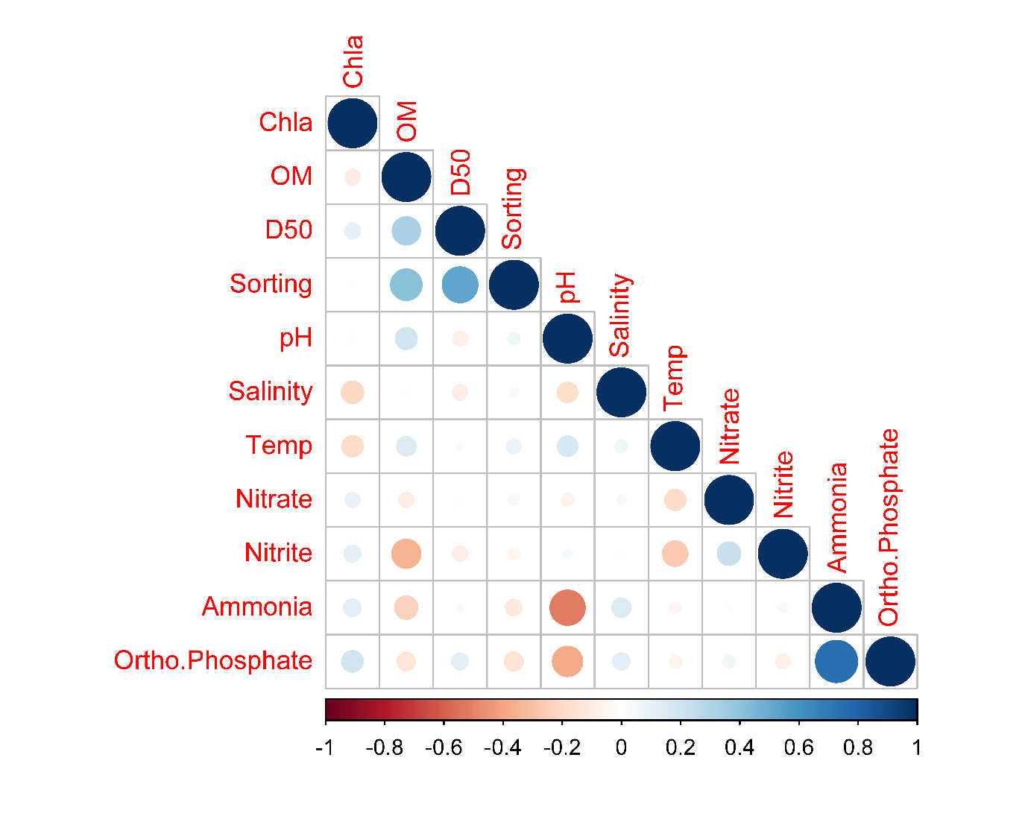 **Figure S1.** Spearman correlation plot for measuring collinearity among the environmental conditions recorded at the eight sites across the southern Australian coast. All environmental conditions were retained for the analyses performed. Chl *a*: chlorophyll *a*; OM: organic matter; DO: dissolved oxygen, Temp: Temperature.



**Figure S2.** Visual summary of PERMANOVA Pairwise test outcomes for taxa. Season: Blue= significant difference p<0.01; Grey= not significant difference p>0.01. Site x Season interaction: *= significant difference p<0.01 between seasons by site; s= significant difference p<0.01 in summer season; w= significant difference p<0.01 in winter season. LB: Long Beach; KB: Kellidie Bay; MB: Middle Beach; PPa: Port Parham; PG: Port Germein, FB: Fisherman Bay; PP: Pelican Point; N: Noonameena.



**Figure S3.** Visual summary of PERMANOVA Pairwise test outcomes for taxa. Season: Blue= significant difference p<0.01; Grey= not significant difference p>0.01. Site x Season interaction: *= significant difference p<0.01 between seasons by site; s= significant difference p<0.01 in summer season; w= significant difference p<0.01 in winter season. a) Number of taxa, b) Abundance (ind.m2), c) Shannon Index H’, d) Evenness Index J’. LB: Long Beach; KB: Kellidie Bay; MB: Middle Beach; PPa: Port Parham; PG: Port Germein, FB: Fisherman Bay; PP: Pelican Point; N: Noonameena.



**Figure S4.** Visual summary of PERMANOVA Pairwise test outcomes for traits. Season: Blue= significant difference p<0.01; Grey= not significant difference p>0.01. Site x Season interaction: *= significant difference p<0.01 between seasons by site; s= significant difference p<0.01 in summer season; w= significant difference p<0.01 in winter season. LB: Long Beach; KB: Kellidie Bay; MB: Middle Beach; PPa: Port Parham; PG: Port Germein, FB: Fisherman Bay; PP: Pelican Point; N: Noonameena.

1. Long Beach summer

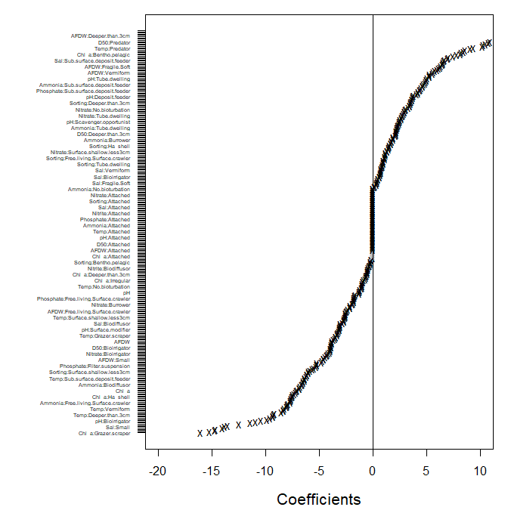

1. Long Beach winter

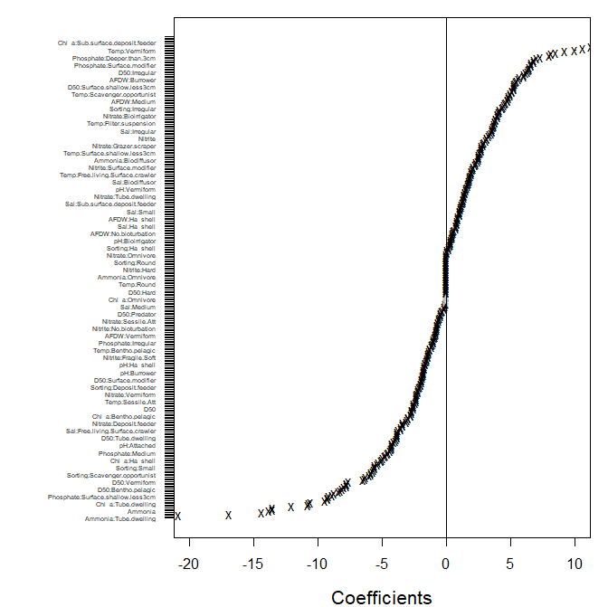

**Figure S5.** Estimated coefficients for predictors and their confidence intervals for the fourth corner interaction (taxa abundance, traits, and environmental conditions) using NB-GLLVM by site by season: a) Long Beach summer, b) Long Beach winter. Lines represented their 95% confidence interval, black dots denoted intervals not containing zeros (evidence of association between environmental conditions, traits, and taxa abundance), while grey dots denoted intervals containing zeros (no associations).

1. Kellidie Bay summer

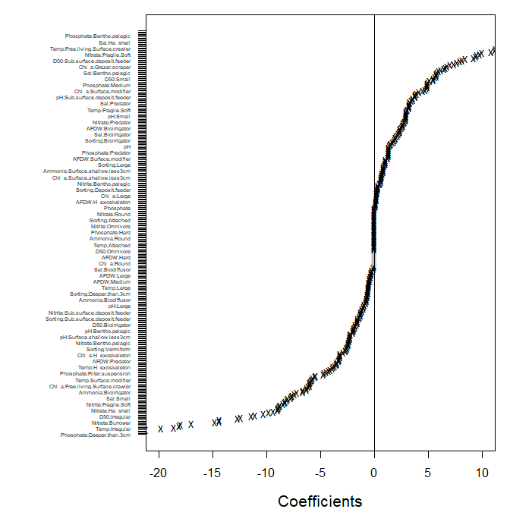

1. Kellidie Bay winter

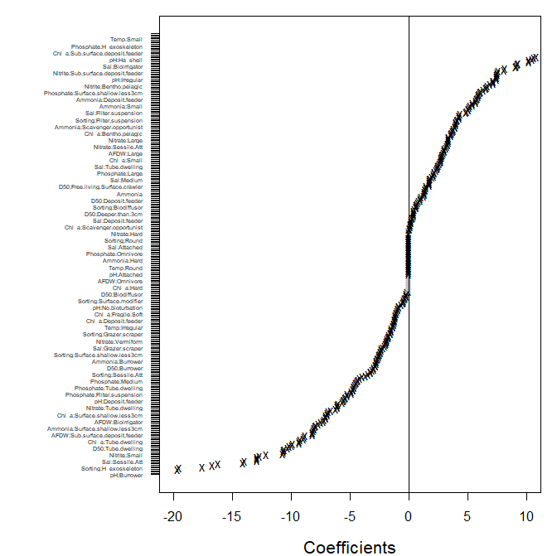

**Figure S6.** Estimated coefficients for predictors and their confidence intervals for the fourth corner interaction (taxa abundance, traits, and environmental conditions) using NB-GLLVM by site by season: a) Kellidie Bay summer, b) Kellidie Bay winter. Lines represented their 95% confidence interval, black dots denoted intervals not containing zeros (evidence of association between environmental conditions, traits, and taxa abundance), while grey dots denoted intervals containing zeros (no associations).

1. Port Germein summer

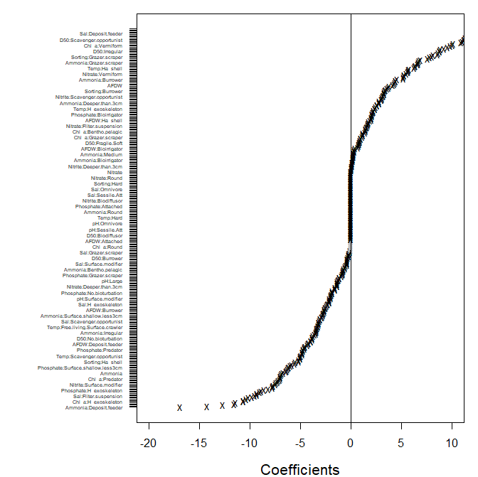

1. Port Germein winter

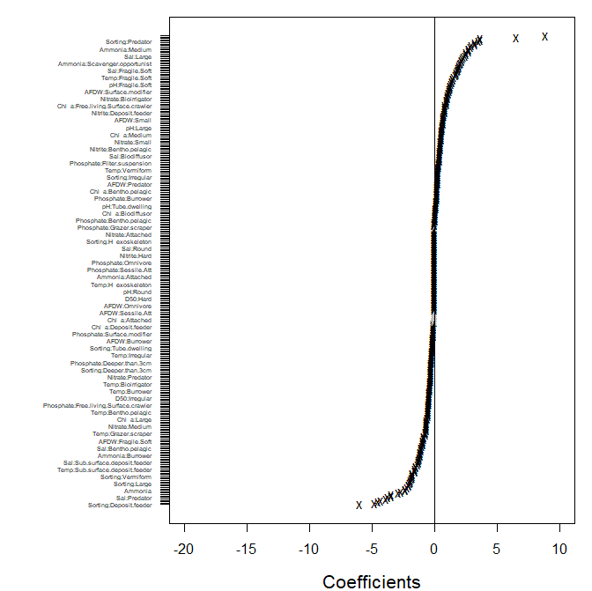

**Figure S7.** Estimated coefficients for predictors and their confidence intervals for the fourth corner interaction (taxa abundance, traits, and environmental conditions) using NB-GLLVM by site by season: a) Port Germein summer, b) Port Germein winter. Lines represented their 95% confidence interval, black dots denoted intervals not containing zeros (evidence of association between environmental conditions, traits, and taxa abundance), while grey dots denoted intervals containing zeros (no associations).

1. Fisherman Bay summer

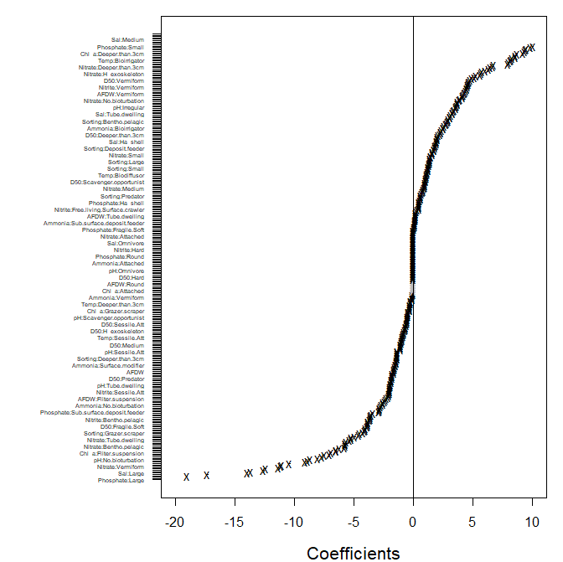

1. Fisherman Bay winter

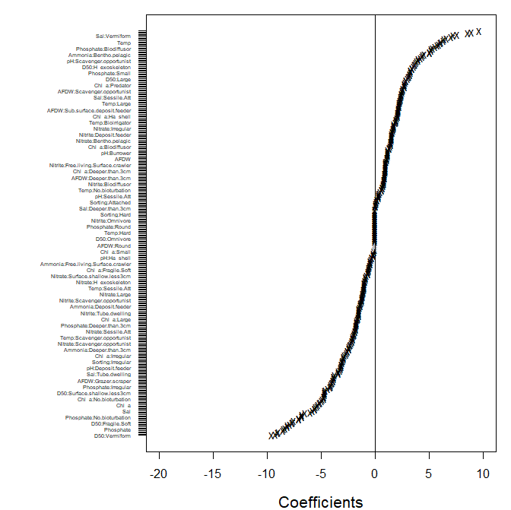

**Figure S8.** Estimated coefficients for predictors and their confidence intervals for the fourth corner interaction (taxa abundance, traits, and environmental conditions) using NB-GLLVM by site by season: a) Fisherman Bay summer, b) Fisherman Bay winter. Lines represented their 95% confidence interval, black dots denoted intervals not containing zeros (evidence of association between environmental conditions, traits, and taxa abundance), while grey dots denoted intervals containing zeros (no associations).

1. Port Parham summer

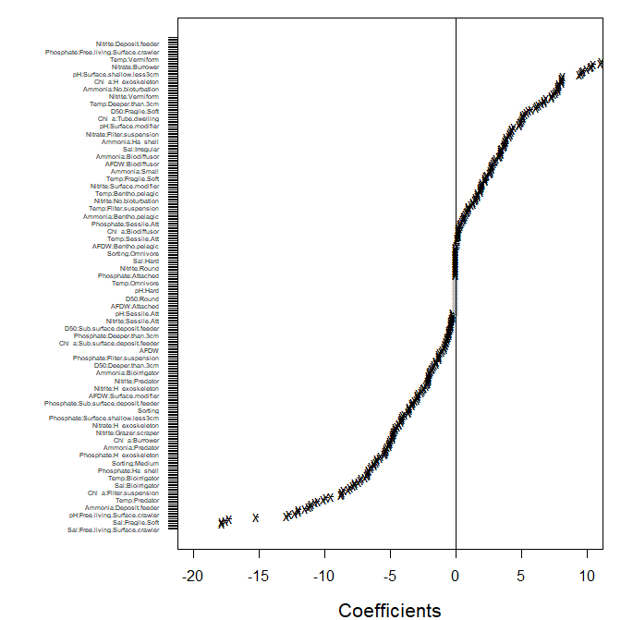

1. Port Parham winter

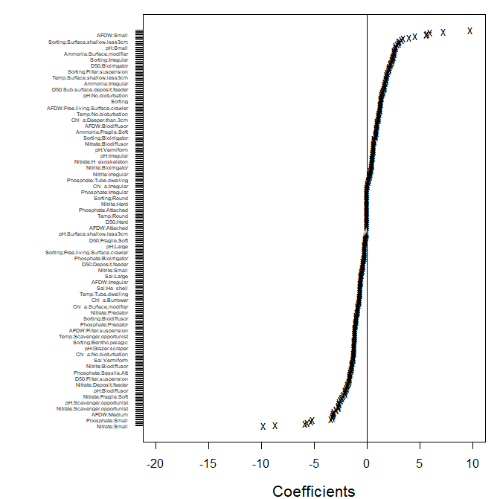

**Figure S9.** Estimated coefficients for predictors and their confidence intervals for the fourth corner interaction (taxa abundance, traits, and environmental conditions) using NB-GLLVM by site by season: a) Port Parham summer, b) Port Parham winter. Lines represented their 95% confidence interval, black dots denoted intervals not containing zeros (evidence of association between environmental conditions, traits, and taxa abundance), while grey dots denoted intervals containing zeros (no associations).

1. Middle Beach summer

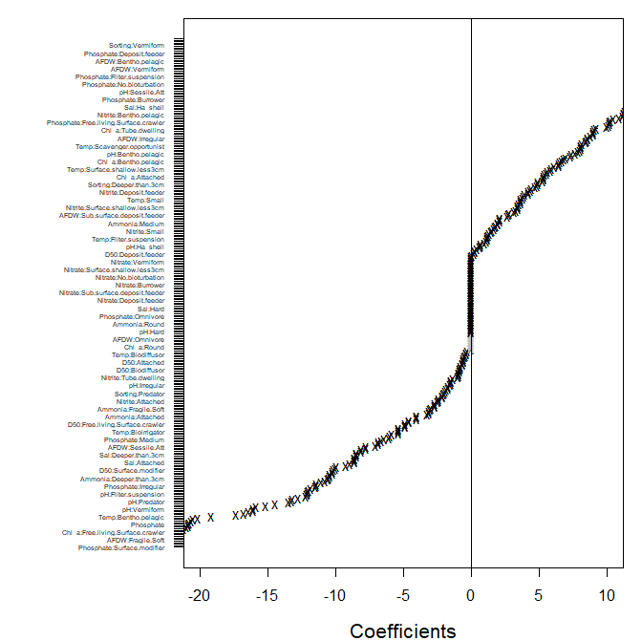

1. Middle Beach winter

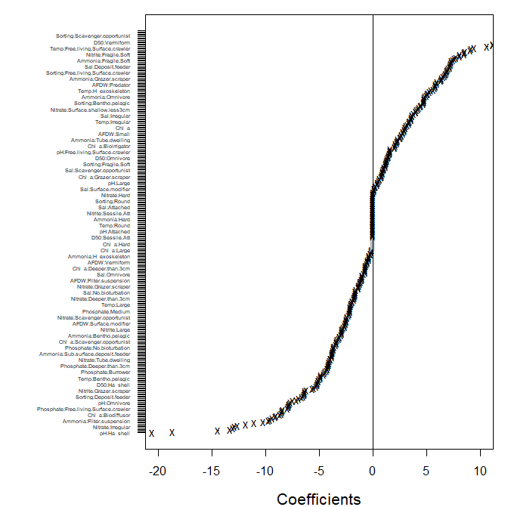

**Figure S10.** Estimated coefficients for predictors and their confidence intervals for the fourth corner interaction (taxa abundance, traits, and environmental conditions) using NB-GLLVM by site by season: a) Middle Beach summer, b) Middle Beach winter. Lines represented their 95% confidence interval, black dots denoted intervals not containing zeros (evidence of association between environmental conditions, traits, and taxa abundance), while grey dots denoted intervals containing zeros (no associations).

1. Pelican Point summer

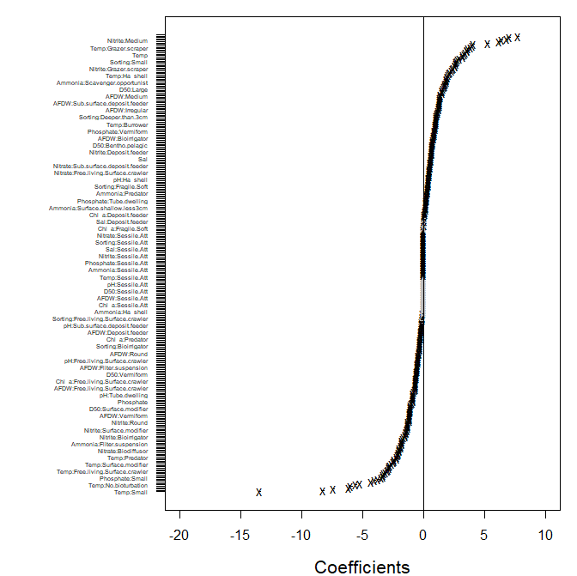

1. Pelican Point winter

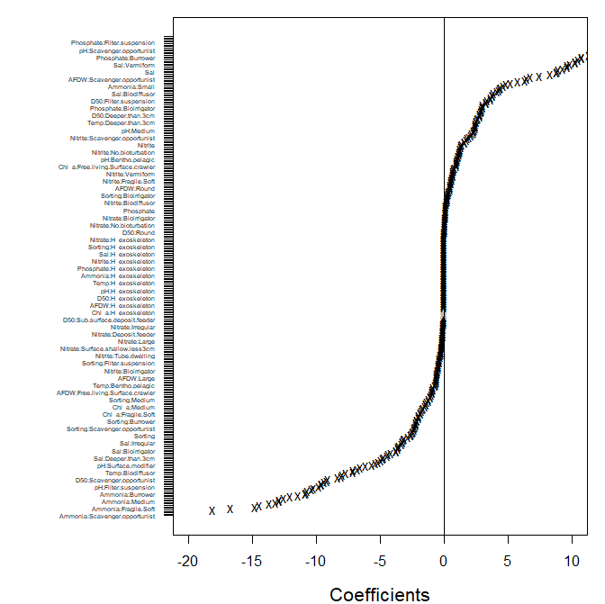

**Figure S11.** Estimated coefficients for predictors and their confidence intervals for the fourth corner interaction (taxa abundance, traits, and environmental conditions) using NB-GLLVM by site by season: a) Pelican Point summer, b) Pelican Point winter. Lines represented their 95% confidence interval, black dots denoted intervals not containing zeros (evidence of association between environmental conditions, traits, and taxa abundance), while grey dots denoted intervals containing zeros (no associations).

1. Noonameena summer

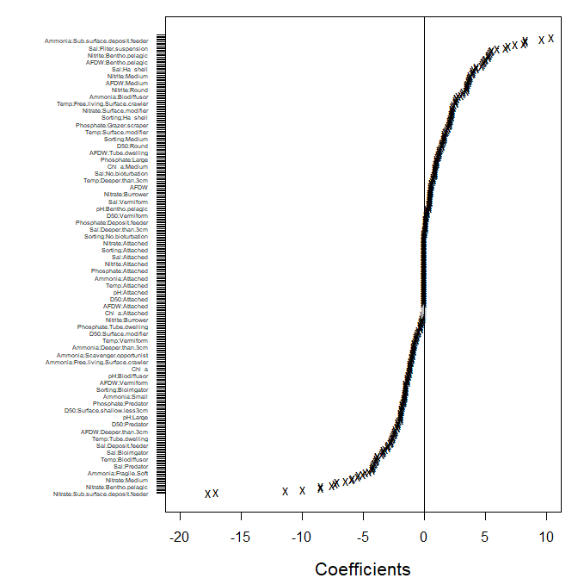

1. Noonameena winter

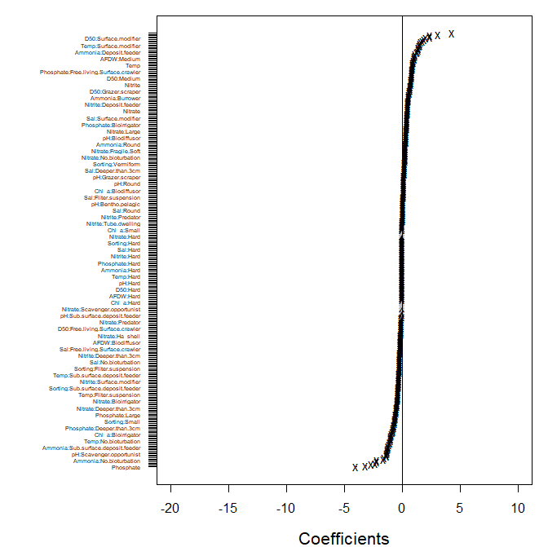

**Figure S12.** Estimated coefficients for predictors and their confidence intervals for the fourth corner interaction (taxa abundance, traits, and environmental conditions) using NB-GLLVM by site by season: a) Noonameena summer, b) Noonameena winter. Lines represented their 95% confidence interval, black dots denoted intervals not containing zeros (evidence of association between environmental conditions, traits, and taxa abundance), while grey dots denoted intervals containing zeros (no associations).