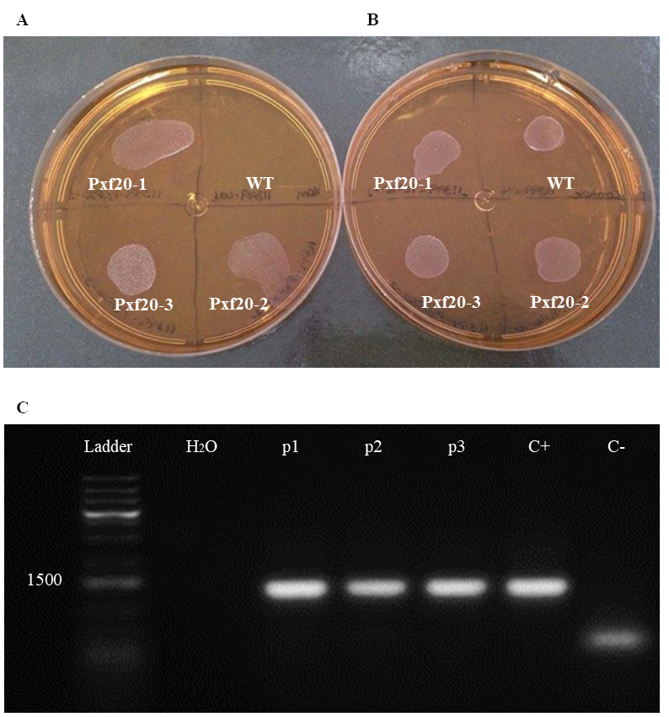
Figure S1. Selection and confirmation of X. fastidiosa transformed with the pXF20 empty vector. The obtained transformants were plated in PW containing kanamycin(A), and in PW without this antibiotic (control) (B). WT: wild-type (WT)X. fastidiosa strain 11399, used as negative control; pXF20-1 to -3: clones 1, 2 and 3 of the bacterium transformed with the pXF20 empty vector. (C)1% agarose gel of the PCR carried out with specific pairs of primers to detect the pXF20 empty vector inX. fastidiosa clones to confirm the transformation. The oriV and trfA ORFs of the pXF20 vector were amplified as a single amplicon. Ladder:GeneRuler 1 kb Plus DNA Ladder (Thermo Fisher Scientific, Waltham, Massachusetts, United States); H₂O: non-template control PCR (negative control); p1, p2 and p3: PCRs carried out with the clones pXF20-1, pXF20-2 and pXF20-3, respectively; C+: PCR carried out with purified pXF20 vector (positive control); C-: PCR carried out with the WT strain 11399, which does not contain the pXF20 vector (negative control); Amplicon size: 1194 bp. Amplification of the specific amplicon only in the positive control and tested clones confirmed the transformation of X. fastidiosa strain 11399 with the pXF20 empty vector.

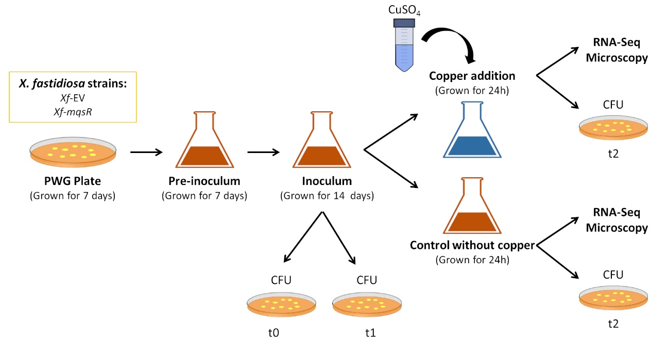
Figure S2. Experimental conditionsforX. fastidiosastrains under copper-induced stress. All bacteria were grown in PWG plate for 7 days. After, to prepare the pre-inoculum,cells were collected and grown in PW broth for 7 days. The inoculum was prepared by adding the pre-inoculum into 90 mL of PW to an initial OD₆₀₀ of 0.1 (t0) and incubating under shaking for 14 days (t1). Samples were treated with 3 mM CuSO₄ and allowed to grow for additional 24 hours under copper stress (t2). The non-copper control samples of both strains were grown in pure PW broth. Aliquots of the entire experimental condition described above were collected to determine the CFU.mL⁻¹ of each biological experiment at the following time course: inoculation time (t0), 14 days after growth in fresh PW broth when CuSO₄ was added (t1) and 24 hours after copper sulfate treatment (t2), completing 15 days of growthl. From each sample a 10-fold serial dilution was performed and plated in PWG to estimate CFU. Four replicates were used for each sample, which were grown at 28 °C for 30 days.

Figure S3. Reads of RNA-Seq. C-0: Xf-EV cells without copper treatment; C-3: Xf-EV cells treated with 3 mM CuSO4. M-0: Xf-mqsR cells without copper treatment. M-3: Xf-mqsR cells treated with 3mM CuSO4.This graphic represents average of each treatment in triplicate.
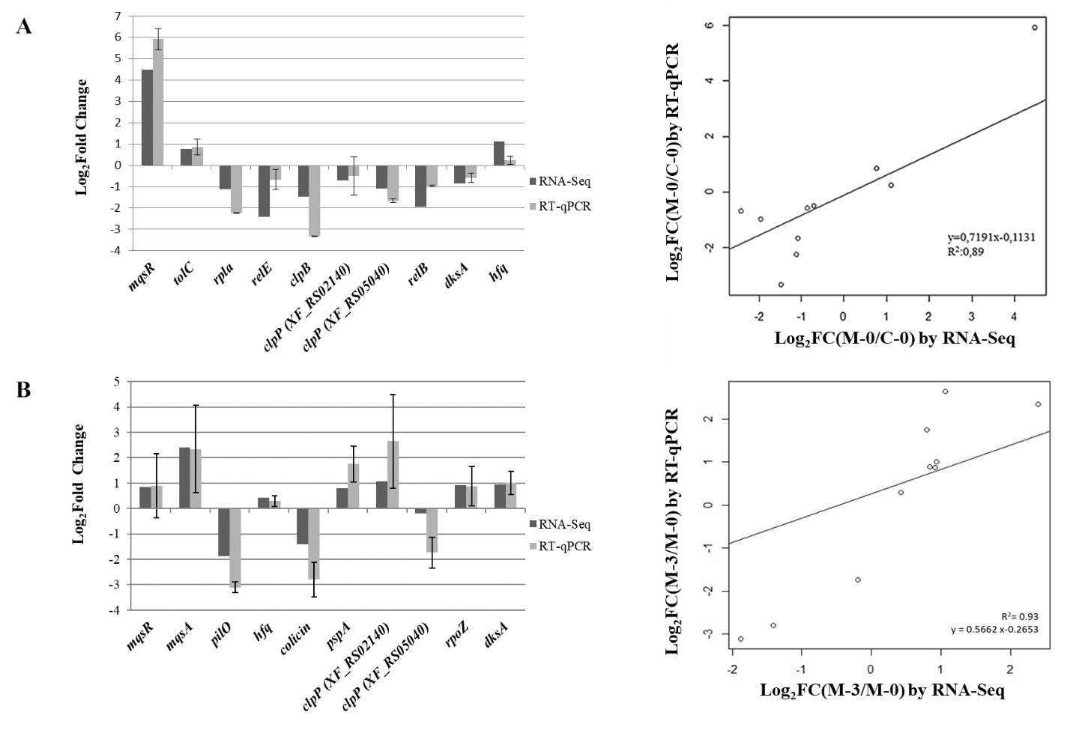
Figure S4. Validation RNA-Seq data. (A) RNA-Seq validation using RT-qPCR of the pairwise comparison of the M-0/C-0 libraries and correlation of the RT-qPCR and RNA-Seq data of the M-0/C-0 libraries. (B) RNA-Seq validation using RT-qPCR of the pairwise comparison of the M-3/M-0 libraries and correlation of the RT-qPCR and RNA-Seq data of the M-3/M-0 libraries. Log₂ Fold Change of RT-qPCR data was plotted against Log₂ Fold Change of RNA-Seq data for 10 genes. The equation of the line and the Pearson correlation coefficient (R²) are shown. Bars indicate standard errors. Mean of 3 biological replicates for experiments with RT-qPCR and RNA-Seq. Log₂ Fold Change (Log₂FC) values lower than 0 indicate downregulation of genes, whereas values greater than 0 indicate upregulation of genes.

