Supplementary Material

Supplementary Tables
Table S1. Histological evaluation of kidney biopsies according to Banff 2019 classification
Histological scores  (0/1/2/3) | ATN | aABMR | P | Normal | caABMR | P
C4d | 11/0/0/0 | 1/0/1/8 | <0.001 | 12/0/0/0 | 3/4/1/1* | 0.004
Glomerulitis (g) | 11/0/0/0 | 4/4/1/0* | 0.008 | 12/0/0/0 | 1/5/3/1 | <0.001
Peritubular capillaritis score (ptc-s) | 11/0/0/0 | 7/2/0/0* | 0.099 | 12/0/0/0 | 2/1/4/0† | 0.001
Peritubular capillaritis quality (ptc-q) | 11/0/0/0 | 7/2/0/0* | 0.099 | 12/0/0/0 | 2/0/5/0† | <0.001
Peritubular capillaritis extent (ptc-e) | 11/0/0/0 | 7/2/0/0* | 0.099 | 12/0/0/0 | 2/2/3/0† | 0.001
Glomerular capillaries double contours (cg) | 11/0/0/0 | 9/0/0/0* | 1.000 | 12/0/0/0 | 0/1/5/4 | <0.001
Mesangial matrix increase (mm) | 11/0/0/0 | 9/0/0/0* | 1.000 | 12/0/0/0 | 1/5/3/1 | <0.001
Arteritis (v) | 10/0/0/0 | 8/1/0/0* | 0.279 | 12/0/0/0 | 7/2/0/0* | 0.086
Interstitial inflammation (i) | 11/0/0/0 | 9/0/0/0* | 1.000 | 12/0/0/0 | 8/0/0/0‡ | 1.000
Tubulitis (t) | 11/0/0/0 | 9/0/0/0* | 1.000 | 12/0/0/0 | 8/0/0/0‡ | 1.000
Interstitial inflammation in total parenchyma (ti) | 11/0/0/0 | 7/2/0/0* | 0.099 | 11/1/0/0 | 1/3/2/2‡ | <0.001
Fibrous intimal thickening (cv) | 0/3/3/4 | 0/5/2/2* | 0.268 | 2/5/4/1 | 0/2/4/3* | 0.048
Arteriolar hyaline thickening (ah) | 1/7/1/2 | 1/3/4/1* | 0.621 | 1/5/4/2 | 0/2/1/7 | 0.025
Alternate arteriolar hyaline thickening (aah) | 7/4/0/0 | 7/1/0/1* | 0.807 | 7/4/0/1 | 2/0/1/4† | 0.017
Interstitial fibrosis (ci) | 0/10/1/0 | 2/7/0/0* | 0.070 | 2/10/0/0 | 0/1/6/1‡ | <0.001
Tubular atrophy (ct) | 0/10/1/0 | 2/7/0/0* | 0.070 | 2/10/0/0 | 0/1/6/1‡ | <0.001
Pearson’s chi-squared test.
* data from 1 sample was not available
† data from 3 samples were not available
‡ data from 2 samples were not available

Table S2. Genes evaluated by RT-qPCR.
Gene | Coding protein | Main source.  Significance | Assay ID
IFNG (Interferon-gamma) | IFNG | NK-cells, T-cells.  TCMR-associated (1) | Hs00989291_m1
GNLY (Granulysin) | GNLY | NK-cells, T-cells.  DSA selective, ABMR-associated (2) | Hs01120727_m1
CD14 (Monocyte Differentiation Antigen CD14) | CD14 | Mon, MC.  ABMR-associated (3) | Hs00169122_g1
SH2D1B (SH2 Domain-Containing Protein 1B) | SH2D1B | NK-cells, T-cells.  DSA selective, ABMR-selective (4) | Hs01592483_m1
CX3CR1 (C-X3-C Motif Chemokine Receptor 1) | CX3CR1 | NK-cells, Mon, MC.  DSA selective, ABMR-selective (2) | Hs00365842_m1
IGHG1 (Immunoglobulin IgG1 Heavy Chain Constant Region) | IGHG1 | B-cells, plasma-cells.  ABMR-associated (5) | Hs00378340_m1
IRF4 (Interferon Regulatory Factor 4) | IRF4 | B-cells, T-cells, Mon, MC  ABMR-associated (5) | Hs00180031_m1
TNFRSF17 (TNF Receptor Superfamily Member 17) | TNFRSF17 | B-cells, plasma-cells.  ABMR-associated (5) | Hs03045080_m1
MS4A1 (Membrane Spanning 4-Domains A1) | CD20 | B-cells.  ABMR-associated (6) | Hs00174849_m1
TGFB1 (Transforming Growth Factor b1) | TGFB1 | Ubiquitous.  rejection-associated (7) | Hs00998133_m1
C5 (Complement Component C5) | C5 | Mon, MC, DC, EC, fibroblasts, muscle cells.  ABMR-associated (8) | Hs01004342_m1
CD46 (Membrane Cofactor Protein) | CD46 (MCP) | Ubiquitous.  Complement regulation.  ABMR-associated (9) | Hs00611257_m1
CXCL10 (C-X-C Motif Chemokine Ligand 10) | CXCL10 | Leukocytes, TEC, EC, fibroblasts.  IFNG-inducible, AMBR and rejection associated (10) | Hs00171042_m1
HAVCR1 (Hepatitis A Virus Cellular Receptor 1) | KIM1 (Kidney injury molecule 1) | TEC.  Acute Kidney Injury-associated (11) | Hs00273334_m1
Controls
NPHS2 (NPHS2 Stomatin Family Member) | Podocin | podocytes | Hs00387817_m1
GAPDH (Glyceraldehyde-3-Phosphate Dehydrogenase) | GAPDH | ubiquitous | Hs99999905_m1
Abbreviations: ABMR: antibody-mediated rejection, DC: dendritic cells, DSA: donor-specific antibodies, EC: endothelial cells, Mon: monocytes, MC: macrophages, TEC: tubular epithelial cells.

1. Venner, J. M., Hidalgo, L. G., Famulski, K. S., Chang, J., Halloran, P. F. (2015). The molecular landscape of antibody-mediated kidney transplant rejection: evidence for NK involvement through CD16a Fc receptors. Am J Transplant. 15, 1336-1348.
2. Sellares, J., Reeve, J., Loupy, A., Mengel, M., Sis, B., Skene, A., et al. (2013). Molecular diagnosis of antibody-mediated rejection in human kidney transplants. Am J Transplant. 13, 971-983.
3. Magil, A. B. (2009). Monocytes/macrophages in renal allograft rejection. Transplant Rev (Orlando). 23, 199-208.
4. Hidalgo, L. G., Sis, B., Sellares, J., Campbell, P. M., Mengel, M., Einecke, G., et al. (2010). NK cell transcripts and NK cells in kidney biopsies from patients with donor-specific antibodies: evidence for NK cell involvement in antibody-mediated rejection. Am J Transplant. 10, 1812-1822.
5. Einecke, G., Reeve, J., Mengel, M., Sis, B., Bunnag, S., Mueller, T. F., et al. (2008). Expression of B cell and immunoglobulin transcripts is a feature of inflammation in late allografts. Am J Transplant. 8, 1434-1443.
6. Heidt, S., Vergunst, M., Anholts, J. D. H., Swings, G., Gielis, E. M. J., Groeneweg, K. E., et al. (2019). Presence of intragraft B cells during acute renal allograft rejection is accompanied by changes in peripheral blood B cell subsets. Clin Exp Immunol. 196, 403-414.
7. Elster, E. A., Hawksworth, J. S., Cheng, O., Leeser, D. B., Ring, M., Tadaki, D. K., et al. (2010). Probabilistic (Bayesian) modeling of gene expression in transplant glomerulopathy. J Mol Diagn. 12, 653-663.
8. Reis, E. S., Barbuto, J. A., Isaac, L. (2006). Human monocyte-derived dendritic cells are a source of several complement proteins. Inflamm Res. 55, 179-184.
9. Hruba, P., Krejcik, Z., Stranecky, V., Maluskova, J., Slatinska, J., Gueler, F., et al. (2019). Molecular Patterns Discriminate Accommodation and Subclinical Antibody-mediated Rejection in Kidney Transplantation. Transplantation. 103, 909-917.
10. Halloran, P. F., Venner, J. M., Madill-Thomsen, K. S., Einecke, G., Parkes, M. D., Hidalgo, L. G., et al. (2018). Review: The transcripts associated with organ allograft rejection. Am J Transplant. 18, 785-795.
11. Famulski, K. S., de Freitas, D. G., Kreepala, C., Chang, J., Sellares, J., Sis, B., et al. (2012). Molecular phenotypes of acute kidney injury in kidney transplants. J Am Soc Nephrol. 23, 948-958.

Table S3. Correlation of transcript expression with selected histological scores
 |  | Glomerulitis (g) | Peritubular capillaritis score (ptc-s) | Microvascular inflammation (MVI) | Glomerular capillaries double contours (cg) | Interstitial inflammation in total parenchyma (ti) | Interstitial fibrosis (ci)
IFNG | glomeruli | ** | ** | *** | * | NS | NS
 | TI | * | NS | ** | ** | *** | NS
GNLY | glomeruli | ** | *** | ** | ** | NS | NS
 | TI | ** | *** | *** | ** | ** | NS
CD14 | glomeruli | * | NS | NS | *** | NS | *
 | TI | NS | NS | NS | ** | * | NS
SH2D1B | glomeruli | NS | NS | NS | NS | NS | NS
 | TI | ** | *** | ** | *** | * | *
CX3CR1 | glomeruli | * | *** | * | * | NS | NS
 | TI | ** | *** | ** | *** | *** | NS
IGHG1 | glomeruli | - | - | - | - | - | NS
 | TI | * | NS | NS | ** | NS | NS
IRF4 | glomeruli | NS | * | * | NS | NS | NS
 | TI | *** | ** | *** | *** | *** | *
MS4A1 | glomeruli | NS | NS | NS | NS | NS | NS
 | TI | NS | NS | NS | * | ** | NS
TGFB1 | glomeruli | *** | NS | ** | ** | * | NS
 | TI | ** | ** | ** | *** | *** | NS
C5 | glomeruli | NS | NS | NS | NS | NS | NS
 | TI | NS | NS | NS | * | * | NS
CD46 | glomeruli | NS | NS | NS | NS | NS | NS
 | TI | NS | NS | NS | NS | NS | NS
CXCL10 | glomeruli | ** | ** | *** | ** | * | NS
 | TI | * | *** | * | * | NS | NS
Spearman’s rank correlation test.
* P < 0.05
** P < 0.01
*** P < 0.001
NS not significant

Supplementary Figures
Supplementary Figure S1. The expression of glomeruli-specific podocin (NPSH2) transcript in glomeruli and tubulointerstitium as a control of sampling accuracy.

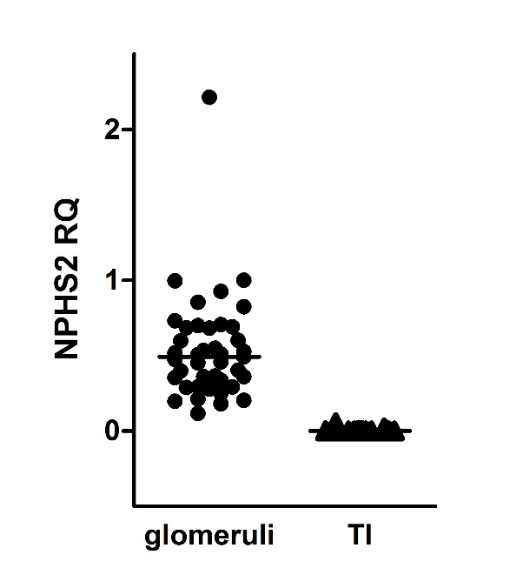
Supplementary Figure S2. Differences in gene expression (log2 FC) between acute tubular necrosis (ATN) and active ABMR (aABMR), normal 3M protocol biopsies (3M normal) and chronic active ABMR (caABMR) and aABMR and caABMR in glomeruli (dark marks) and tubulointerstitium (empty marks). Genes up-regulated in ABMR in glomeruli or both glomeruli and tubulointerstitium (A). Genes up-regulated in ABMR in tubulointerstitium (B).
Differences are calculated by Mann-Whitney test.
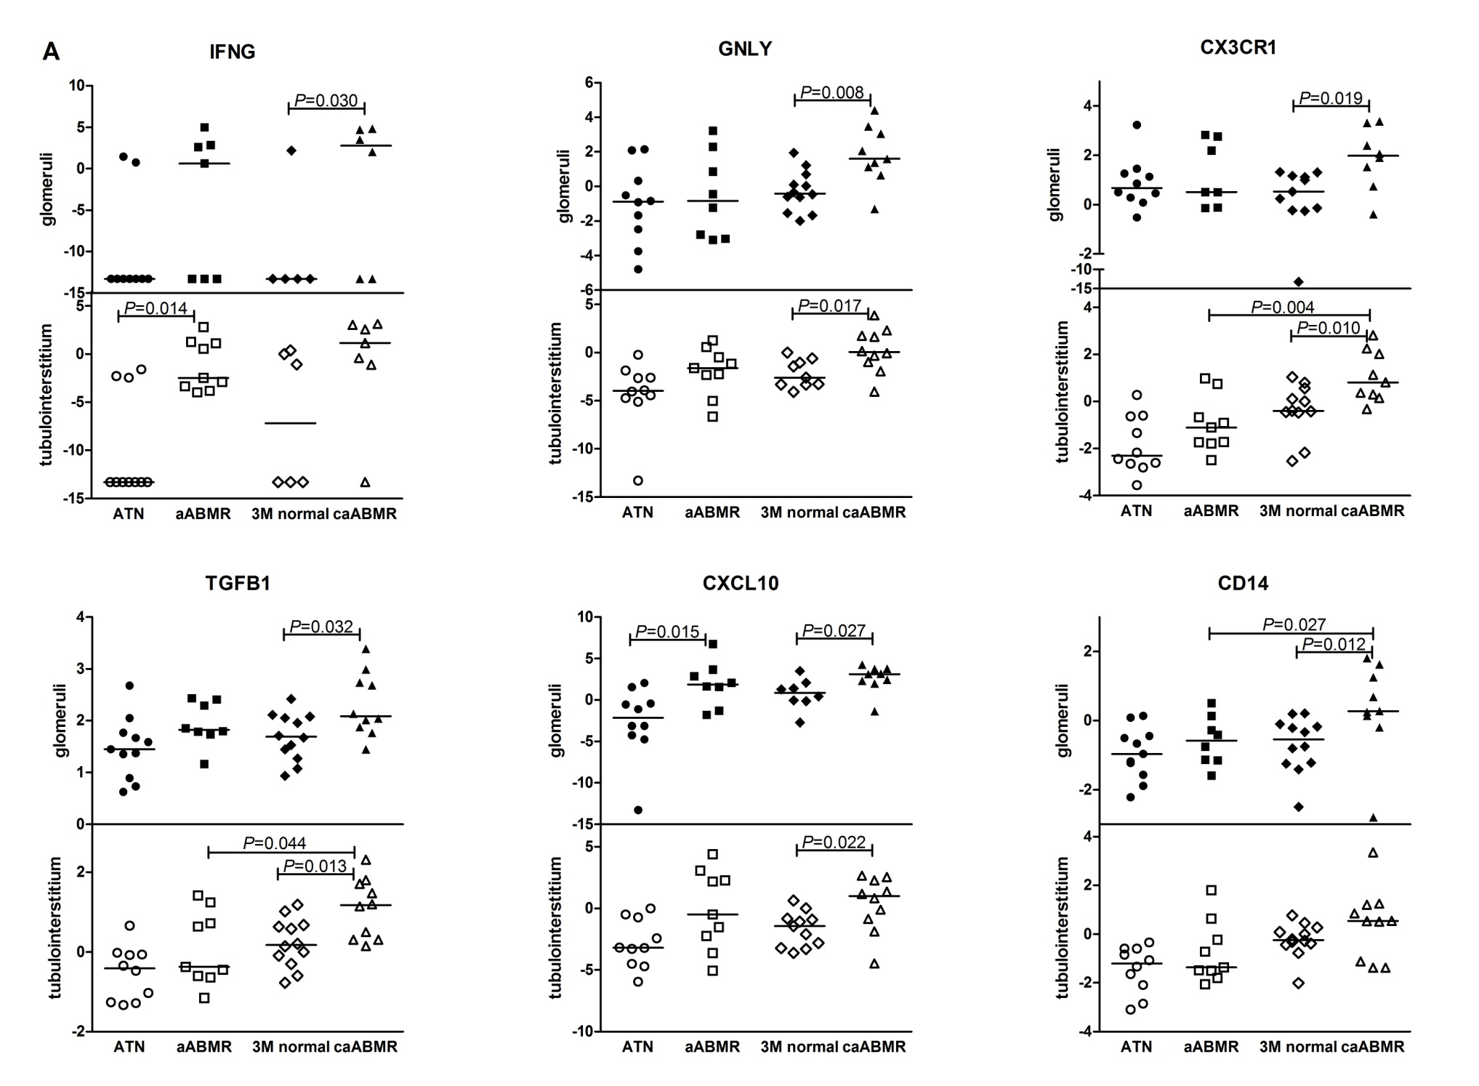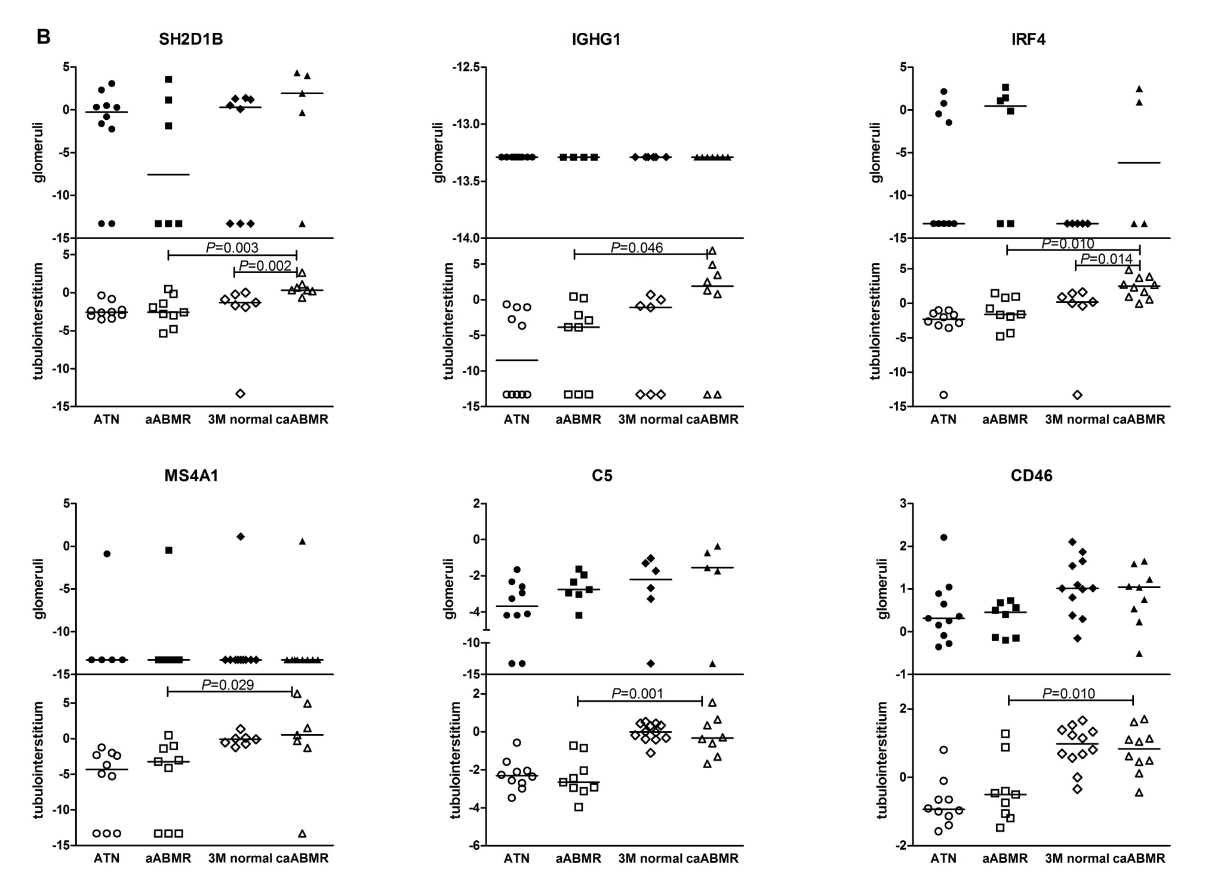
Supplementary Figure S3. Differences in gene expression (log2 FC) between glomeruli (G, dark bars) and tubulointerstitium (TI, empty bars) in the groups with: A) acute tubular necrosis (ATN, n=11), and B) normal 3M protocol biopsies (3M normal, n=12). Boxes extends from the 25th to 75th percentiles, lines in the middle of the box shows median and whiskers indicate the highest and lowest value within inner fences (Tukey whiskers).
Differences are calculated by Mann-Whitney test.
