**3D Printed PEI Containing Adsorbents Supported by Carbon Nanostructures for Post-combustion Carbon Capture from biomass fired power plants**

Shreenath Krishnamurthy1*, Richard Blom1, Kari Anne Andreassen1, Vesna Middelkoop2, Marleen Rombouts2 and Adolfo Benedito Borras3.

1. Process Technology, SINTEF Industry, Oslo 0373, Norway
2. Vlaamse Instelling voor Technologisch Onderzoek (VITO), Mol, 2400, Belgium
3. AIMPLAS Technological Institute of Plastics, 46980, Valencia, Spain

**1D adsorption model**

A non-isothermal, non-isobaric model based on the following assumptions is used:

1. Axial dispersion is considered
2. No radial temperature or concentration gradients
3. Ideal gas law is valid
4. The adsorbent properties are uniform throughout the column
5. Uniform porosity throughout the column

The model equations are a set of coupled partial differential equations, which are given below.

Component mass balance:

 (1)

By applying ideal gas law  equation (1) becomes

 (2)

The overall mass balance equation is given by

 (3)

As mentioned earlier, the mass transfer between the gas and the solid phases was described by linear driving force approximation which is of the following form:

 (4)

where, *ki* is the mass transfer coefficient and *qi*\* is the equilibrium solid phase concentration

The linear driving force approximation is given by

 (5)

Nitrogen value was taken to be 10. The equilibrium solid concentration is defined by a dual site Langmuir model

 (6)

The column energy balance and the wall temperature balance equations are as follows:

 (7)

 (8)

The pressure drop across the column was described by the following equation for a monolith with square channels (Patton et al., 2004).

 (9)

Rearranging Equation (9) gives the local velocity

 (10)

The model equations were converted into their corresponding dimensionless form by using the following dimensionless variables:



Component mass balance:

 (11)

Total mass balance:

 (12)

Mass transfer rate equation:

 (13)

Energy balance:

 (14)

Wall temperature balance:

 (15)

Frictional pressure drop

 (16)

 (17)

The dimensionless groups in Equations (11) -(17) are given in Table 1. Each of the equations requires appropriate initial and boundary conditions, which are given in Table 2. The initial conditions of each step are the final conditions of the previous step

Table 1: Dimensionless groups in the model equations.

|  |
| --- |
|  |

Table 2: Boundary conditions for a 6-step VSA process.

|  |  |  |
| --- | --- | --- |
| **Step** | **Inlet BCs** | **Outlet BCs** |
| **Adsorption** |  |  |
| **Co-current evacuation** |  |  |
| **Counter current-Evacuation** |  |  |
| **Light product pressurization** |  |  |
| **Rinse** |  |  |
| **Light Reflux/purge** |  |  |

Correlations used to calculate parameters

Specific heat capacity of gas mixtures

 (18)

Axial dispersion

 (19)

Dmol is the molecular diffusivity, dP is the pellet diameter and v0 is the interstitial velocity

Molecular diffusion

 (20)

Kundsen diffusion corrected by Derjaguin correction factor

 (21)

rpore is the macropore radii and T and M are temperature in K and molecular weight of the gas.

Axial thermal conductivity

 (22)

kg is the thermal conductivity of the gas mixture Pr number taken 0.7 for gases.

Energy consumed by vacuum pump

 (23)

Efficiency, η =0.72

Energy consumed by compressor

 (24)

Modelling of the thermocouple response

The response of the thermocouple was modelled according to the following relationship (Skogestad, 2008) description for the breakthrough experiments

 (25)

T is the temperature of the surroundings which in this case is the packed bed. hc is the heat transfer co-efficient calaculated from Nusselt number.  are the density and specific heat capacity of the thermocouple, respectively. For the breakthrough experiments the residual between the experimental temperature and TC is minimized.

The properties of the thermcouple are provided in Table 3

**Table 3: Thermocouple properties**

|  |  |
| --- | --- |
| Property | Value |
| ρc (Kg/m3) | 8900 |
| CPC (J/kg K) | 440 |
| Rc (mm) | 0.5 |
| Nusselt number | 0.1 |

Tables 4 and 5 showthe raw data for CO2 and H2O isotherms in the 3D printed sorbent

**Figure 1: Adsorption desorption curves of N2 at 77K**

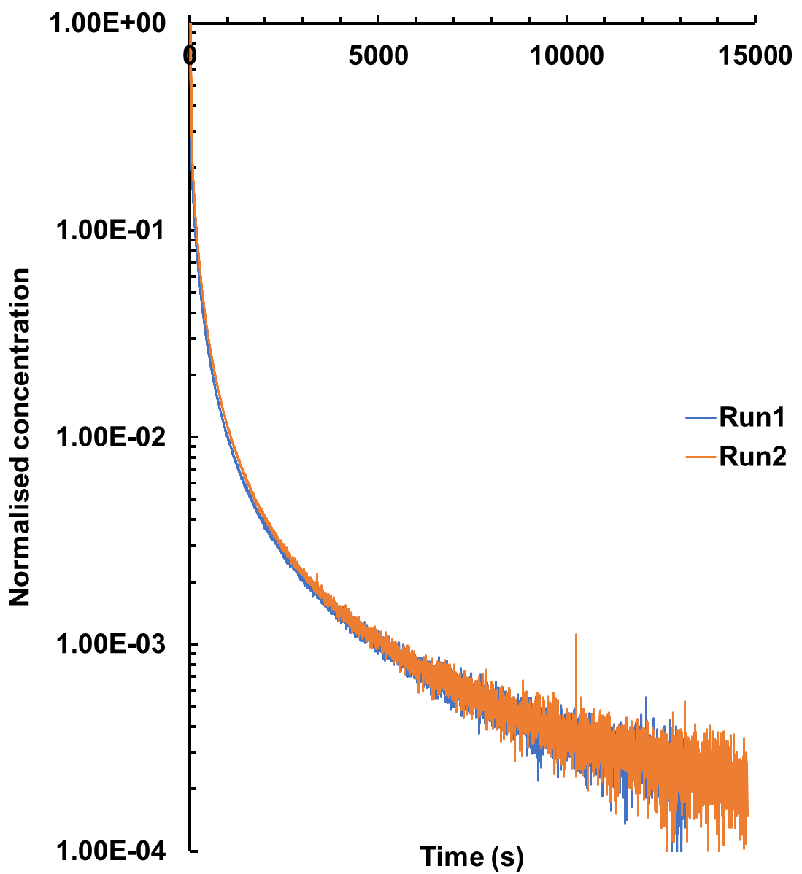

**Figure 2: Reproducible desorption curves for 10% CO2-N2 mixture at 70°C**

**Table 4: CO2 isotherm data from volumetry**

|  |  |  |  |  |  |  |  |
| --- | --- | --- | --- | --- | --- | --- | --- |
| 70°C |  | 80°C |  | 90°C |  | 100°C |  |
| C (mol/m3) | q(mol/kg) | C (mol/m3) | q(mol/kg) | C (mol/m3) | q(mol/kg) | C (mol/m3) | q(mol/kg) |
| 0.015 | 0.031 | 0.017 | 0.026 | 0.011 | 0.016 | 0.067 | 0.019 |
| 0.107 | 0.085 | 0.136 | 0.073 | 0.150 | 0.055 | 0.281 | 0.037 |
| 0.239 | 0.130 | 0.302 | 0.109 | 0.347 | 0.079 | 0.498 | 0.054 |
| 0.391 | 0.168 | 0.477 | 0.140 | 0.780 | 0.125 | 0.975 | 0.083 |
| 0.763 | 0.227 | 0.807 | 0.183 | 1.147 | 0.159 | 1.458 | 0.110 |
| 1.171 | 0.270 | 1.164 | 0.220 | 1.496 | 0.186 | 1.930 | 0.139 |
| 1.558 | 0.302 | 1.525 | 0.251 | 1.986 | 0.216 | 2.289 | 0.158 |
| 1.934 | 0.327 | 1.886 | 0.275 | 2.485 | 0.244 | 2.767 | 0.179 |
| 2.458 | 0.353 | 2.378 | 0.305 | 2.999 | 0.268 | 3.245 | 0.200 |
| 2.999 | 0.374 | 2.764 | 0.322 | 3.500 | 0.289 | 5.049 | 0.260 |
| 3.539 | 0.391 | 3.252 | 0.345 | 5.218 | 0.342 | 6.882 | 0.302 |
| 5.561 | 0.428 | 3.780 | 0.363 | 7.060 | 0.386 | 8.477 | 0.338 |
| 7.374 | 0.448 | 5.397 | 0.405 | 8.758 | 0.416 | 10.100 | 0.366 |
| 9.284 | 0.464 | 7.228 | 0.440 | 10.402 | 0.442 | 12.096 | 0.397 |
| 11.060 | 0.478 | 8.959 | 0.466 | 12.462 | 0.468 | 13.725 | 0.418 |
| 13.232 | 0.491 | 10.727 | 0.486 | 14.151 | 0.487 | 15.377 | 0.439 |
| 15.014 | 0.499 | 12.800 | 0.505 | 15.755 | 0.503 | 16.987 | 0.456 |
| 16.738 | 0.507 | 14.518 | 0.519 | 17.405 | 0.518 | 18.595 | 0.471 |
| 18.471 | 0.513 | 16.250 | 0.534 | 19.088 | 0.534 | 20.183 | 0.487 |
| 20.209 | 0.519 | 17.916 | 0.545 | 20.728 | 0.547 | 21.805 | 0.502 |
| 21.954 | 0.526 | 19.606 | 0.555 | 22.402 | 0.557 | 23.412 | 0.514 |
| 23.709 | 0.531 | 21.303 | 0.563 | 24.061 | 0.570 | 25.036 | 0.527 |
| 25.468 | 0.539 | 23.021 | 0.572 | 25.712 | 0.580 | 26.631 | 0.539 |
| 27.210 | 0.544 | 24.719 | 0.580 | 27.354 | 0.591 | 28.253 | 0.550 |
| 28.965 | 0.549 | 26.410 | 0.588 | 29.012 | 0.601 | 29.866 | 0.562 |
| 30.716 | 0.555 | 28.120 | 0.594 | 30.686 | 0.611 | 31.479 | 0.572 |
| 32.499 | 0.561 | 29.848 | 0.600 | 32.354 | 0.620 |  |  |
| 34.236 | 0.566 | 31.546 | 0.608 |  |  |  |  |
|  |  | 33.253 | 0.614 |  |  |  |  |

**Table 5: H2O adsorption data from volumetric experiments**

|  |  |  |  |  |  |
| --- | --- | --- | --- | --- | --- |
| **70°C** | | **80°C** | | **90°C** | |
| C(mol/m3) | q(mol/kg) | C(mol/m3) | q(mol/kg) | C(mol/m3) | q(mol/kg) |
| 0.034 | 0.116 | 0.046 | 0.114 | 0.060 | 0.103 |
| 0.073 | 0.220 | 0.130 | 0.229 | 0.111 | 0.159 |
| 0.137 | 0.329 | 0.272 | 0.350 | 0.250 | 0.274 |
| 0.248 | 0.456 | 0.406 | 0.460 | 0.396 | 0.377 |
| 0.380 | 0.579 | 0.463 | 0.514 | 0.466 | 0.424 |
| 0.449 | 0.643 | 0.693 | 0.691 | 0.694 | 0.564 |
| 0.659 | 0.854 | 0.884 | 0.841 | 0.888 | 0.689 |
| 0.717 | 0.921 | 1.053 | 0.989 | 0.995 | 0.766 |
| 0.865 | 1.095 | 1.173 | 1.105 | 1.141 | 0.875 |
| 0.913 | 1.155 | 1.217 | 1.150 | 1.193 | 0.916 |
| 1.060 | 1.315 | 1.302 | 1.248 | 1.266 | 0.975 |
| 1.169 | 1.450 | 1.381 | 1.349 | 1.365 | 1.072 |
| 1.234 | 1.560 | 1.416 | 1.409 | 1.376 | 1.086 |
| 1.305 | 1.681 |  |  |  |  |
| 1.333 | 1.747 |  |  |  |  |
| 1.344 | 1.846 |  |  |  |  |

References:

Patton, A., Critteden, B.D., Perera, S.P.,use of the linear driving force approximation to Guide the design of monolithic adsorbents, Trans IChemE, Part A, August 2004

[Skogestad, Sigurd](https://www.akademika.no/product/person/Skogestad%2C%20Sigurd), Chemical and Energy Process Engineering**,** 2008, CRC press