Supplementary Material
1. Supplementary Figures
1.1 Supplementary Figure 1
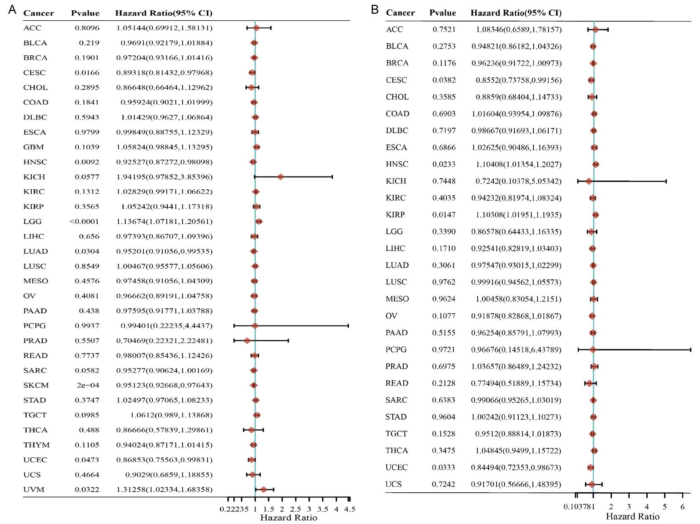
Supplementary FIGURE 1 ⎜ Association between the SNX20 expression and the DSS and PFS of cancer patients. (A) A forest plot of hazard ratios shown that the DSS of SNX20 in 33 types of tumors. (B) A forest plot of hazard ratios shown that the PFS of SNX20 in 33 types of tumors.
1.2 Supplementary Figure 2
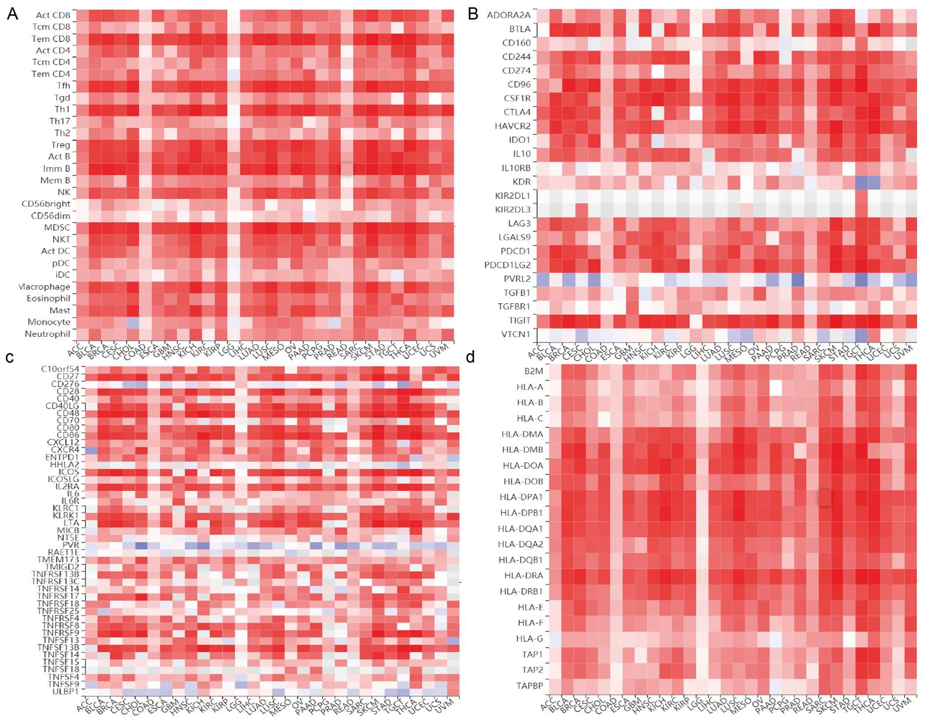
Supplementary FIGURE 2 ⎜ The relationship between SNX20 expression and TILs across multiple cancer types.
(A) The correlations between SNX20 expression and tumor-infiltrating lymphocytes (TILs) in multiple cancer types.(B) The correlations between SNX20 expression and immunoinhibitor s in multiple cancer types.(C) The correlations between SNX20 expression and immunostimulator s in multiple cancer types.(D) The correlations between SNX20 expression and MHC molecule in multiple cancer types.

