Improved dielectric properties and grain boundary effect of phenanthrene under high pressure
Xiaofeng Wang ¹, Qinglin Wang ^{1*}, Tianru Qin ², Guozhao Zhang^{1*}, Haiwa Zhang¹, Dandan Sang¹, Cong Wang³, Jianfu Li⁴, Xiaoli Wang^{4*}, Cailong Liu¹
¹Shandong Key Laboratory of Optical Communication Science and Technology, School of Physics Science and Information Technology, Liaocheng University, Liaocheng 252059, China
²Heilongjiang Province Key Laboratory of Superhard Materials, Department of Physics, Mudanjiang Normal University, Mudanjiang 157012, China
³College of Mathematics and Physics, Beijing University of Chemical Technology, Beijing 100029, China
⁴School of Opto-electronic Information Science and Technology, Yantai University, Yantai 264005, China
* Correspondence:
Qinglin Wang, Guozhao Zhang, Xiaoli Wang
wangqinglin@lcu.edu.cn, Z2012GZ@163.com, and xlwang@ytu.edu.cn

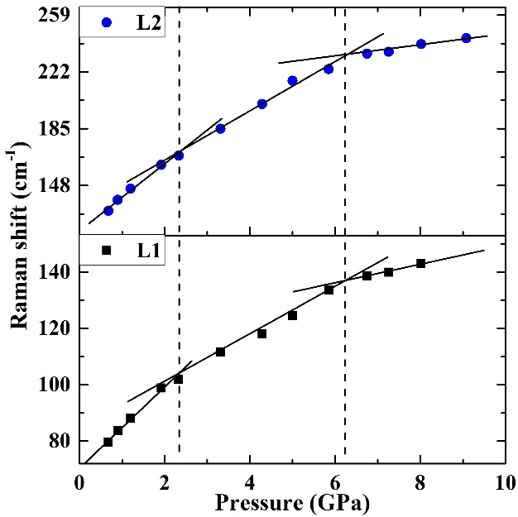
Fig. S1 Raman modes of L1 and L2 as a function of pressure. The solid lines are the linear fit to the data.

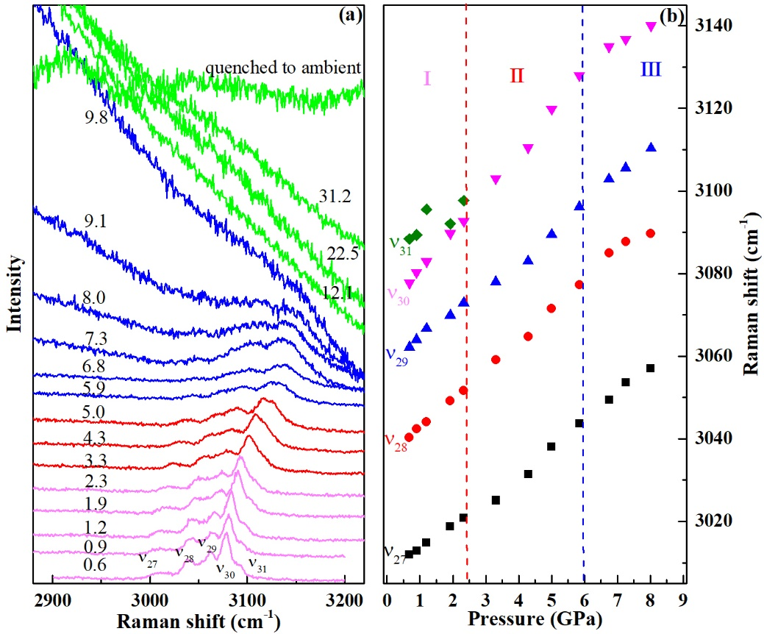
Fig. S2 High pressure Raman spectra of phenanthrene and pressure dependence of the Raman shift in region of 2800-3250 cm⁻¹. Dashed vertical lines represent phase boundaries, and phases are assigned with Roman numbers. (ν₂₉, ν₃₀) and (ν₂₇, ν₂₈, ν₃₁) correspond to the symmetric and asymmetric stretching vibrations of the C-H bond, respectively.

Table S1 The pressure dependence of intramolecular and intermolecular bond distances.
Phase | Intramolecular | dL_{Intra}/dP (Å/GPa) | Intermolecular | dL_{Inter}/dP (Å/GPa)
I | C24-C28 | -0.00087 | C18-H18 | -0.00042
 | C26-C24 | -0.00150
 | C16-C26 | -0.00150
 | C18-C20 | -0.00062 | H18-H8 | -0.02800
 | C28-C18 | -0.00049
 | C16-C20 | -0.00100
II | C46-C47 | -0.00160 | C44-C21 | -0.06100
 | C47-C48 | -0.00210
 | C45-C46 | -0.00160 | H32-H27 | -0.04100
 | C44-C45 | -0.00160
 | C48-C43 | -0.00130 | C44-H32 | -0.00087

