SUPPLEMENTARY DATA

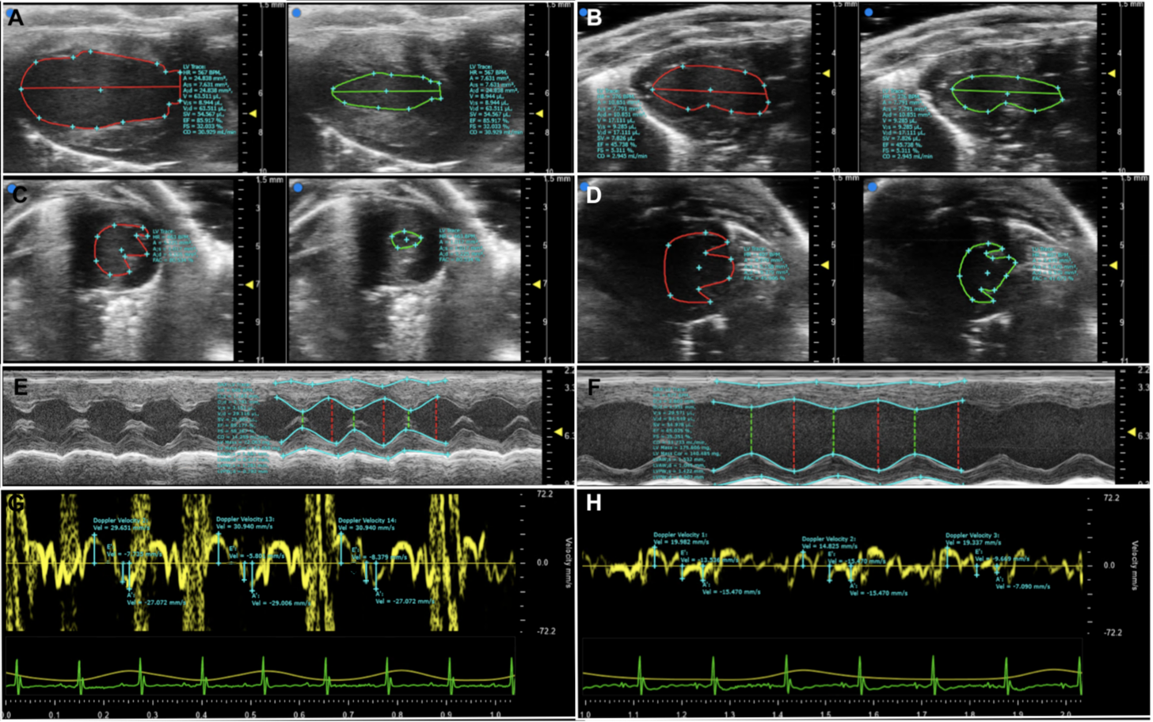

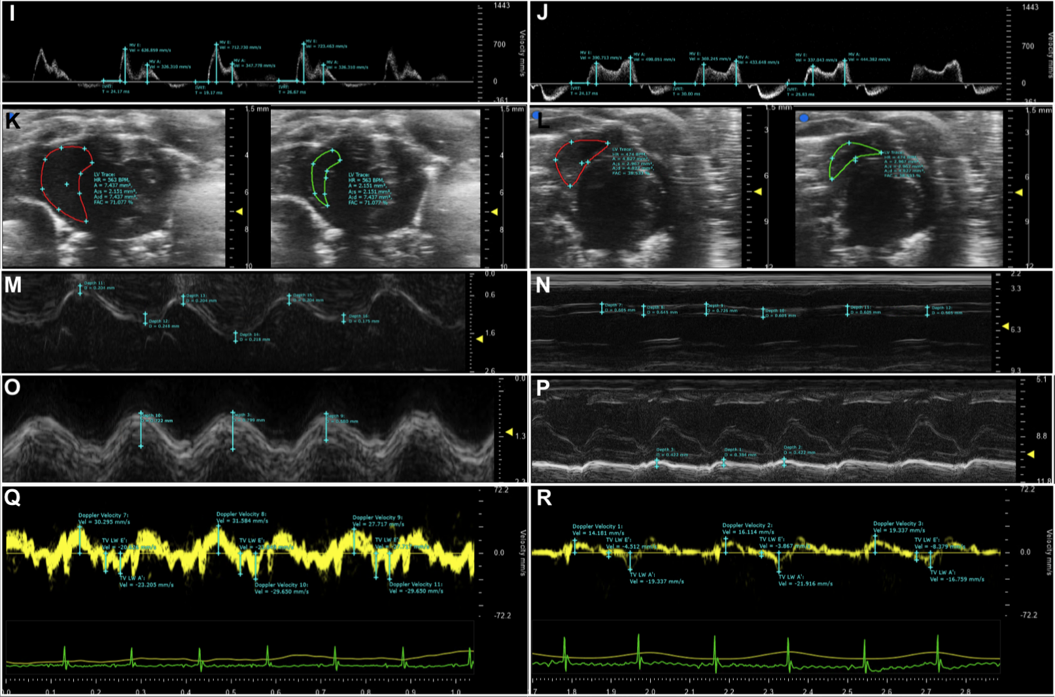
Supplementary Figure 1: Photographs exemplifying analysis methods and demonstrating the difference in echocardiogram measurements between healthy male C57BL/6J mice and IAV-infected mice with T1DM. A | Parasternal long-axis (PSLAX) view of the left ventricle in diastole and systole; healthy. B | PSLAX view of the left ventricle in diastole and systole; unhealthy. C | Short-axis (SAX) view of the left ventricle in diastole and systole; healthy. D | SAX view of the left ventricle in diastole and systole; unhealthy. E | SAX M-mode view of the left ventricle; healthy. F | SAX M-mode view of the left ventricle; unhealthy. G | 4-chamber view (4CV) tissue Doppler image of the mitral valve; healthy. H | 4CV tissue Doppler image of the mitral valve; unhealthy. I | 4CV pulse-wave Doppler image of blood flow through the mitral valve; healthy. J | 4CV pulse-wave Doppler image of blood flow through the mitral valve; unhealthy. K | SAX view of the right ventricle in diastole and systole; healthy. L | SAX view of the right ventricle in diastole and systole; unhealthy. M | SAX M-mode view of the right ventricle showing right ventricular free wall thickness; healthy. N | SAX M-mode view of the right ventricle showing right ventricular free wall thickness; unhealthy. O | 4CV M-mode view of depicting the tricuspid annular plane systolic excursion (TAPSE); healthy. P | 4CV M-mode view of depicting TAPSE; unhealthy. Q | 4CV tissue Doppler image of the tricuspid valve; healthy. R | 4CV tissue Doppler image of the tricuspid valve; unhealthy. S | SAX pulse-wave Doppler image of blood flow through the pulmonary artery; healthy. T | SAX pulse-wave Doppler image of blood flow through the pulmonary artery; unhealthy. Photographs are examples of typical ‘healthy’ and ‘unhealthy’ only and are not necessarily from the same mice; inconsistencies between photos are not reflective of actual data.

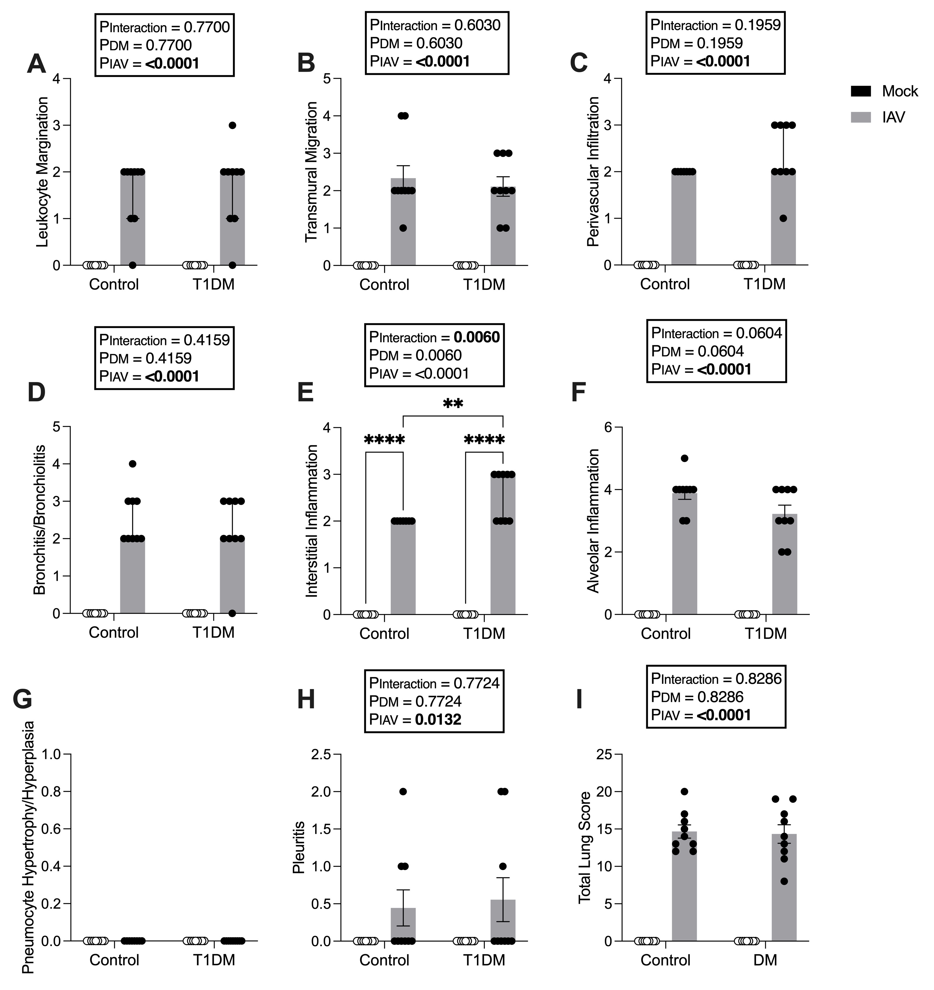
Supplementary Figure 2: Scoring of lung histology in IAV-infected male C57BL/6J mice with and without T1DM. A | Leukocyte margination score. B | Transmural migrations score. C | Perivascular infiltration score. D | Bronchitis/bronchiolitis score. E | Interstitial inflammation extending into alveolar septae beyond the immediate perivascular and peribronchiolar interstitial tissue score. F | Alveolar inflammation score. G | Pneumocyte hypertrophy/hyperplasia score. H | Pleuritis score, including mesothelial cell hypertrophy. I | Total lung score. Scores: 0 = no change; 1 = minimal change (or possibly non-specific background or appearance compounded by lung collapse, i.e., not inflated); 2 = mild change; 3 = moderate change; 4 = severe change in <50% of lung lobe; 5 = severe change in >50% of lung lobe. Each data point represents one mouse with at least n=9 per group and mean ± SEM for graphs B, F, G, H, and I, and median ± IQR for graphs A, C, D, and E. Statistical analysis was performed as described in “Methods” with **P<0.01; ****P<0.0001.

