Supplementary Material

Supplementary Table 1. Conservation of nif, nod and fix genes in respective rhizobia strains.
Rhizobia strains | Percent nif genes | Percent nod genes | Percent fix genes
B3 | 100 | 81.81818 | 100
S2 | 100 | 81.81818 | 100
Rizobium phaseoli | 100 | 81.81818 | 100
Rizobium etli | 100 | 81.81818 | 100
Rizobium tropici | 100 | 81.81818 | 100
Rizobium leguminosarum bv trifoli | 71.42857 | 72.72727 | 81.81818
Rizobium leguminosarum bv viciae | 64.28571 | 72.72727 | 100
Sinorhizobium meliloti | 71.42857 | 81.81818 | 100
Rhizobium grahamii | 100 | 90.90909 | 100
Rhizobium pusense | 7.142857 | 54.54545 | 100
Rhizobium esperanseae | 71.42857 | 63.63636 | 81.81818
Rhizobium laguarrae | 64.28571 | 72.72727 | 81.81818
Rhizobium sullae | 28.57143 | 36.36364 | 81.81818
Rhizobium favelukesi | 100 | 81.81818 | 81.81818

Supplementary Figure 1. Bromothymol blue (BTB) reaction test. Acid producing bacteria (B3 and S2) turns blue BTB to yellow while alkaline producing bacteria (CIAT899) turns it to green.

Supplementary Figure 2. Congo red absorption test. B3 and S2 only slightly absorbs congo red.

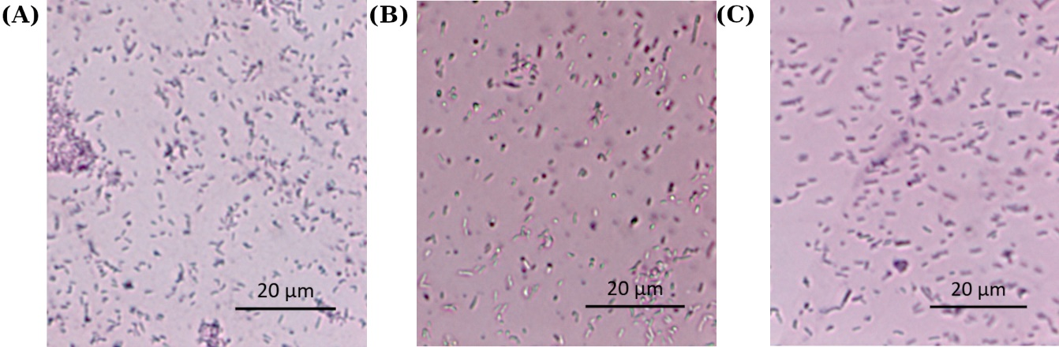
Supplementary Figure 3. Gram staining test. Gram-negative bacteria (all isolates) turns red on staining.

