TABLE S1: Primers used to generate DSR-MΔ2 variants
Primer Name | Nucleotide Sequence | Mutation position
L415A for | 5'- ctctactaaccatgtgcaaaatgg -3' | Mutation at position 415
L415A rev | 5'- ccattttgcacatggttagtagag -3'
R515D for | 5'- gatagcattcgaattgacgc-3' | Mutation at position 515
R515D rev | 5'- gcgtcaattcgaatgctatc -3'
N521Y for | 5'- cgcagtagataatgttgatgc -3' | Mutation at position 521
N521Y rev | 5'- gcatcaacattatctactgcg-3'
H629D for | 5'- tcgagctcatgatagtgagg-3' | Mutation at position 629
H629D rev | 5'- cctcactatcatgagctcga-3'
Q634A for | 5'- atagtgaggttgcgacaataattgc-3' | Mutation at position 634
Q634A rev | 5'- gcaattattgtcgcaacctcactat-3'
V652A for | 5'- cccactgcagataaggctttactgg-3' | Mutation at position 652
V652A rev | 5'- agtaaagccttatcagcagtgg-3'
K654A for | 5'- ccactgttgatgcggctttactgg-3' | Mutation at position 654
K654A rev | 5'- ccagtaaagccgcatcaacagtgg-3'
L656A for | 5'- aaggctttagcggctaaggatagtgc-3' | Mutation at position 656
L656A rev | 5'- ctatccttagccggtaaagcctta-3'
D958A for | 5'- catttttggacgcagtagatac-3' | Mutation at position 958
D958A rev | 5'- gtatctactgcgtccaaaaatg-3'
Y967A for | 5'- caaaatggttatgcgtttactg-3' | Mutation at position 967
Y967A rev | 5'- cagtaaacgcataaccattttg-3'
Q1023K for | 5'- cctgatcaactttataatatgcc-3' | Mutation at position 1023
Q1023K rev | 5'- ggcatattataaagttgatcagg-3'

TABLE S2: Dextran yield and flux of each separation process
 | Yield of dextran (%) | Flux of separation（L/m²∙h）
Microfiltration (MOF 205) | 99.6 | 20.82
Ultrafiltration (S-UF 5.0 K) | 94.3 | 8.80
Ultrafiltration (S-UF 1.0K) | 85.5 | 6.48
Total yield of separation | 80.3

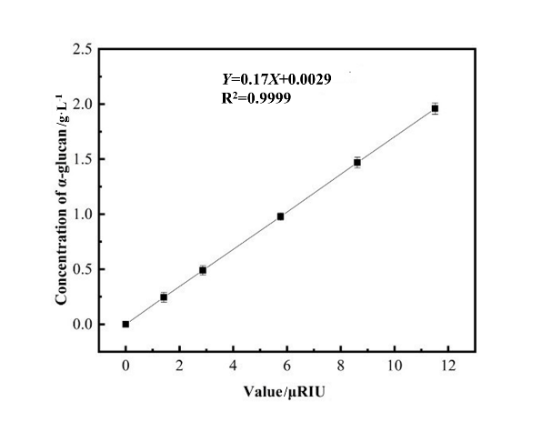
FIGURE S1 Standard curve of L-dextran concentration and peak area. The concentration (Y) of L-dextran can be calculated by the peak area (X) with the formula: Y= 0.17X+ 0.0029

