Fig. S1 agarose gel electrophoresis showing NtSOS2 PCR. The first lanes is 2 000 DNA marker and the second to fifth lanes are NtSOS2 genes from four separate seedings.

Fig. S2 Protein domains within the NtSOS2 protein as shown by NCBI CDD (https://www.ncbi.nlm.nih.gov/cdd).

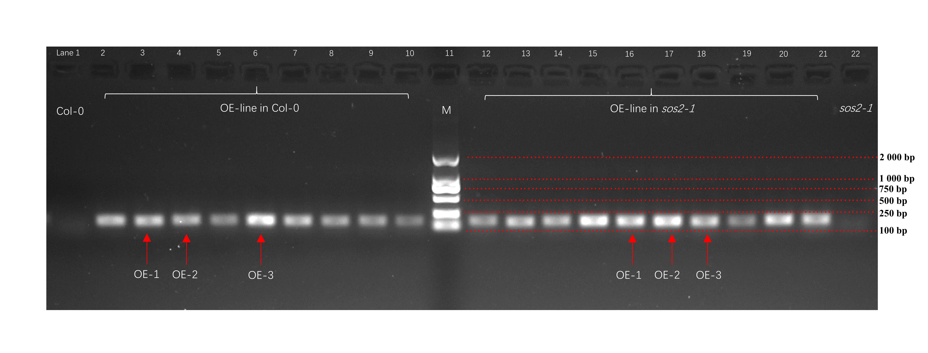
Fig. S3. Semi-quantification of NtSOS2 in transgenic Arabidopsis. The overexpressed lines used in the article in the wild type and mutant sos2-1 are marked with red arrows respectively.

Fig.S4
Pentamers | Integral
0 | 0
0.06 | 9.65
0.23 | 0
1.58 | 0
2.4 | 0.16
0 | 0
0 | 0.03
0.39 | 0
0.13 | 0.15
0 | 0

Fig. S4. Prediction of NtSOS2 subcellular localization by ProtComp9.0 (http://linux1.softberry.com/berry.phtml).

