Supplementary materials

According to the manufacturer’s instruction, one unit salvianolate injection (50mg) contains 40mg salvianolic acid B magnesium salt (Magnesium Lithospermate B, CAS.No:122021-74-3, Figure S1).
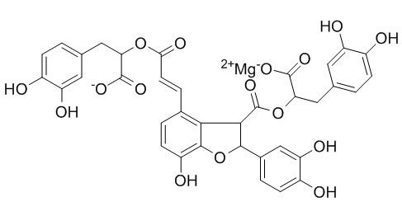
Figure S1 Salvianolic acid B magnesium salt
(Magnesium Lithospermate B, CAS.No:122021-74-3)

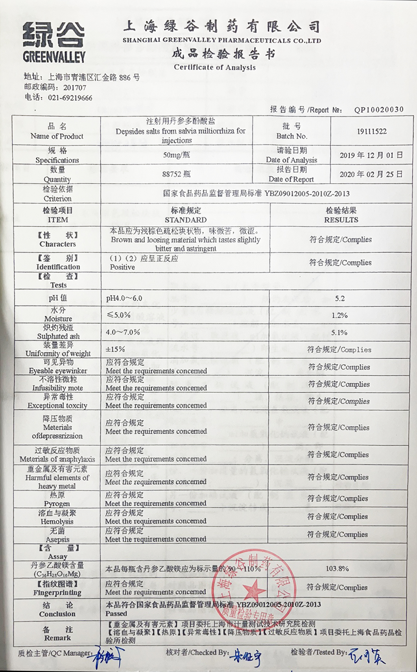
Figure S2 The certificate of analysis of Salvianolate injection
Figure S3 The HPLC analysis of salvianolate.

