Supplementary Material

Additional Methods

Table A1. Survey locations displayed in Figure 1.
Map B | Sepik River | 1. Kopar Village, 2. Angoram, 3. Timbunke Village, 4. Aibom Village, 5. Idingai Village, 6. Korogu Village
 | Ramu River | 7. Marangis
Map C | Mia Kussa River | 8. Buzi Village, 9. Sibidiri Village
 | South Fly Coast | 10. Old Mawatta Village, 11. Tureture Village, 12. Warrior Reef, 13. Daru Market, 14. Daru Passage, 15. Bristow Island, 16. Oriomo River Mouth, 17. Kadawa Village, 18. Upiari Village, 19. Katatia Village, 20. Gaziro fishing camp (Katatai Village)
 | Fly River | 21. Sui Village, 22. Nemadabu fishing camp (Wariobodoro Village)
 | Aramia River | 23. Garu Village, 24. Saiwase Village, 25. Madila Village, 26. Kewa Village, 27. Kawito Village, 28. Tebini Village, 29. Makapa Village, 30. Ali (Bogola Village)
 | Bamu River | 31. Bina Village, 32. Oropai Village, 33. Sisiaimi Village, 34. Sogere Village, 35. Sasairi Village
 | Turama River | 36. Meagio Village, 37. Masusu Village, 38. Saragi Village, 39. Moka 2 Village, 40. Moka 1 Village, 41. Kuri logging station
 | Kikori River | 42. Begere fishing camp (Kemei Village), 43. Kemei Village, 44. Pioi fishing camp (Mubagowo Village), 45. Aiedio Village, 46. Goare Village, 47. Bomobari fishing camp (Goare Village), 48. Omarti Creek (Goare Village), 49. Evamu Village, 50. Babi Village, 51. Kotoioia fishing camp (Apeawa Village), 52. Iribibari (Babeio Village), 53. Veraibari Village, 54. Babeio Village, 55. Kikori market, 56. Omo Village (Sirebi tributary)
 | Kerema Coast | 57. Marieke Village, 58. Vailala 1 Village (Vailala River Mouth), 59. Vailala 2 Village (Vailala River Mouth), 60. Kerema Town, 61. Siroui fishing camp (Kerema Village), 62. Karama Village, 63. Pukari Village

Species identification
Due to inaccuracies that can arise in species identification (ID) from photographs (Smart et al. 2016; Tillett et al. 2012; White et al. 2020), species ID’s were assigned to all photographs by two assessors independently (MIG and WTW). Species ID’s agreed for 395/458 (86.2%) specimens. Where ID’s differed (63 specimens), a consensus ID was conducted with both assessors. If an agreement to species level could not be made, specimens were identified to lowest taxonomic level possible (genera or family). River sharks were generally difficult to ID due to poor quality photographs taken by some enumerators (poor lateral resolution) and discrete differentiating morphological features. For this reason, a third assessor (PMK) assisted with consensus ID’s. In total, only three river sharks could not be identified to species level from consensus ID’s from whole specimens. Species ID from 99 specimens from the Sepik River were also identified from photographs (WW) although these specimens contributed to a report prepared for the Australian Centre for International Agricultural Research (FIS-2012-102) and these ID’s are not included in the above numbers.

In some instances, specimens observed were already finned and portioned for sale, or enumerators recorded a species or common name though did not take a photograph. These species were recorded at genus or family level where available data were not sufficient to make a higher-level ID. Due to the high degree in morphological similarity between the common blacktip shark Carcharhinus limbatus and Australian blacktip shark Carcharhinus tilstoni, these species were identified as C. limbatus/tilstoni in instances where tissue was not available for genetic ID.

Genetic ID’s based on COI barcodes
As per Appleyard et al. (2018) where required for genetic ID, genomic DNA was extracted from muscle or fin tissue using a Promega Wizard® Genomic DNA Purification kit (Promega Corporation, USA) at the CSIRO Marine Laboratories in Hobart, Tasmania, Australia. DNA was precipitated in water, diluted to 10 ng/μl and stored at 4°C for working applications. Archival DNA is stored at -80°C at the Marine Laboratories.

Barcoding of the mitochondrial DNA cytochrome oxidase subunit 1 (COI) gene using the Fish-BCL-5′TCAACYAATCAYAAAGATATYGGCAC-3′ and Fish-BCH-5′ACTTCYGGGTGRCCRAARAATCA-3′ primers (Baldwin et al. 2009) and the Big Dye Terminator v3.1 cycle sequencing ready reaction kit (Thermofisher, USA) with cycle sequenced products run on an ABI 3130XL DNA Autosequencer (Applied Biosystems™, USA) at the Marine Laboratories (as per protocols outlined in Appleyard et al. 2018). Forward and reverse sequences were trimmed; denovo assembled; sequences were checked by eye; and then converted into consensus sequences (using Geneious R8.1.4; Biomatters Ltd, New Zealand). Consensus sequences were compared using the BarCode of Life Database (http://www.boldsystems.org/) BOLD IDS tool, where species identification was based on a percentage of sequence identity with homology of ≥98%.

For specimens suspected to be Glyphis spp., a 463 bp region in the cytochrome B (cytB) gene was selected for optimal inter- and intra-specific variation. Newly designed primers were used to amplify this region: Ggar14277_For-5’ATTCCTACCTGGACTTTAACCAAGAC-3’ and Car14731_ rev-5’CCGACGAAGGCTGTTGCTAT-3’. PCR and dual-direction Sanger sequencing were performed at the Australian Genome Research Facility in Brisbane, Queensland using the Big Dye Terminator kit and the products run on an ABI 3730XL DNA Analyzer. Resulting paired-end sequences were analysed in Geneious R11.1.5. Primer sequences were removed, and low-quality bases were removed at a 0.05 error probability from both 5’ and 3’ ends. Forwards and reversed reads were paired and merged. The resulting sequences were blasted (Megablast) against the GenBank nr/nt database. All sequences had an identity ≥99% to species level.

In total, 256 specimens (94 ‘other species’ and 142 Glyphis spp.) were identified from these respective genetic approaches.

Sawfish rostra
Length measurements for sawfish rostra were used to estimate total length (TL) using available relationships from the literature (Table A2). Total length was estimated for all species using standard rostrum length (SRL)–TL relationships presented in Whitty et al. (2014). Due to possible bias in SRL–TL relationships in Whitty et al. (2014) source data (e.g. largely based on immature specimens), measurements of total rostrum length (TRL) were additionally converted to TL using the TRL–TL relationship available in Morgan et al. (2011) for largetooth sawfish Pristis pristis, Thorburn et al. (2008) for dwarf sawfish P. clavata, and Morgan et al. (2011) for green sawfish P. zijsron. No TRL–TL relationship is currently available for narrow sawfish Anoxypristis cuspidata, so TL was estimated using the proportion ratio given by Whitty et al. (2014), which was equal to the ratio also calculated from measurements made in this study (Table A3).

Where only one of either SRL or TRL was measured, SRL/TRL ratios in Whitty et al. (2014) were used to estimate the other. This was to allow estimations of TL from both SRL and TRL relationships. Final estimations of TL from rostra were the average of these SRL and TRL relationships. In a few instances, only body length could be measured for A. cuspidata as their rostrums had been cut and discarded at sea prior to observation. In order to estimate TL, the body length/TRL ratio available in Whitty et al. (2014) was used.

Table A2. Published relationships for rostra and total length (TL) used to estimate TL from total rostrum length (TRL) and standard rostrum length (SRL) for sawfish species.
Species | Relationship | r² | Source
Anoxypristis cuspidata | Figure 3 p 796 | 0.81 | Whitty et al. (2014)
 | TRL = 0.26TL | N/A | Whitty et al. (2014); This study
Pristis clavata | SRL = 0.5033TL^{0.8643} | 0.98 | Whitty et al. (2014)
 | TRL = 0.6142TL^{0.8475} | Not presented | Thorburn et al. (2008)
Pristis pristis | SRL = 0.5592TL^{0.8749} | 0.99 | Whitty et al. (2014)
 | TRL = 3.7768+(0.209TL) | 0.98 | Morgan et al. (2011)
Pristis zijsron | SRL = 0.0733TL^{1.1683} | 0.96 | Whitty et al. (2014)
 | TRL = 0.2825TL-3.7389 | Not presented | Morgan et al. (2011); Faria (2007)

Table A3. Rostral morphometric data collected from sawfish species in Papua New Guinea. Difference between left and right rostral tooth counts is presented as absolute values. SE, standard error; SRL, standard rostrum length; TRL, total rostrum length.
 |  | Rostral Teeth |  |  |  | Rostral proportions
Species | Statistic | Left | Right | Total | Left–Right difference | SRL/TRL | SRL/TL | TRL/TL
Anoxypristis cuspidata | n | 48 | 48 | 48 | 48 | 7 | 3 | 13
 | Range | 19–27 | 18–26 | 37–51 | 0–3 | 0.72–0.78 | 0.21–0.27 | 0.20–0.36
 | Mean ±SE | 21.9 ±0.26 | 22.0 ±0.25 | 43.9 ±0.48 | 1.1 ±0.12 | 0.75 ±0.01 | 0.23 ±0.02 | 0.26 ±0.01
Pristis clavata | n | 6 | 6 | 6 | 6 | 2 | 2 | 2
 | Range | 21–25 | 21–25 | 42–48 | 0–3 | 0.95–0.96 | 0.18 | 0.19
 | Mean ±SE | 22.3 ±0.56 | 23.0 ±0.58 | 45.3 ±0.88 | 1.3 ±0.49 | 0.95 ±0.00 | 0.18 ±0.00 | 0.19 ±0.00
Pristis pristis | n | 55 | 55 | 55 | 55 | 27 | 1 | 1
 | Range | 16–23 | 16–23 | 32–45 | 0–2 | 0.90–0.96 | 0.23 | 0.25
 | Mean ±SE | 19.7 ±0.21 | 19.9±0.25 | 39.6 ±0.45 | 0.5 ±0.09 | 0.94 ±0.00
Pristis zijsron | n | 1 | 1 | 1 | 1
 | Range | 27 | 26 | 53 | 1

Dried fin
Data used in total length (TL) estimation from dried fin is shown in Table A4. Proportionate ratios for use in TL estimation were produced for Glyphis garricki (Table A5) and Glyphis glyphis (Table A6) from measurements taken during this study.

Table A4. First dorsal height (D1H) and dorsal caudal margin (DCM) to total length (TL) conversion ratios used to estimate TL from dried fin encountered during surveys.
Species | 1st dorsal fin dimension –total length (TL) relationship | Source
Carcharhinus amboinensis | TL = D1H/0.109 | Garrick (1982); W. White (unpubl. data)
Carcharhinus coatesi | TL = D1H/0.098 | W. White (unpubl. data)
Carcharhinus fitzroyensis | TL = D1H/0.089 | Garrick (1982); W. White (unpubl. data)
Carcharhinus leucas | TL = D1H/0.102 | Garrick (1982)
Carcharhinus limbatus | TL = D1H/0.125 | Garrick (1982)
Carcharhinus sorrah | TL = (D1H/0.106)+1.523 | Garrick (1982); W. White (unpubl. data)
Eusphyra blochii | TL = D1H/0.150 | W. White (unpubl. data)
Sphryna mokarran | TL = D1H/0.166 | Gilbert (1967)
Rhynchobatus palpebratus | TL = (D1H/0.109)+0.516 | Based on Rhynchobatus australiae, W. White (unpubl. data)
Anoxypristis cuspidata | TL = D1H/0.08 | White et al. (2017)
Pristis clavata | TL = D1H/0.06  TL = DCM/0.14 | White et al. (2017)
Pristis pristis | TL = D1H/0.07 | White et al. (2017)
Glyphis garricki | TL = D1H/9.38 | Compagno et al. (2008); This study
Glyphis glyphis | TL = D1H/8.41 | Compagno et al. (2008); This study

Table A5. First dorsal fin dimensions to total length (TL; in mm) ratios for Glyphis garricki. Ratios provided for first dorsal length (D1L), height (D1H), anterior length (D1A), and second dorsal height (D2H).
Country & sample size | Statistic | D1L/TL | D1H/TL | D1A/TL | D2H/TL | D2H/D1H
Australia*  n = 8  TL range 670–1418 | Mean | 17.40 | 10.17 | 14.27 | 6.30 | 62.00
 | Standard Error | 0.25 | 0.22 | 0.18 | 0.15 | 1.30
 | Minimum | 16.70 | 9.40 | 13.90 | 5.80 | 57.55
 | Maximum | 18.70 | 10.80 | 15.20 | 6.90 | 67.01
Papua New Guinea  n = 10 **  TL range 655–1050 | Mean | 15.98 | 8.83 | 12.54 | 5.20 | 59.34
 | Standard Error | 0.29 | 0.36 | 0.31 | 0.16 | 1.72
 | Minimum | 14.57 | 7.20 | 11.53 | 4.32 | 48.25
 | Maximum | 17.39 | 10.86 | 13.98 | 6.23 | 68.33
Combined  n = 18  TL range 655–1418 | Mean | 16.57 | 9.38 | 13.25 | 5.65 | 60.43
 | Standard Error | 0.26 | 0.28 | 0.29 | 0.18 | 1.16
 | Minimum | 14.57 | 7.20 | 11.53 | 4.32 | 48.25
 | Maximum | 18.70 | 10.86 | 15.20 | 6.90 | 68.33
*Data sourced from Compagno et al. (2008)
** Additionally, a male G. garricki individual of 1050 mm TL had a pectoral fin length/TL ratio of 0.176, pectoral fin anterior length/TL ratio of 0.211, and a dorsal caudal margin/TL ratio of 0.252

Table A6. First dorsal fin dimensions to total length (TL; in mm) ratios for Glyphis glyphis. Ratios provided for first dorsal length (D1L), height (D1H), anterior length (D1A), and second dorsal height (D2H).
Country & sample size | Statistic | D1L/TL | D1H/TL | D1A/TL | D2H/TL | D2H/D1H
Australia*  n = 9  TL range 590–1447 | Mean | 18.09 | 8.88 | 13.82 | 6.28 | 71.14
 | Standard Error | 0.34 | 0.33 | 0.30 | 0.17 | 2.09
 | Minimum | 16.20 | 6.80 | 12.30 | 5.50 | 66.27
 | Maximum | 19.60 | 10.30 | 15.00 | 7.00 | 85.29
Papua New Guinea  n = 10**  TL range 593–715 | Mean | 16.40 | 8.00 | 11.76 | 5.18 | 64.80
 | Standard Error | 0.32 | 0.22 | 0.20 | 0.14 | 1.40
 | Minimum | 14.37 | 7.18 | 10.94 | 4.65 | 60.34
 | Maximum | 17.48 | 9.58 | 12.68 | 5.92 | 72.73
Combined  n = 19  TL range 590–1447 | Mean | 17.20 | 8.41 | 12.74 | 5.73 | 67.97
 | Standard Error | 0.30 | 0.21 | 0.30 | 0.17 | 1.44
 | Minimum | 14.37 | 6.80 | 10.94 | 4.65 | 60.34
 | Maximum | 19.60 | 10.30 | 15.00 | 7.00 | 85.29
*Data sourced from Compagno et al. (2008)
**Additionally, two male G. glyphis individuals of 710 and 700 mm TL had a pectoral fin length/TL ratio of 0.131 (SE ±0.005) and a pectoral fin anterior length/TL ratio of 0.160 (SE ±0.002).
Additional Results and Discussion
Table A7. Abundance (n), proportion of total abundance (%), size range (DW, disc width; TL, total length), sex ratio (F, female; M, male; ?, unknown), size-at-maturity from White et al. (2017b), n mature for each sex, gear type used in capture, location of capture (Figure 1 map reference) and IUCN Red List of Threatened Species category (IUCN 2021) for all specimens observed in small-scale fisheries on the north coast of Papua New Guinea. CR, Critically Endangered; EN, Endangered; VU, Vulnerable; NT, Near Threatened; LC, Least Concern; DD, Data Deficient. Aetobatidae size is in disc width (DW), all others are in total length (TL).
Species | n (% of catch) | Size range (cm DW/TL) | Sex ratio (F:M:?) | Size-at-maturity (cm DW/TL) | n mature | Gear type (n) | Locality (Figure 1) | IUCN Red List category
Aetobatidae | 1 (0.6)
Aetobatus ocellatus | 1 (0.6) | 44.3 | F: 1 | F: 155 M: 115 |  | Gillnet (1) | 1 | VU
Carcharhinidae | 101 (57.4)
Carcharhinus amblyrhynchoides | 19 (10.8) | 75.3–160.9 | F: 7 M: 12 | F & M: 112.5 | F: 3 M: 7 | Gillnet (19) | 1 | NT
Carcharhinus amboinensis | 1 (0.6) | 117.0 | F: 1 | F: 210.5 M: 202.5 |  | Gillnet (1) | 1 | DD
Carcharhinus coatesi | 2 (1.1) | 71.7–123* | F: 1 M: 1 | F & M: 70 | F: 1 M: 1 | Gillnet (2) | 1 | LC
Carcharhinus leucas | 35 (19.9) | 71.0–157.7 | F: 17 M: 18 | F: 230 M: 220 |  | Gillnet (35) | 1 | NT
Carcharhinus limbatus | 1 (0.6) | 135.0 | F: 1 | F: 172.5 M: 185 |  | Gillnet (1) | 1 | NT
Carcharhinus limbatus/tilstoni | 13 (7.4) | 73.4–168.0 | F: 10 M: 3 |  |  | Gillnet (13) | 1
Carcharhinus macloti | 17 (9.7) | 65.4–82.6 | F: 5 M: 12 | F: 79.5 M: 71.5 | F: 0 M: 11 | Gillnet (17) | 1 | NT
Carcharhinus tilstoni | 2 (1.1) | 118.0–145.0 | F: 2 | F: 110 M: 107.5 | F: 2 | Gillnet (2) | 1 | LC
Carcharhinus sp. | 8 (4.5) |  |  |  |  | Gillnet (8) | 1
Rhizoprionodon acutus | 3 (1.7) | 67.6–74.5 | F: 1 M: 2 | F: 47 M: 42 |  | Gillnet (3) | 1 | VU
Glaucostegidae | 2 (1.1)
Glaucostegus typus | 2 (1.1) | 73.0–76.0 | F: 1 M: 1 | F: & M: 165 |  | Gillnet (2) | 1 | CR
Pristidae | 26 (14.8)
Anoxypristis cuspidata | 13 (7.4) | 100.0–300.0 | F: 7 M: 4 ?: 2 | F: 225 M: 200 | F: 1 M: 1 ?: 2 | Gillnet (13) | 1, 7 | EN
Pristis pristis | 13 (7.4) | 49.0–484.9 | ?: 13 | F & M: 290 | ?: 5 | Gillnet (13) | 1–6 | CR
Rhinidae | 1 (0.6)
Rhynchobatus australiae | 1 (0.6) | 231.4 | F: 1 | F: ? M: 120 | F: 1 | Gillnet (1) |  | CR
Sphyrnidae | 45 (25.6)
Eusphyra blochii | 42 (23.9) | 64.4–155.0 | F: 15 M: 27 | F: 115.5 M: 105.5 | F: 9 M: 13 | Gillnet (42) | 1 | EN
Sphryna lewini | 3 (1.7) | 53.5–73.5 | F: 2 M: 1 | F: 210 M: 160 |  | Gillnet (3) | 1 | CR

Table A8. Abundance (n), proportion of total abundance (%), size range (DW, disc width; TL, total length), sex ratio (F, female; M, male; ?, unknown), size-at-maturity from White et al. (2017b), n mature for each sex, gear type used in capture, location of capture (Figure 1 map reference) and IUCN Red List of Threatened Species category (IUCN 2021) for all specimens observed in small-scale fisheries on the south coast of Papua New Guinea. CR, Critically Endangered; EN, Endangered; VU, Vulnerable; NT, Near Threatened; LC, Least Concern; DD, Data Deficient; NE, Not Evaluated. Aetobatidae and Dasyatidae sizes are in disc width (DW), all others are in total length (TL).
Species | n (% of catch) | Size range (cm DW/TL cm) | Sex ratio (F:M:?) | Size-at-maturity (cm DW/TL) | n mature | Gear type | Locality | IUCN Red List category
Aetobatidae | 2 (0.3)
Aetobatus ocellatus | 2 (0.3) | 70.0–89.0 | F: 1 M: 1 | F: 155 M: 115 |  | Gillnets (2) | 12, 15 | VU
Carcharhinidae | 344 (56.7)
Carcharhinus amblyrhynchoides | 13 (2.1) | 55.0–125.0 | F: 2 M: 4 ?: 7 | F & M: 112.5 | F: 1 | Gillnet (13) | 8, 13, 17, 19, 46 | NT
Carcharhinus amboinensis | 7 (1.2) | 56.9–120.2 | F: 1 M: 2 ?: 4 | F: 210.5 M: 202.5 |  | Gillnet (7) | 8, 21, 46, 49 | DD
Carcharhinus cautus | 5 (0.8) | 64.0–118.0 | M: 2 ?: 3 | F: 85 M: 80 | M: 2 ?: 2 | Gillnet (5) | 8, 12, 19 | LC
Carcharhinus coatesi | 15 (2.5) | 32.0–78.0 | F: 2 M: 2 ?: 11 | F: & M: 70 | ?: 2 | Gillnet (6)  Hook & line (9) | 8–9, 13, 16, 19 | LC
Carcharhinus fitzroyensis | 3 (0.5) | 71.0–96.5 | F: 1 ?: 2 | F: 90 M: 80 | ?: 1 | Gillnet (3) | 8, 46 | LC
Carcharhinus leucas | 40 (6.6) | 49.0–130.0 | F: 12 M: 7 ?: 21 | F: 230 M: 220 |  | Gillnet (40) | 9, 13, 16, 20, 22, 31, 33–34, 36, 39, 43–47, 49, 52, 61 | NT
Carcharhinus limbatus | 1 (0.2) | 94.4 | ?: 1 | F: 172.5 M: 185 |  | Unspecified (1) | 62 | NT
Carcharhinus limbatus/tilstoni | 15 (2.5) | 57.0–91.0 | F: 2 ?: 13 |  |  | Gillnet (15) | 8–9, 17, 19
Carcharhinus melanopterus | 34 (5.6) | 62.0–127.0 | F: 13 M: 18 ?: 3 | F: 113 M: 98 | M: 2 | Gillnet (34) | 12–13, 15, 17 | VU
Carcharhinus sorrah | 9 (1.5) | 61.9–100.0 | F: 2 M: 2 ?: 5 | F & M: 92.5 | F: 1 M: 1 ?: 1 | Gillnet (8) Unspecified (1) | 8, 17, 19, 57 | NT
Carcharhinus sp. | 2 (0.3) | 59.0–60.0 | M: 1 ?: 1 |  |  | Gillnet (2) | 8, 46
Glyphis garricki | 140 (23.1) | 49.0–117.0 | F: 56 M: 40 ?: 44 | F: 177 M: 140 |  | Gillnet (139) Unspecified (1) | 9, 17, 22, 31–32, 34, 42–43, 45–50, 52–53 | CR
Glyphis glyphis | 38 (6.3) | 46.4–122.0 | F: 11 M: 16 ?: 11 | F: 250 M: 228 |  | Gillnet (38) | 15, 22, 42–49, 52 | EN
Glyphis sp. | 2 (0.3) | 88.5–97.0 | F: 2 |  |  | Gillnet (2) | 22
Negaprion acutidens | 3 (0.5) | 70.0–113.0 | M: 1 ?: 2 | F & M: 220 |  | Gillnet (3) | 8–9 | VU
Rhizoprionodon acutus | 7 (1.2) | 56.5–65.0 | F: 3 M: 2 ?: 2 | F: 75.5 M: 70 |  | Gillnet (7) | 12–13, 19 | VU
Rhizoprionodon taylori | 10 (1.6) | 45.0–95.0 | F: 6 M: 3 ?: 1 | F: 48.5 M: 41 | F: 6 M: 3 | Gillnet (9)  Hook & line (1) | 8, 13, 19 | LC
Dasyatidae | 45 (7.4)
Himantura australis | 7 (1.2) | 32.0–47.0 | F: 4 M: 2 ?: 1 | F: Unkown M: ~112 |  | Gillnet (7) | 13, 19 , 46 | NE
Hemitrygon longicauda | 4 (0.7) | 36.0 | M: 1 | F & M: Unknown |  | Gillnet (1) Unspecified (3) | 13, 46 | NT
Maculabatis toshi | 10 (1.6) | 45.0–68.0 | F: 5 M: 5 | F: Unknown M: 50 | M: 2 | Gillnet (9) Unspecified (1) | 12–14, 19, 46 | LC
Neotrygon australiae | 1 (0.2) | 23.0 | F: 1 | M: 31 |  | Gillnet (1) | 15 | NE
Pateobatis fai | 2 (0.3) | 58.0–67.0 | F: 1 M: 1 | F: Unknown M: 112 |  | Gillnet (2) | 12, 19 | VU
Rhinoptera neglecta | 3 (0.5) | 30.0–134.2 | F: 1 M: 1 ?: 1 | F: Unknown M: 115 |  | Gillnet (3) | 46 | DD
Taeniura lymma | 8 (1.3) | 20.0–27.0 | F: 6 ?: 3 | F: Unknown M: 20 |  | Gillnet (7) Unspecified (1) | 8, 12–13, 15, 19 | LC
Urogymnus dalyensis | 5 (0.8) | 77.0–100.0 | F: 2 M: 2 ?: 1 | F: Unknown M: 90 |  | Gillnet (1)  Hook & Line (4) | 19, 35, 46 | LC
Urogymnus granulatus | 5 (0.8) | 31.0–36.0 | F: 5 | F: Unknown M: 60 |  | Poison root (5) | 15 | VU
Glaucostegidae | 9 (1.5)
Glaucostegus typus | 9 (1.5) | 50.5–186.0 | F: 4 M: 2 ?: 3 | F & M: 165 | F: 1 M: 1 | Gillnet (9) | 8, 15, 19, 46, 52 | CR
Hemigaleidae | 2 (0.3)
Hemigaleus australiensis | 2 (0.3) | 79.0–87.0 | F: 2 | F: 65 M: 60 | F: 2 | Gillnet (2) | 19 | LC
Hemiscylliidae | 3 (0.5)
Chiloscyllium punctatum | 3 (0.5) | 54,0–83.0 | F: 1 M: 2 | F: 84 M: 65.5 | M: 2 | Gillnet (2)  Hook & line (1) | 9, 13, 19 | NT
Orectolobidae | 1 (0.2)
Orectolobus wardi | 1 (0.2) | 52.2 | F: 1 | F: Unknown M: 45 |  | Hook & Line (1) | 9 | LC
Pristidae | 123 (20.3)
Anoxypristis cuspidata | 52 (8.6) | 55.0–309.4 | F: 1 ?: 51 | F: 225 M: 200 | ?: 43 | Gillnet (49) Unspecified (3) | 8, 10–11, 16–20, 46, 53, 57–59, 62–63 | EN
Pristis clavata | 9 (1.5) | 103.0–248.4 | ?: 9 | F: Unknown M: 260 |  | Gillnet (9) | 8, 46, 51 | EN
Pristis pristis | 60 (9.9) | 72.9–561.8 | F: 1 M: 2 ?: 57 | F & M: 290 | ?: 8 | Gillnet (34)  Hook & Line (7) Unspecified (19) | 16–17, 19, 21, 23–30, 35–38, 40–41, 43, 45–46, 50, 53–54, 56, 59–60 | CR
Pristis zijsron | 1 (0.2) | 352.0 |  | F & M: 430 |  | Gillnet (1) | 19 | CR
Pristidae sp. | 1 (0.2) | 210.0 | ?: 1 |  |  | Unspecified (1) | 46
Rhinidae | 10 (1.6)
Rhynchobatus palpebratus | 10 (1.6) | 60.0–166.0 | F: 1 M: 6 ?: 3 | F: Unknown M: 103 | M: 1 | Gillnet (10) | 8, 12, 14, 17, 19, 46 | NT
Sphyrnidae | 68 (11.2)
Eusphyra blochii | 44 (7.2) | 40.0–188.0 | F: 3 M: 18 ?: 23 | F: 115.5 M: 105.5 | F: 1 M: 3 ?: 14 | Gillnet (29) Unspecified (15) | 8–9, 14, 17, 22, 46, 57, 62–63 | EN
Sphyrna lewini | 16 (2.6) | 51.8–91.0 | F: 2 M: 2 ?: 14 | F: 210 M: 160 |  | Gillnet (16) | 13, 19 | CR
Sphyrna mokarran | 7 (1.2) | 94.1–255.4 | F: 1 M: 4 ?: 2 | F: 255 M: 247 | ?: 1 | Gillnet (7) | 9, 11–12, 19 | CR
Sphyrna sp. | 1 (0.2) | 108.0 | M: 1 |  |  | Gillnet (1) | 19

Additional observations made on use and trade of elasmobranchs

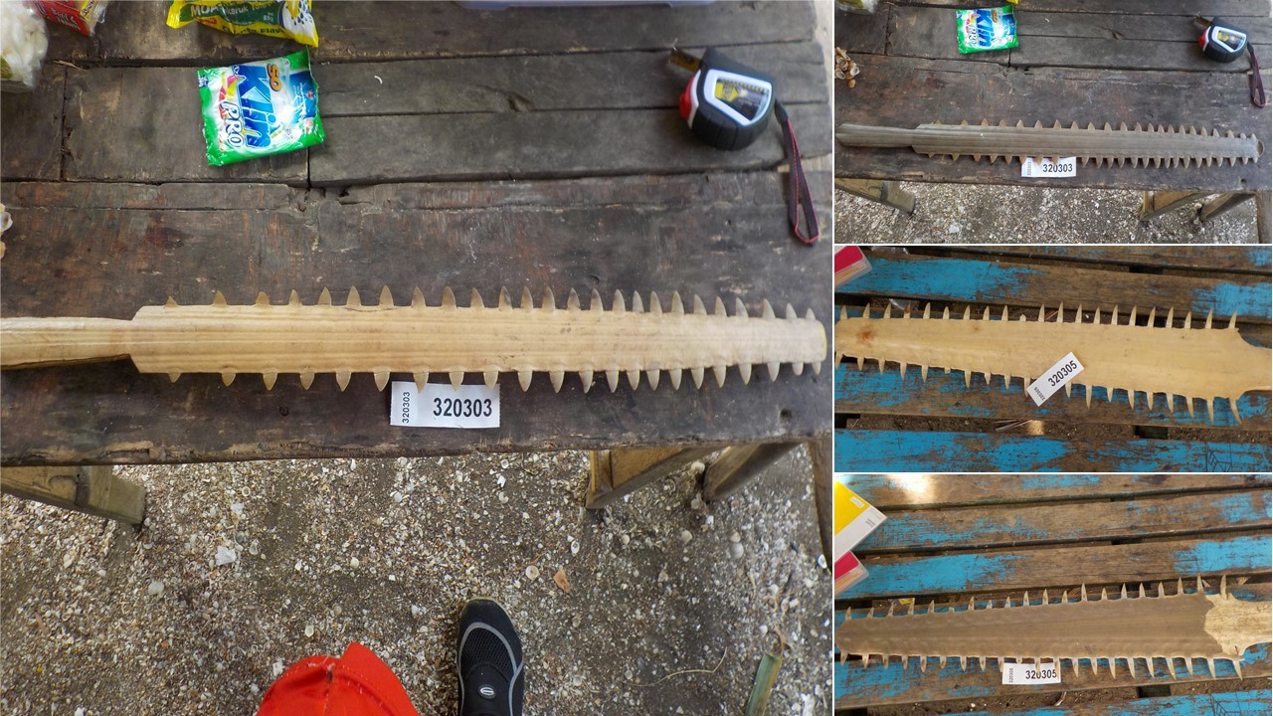
Figure A1. Sawfish rostra from the South Fly Coast that have been modified for use as weapons. Left; Anoxypristis cuspidata (ventral). Top right; A. cuspidata (dorsal). Middle right; Pristis pristis (ventral). Bottom right; P. pristis (dorsal).

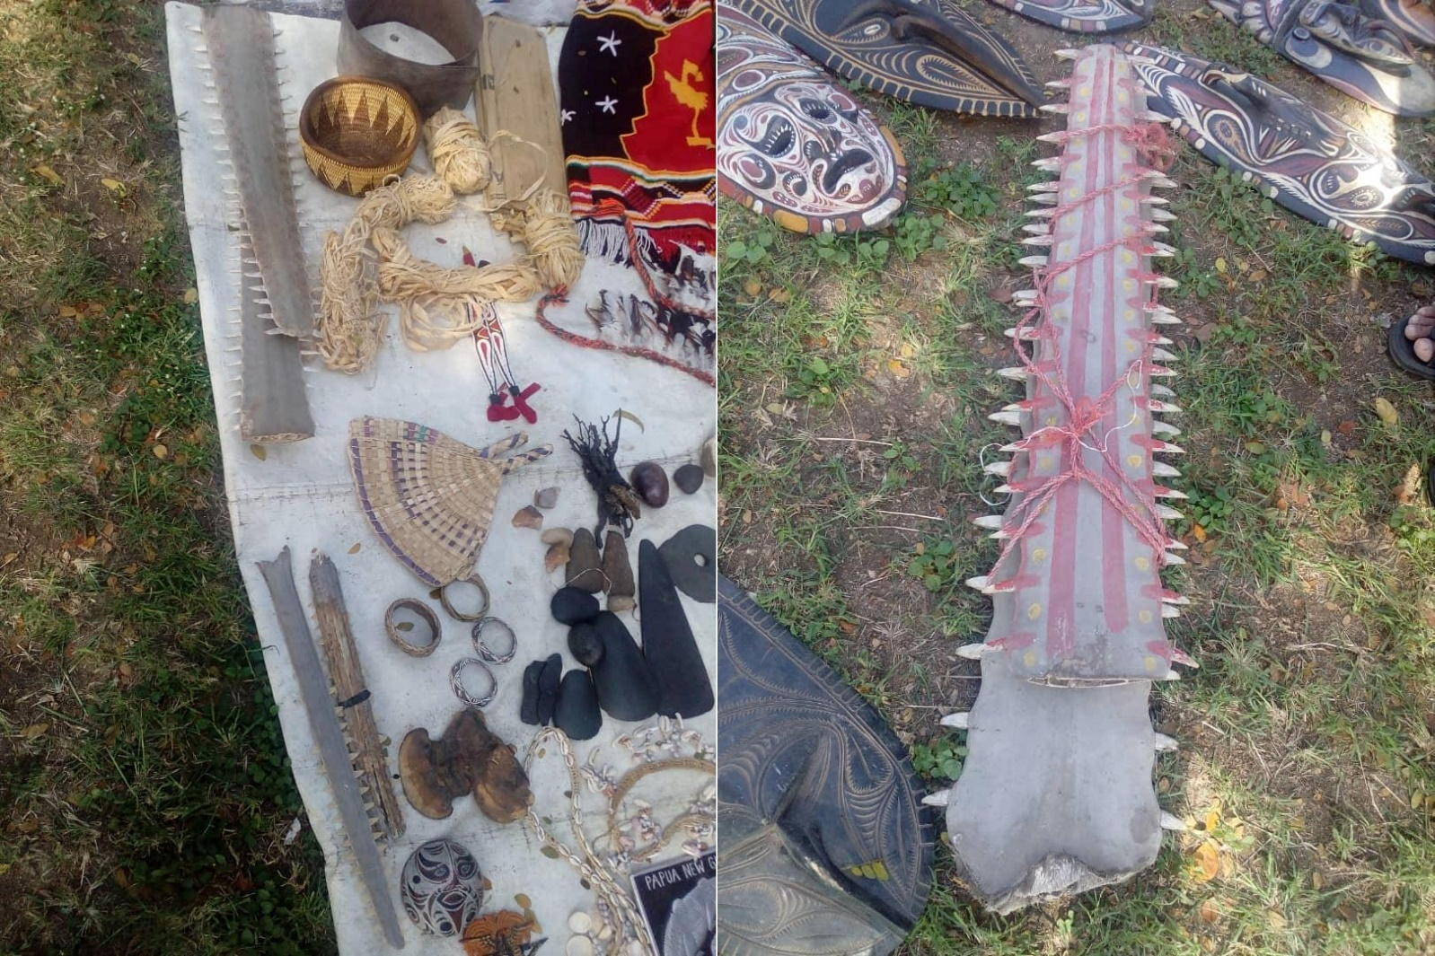
Figure A2. Sawfish (Pristidae) rostra for sale at a market in Port Moresby, National Capital District Province, Papua New Guinea. Left image: Rostra on the top of image were $200 PGK (Papua New Guinean Kina, = 0.28 USD, 04/04/2021) each and are identified as largetooth sawfish Pristis pristis. Rostra on bottom of image were $100 PGK each and are identified as narrow sawfish Anoxypristis cuspidata. Right image: Rostra were $500 PGK each and are identified as P. pristis. All rostra reportedly came from Western Province (no further location information available). Observed by YA on 18 July 2020.

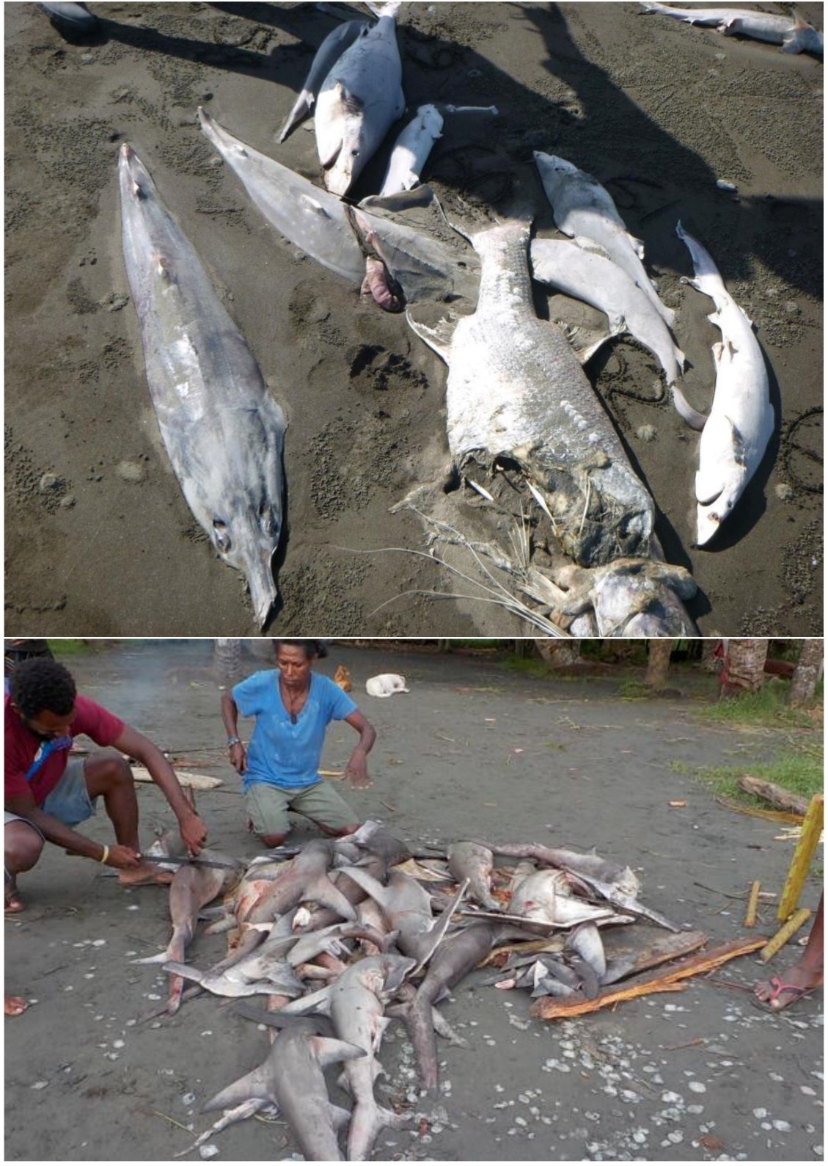
Figure A3. Top image: Discarded catch from swim bladder fishers in the Kikori River Delta. Elasmobranch bycatch include a narrow sawfish Anoxypristis cuspidata, an eyebrow wedgefish Rhynchobatus palpebratus and several Carcharhinus spp. A large barramundi Lates calcarifer, estimated to be over 1m in length is also discarded with only its swim bladder harvested, despite a value of $40–60 PGK at the nearby Kikori Fish Plant (comparatively, elasmobranch is valued at $3 PGK kg⁻¹, with fin attached at this facility). Bottom Image: Elasmobranch catch from fishers at the Sepik River mouth. In this instance, winghead sharks Eusphyra blochii constituted most of the elasmobranch catch. All individuals were finned, and carcasses discarded. Shark fin in an important economic resource for the community at the mouth of the Sepik River (Leeney et al. 2018). The value of swim bladder and its role in local economies comparatively is not understood, although fishers in coastal regions around the Sepik and Ramu Rivers do target croakers (Sciaenidae) for swim bladder.

Table A9. Estimated commercial prices for swim bladder for the four key species being traded in Gulf Province. Estimates made by Gulf Provincial Fisheries (Ibana 2020). PGK, Papua New Guinean Kina (1 PGK = ~$0.28 USD, 04/04/2021)
 |  | Maximum estimated price for key species (PGK)
Grade | Dried weight range per grade (g) | Catfish (Siluriformes) | King Threadfin (Polydactylus macrochir) | Barramundi (Lates calcarifer) | Jewel Fish (Nibea squamosa)
A | 200–1000 | 300 | 300 | 500 | 1400
B | 70–199 | 150 | 150 | 300 | 750
C | 0–69 | 50 | 50 | 50 | 300

Literature Cited
Appleyard, S., White, W., Vieira, S., Sabub, B. 2018. Artisanal shark fishing in Milne Bay Province, Papua New Guinea: biomass estimation from genetically identified shark and ray fins. Scientific Reports. 8: 1–12. https://doi.org/10.1038/s41598-018-25101-8
Baldwin, C., Mounts, J., Smith, D., Weigt, L. 2009. Genetic identification and color descriptions of early life-history stages of Belizean Phaeoptyx and Astrapogon (Teleostei: Apogonidae) with comments on identification of adult Phaeoptyx. Zootaxa. 26: 1–22. https://doi.org/10.5281/zenodo.185742
Compagno, L.J.V., White, W.T., Last, P.R. 2008. Glyphis garricki sp. nov., a new species of river shark (Carcharhiniformes: Carcharhinidae) from northern Australia and Papua New Guinea, with a redescription of Glyphis glyphis (Müller & Henle, 1839). CSIRO Marine and Atmospheric Research Paper. 22: 203–226
Faria, V.V. 2007. Taxonomic review, phylogeny, and geographical population structure of the sawfishes (Chondrichthyes, Pristiforms). PhD Thesis, Iowa State University, Ames, Iowa.
Garrick, J.A.F. 1982. Sharks of the genus Carcharhinus. NOAA (National Oceanic and Atmospheric Administration) Technical Report NMFS (National Marine Fisheries Service) Circular. 445: 1–194
Gilbert, C.R. 1967. A revision of the hammerhead sharks (family Sphyrnidae). Proceedings of the United States National Museum. 199: 1–88. https://doi.org/10.5479/si.00963801.119-3539.1
Ibana, D. 2020. Fish Maw Report. Report prepared for the Gulf Provincial Administration, Fisheries and Marine Resource Division.
IUCN. 2021. The IUCN Red List of Threatened Species. Version 2021-1. https://www.iucnredlist.org.
Leeney, R.H., Mana, R.R., Dulvy, N.K. 2018. Fishers ecological knowledge of sawfishes in the Sepik and Ramu rivers, northern Papua New Guinea. Endangered Species Research. 36: 15–26. https://doi.org/10.3354/esr00887
Morgan, D.L., Whitty, J.M., Phillips, N.M., Thorburn, D.C., Chaplin, J.A., McAuley, R. 2011. North-western Australia as a hotspot for endangered elasmobranchs with particular reference to sawfishes and the northern river shark. Journal of the Royal Society of Western Australia. 2: 345–358.
Smart, J.J., Chin, A., Baje, L., Green, M.E., Appleyard, S.A., Tobin, A.J., Simpfendorfer, C.A., White, W.T. 2016. Effects of including misidentified sharks in life history analyses: A case study on the grey reef shark Carcharhinus amblyrhynchos from Papua New Guinea. PLoS One. 11: e0153116. https://doi.org/10.1371/journal.pone.0153116
Thorburn, D.C., Morgan, D.L., Rowland, A.J., Gill, H.S., Paling, E. 2008. Life history notes of the critically endangered dwarf sawfish, Pristis clavata, Garman 1906 from the Kimberley region of Western Australia. Environmental Biology of Fishes. 83: 139–145. https://doi.org/10.1007/s10641-007-9306-6
Tillett, B.J., Field, I.C., Bradshaw, C.J.A., Johnson, G., Buckworth, R.C., Meekan, M.G., Ovenden, J.R. 2012. Accuracy of species identification by fisheries observers in a north Australian shark fishery. Fisheries Research. 127–128: 109–115. https://doi.org/10.1016/j.fishres.2012.04.007
White, W.T., Appleyard, S.A., Kyne, P.M., Mana, R.R. 2017a. Sawfishes in Papua New Guinea: a preliminary investigation into their status and level of exploitation. Endangered Species Research. 32: 277–291. https://doi.org/10.3354/esr00810
White, W.T., Baje, L., Sabub, B., Appleyard, S.A., Pogonoski, J.J., Mana, R.R. 2017b. Sharks and rays of Papua New Guinea. ACIAR Monograph No. 189. Australian Centre for International Agricultural Research, Canberra.
White, W.T., Baje, L., Appleyard, S.A., Chin, A., Smart, J.J., Simpfendorfer, C.A. 2020. Shark longline fishery of Papua New Guinea: size and species composition and spatial variation of the catches. Marine and Freshwater Research. 71: 627–640. https://doi.org/10.1071/MF19191
Whitty, J.M., Phillips, N.M., Thorburn, D.C., Simpfendorfer, C.A., Field, I., Peverell, S.C., Morgan, D.L. 2014. Utility of rostra in the identification of Australian sawfishes (Chondrichthyes: Pristidae). Aquatic Conservation: Marine and Freshwater Ecosystems. 24: 791–804. https://doi.org/0.1002/aqc.2398

