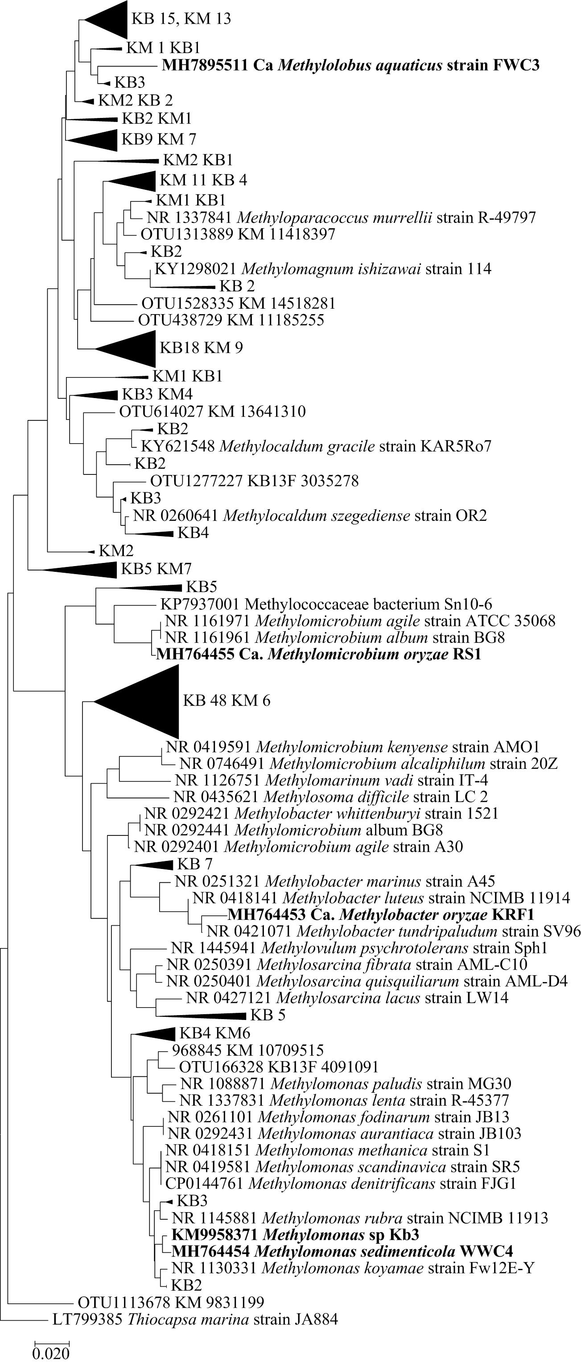

**Supplementary Figure 1:** Maximum-likelihood bootstrap tree of the 16S rRNA gene sequences of *Methylococcaceae* methanotrophic isolates in comparison with those of other metagenome clones obtained from KB (KB in Figure) and KM (KM in Figure) rice rhizosphere samples. The number in front of each denotes the number of metagenome sequences from that sample, e.g., KB 15 (15 metagenome sequences from the KB sample). Evolutionary analyses were conducted in MEGA7. The bar represents 1% divergence

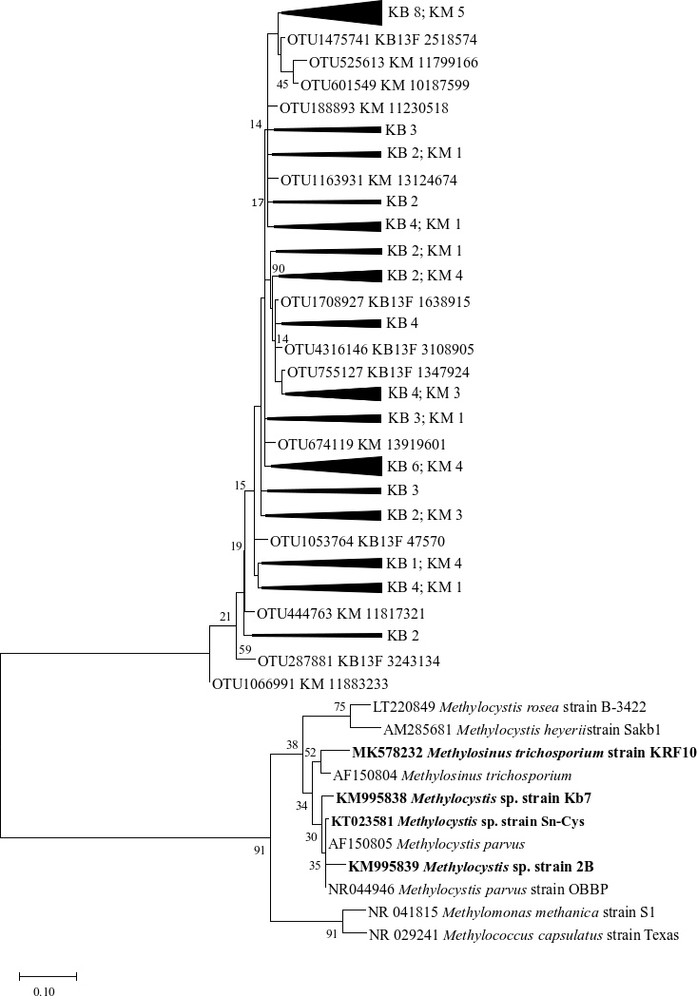

**Supplementary Figure 2:** *Methylocystaceae* family phylogenetic tree of the V3-V4 sequences derived from the metagenome of the KB (KB in the Figure) and the KM (KM in the Figure) samples. The number against the sample name represents the number of sequences retrieved for that sample. The tree also consists of methanotrophic isolate sequences for co-relation with the metagenome sequences. The phylogenetic tree was constructed using MEGAX, and the bar represents 1% divergence

|  |  |  |  |  |
| --- | --- | --- | --- | --- |
| **Supplementary Figure 3: Growth of isolates on solid media and their respective phase contrast image** | | | | |
| **S. No.** | **Sample** | **Strain name** | **Plate image** | **Phase contrast** |
| **1** | Kerala rice field rhizosphere | KRF 2 |  |  |
| **2** | KRF 3 |  |  |
| **3** | KRF 4 |  |  |
| **4** | KRF 5 |  |  |
| **5** | KRF 6 |  |  |
| **6** | KRF 7 |  |  |
| **7** | KRF 8 |  |  |
| **8** | KRF 9 |  |  |
| **9** | KRF 10 |  |  |
| **10** | KM 2 |  |  |
| **11** | KM 3 |  |  |
| **12** | KM 4 |  |  |
| **13** | KM 5 |  |  |
| **14** | KM 6 |  |  |
| **15** | KM 7 |  |  |
| **16** | KM 8 |  |  |
| **17** | KM 9B |  |  |
| **18** | KM 9W |  |  |
| **19** | KM 10 |  |  |
| **20** | Malegaon, Indrayani | IR 1 |  |  |
| **21** | IR 2 |  |  |
| **22** | Malegaon, Ratna stem | RS2 |  |  |
| **23** | Kasar Amboli, Ratna | KAR5Ro7 |  |  |
| **24** | Malegaon, Basmati | BM10 |  |  |
| **25** | Kalbhorwadi, Indrayani | Kb7 |  |  |
| **26** | Kasar Amboli | URRH |  |  |

**Supplementary Figure 3:** Growth of isolates on solid media plates and their respective phase-contrast images with 1000X magnification. The bar represents 5 µm.

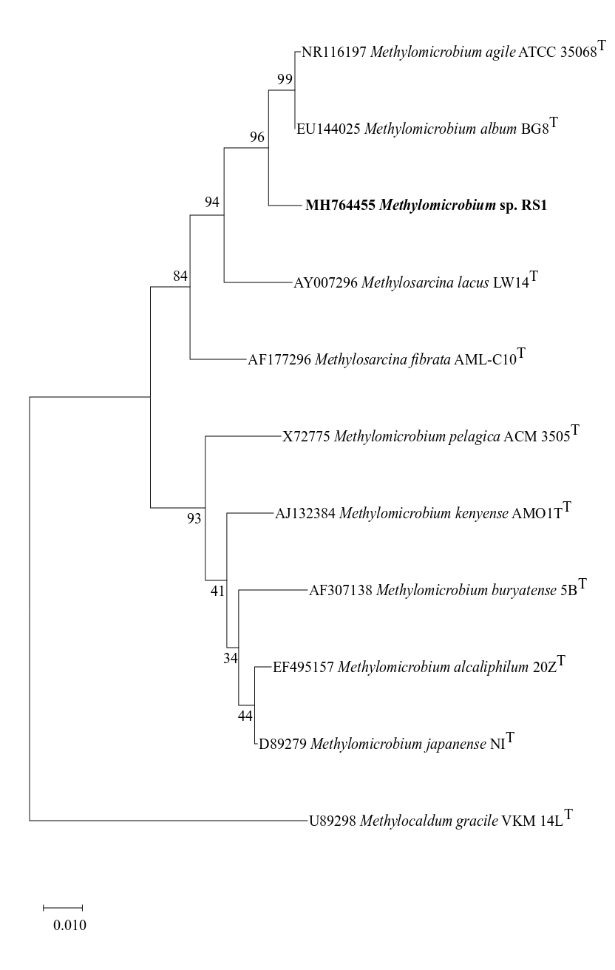 **Supplementary Figure 4a:** Maximum-likelihood 1000 bootstrap tree of the 16S rRNA gene sequence of strain RS1 in comparison with the closely associated *Methylococcaceae* bacteria. The phylogenetic tree was constructed using MEGA X and analysed based on the Tamura-Nei model. Bar represented 1% divergence

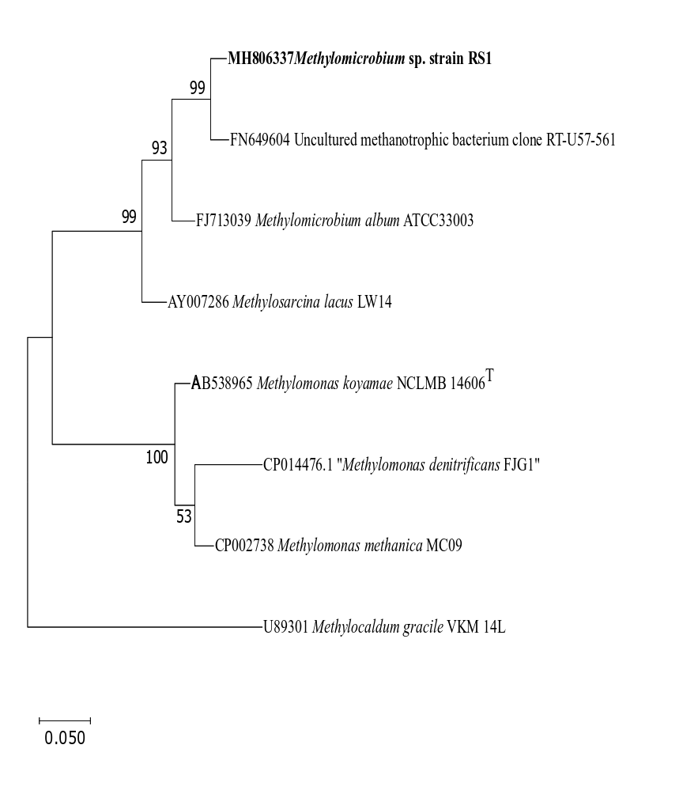

**Supplementary Figure 4b:** Maximum-likelihood 1000 bootstrap tree of the partial *pmo*A nucleotide sequence of strain RS1 in comparison with the *pmo*A gene sequences of closely related Type I methanotrophs. The evolutionary history was inferred by using the maximum-likelihood method based on the Tamura-Nei model with MEGAX. Bar representing 5% divergence. **Supplementary Figure 4b**