Supplementary Material

Supplementary Figures and Tables

Supplementary Figures
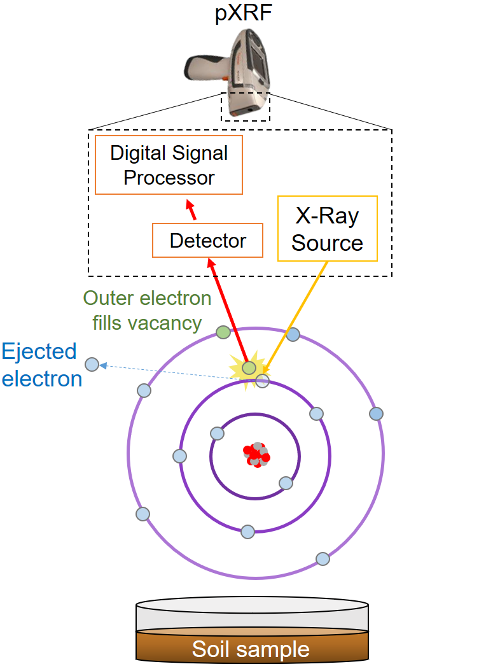
Supplementary Figure 1. Principles of the X-ray fluorescence methodology. An X-ray source emitted by the portable XRF device (here, Niton xl3t Goldd+, Thermo Fisher Scientific) excites and ejects an electron from a specific atom. An outer electron fills vacancy to stabilize the overall atom and the electron translocation process implies an energy loss (fluorescence). This energy, specific to each atom, is detected, amplified and processed by the pXRF device. The processing converts photon energy of a specific wavelength to counts per seconds to concentration of a specific element.

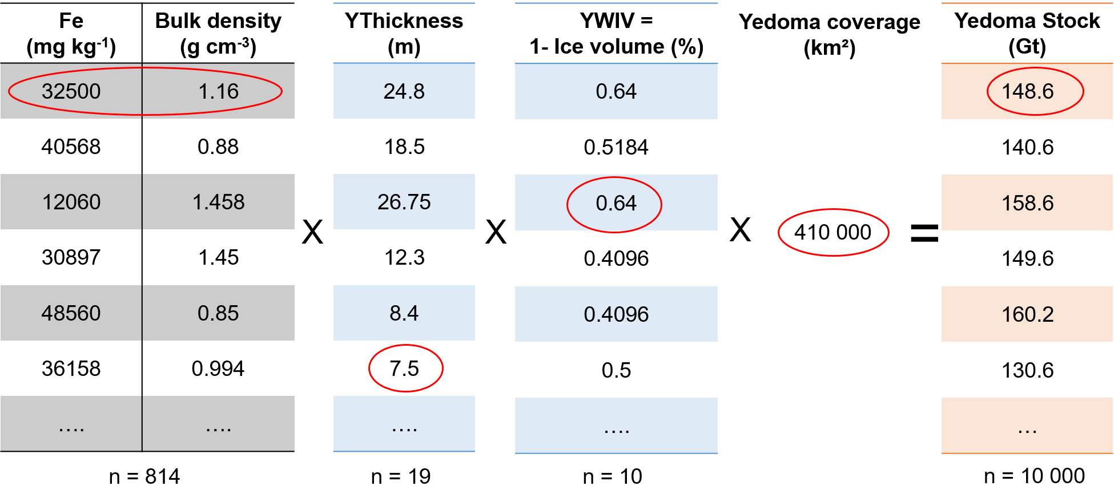
Supplementary Figure 2. Principles of the mean-bootstrapping technique to calculate mineral element stock in Yedoma domain deposits illustrated for Fe in Yedoma (Y). The bootstrapping statistical method use resampled (10,000 times) observed values (circled in red; i.e., mineral element concentration, bulk density, deposits thickness (mean = 19.6 m; n = 19) and ice-wedge volume (WIV; mean = 49.1%; n = 10)) and derive the mean afterward. This bootstrapping technique is used due to the non-normal distribution of the parameters. We used sampling with replacement, which means that after each step of the random draw from the original sample, we put the observation back before the following step. The process is done with 10,000 steps from which a stock density distribution is obtained. To estimate mineral elements stocks, we use the arithmetic mean and standard deviation assuming normality of the stock estimate distribution (Strauss et al., 2013).

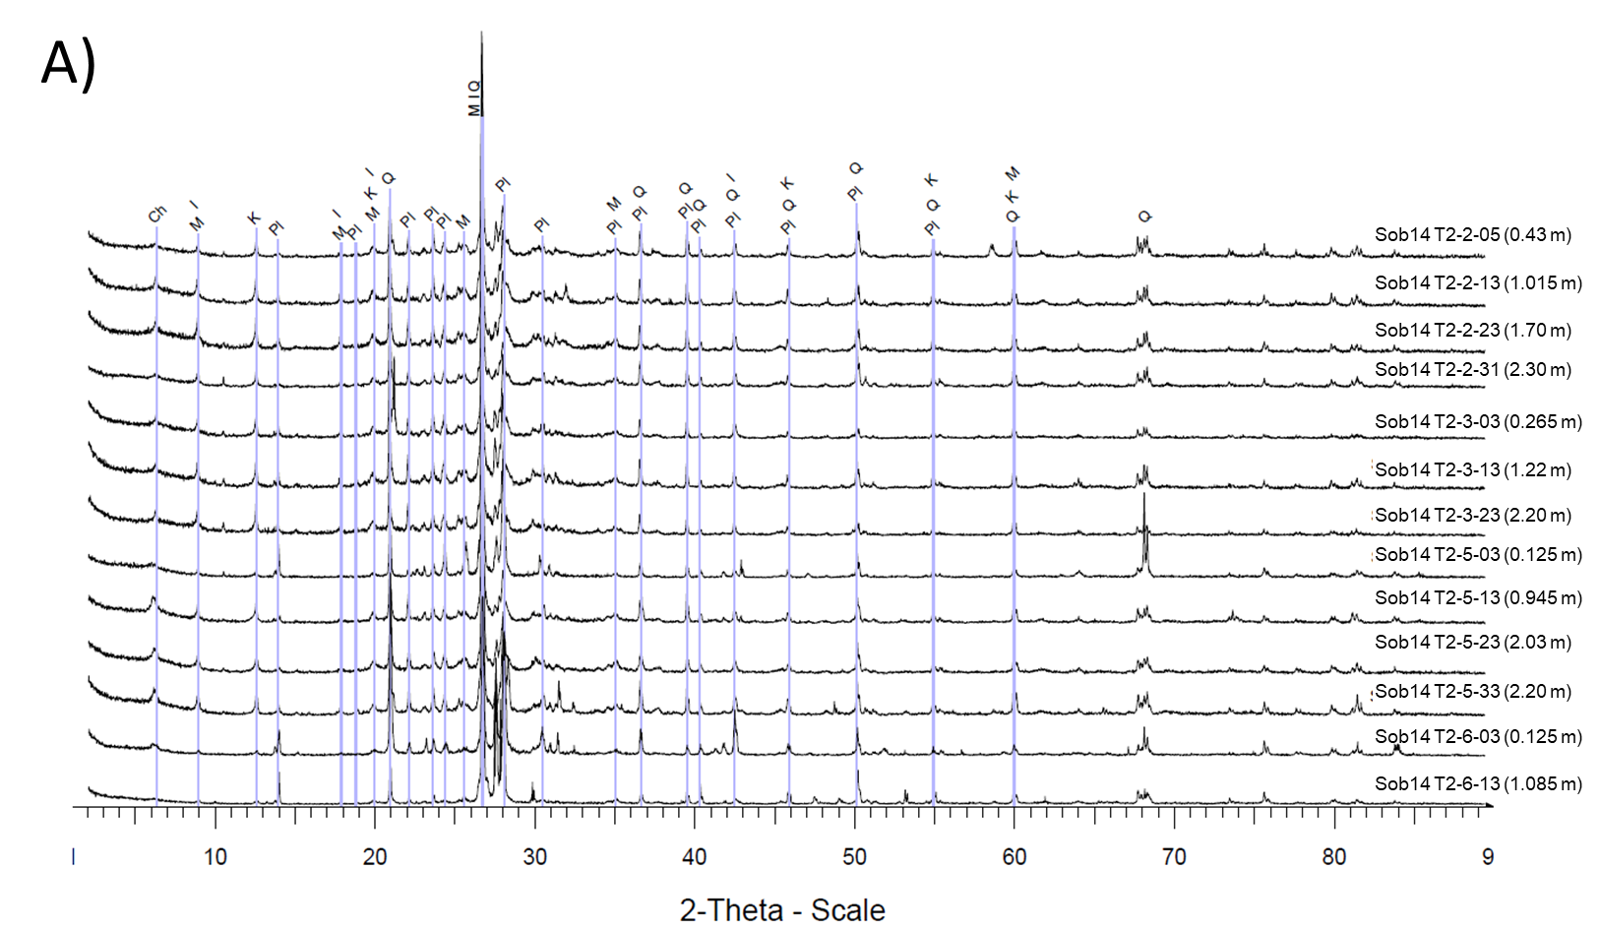
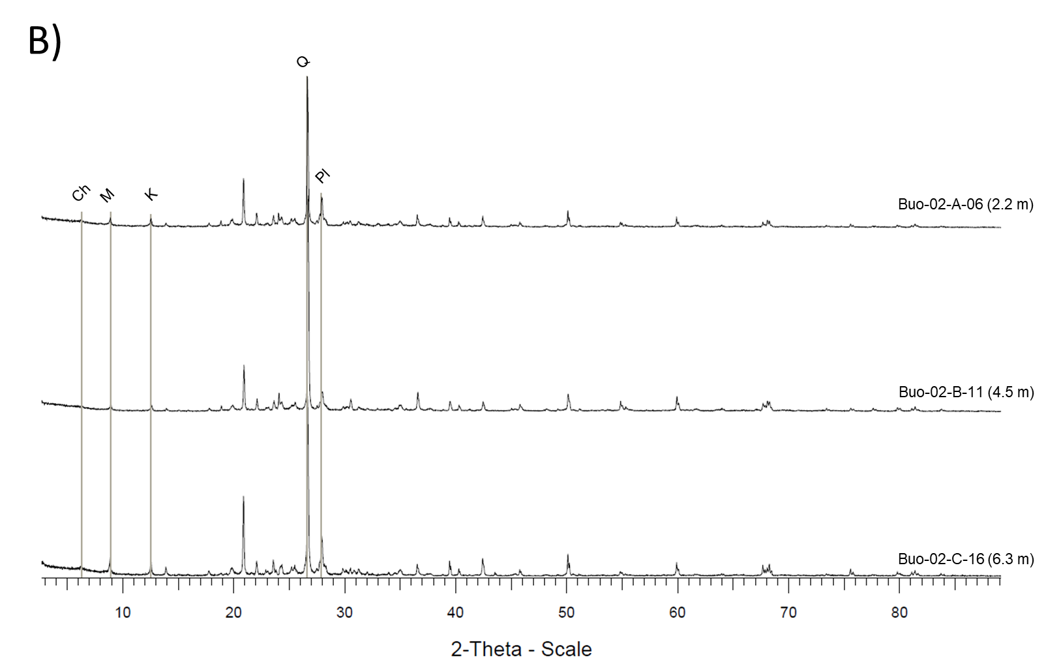
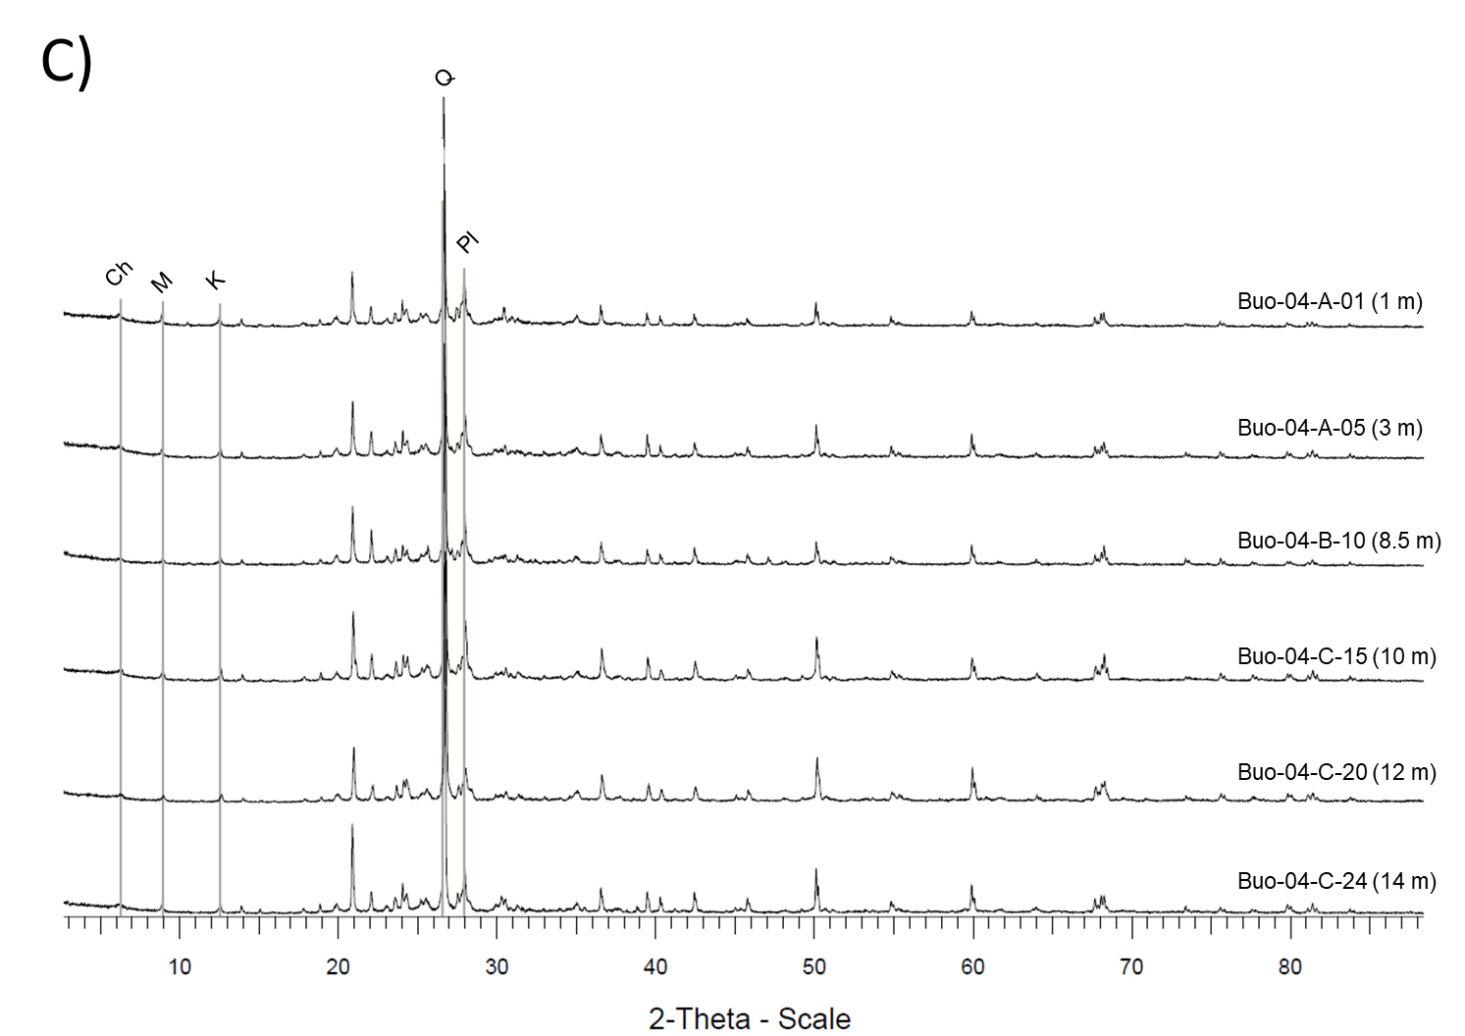
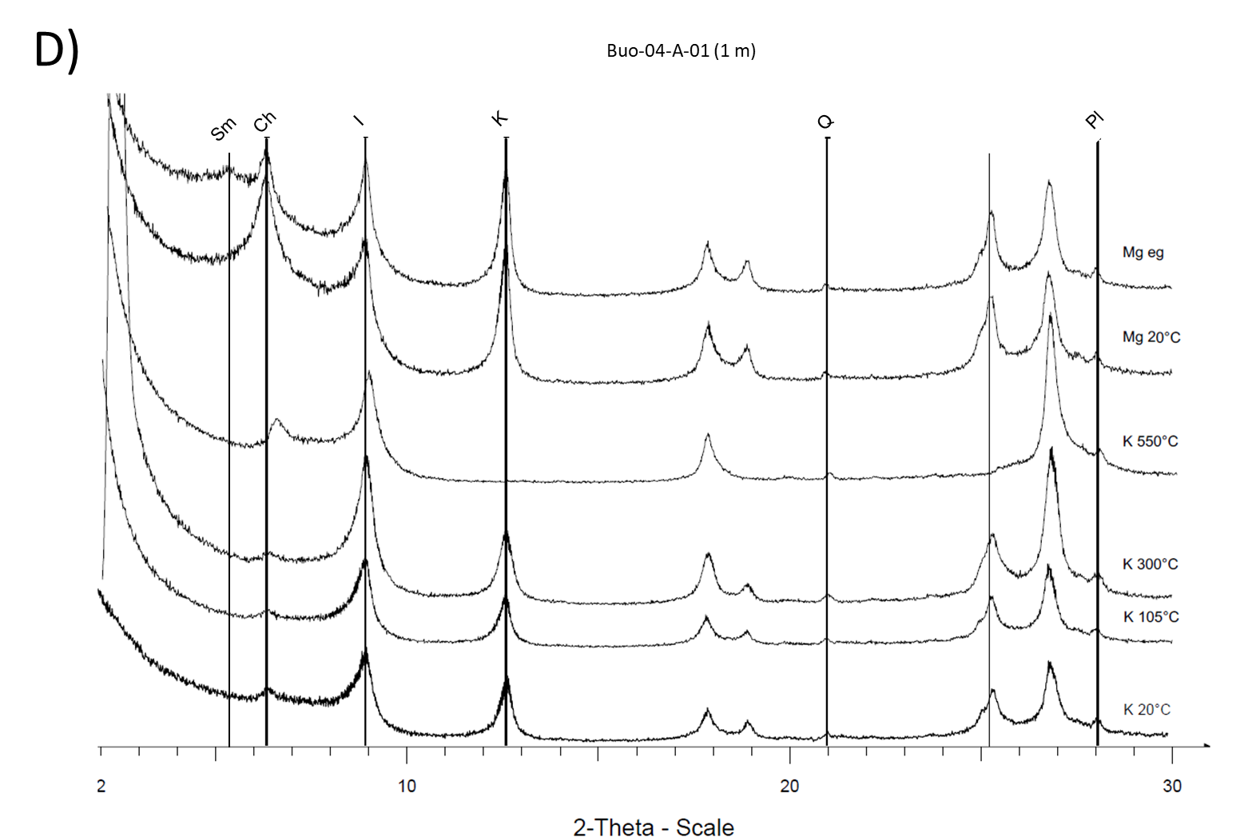
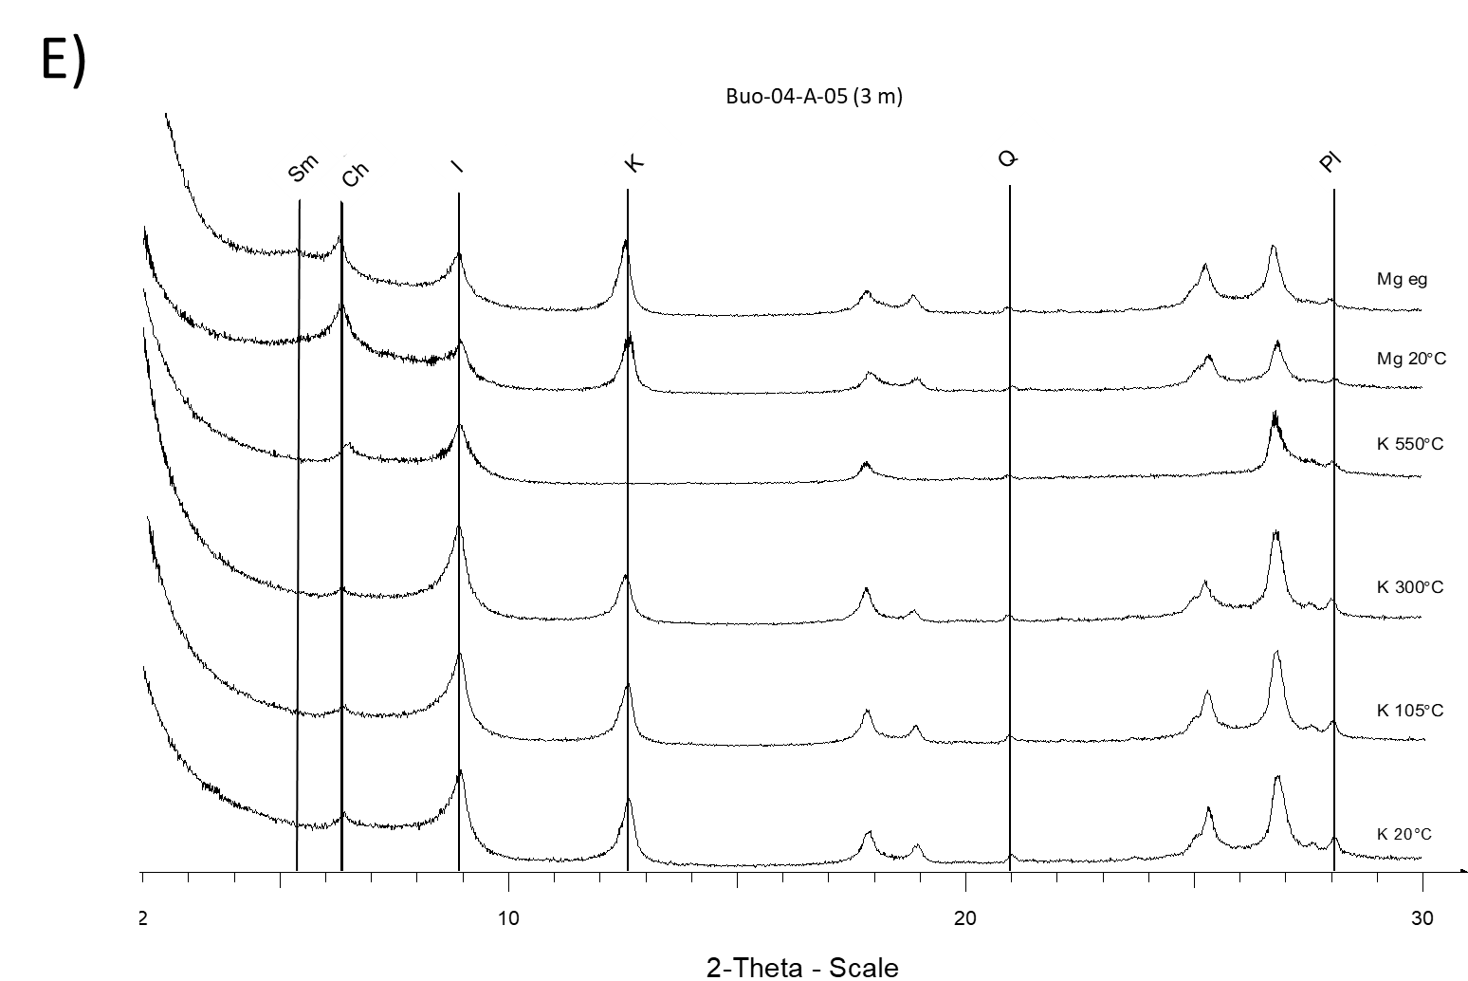
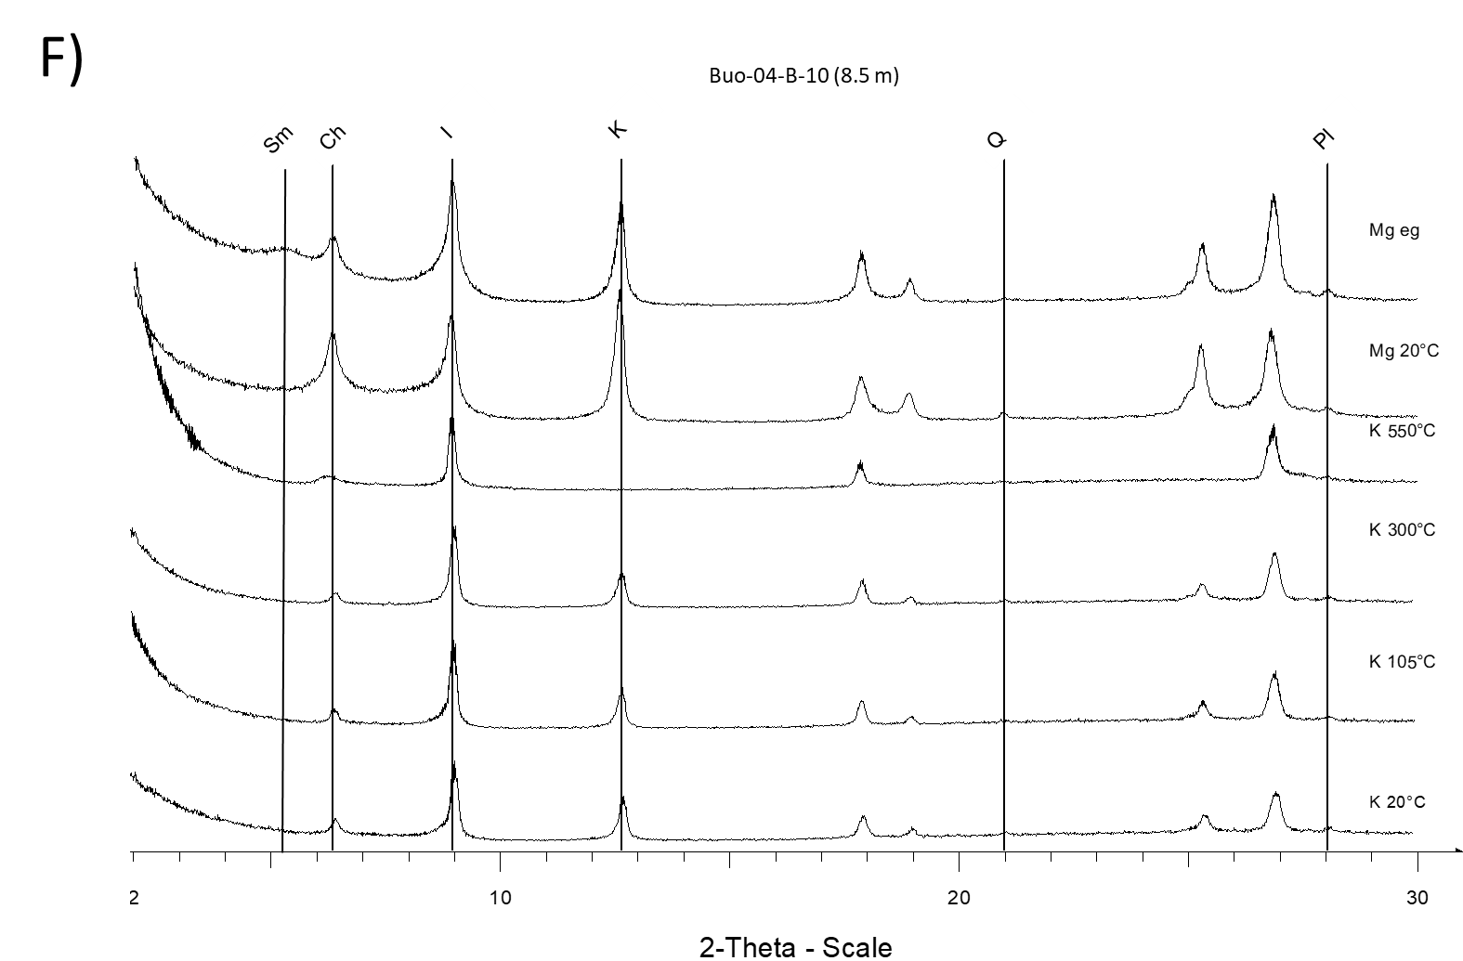
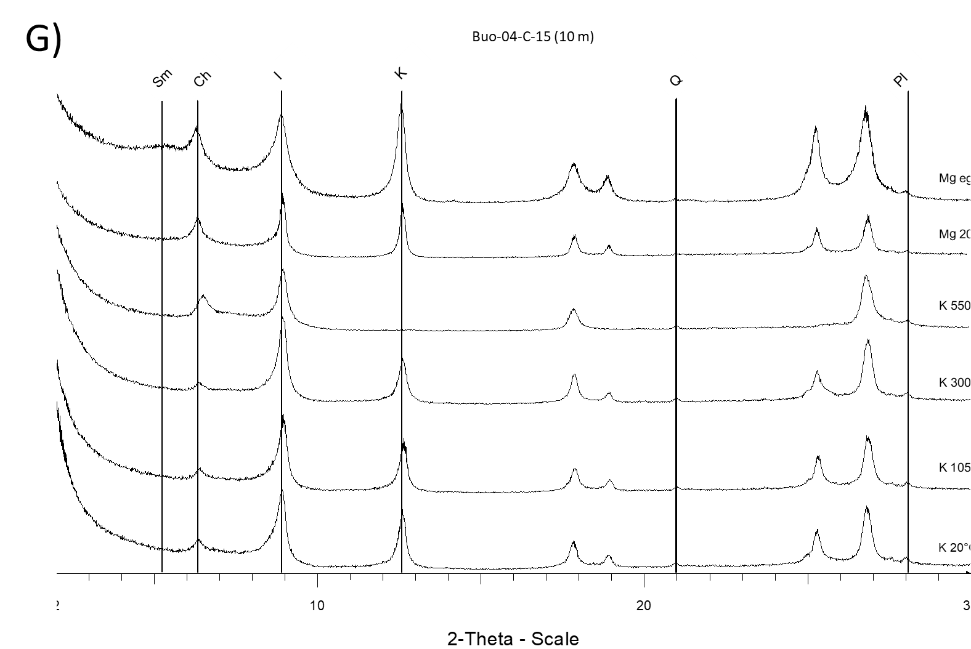
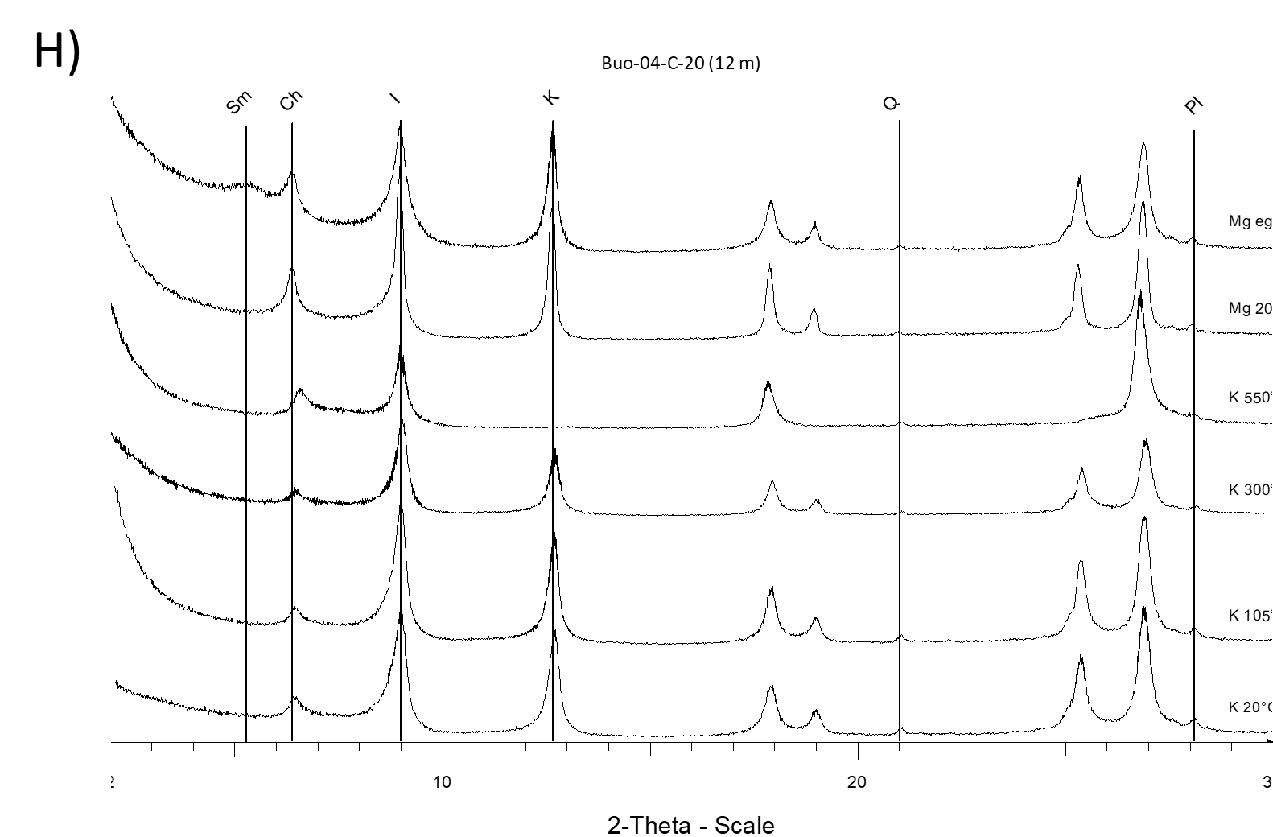
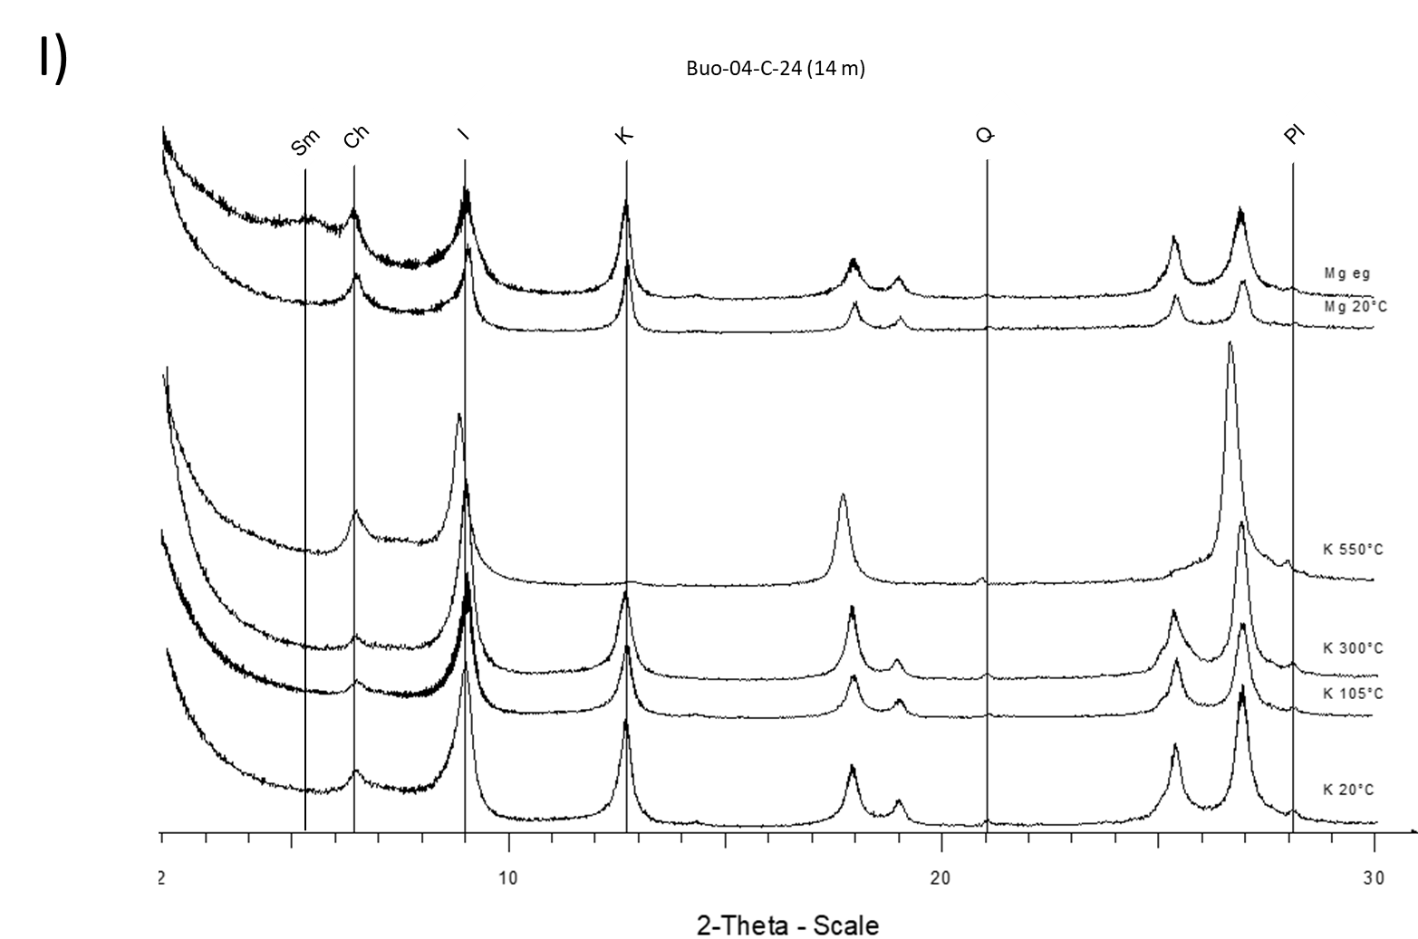
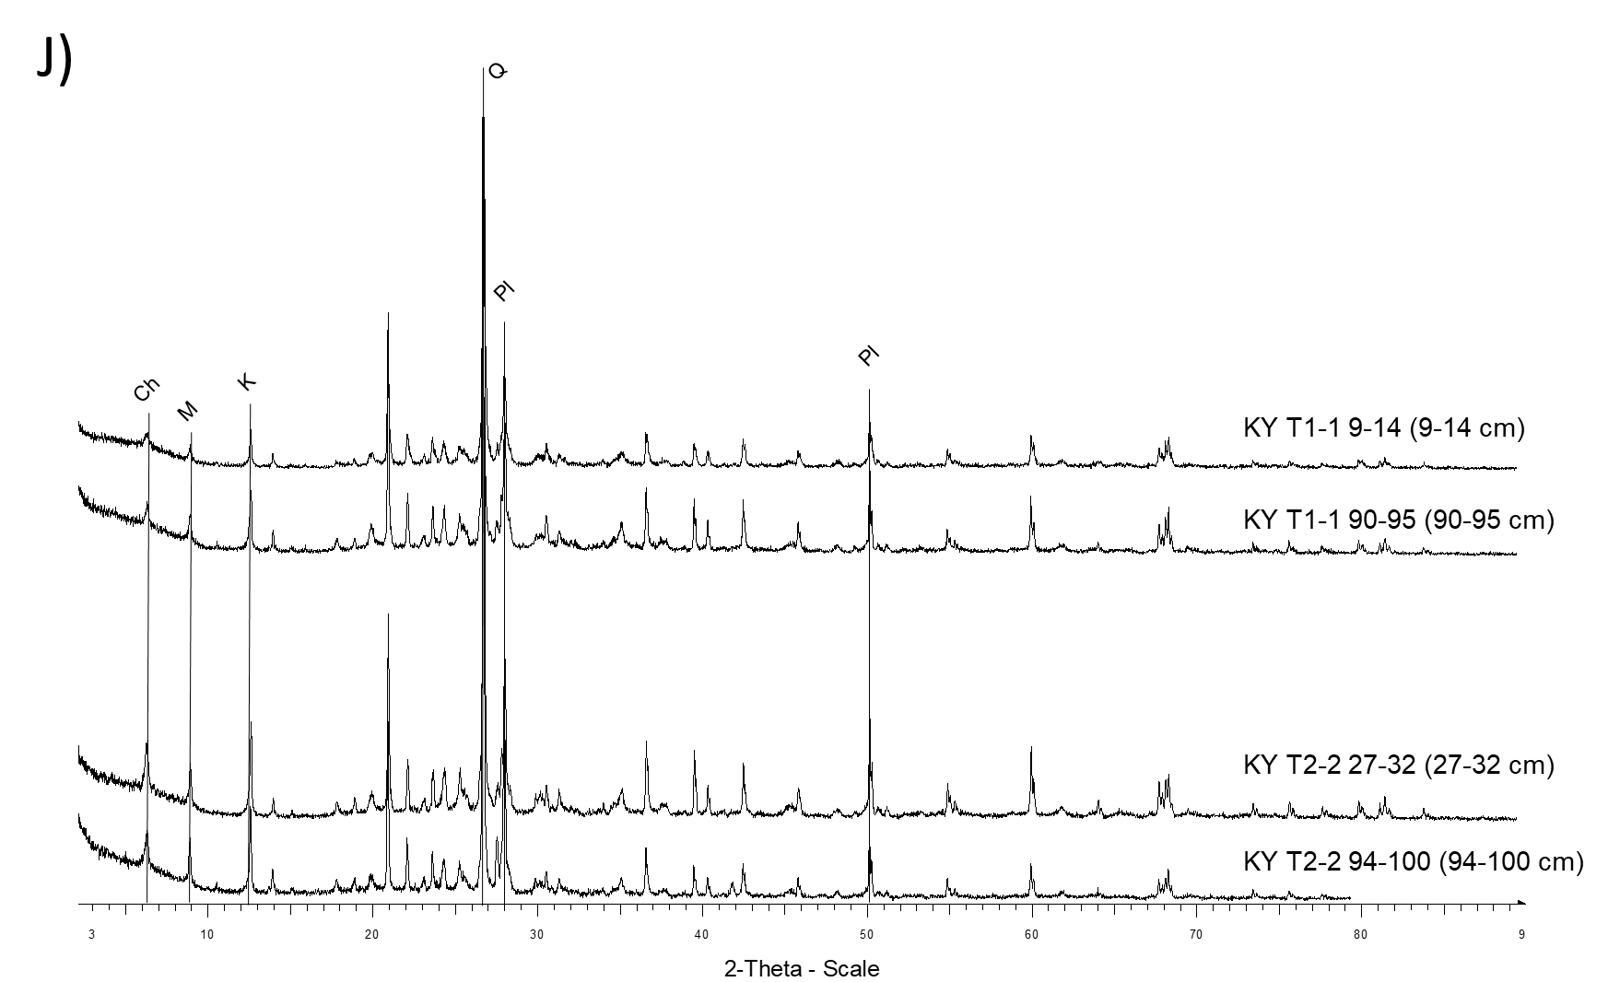
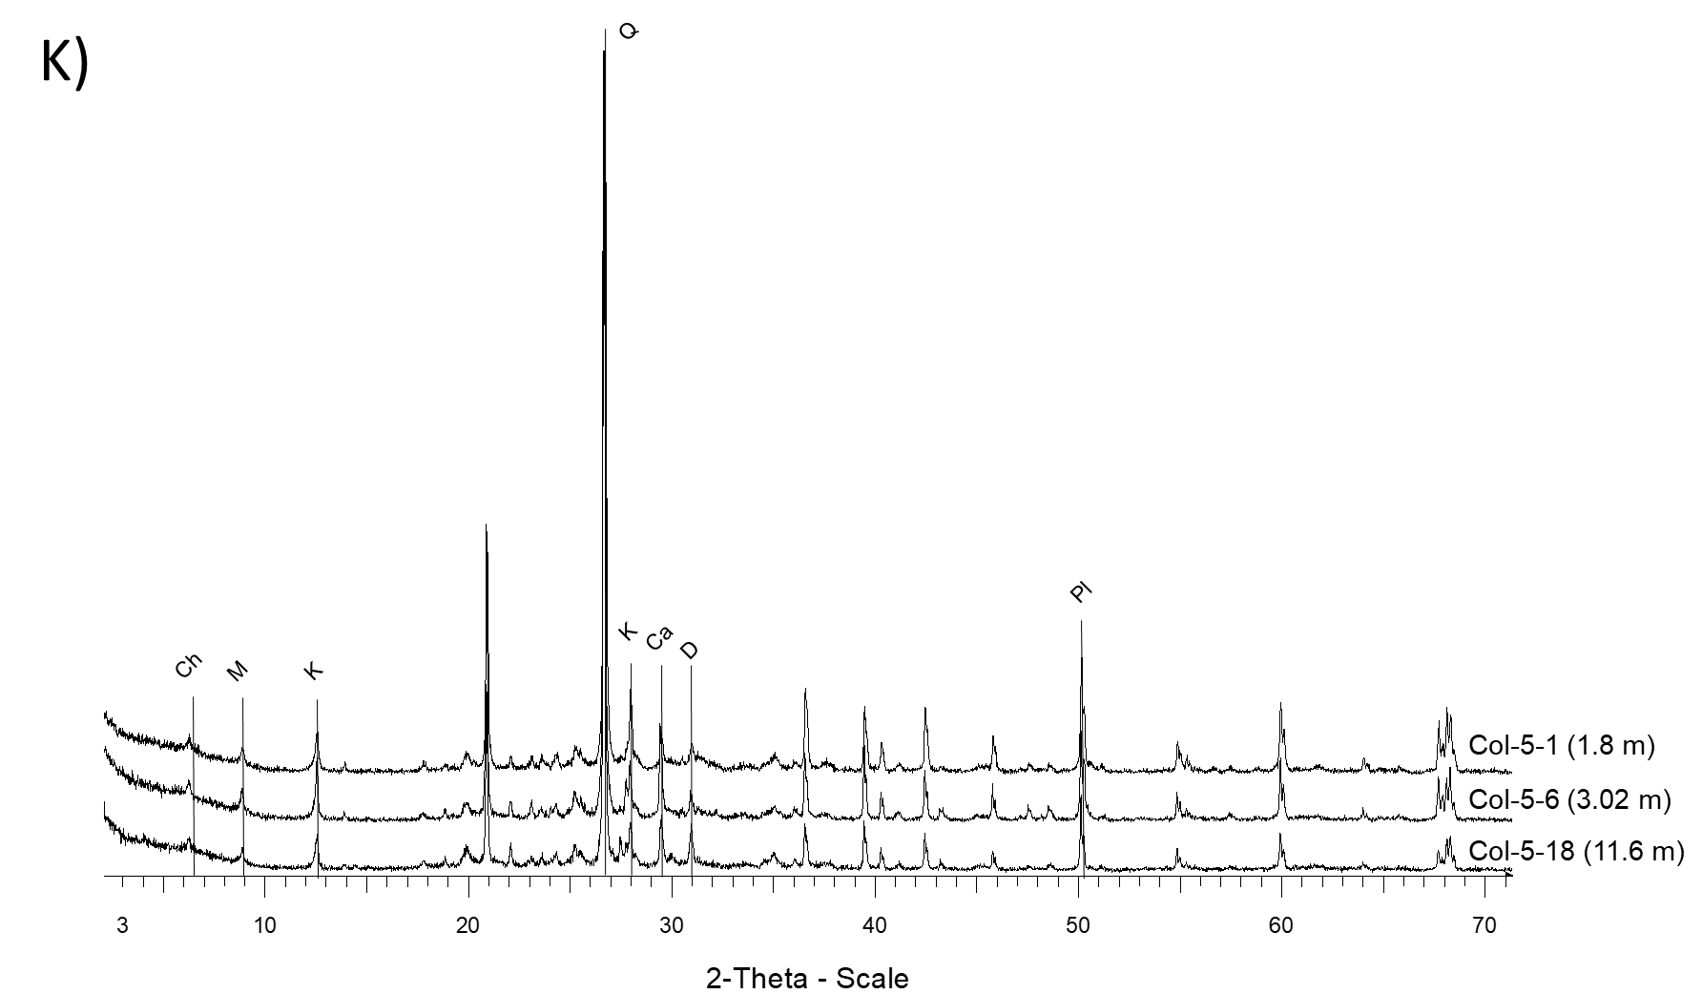
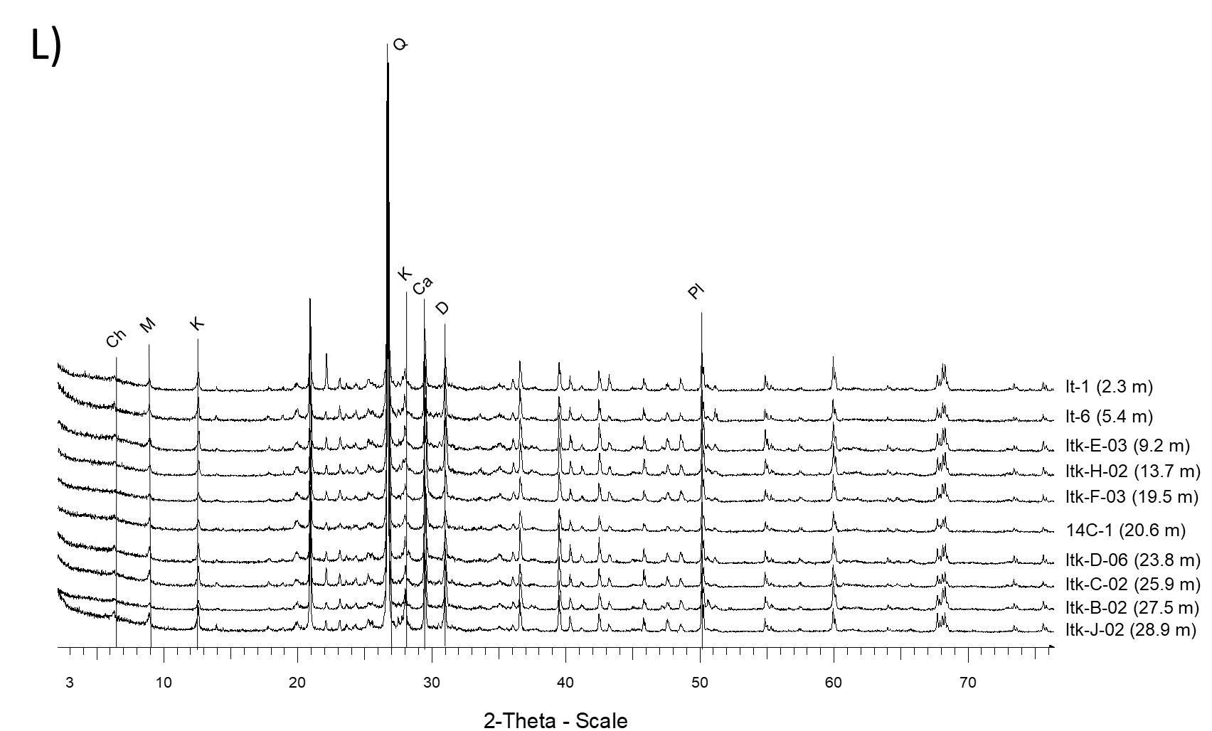

Supplementary Figure 3. X-ray diffractograms of Yedoma, Alas and fluvial deposits in Siberia and Alaska (Q, quartz; Pl, Plagioclase; Ch, Chlorite; M, Mica; I, Illite; K, Kaolinite; D, Dolomite; Ca, Calcite; Sm, Smectite). Each diffractogram is labelled according to label code from Table 1 and samples depth is specified next to each label. (A) Sobo Sise profiles, (B) Buo-02 profile, (C) Buo-04 profile, (D) to (I) Buo-04 clay fractions (including the following treatments: K⁺ and Mg²⁺ saturation, ethylene glycol (eg) solvation and thermal treatments at 300 and 550°C), (J) Kytalyk profiles, (K) Colville profile and (L) Itkillik profile. Diffractograms include Yedoma (Sob T2-2, Sob T2-3, Buo-02, Buo-04, KY T1-1, Col, Itk) and Alas or fluvial deposits (Sob T2-5, Sob T2-6, KY T2-2). A summary of the mineral phases identified in each location is provided in Table 6.

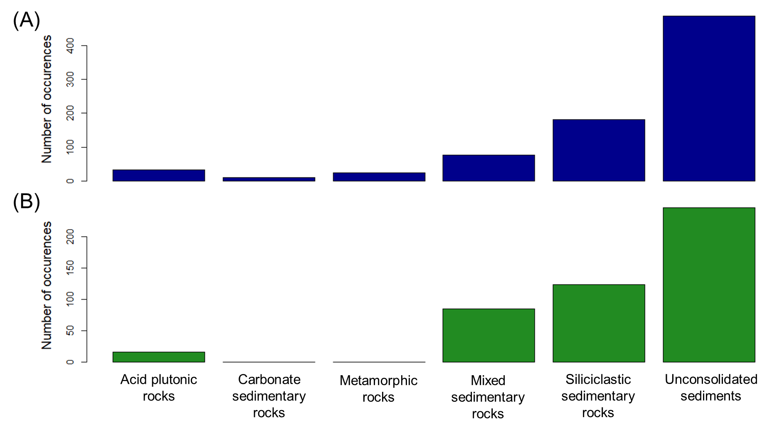
Supplementary Figure 4. Lithology of the bedrock underlying (A) Yedoma deposits (in blue, n=814) and (B) Alas deposits (in green, n=470) inferred from the Global Lithological Map (GLiM; Hartmann and Moosdorf, 2012).

Supplementary Tables
Supplementary Table 1. Studied locations from the Yedoma domain with associated labels, total number of sampled profiles, number of samples analyzed with portable X-ray Fluorescence (pXRF), inductively coupled plasma optical emission spectrometry (ICP-OES) after alkaline fusion and X-ray diffraction method (XRD). A simplified geomorphological description of each sampling location is presented (detailed information is provided in the reference papers cited in Table 1). The site numbers (Site Nb) 1-17 are from Siberia, and 18-22 are from Alaska
Site Nb | Site Name | Label | Total sampled profiles | Samples analyzed with pXRF method | Samples analyzed with ICP-OES method | Samples characterized with XRD method | Geomorphology of sampling location
1 | Cape Mamontov Klyk | Mak | 3 | 80 | - | - | Sedimentary coastal plain
2 | Nagym (Ebe Sise Island) | Nag | 3 | 29 | - | - | Cliff section with thermokarst mounds
3 | Khardang Island | Kha | 1 | 31 | 1 | - | Cliff section with thermokarst mounds
4 | Kurungnakh Island | Bkh, KUR | 4 | 143 | 2 | - | Fragment of a broad foreland plain north of the Chekanovsky Ridge
5 | Sobo Sise Island | Sob | 4 | 58 | 58 | 13 | Yedoma uplands but also features permafrost degradation landforms (thermokarst lakes, drained thaw lake basin, and thermo-erosional gullies)
6 | Bykovsky Peninsula | Mkh, BYK | 7 | 150 | 2 | - | Remnants of an accumulation plain
7 | Muostakh Island | Muo | 1 | 11 | - | - | Remnants of an accumulation plain
8 | Buor Khaya Peninsula | Buo | 5 | 80 | 44 | 10 | Coastal lowlands - late Pleistocene accumulation plains
9 | Stolbovoy Island | Sto | 4 | 16 | 1 | - | Step-like cryoplanation terraces with several levels
10 | Belkovsky Island | Bel | 2 | 12 | - | - | Step-like cryoplanation terraces with several levels
11 | Kotel’ny Island | KyS | 1 | 10 | - | - | Step-like cryoplanation terraces with several levels
12 | Bunge Land | Bun | 1 | 8 | - | - | More-or-less homogeneous flat sandy plain
13 | Bol’shoy Lyakhovsky Island | TZ, R, L | 15 | 150 | 3 | - | Gradually sloping terrain intersected by rivers and thermo-erosional valleys
14 | Oyogos Yar coast | Oy | 2 | 50 | 1 | - | Very gently inclined step-like surface of the Yana-Indigirka Lowland
15 | Kytalyk | KY, KH | 3 | 50 | 4 | 4 | Recent and sub-recent floodplains, Yedoma and Alas
16 | Duvanny Yar | DY | 6 | 143 | 5 | - | Hills dissected by deep thermos-erosional valleys and thermokarst depressions
17 | Yukechi | Yuk-Yul | 4 | 87 | 2 | - | Yedoma uplands and drained alas basins, indicating active thermokarst processes
18 | Kitluk | Kit | 2 | 45 | 2 | - | Tundra-covered coastal plain
19 | Baldwin Peninsula | Bal | 4 | 70 | 1 | - | Sequence of marine, fluvial and glaciogenic sediments, which are well exposed along coastal bluffs and in some regions covered by loess-like deposits
20 | Colville | Col | 1 | 23 | 8 | 3 | High exposure along the Colville River
21 | Itkillik | Itk, It | 1 | 22 | 10 | 10 | High exposure along the lower Itkillik River formed by active river erosion of a large remnant of originally gently undulating Yedoma terrain
22 | Vault Creek Tunnel | FAI | 1 | 24 | - | - | Permafrost tunnel about 40 m deep and 220 m long on north facing slope
TOTAL | 22 |  | 75 | 1292 | 144 | 40

Supplementary Table 2. Accuracy on the measurement by inductively coupled plasma optical-emission spectrometry (ICP-OES) after alkaline fusion for three certified reference materials: i) USGS BHVO-2 (Wilson, 1997), ii) GBW07401 (GSS-1) and iii) GBW07404 (GSS-4) (National Research Centre for CRM, 1986). The mean and standard deviation (SD; n= number of repetitions) of ICP-OES values and certified values are shown. The offset, defined as the difference between certified and ICP-OES value over the certified value, expressed in %, is provided for each reference material.
 | Si | Al | Fe | Ca | K | Ti | Mn | Zn | Sr | Zr
Units | Wt % | Wt % | Wt % | Wt % | Wt % | Wt % | mg kg⁻¹ | mg kg⁻¹ | mg kg⁻¹ | mg kg⁻¹
BHVO-2
n | 12 | 12 | 12 | 12 | 12 | 12 | 12 | 5 | 11 | 12
ICP-OES mean  (SD) | 23.2  (0.2) | 7.16  (0.07) | 8.56 (0.14) | 8.06 (0.11) | 0.43  (0.03) | 1.61 (0.02) | 1291  (49) | 110  (7) | 392  (29) | 176  (9)
Certified values mean (SD) | 23.3 (0.3) | 7.16 (0.08) | 8.63 (0.14) | 8.17 (0.12) | 0.43 (0.01) | 1.63 (0.02) | 1290  (40) | 103  (6) | 389  (23) | 172  (11)
Offset (%) | -0.3 | 0.02 | -0.8 | -1.4 | 0.5 | -1.2 | 0.05 | 7.2 | 0.8 | 2.4
GBW07401 (GSS-1)
n | 5 | 5 | 5 | 5 | 5 | 5 | 5 | 5 | 5 | 5
ICP-OES mean  (SD) | 28.7  (0.79) | 7.43  (0.16) | 3.48  (0.05) | 1.15  (0.01) | 2.09  (0.04) | 0.47  (0.01) | 1703  (30) | 666  (9) | 152  (3) | 239  (10)
Certified values mean (SD) | 29.3 (0.07) | 7.50  (0.07) | 3.63 (0.06) | 1.23 (0.04) | 2.15  (0.03) | 0.48 (0.02) | 1760  (63) | 680  (25) | 155  (7) | 245  (12)
Offset (%) | -2.0 | -0.9 | -4.2 | -6.2 | -2.6 | -2.8 | -3.2 | -2.1 | -1.9 | -2.3
GBW07404 (GSS-4)
n | 5 | 5 | 5 | 5 | 5 | 5 | 5 | 5 | 5 | 5
ICP-OES mean  (SD) | 23.7  (0.4) | 12.3  (0.3) | 6.76  (0.15) | 0.15  (0.01) | 0.87  (0.02) | 1.06  (0.02) | 1404  (19) | 209  (3) | 78  (1) | 518  (4)
Certified values mean (SD) | 23.8  (0.1) | 12.4  (0.1) | 7.20 (0.08) | 0.19 (0.03) | 0.86  (0.05) | 1.08 (0.03) | 1420  (75) | 210  (13) | 77  (6) | 500  (42)
Offset (%) | -0.3 | -0.6 | -6.1 | -21 | 1.3 | -2.1 | -1.2 | -0.4 | 1.0 | 3.7

Supplementary Table 3. List of samples (n=144) analysed by both inductively coupled plasma optical-emission spectrometry (ICP-OES) and portable X-ray fluorescence (XRF) method for linear regressions determination. Depth (below surface level) or *height (above sea level) are provided (in metres) if available. Labels are associated to labels from the Yedoma domain Mineral Concentration Assessment (YMCA) dataset for additional characteristics.
n | Sample label | Depth/  *Height  (m) | n | Sample label | Depth/  *Height  (m) | n | Sample label | Depth/  *Height  (m)
1 | Sob14-T2-2-03 | 0.225 | 49 | Sob14-T2-6-09 | 0.775 | 97 | Buo-02-D-23 | 7
2 | Sob14-T2-2-05 | 0.43 | 50 | Sob14-T2-6-11 | 0.96 | 98 | Col-5-1 | 1.8
3 | Sob14-T2-2-07 | 0.6 | 51 | Sob14-T2-6-13 | 1.085 | 99 | Col-5-6 | 3.02
4 | Sob14-T2-2-09 | 0.745 | 52 | Sob14-T2-6-15 | 1.15 | 100 | Col-5-10 | 5.4
5 | Sob14-T2-2-11 | 0.87 | 53 | Sob14-T2-6-16 | 1.2 | 101 | Col-5-13 | 6.9
6 | Sob14-T2-2-13 | 1.015 | 54 | Buo-04-A-00 | 0.1 | 102 | Col-5-15 | 9
7 | Sob14-T2-2-15 | 1.15 | 55 | Buo-04-A-01 | 1 | 103 | Col-5-18 | 11.6
8 | Sob14-T2-2-17 | 1.25 | 56 | Buo-04-A-02 | 1.5 | 104 | It-1 | 2.3
9 | Sob14-T2-2-19 | 1.4 | 57 | Buo-04-A-03 | 2 | 105 | It-6 | 5.4
10 | Sob14-T2-2-21 | 1.565 | 58 | Buo-04-A-04 | 2.5 | 106 | Itk-E-03 | 9.2
11 | Sob14-T2-2-23 | 1.7 | 59 | Buo-04-A-05 | 3 | 107 | Itk-H-02 | 13.7
12 | Sob14-T2-2-25 | 1.82 | 60 | Buo-04-A-06 | 3.5 | 108 | Itk-F-03 | 19.5
13 | Sob14-T2-2-27 | 1.935 | 61 | Buo-04-A-07 | 4.5 | 109 | 14C-1 | 20.6
14 | Sob14-T2-2-29 | 2.14 | 62 | Buo-04-A-08 | 5 | 110 | Itk-D-06 | 23.8
15 | Sob14-T2-2-31 | 2.3 | 63 | Buo-04-B-09 | 8 | 111 | Itk-C-02 | 25.9
16 | Sob14-T2-3-03 | 0.265 | 64 | Buo-04-B-10 | 8.5 | 112 | Itk-B-02 | 27.5
17 | Sob14-T2-3-05 | 0.52 | 65 | Buo-04-B-11 | 9 | 113 | Itk-J-02 | 28.9
18 | Sob14-T2-3-07 | 0.66 | 66 | Buo-04-B-12 | 9.5 | 114 | Sob14-T2-2-03bis | 0.225
19 | Sob14-T2-3-09 | 0.835 | 67 | Buo-04-B-13 | 10 | 115 | Sob14-T2-2-07bis | 0.6
20 | Sob14-T2-3-11 | 1.045 | 68 | Buo-04-C-14 | 9.5 | 116 | Sob14-T2-2-15bis | 1.15
21 | Sob14-T2-3-13 | 1.22 | 69 | Buo-04-C-15 | 10 | 117 | Sob14-T2-2-20bis | 1.5
22 | Sob14-T2-3-15 | 1.45 | 70 | Buo-04-C-16 | 10.5 | 118 | Sob14-T2-2-30bis | 2.2
23 | Sob14-T2-3-17 | 1.685 | 71 | Buo-04-C-17 | 11 | 119 | KY-T1-1-9-14 | 0.125
24 | Sob14-T2-3-19 | 1.885 | 72 | Buo-04-C-19 | 11.7 | 120 | KY-T1-1-90-95 | 0.925
25 | Sob14-T2-3-21 | 2.04 | 73 | Buo-04-C-20 | 12 | 121 | KY-T2-2-27-32 | 0.295
26 | Sob14-T2-3-23 | 2.2 | 74 | Buo-04-C-21 | 12.5 | 122 | KY-T2-2-94-100 | 0.97
27 | Sob14-T2-3-25 | 2.4 | 75 | Buo-04-C-22 | 13 | 123 | Oy7-11-16 | 11.9*
28 | Sob14-T2-5-03 | 0.125 | 76 | Buo-04-C-23 | 13.5 | 124 | 52Mkh-KB-7-5 | 22.3*
29 | Sob14-T2-5-05 | 0.375 | 77 | Buo-02-A-01 | 0.3 | 125 | DY-01-F-34 | 29.1*
30 | Sob14-T2-5-07 | 0.48 | 78 | Buo-02-A-02 | 0.6 | 126 | DY-02-A-01 | 5*
31 | Sob14-T2-5-09 | 0.635 | 79 | Buo-02-A-03 | 0.7 | 127 | DY-04-A-01 | 7.85*
32 | Sob14-T2-5-11 | 0.775 | 80 | Buo-02-A-04 | 1.2 | 128 | DY-04-A-02 | 7.7*
33 | Sob14-T2-5-13 | 0.945 | 81 | Buo-02-A-05 | 1.7 | 129 | DY-05-B-05 | 2.7*
34 | Sob14-T2-5-15 | 1.15 | 82 | Buo-02-A-06 | 2.2 | 130 | Kit-8-5 | -
35 | Sob14-T2-5-17 | 1.32 | 83 | Buo-02-B-07 | 2.5 | 131 | Col-5-2 | -
36 | Sob14-T2-5-19 | 1.505 | 84 | Buo-02-B-08 | 3 | 132 | Col-5-17 | -
37 | Sob14-T2-5-21 | 1.75 | 85 | Buo-02-B-09 | 3.5 | 133 | Sto-1-1 | 0.25
38 | Sob14-T2-5-23 | 2.03 | 86 | Buo-02-B-10 | 4 | 134 | 1TZ-2-2 | 17.65*
39 | Sob14-T2-5-25 | 2.19 | 87 | Buo-02-B-11 | 4.5 | 135 | L21+50-S-3 | 4.3*
40 | Sob14-T2-5-27 | 2.39 | 88 | Buo-02-B-13 | 5.5 | 136 | L7-08-03 | 4.5*
41 | Sob14-T2-5-29 | 2.57 | 89 | Buo-02-C-14 | 5.2 | 137 | 126Mkh-6.1.1 | 1.25*
42 | Sob14-T2-5-31 | 2.76 | 90 | Buo-02-C-15 | 5.7 | 138 | 11KH-3007-1-4 | 0.6
43 | Sob14-T2-5-33 | 2.94 | 91 | Buo-02-C-16 | 6.3 | 139 | Bkh2002 S17 | 32.5*
44 | Sob14-T2-5-35 | 3.075 | 92 | Buo-02-C-17 | 6.9 | 140 | BAL16-B2-30 | 10.97
45 | Sob14-T2-5-36 | 3.1525 | 93 | Buo-02-D-18 | 4.5 | 141 | YUK15-YUL7-5 | 7.75*
46 | Sob14-T2-6-03 | 0.125 | 94 | Buo-02-D-19 | 5 | 142 | YUK15-YUL7-15 | 17.96*
47 | Sob14-T2-6-05 | 0.325 | 95 | Buo-02-D-20 | 5.5 | 143 | K-10-14-4 | 14.38
48 | Sob14-T2-6-07 | 0.525 | 96 | Buo-02-D-22 | 6.5 | 144 | Kit-7-2 | -

Supplementary Table 4. Precision of pXRF method on the element concentrations expressed pooled standard deviations (i.e., 2 pooled standard deviations, expressed in mg kg⁻¹) for the 10 elements considered. The values are based on a subset of Yedoma and Alas deposit samples with three to five repetitions of 20 samples. The coefficient of variation (CV; expressed in %), defined as the ratio of the standard deviation to the mean is available. The error bars on Fig. 5 are based on the following standard deviations for pXRF method.

 |  | Si | Al | Fe | Ca | K | Ti | Mn | Zn | Sr | Zr
pXRF | ±2SD_{pooled} (mg kg⁻¹) | ± 3675 | ± 4107 | ± 2288 | ± 1066 | ± 1084 | ± 88.5 | ± 87 | ± 0.587 | ± 15.88 | ± 28.2
 | CV (%) | 2.14 | 3.07 | 3.44 | 5.46 | 2.77 | 3.62 | 8.74 | 7.78 | 4.09 | 4.93

Supplementary Table 5. Mineral elements density (kg m⁻³) summary in Yedoma and Alas deposits (n=814 and 470, respectively). This mineral element density neglects the presence of ice-wedges.

 | Mineral element density (kg m⁻³)
 | Yedoma deposits |  | Alas deposits
Element | Mean | ± 2σ | Mean | ± 2σ
Si | 345.6 | 8.34 | 335.3 | 14.07
Al | 75.4 | 1.74 | 73.0 | 2.96
Fe | 36.0 | 0.843 | 35.3 | 1.38
Ca | 17.3 | 0.916 | 13.1 | 1.02
K | 22.0 | 0.572 | 21.3 | 0.98
Ti | 4.64 | 0.107 | 4.42 | 0.18
Mn | 0.626 | 0.0883 | 0.587 | 0.035
Zn | 0.080 | 0.0019 | 0.078 | 0.0039
Sr | 0.235 | 0.0085 | 0.235 | 0.016
Zr | 0.332 | 0.0094 | 0.315 | 0.017

