Supplemental Information:

Text:

Aerosol Sampling Blanks:
Blank 37 mm Teflon filters (Pall Inc., 1 μm pore size) were collected for approximately 20% of the samples during each campaign. The blank filter is directly downflow of the sample and processed in the same way as samples i.e. collected for 12-23 hours, unloaded into petri dishes, and frozen for offline analysis at Scripps Institution of Oceanography. The blanks serve as both a handling blank and a background measurement for each quantified functional group.

Alkane Group Detection Limit:
The previously published minimum observable peak (MOP) for the alkane functional group was 0.09 bond detection limit (µmol) [Russell et al., 2009] and the MOP used in this work is 0.015 bond detection limit (µmol). When the original MOP detection limit was used in this dataset, only 19% of the alkane groups were above detection limit (ADL), but most of the spectra clearly showed distinct alkane groups. This is likely due to the low particle loads on the filters during the NAAMES campaigns. The alkane detection limit is affected by two variables: the standard deviation of the functional group, which is derived from the uncertainty of the blank, and the alkane peak area being larger than the MOP. The blank used in the uncertainty calculation was an average of all blank samples taken during the 4 campaigns. The MOP was determined to be 0.015 by: 1.) evaluating every spectrum individually and flagging filters that alkane peaks were clearly visible 2.) iterating through various MOP values to see which would eliminate the filters with indistinguishable alkane peaks while retaining the lower alkane peaks that were visible. Using this method, the MOP of 0.015 bond detection limit (µmol) was found to be optimal with 85% of alkane groups being above detection limit when just using the MOP and 83% of alkane groups being ADL when both the standard deviation and MOP were used. While this lower cutoff provides higher uncertainty in the alkane group concentration, the revised criteria were needed to prevent excluding a majority of the samples.

Cosine Similarity Calculations
The cosine similarity calculations in tables S6-8 were calculated by taking the cosine similarity of all spectra above the spectral detection limit, and then averaging the values within the relevant categories i.e. all Winter <1 µm.

Two-Sample T-Tests of OFG
Two-sample t-tests [Walpole et al., 2012] were performed on all filter categories (type, season, and size) that included 3 or more filters. Most tests had p-value >0.01, indicating no statistical difference. The values that were below the 0.01 threshold are shown in Table S10.

References:
Russell, L. M., S. Takahama, S. Liu, L. N. Hawkins, D. S. Covert, P. K. Quinn, and T. S. Bates (2009), Oxygenated fraction and mass of organic aerosol from direct emission and atmospheric processing measured on the R/V Ronald Brown during TEXAQS/GoMACCS 2006, Journal of Geophysical Research: Atmospheres, 114(D7), doi:10.1029/2008jd011275.
Walpole, R. E., R. H. Myers, S. L. Myers, and K. Ye (2012), Probability & statistics for engineers & scientists, Prentice Hall, Boston.

Tables:

Table S1: Campaign comparisons of marine and continental air masses as percentage of time and percentage of filters
 | Marine (time) | Continental (time) | Marine (filters) | Continental (filters) | Mixed (filters)
Winter | 63 % | 37 % | 47 % | 44 % | 9 %
Early Spring | 31 % | 69 % | 12 % | 65 % | 23 %
Late Spring | 62 % | 38 % | 40 % | 35 % | 25 %
Autumn | 42 % | 58 % | 30 % | 44 % | 26 %

Table S2: Campaign averages of wind speed and chlorophyll
 | Wind Speed (m/s) |  | Chlorophyll
 | Marine | Continental | Marine | Continental
Winter | 9.8 + 3.9 | 10.4 + 4.1 | 0.3 + 0.16 | 0.3 + 0.4
Late Spring | 7.0 + 4.0 | 6.1 + 2.6 | 1.6 + 1.2 | 1.5 + 1.3
Autumn | 8.4 + 3.0 | 6.2 + 2.5 | 0.4 + 0.2 | 0.2 + 0.2
Early Spring | 9.2 + 3.2 | 11.8 + 4.1 | 0.6 + 0.3 | 0.6 + 0.4

Table S3: The percentage of filters that sampled when BC < 0.05 µg m⁻³ for 90, 80, and 70% of the sampling time.
 | 90% | 80% | 70%
Marine | 47% | 62% | 71%
Mixed | 0% | 18% | 36%
Continental | 14% | 22% | 22%

Table S4: aPMA Alkane/Alcohol average ratios of 3 different sizes
 | 1 µm | 0.5 µm | 0.18 µm
NA1 | 0.11 | 0.51
NA2 | 0.09 | 0.80 | 0.29
NA3 | 0.19 | 0.37 | 0.57

Table S5: Campaign OM and mass fraction averages of generated primary marine aerosol in 3 different sizes
 |  | Winter | Late Spring | Autumn | Early Spring
gPMA <1.1 µm OM/Na |  | 0.29 + 0.13 (2) | 0.68 + 0.36 (12) | 1.63 + 0.28 (12) |  | 0.84 + 0.28 (7)
Hydroxyl Group (%) |  | 66 + 6 | 85 + 9 | 86 + 3 |  | 69 + 26
Alkane (%) |  | 19 + 10 | 8 + 6 | 7 + 3 |  | 22 + 20
Amine (%) |  | 15 + 4 | 7 + 5 | 7 + 2 |  | 9 + 6
Alkane/Alcohol |  | 0.29 + 0.18 | 0.11 + 0.09 | 0.08 + 0.03 |  | 0.62 + 1.06
gPMA <1 µm OM/Na |  | 0.55 + 0.27 (5) | 0.47 + 0.16 (6) | 0.93 + 0.3 (7) |  | 0.53 + 0.24 (4)
Hydroxyl Group (%) |  | 75 + 9 | 85 + 1 | 87 + 5 |  | 61 + 22
Alkane (%) |  | 13 + 5 | 8 + 4 | 8 + 6 |  | 27 + 15
Amine (%) |  | 12 + 7 | 7 + 4 | 5 + 3 |  | 12 + 7
Alkane/Alcohol |  | 0.18 + 0.09 | 0.1 + 0.05 | 0.09 + 0.07 |  | 0.55 + 0.46
gPMA <0.18 µm OM/Na |  | 0.44 (1) | 0.11 + 0.03 (3) | 0.85 + 0.71 (4) |  | 0.39 + 0.3 (4)
Hydroxyl Group (%) |  | 60 | 79 + 6 | 82 + 8 |  | 83 + 5
Alkane (%) |  | 26 | 16 + 3 | 13 + 9 |  | 10 + 7
Amine (%) |  | 14 | 5 + 7 | 5 + 3 |  | 7 + 6
Alkane/Alcohol |  | 0.44 | 0.2 + 0.04 | 0.16 + 0.12 |  | 0.12 + 0.09

Table S6: Cosine similarity values of <1 µm aPMA to compare different seasons
<1 µm aPMA | Winter (8) | Late Spring (3) | Autumn (3)
Winter (8) | 0.97 ± 0.02 | - | -
Late Spring (3) | 0.94 ± 0.04 | 0.94 ± 0.03 | -
Autumn (3) | 0.9 ± 0.08 | 0.89 ± 0.05 | 0.82 ± 0.10

Table S7: Cosine similarity values of both < 1 and <0.18 µm aPMA and gPMA samples to compare how different sampling methods compare during the different campaigns. <0.5 µm aPMA filters are not included because there are no complementary <0.5 µm gPMA.
<1 µm | Winter gPMA (7) | Late Spring gPMA (18) | Autumn gPMA (15) | <0.18 µm | Winter gPMA (2) | Late Spring gPMA (5) | Autumn gPMA (8)
Winter aPMA (8) | 0.93 ± 0.07 | 0.94 ± 0.06 | 0.95 ± 0.04 | Winter aPMA (0) | NA | NA | NA
Late Spring aPMA (3) | 0.92 ± 0.06 | 0.93 ± 0.04 | 0.93 ± 0.04 | Late Spring aPMA (3) | 0.95 ± 0.02 | 0.82 ± 0.14 | 0.92 ± 0.05
Autumn aPMA (3) | 0.86 ± 0.09 | 0.87 ± 0.09 | 0.89 ± 0.08 | Autumn aPMA (3) | 0.67 ± 0.11 | 0.66 ± 0.14 | 0.63 ± 0.11

Table S8: Cosine similarity values of concurrently sampled aPMA filters of three sizes (<0.18, <0.5, and <1 µm) during different seasons. The first 3 columns are the average cosine similarity values of individual filters when comparing one size with another. The last 3 columns are the average cosine similarity values of individual filters when compared with other filters of the same size.
aPMA | <0.18 and <0.5 | <0.18 and <1 | <0.5 and <1 | <0.18 | <0.5 | <1
Winter | - | - | 0.73 ± 0.13 | - | 0.84 | 0.97
Late Spring | 0.89 ± 0.06 | 0.93 ± 0.04 | 0.89 ± 0.09 | 0.94 ± 0.004 | 0.87 ± 0.07 | 0.94 ± 0.03
Autumn | 0.7 ± 0.08 | 0.66 ± 0.09 | 0.74 ± 0.18 | 0.62 ± 0.08 | 0.71 ± 0.17 | 0.82 ± 0.1

Table S9: P values from two-sample t-test of aMA, aPMA, and gPMA filters. Categories were omitted with sample populations less than 3 above the OM detection limit. This included all <0.18 µm aPMA and aMA samples, Winter and Autumn <0.5 µm aPMA samples, all Early Spring aMA samples, and Winter <0.18 µm aMA. Highlighted cells are p values less than 0.01.

 | Winter x L. Spring | Winter x Autumn | Winter x E. Spring | L.Spring x Autumn | L.Spring x E. Spring | Autumn x E. Spring
<1 µm aPMA OM | 0.66 | 0.21 | NA | 0.01 | NA | NA
<1 µm aPMA Alk/Alc | 0.51 | 0.01 | NA | 0.08 | NA | NA
<1 µm aMA OM | 0.67 | 0.6 | NA | 0.58 | NA | NA
<1 µm aMA Alk/Alc | 0.07 | 0.06 | NA | 0.63 | NA | NA
<0.5 µm aMA OM | 0.67 | 0.55 | NA | 0.24 | NA | NA
<0.5 µm aMA Alk/Alc | 0.34 | 0.3 | NA | 0.65 | NA | NA
<1 µm gPMA OM | 0.96 | 0.04 | 0.26 | 0.001 | 0.09 | 0.1
<1 µm gPMA Alk/Alc | 0.09 | 0.09 | 0.11 | 0.8 | 0.04 | 0.02
<1.1 µm gPMA OM | 0.12 | 0.002 | 0.03 | 4.5e⁻⁶ | 0.3 | 0.002
<1.1 µm gPMA Alk/Alc | 0.04 | 0.001 | 0.68 | 0.42 | 0.11 | 0.09
<0.18 µm gPMA OM | 0.25 | 0.43 | 0.75 | 0.1 | 0.1 | 0.24
<0.18 µm gPMA Alk/Alc | 0.04 | 0.14 | 0.05 | 0.67 | 0.24 | 0.59
.

Table S10: Two sample t-tests comparing composition were performed on all categories (type, season, and size) where the category had 3 or more filters within it. All instances where p < 0.01 are described below.

Category/Size | Quantity | Project (sample number) | Comparison (sample number) | p
<1 µm aPMA | Alkane/Hydroxyl group mass ratio | Winter (8) | Autumn (3) | 0.01
<0.5 µm aMA | Acid group mass concentration | Winter (4) | Late Spring (8) | 0.01
<1 µm gPMA | Hydroxyl group mass concentration | Late Spring (6) | Autumn (7) | 0.007
<1 µm gPMA | Alkane group mass concentration | Late Spring (6) | Early Spring (4) | 4.7*10⁻⁴
<1.1 µm gPMA | Hydroxyl group mass concentration | Late Spring (12) | Autumn (12) | 2.4*10⁻⁷
<1.1 µm gPMA | Alkane group mass concentration | Late Spring (12) | Autumn (12) | 0.001
<1.1 µm gPMA | Amine group mass concentration | Late Spring (12) | Autumn (12) | 7.8*10⁻⁴
<1.1 µm gPMA | Hydroxyl group mass concentration | Autumn (12) | Early Spring (7) | 1.3*10⁻⁶

Figures:

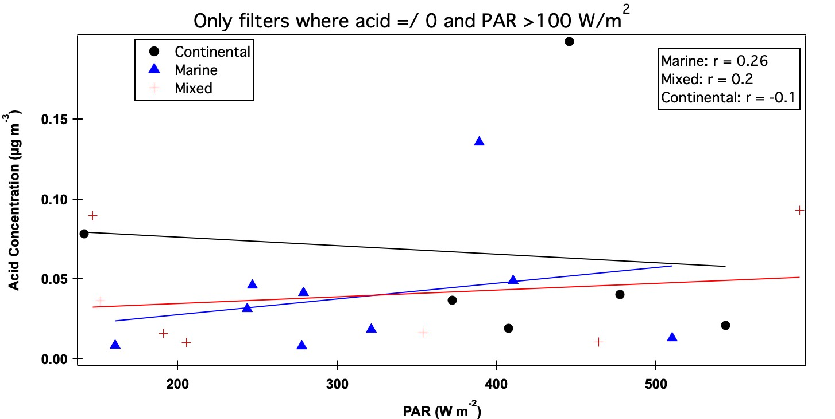

Figure S1: Non-zero acid concentrations from <1 µm filters when PAR values are over 100 W m⁻². Little to no relationship was found between any of the filter categories, but the marine category had the strongest.

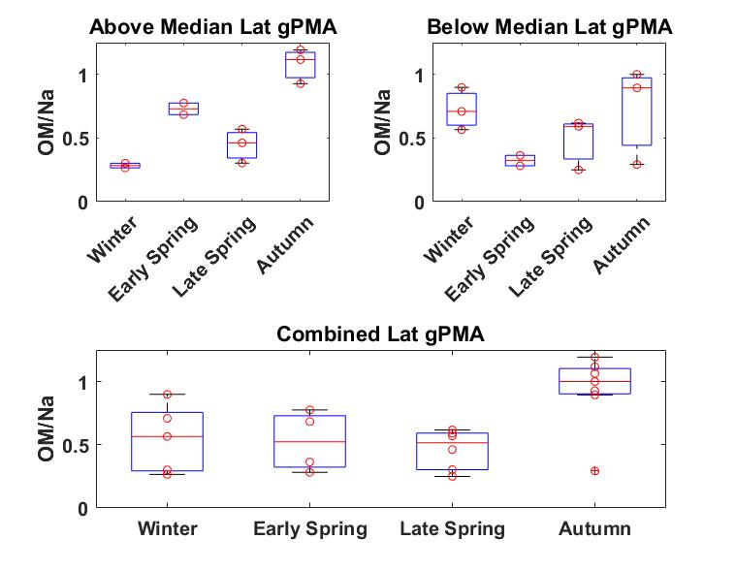
Figure S2: <1 µm gPMA OM, normalized by Na, separated by the median latitude of each campaign with filters a.) above the median, b.) below the median, and c.) with no latitudinal separation. The median latitudes for Winter, Late Spring, Autumn, and Early Spring were 46.2º N, 47.7 º N, 48.6 º N, and 39.4 º N.

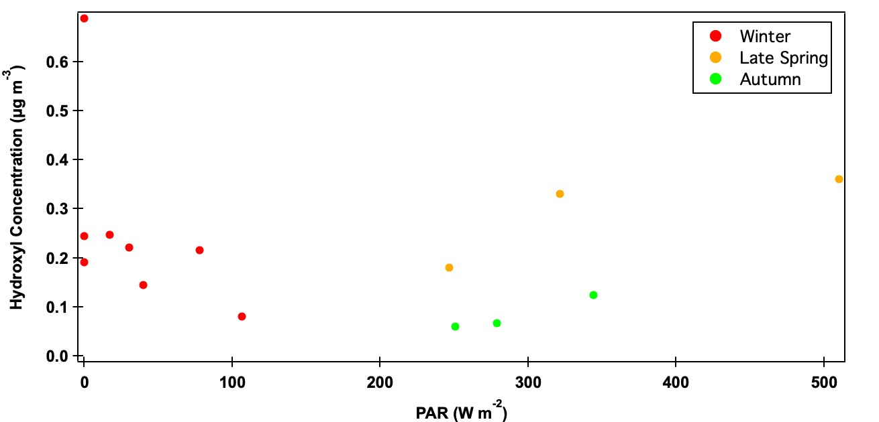
Figure S3: Hydroxyl concentrations from <1 µm aPMA filters from all three campaigns: Winter, Late Spring, and Autumn. No relationship was found when the campaigns were combined (r = -0.14) and there were too few points for a correlation to be used for Late Spring and Autumn campaigns.

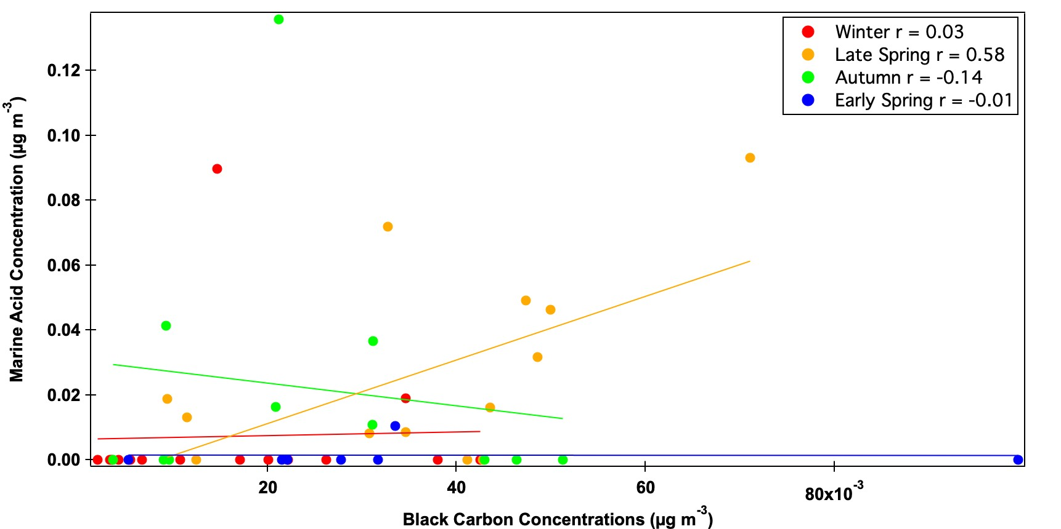
Figure S4: Scatter plot of carboxylic acid concentrations from <1 µm marine filters and BC concentrations. Most campaigns showed no relationship, but the late spring acid had a moderate correlation (r = 0.58).
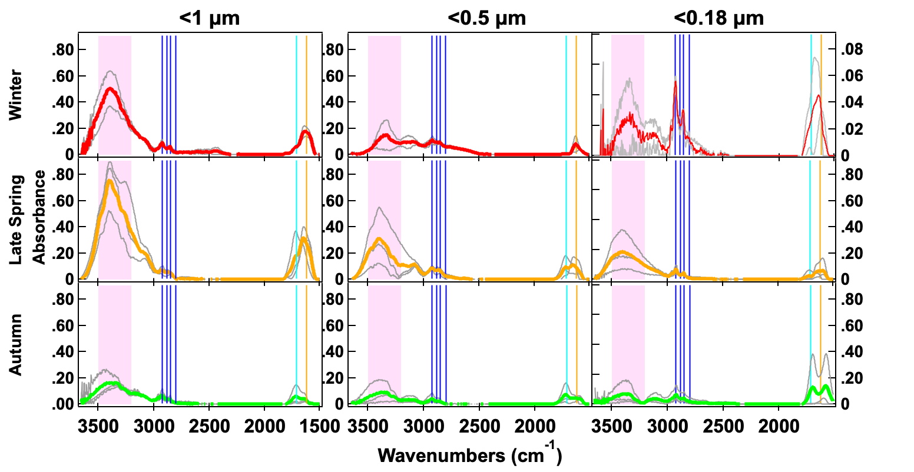
Figure S5: Normalized FTIR spectra of the 3 sizes of aPMA (<1 µm, <0.5 µm, <0.18 µm) seasonal averages (Winter in red, Late Spring in orange, and Autumn in green) with individual spectra shown in grey. The spectral peak locations for the OFG are indicated with the hydroxyl region in the shaded pink region, 4 alkane peaks (blue), carbonyl (both acidic and non-acidic, teal), and amine (orange).

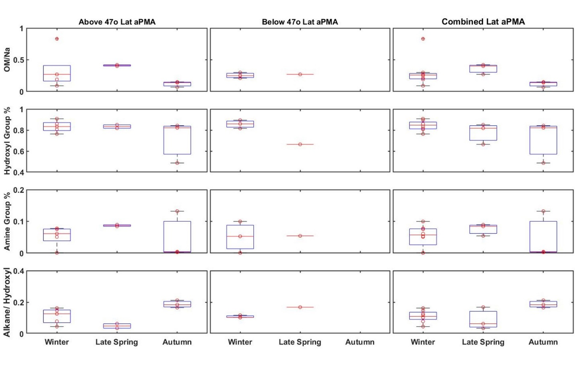
Figure S6: <1 µm aPMA OM, normalized by Na, hydroxyl group fraction of the quantified OM, amine group fraction, and alkane group mass divided by hydroxyl group mass from each campaign (top to bottom): above 47º, 47º or below, and with no latitudinal separation (left to right). Horizontal red lines indicate the median value, red circles are individual values, the top and bottom of the boxes indicate the 25th and 75th percentile, and the whiskers extend to the most extreme data points that are not considered outliers, which are shown with a plus symbol. There were no filters above 47º for Early Spring.

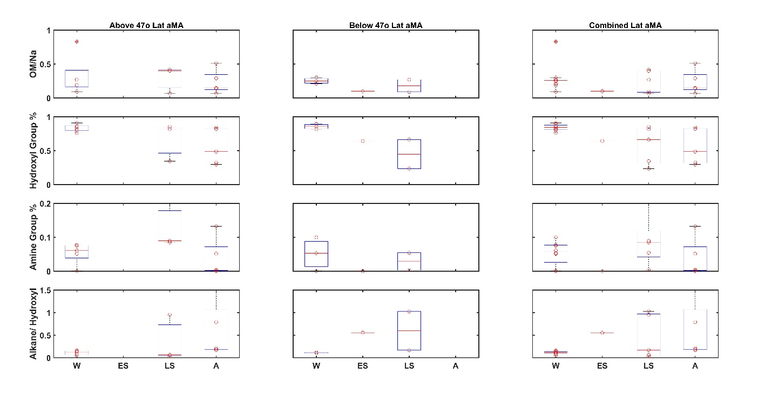
Figure S7: <1 µm aMA OM, normalized by Na, hydroxyl group fraction of the quantified OM, amine group fraction, and alkane group mass divided by hydroxyl group mass from each campaign (top to bottom): above 47º, 47º or below, and with no latitudinal separation (left to right). There were no filters above 47º for Early Spring.

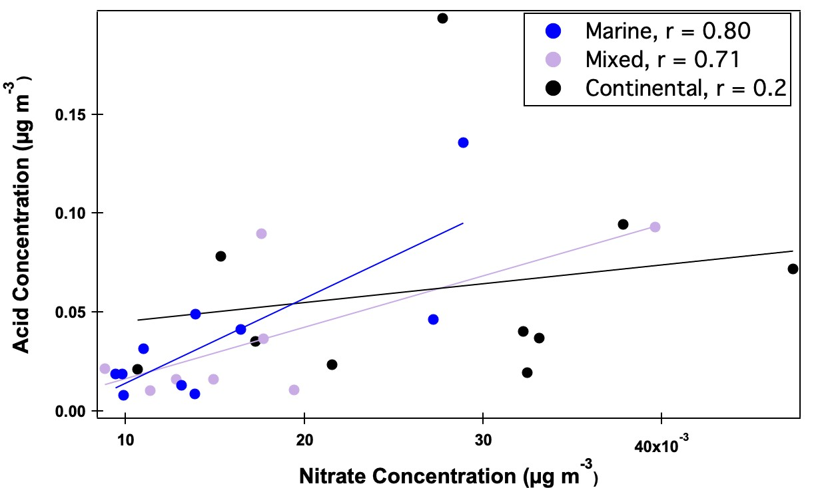
Figure S8: Scatter plot of carboxylic acid group concentration versus nitrate concentrations during marine, mixed, and continental periods. The datapoints are colored by air mass category. The best fit lines, colored by air mass category, are obtained using an ordinary least squares regression.

