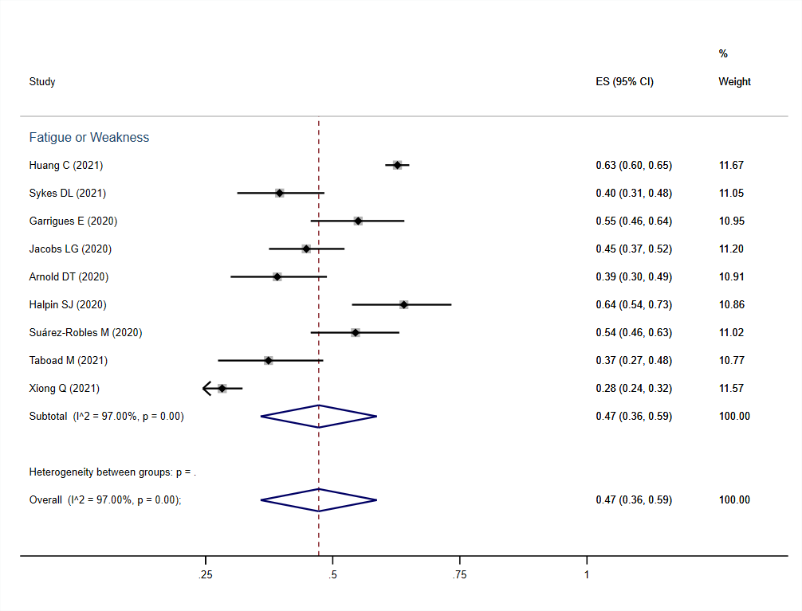
Supplementary Figure 1. The forest plot for prevalence of fatigue or weakness symptom.

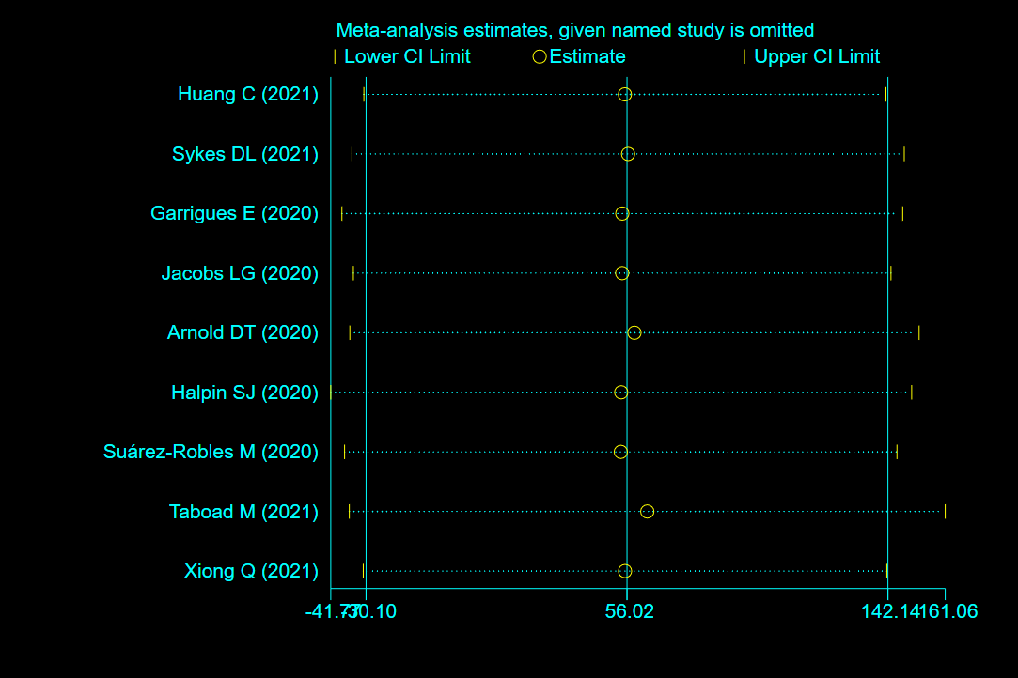
Supplementary Figure 2. The sensitivity analysis for prevalence of fatigue or weakness.
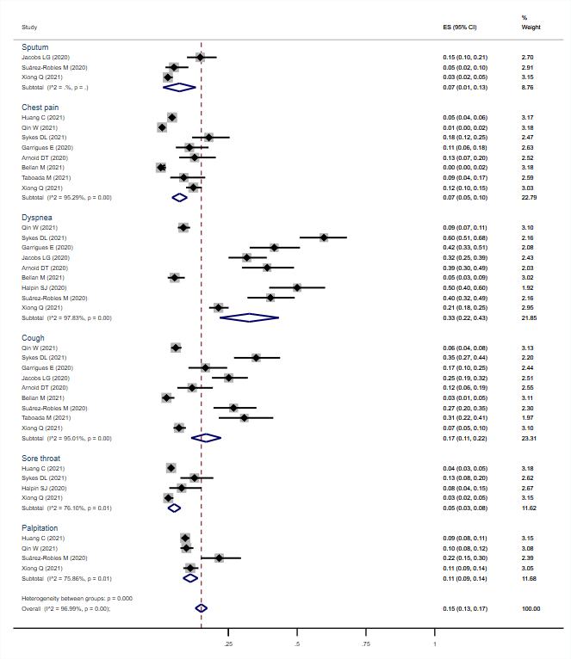
Supplementary Figure 3. The forest plot for prevalence of cardiopulmonary manifestations.

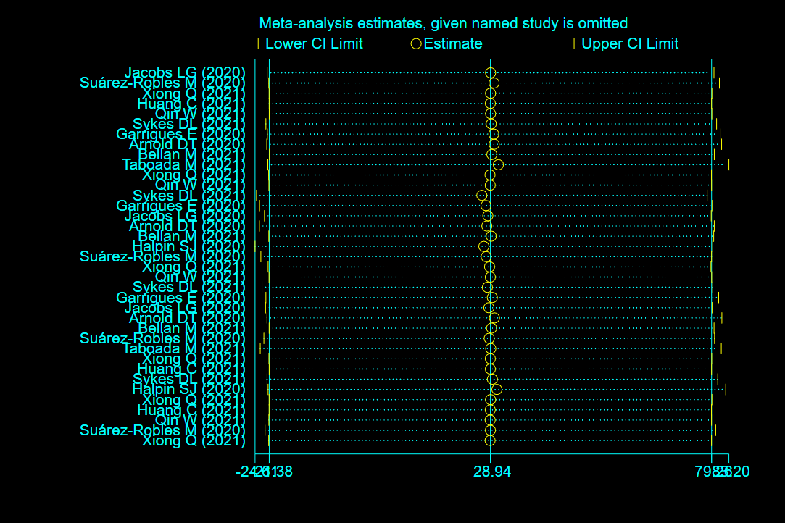
Supplementary Figure 4. The sensitivity analysis for prevalence of cardiopulmonary manifestations.

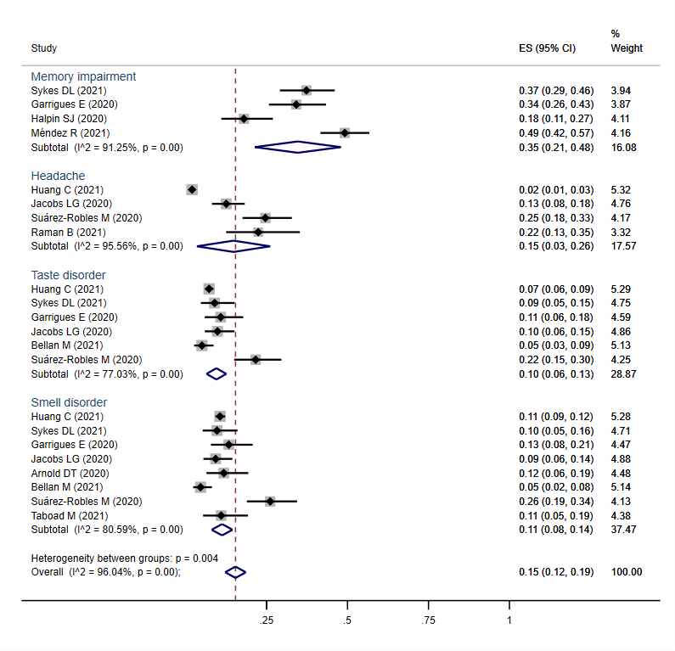
Supplementary Figure 5. The forest plot for prevalence of neurological manifestations.

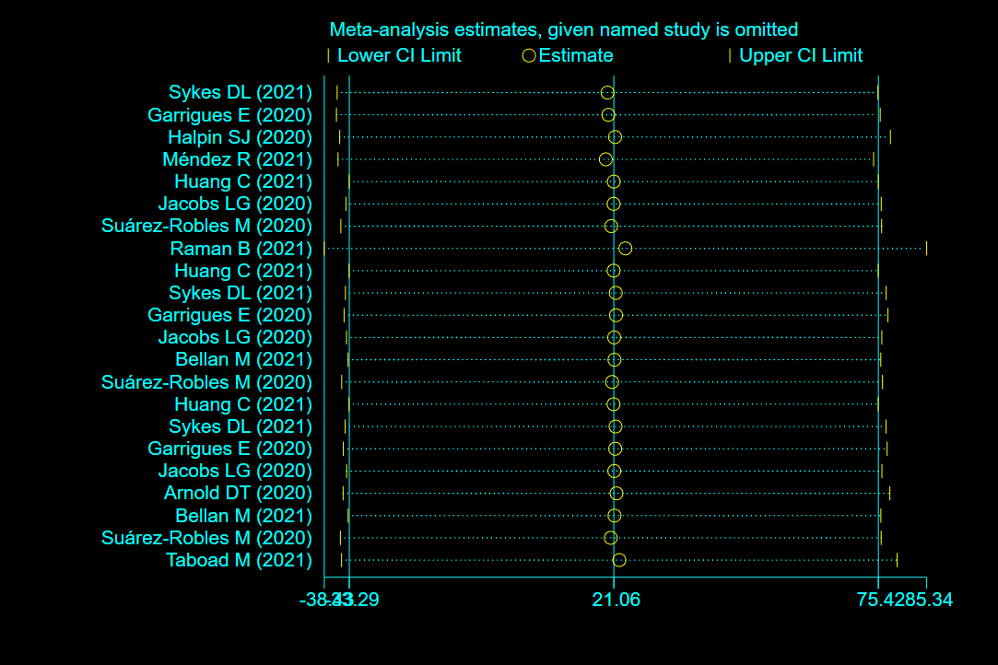
Supplementary Figure 6. The sensitivity analysis for prevalence of neurological manifestations.
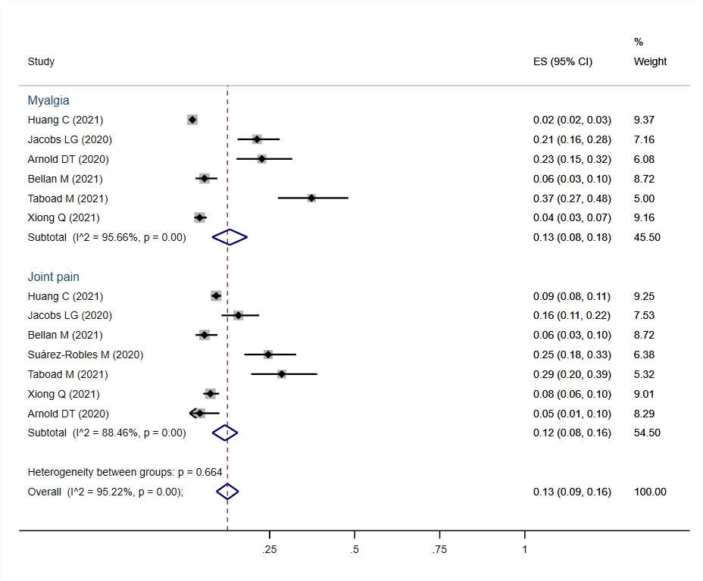
Supplementary Figure 7. The forest plot for prevalence of musculoskeletal manifestations.

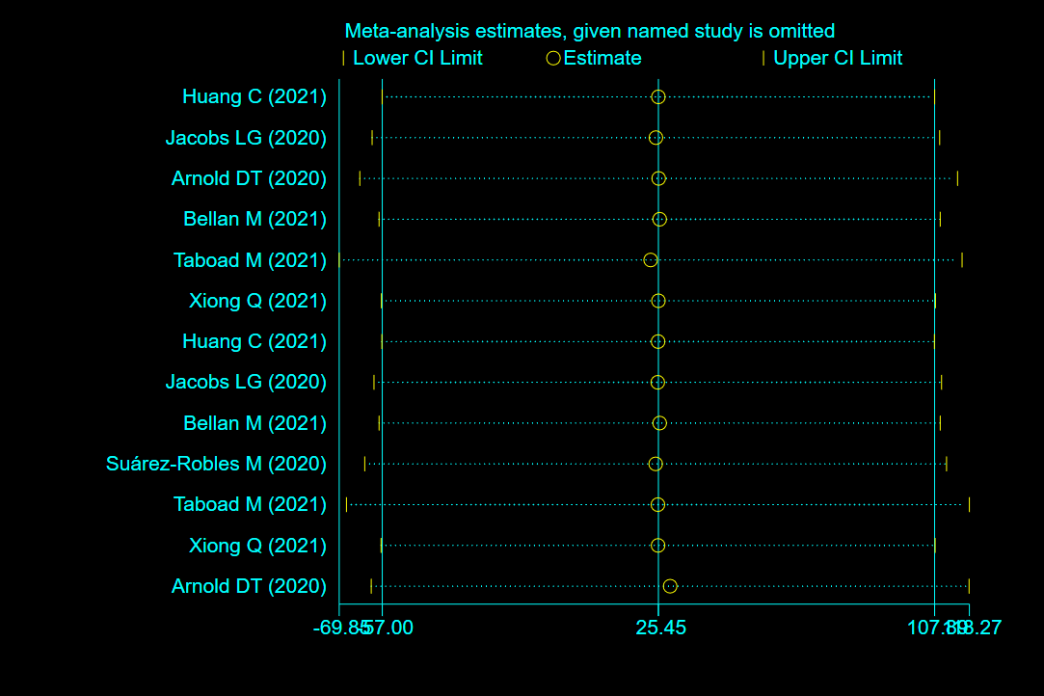
Supplementary Figure 8. The sensitivity analysis for prevalence of musculoskeletal manifestations.
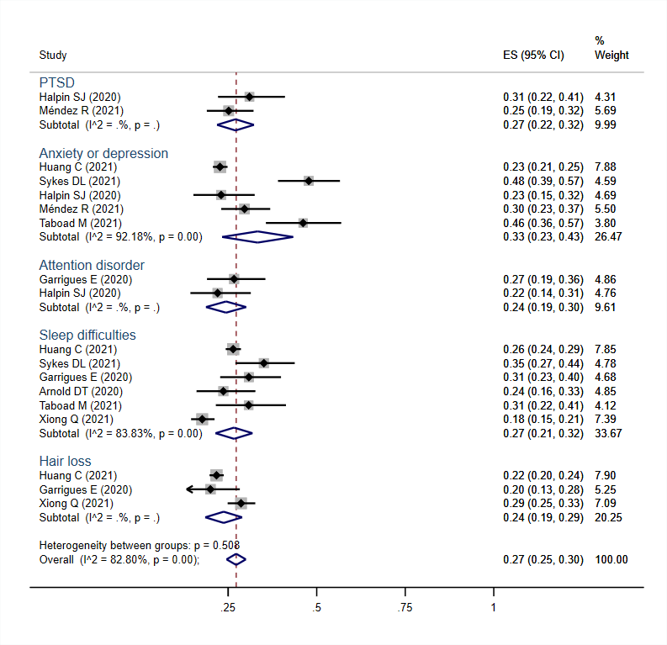
Supplementary Figure 9. The forest plot for prevalence of psychosocial manifestations.

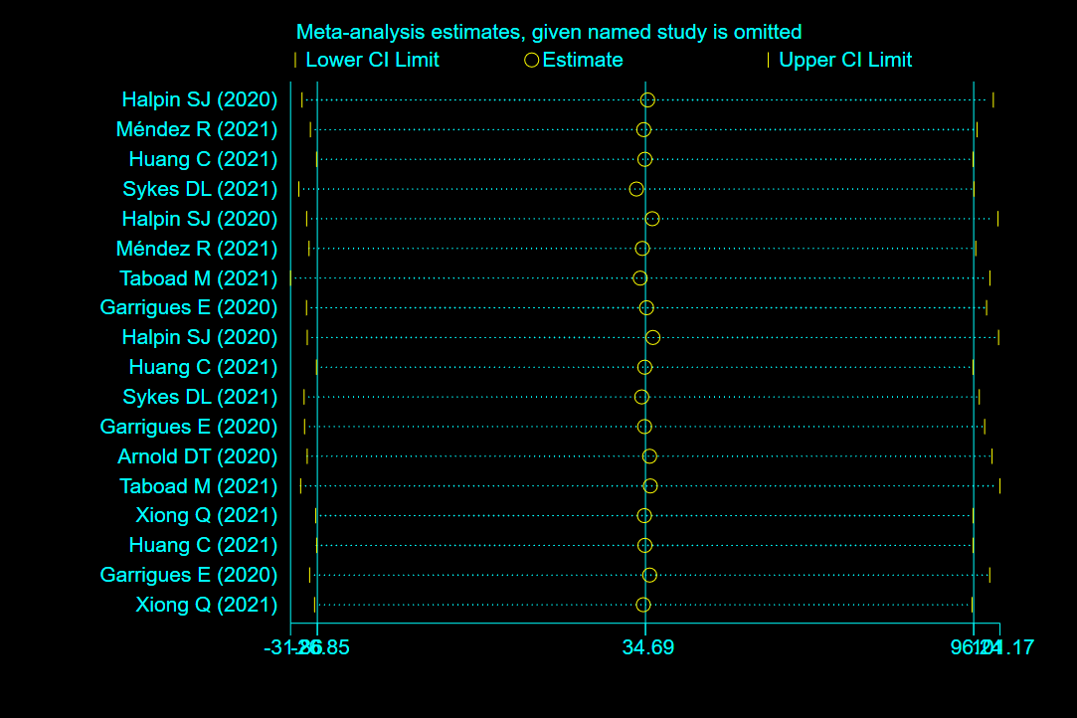
Supplementary Figure 10. The sensitivity analysis for prevalence of psychosocial manifestations.
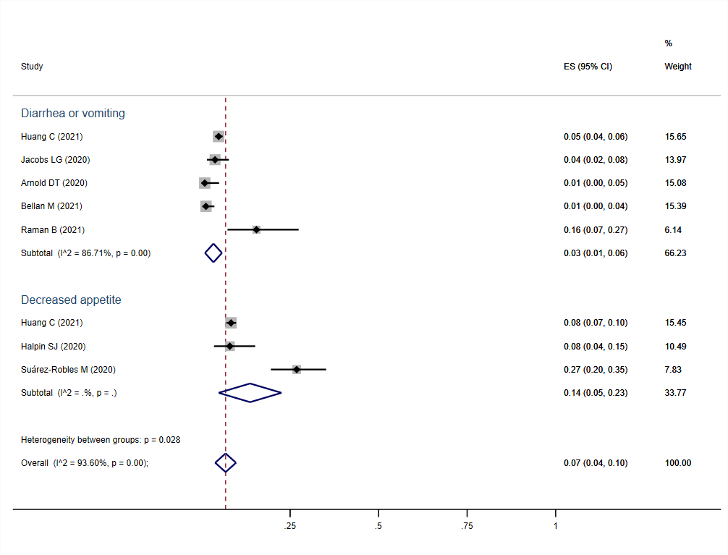
Supplementary Figure 11. The forest plot for prevalence of gastrointestinal manifestations.

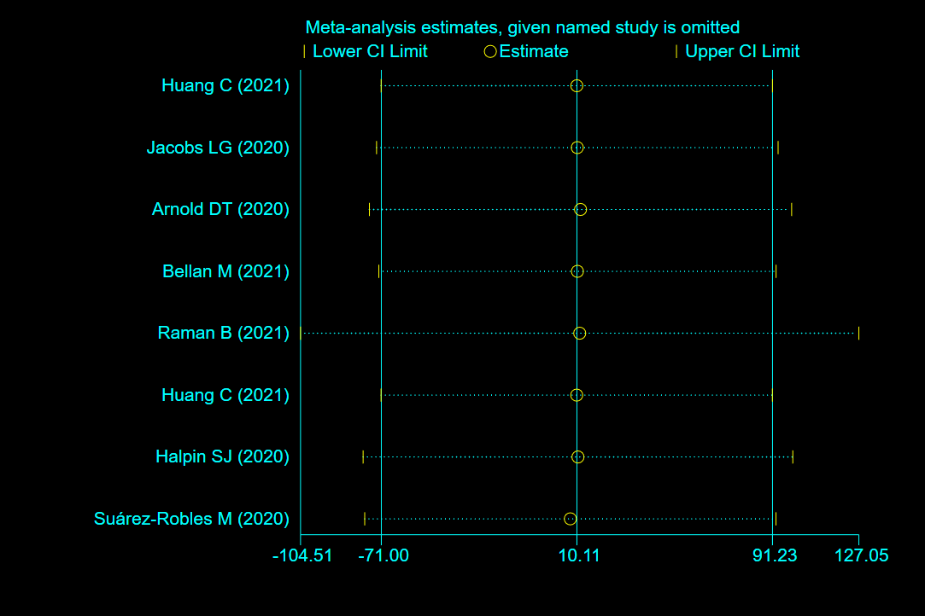
Supplementary Figure 12. The sensitivity analysis for prevalence of gastrointestinal manifestations.
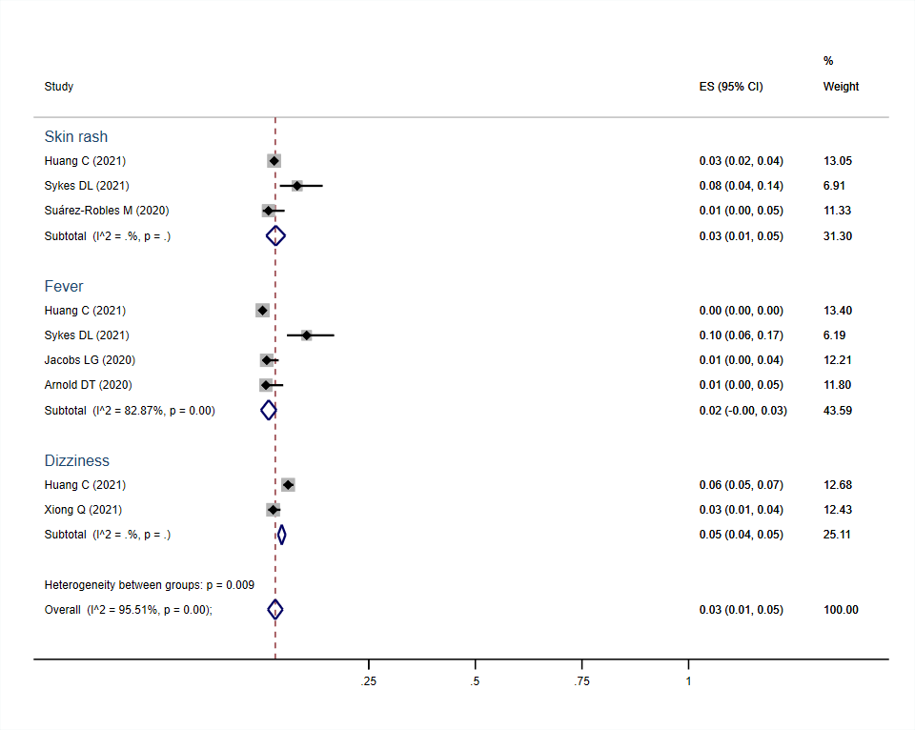
Supplementary Figure 13. The forest plot for prevalence of other symptoms and manifestations.

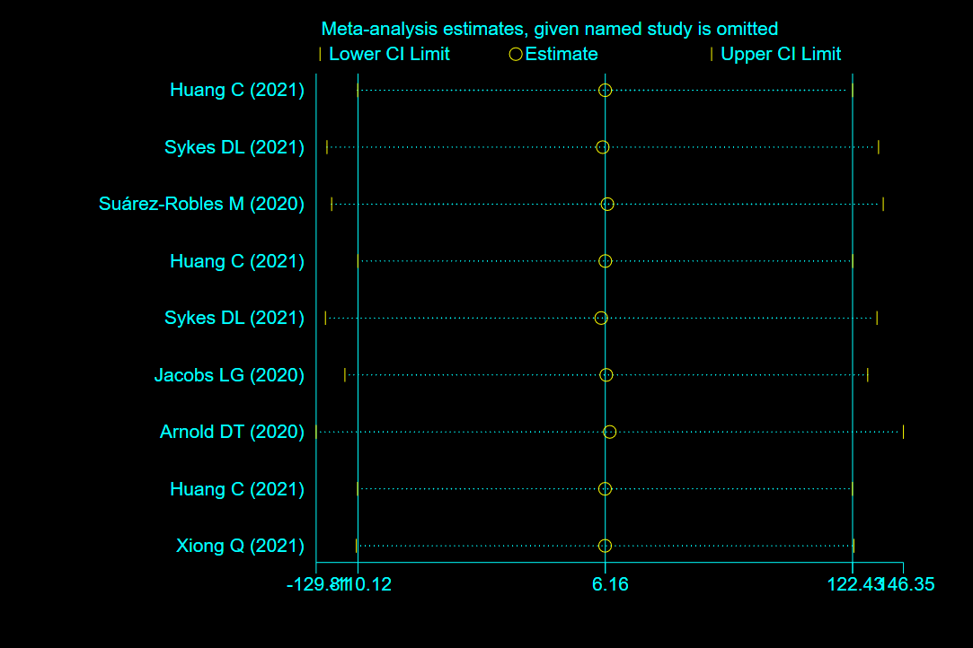
Supplementary Figure 14. The sensitivity analysis for prevalence of other symptoms and manifestations.
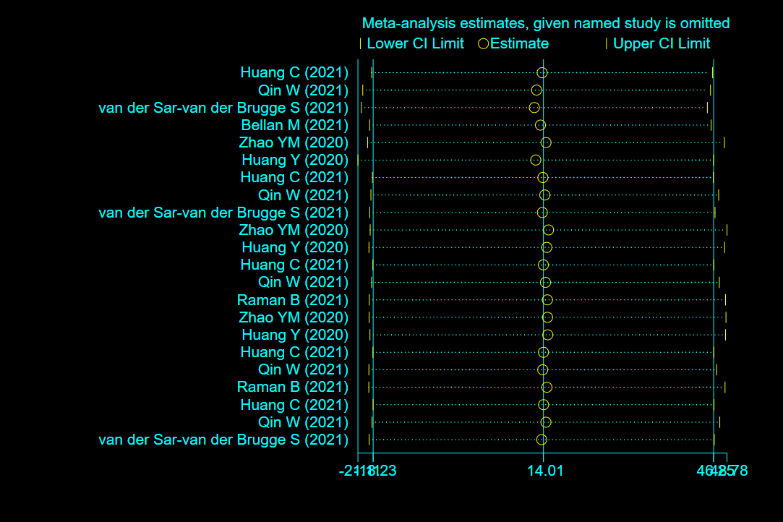
Supplementary Figure 15. The sensitivity analysis for prevalence of abnormal lung function parameters.

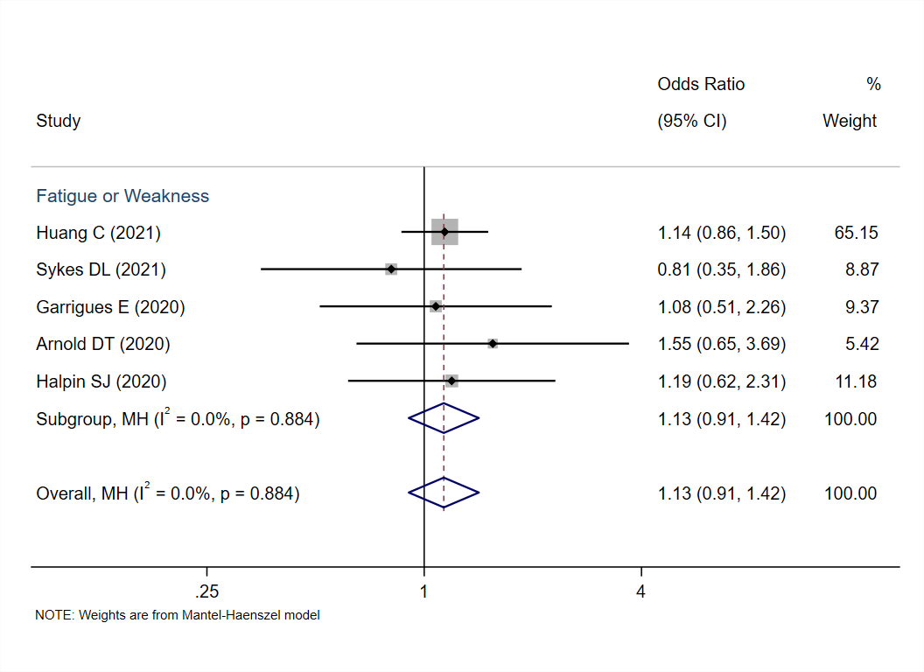
Supplementary Figure 16. The forest plot for risk of fatigue or weakness symptom in severe patients compared to non-severe patients.

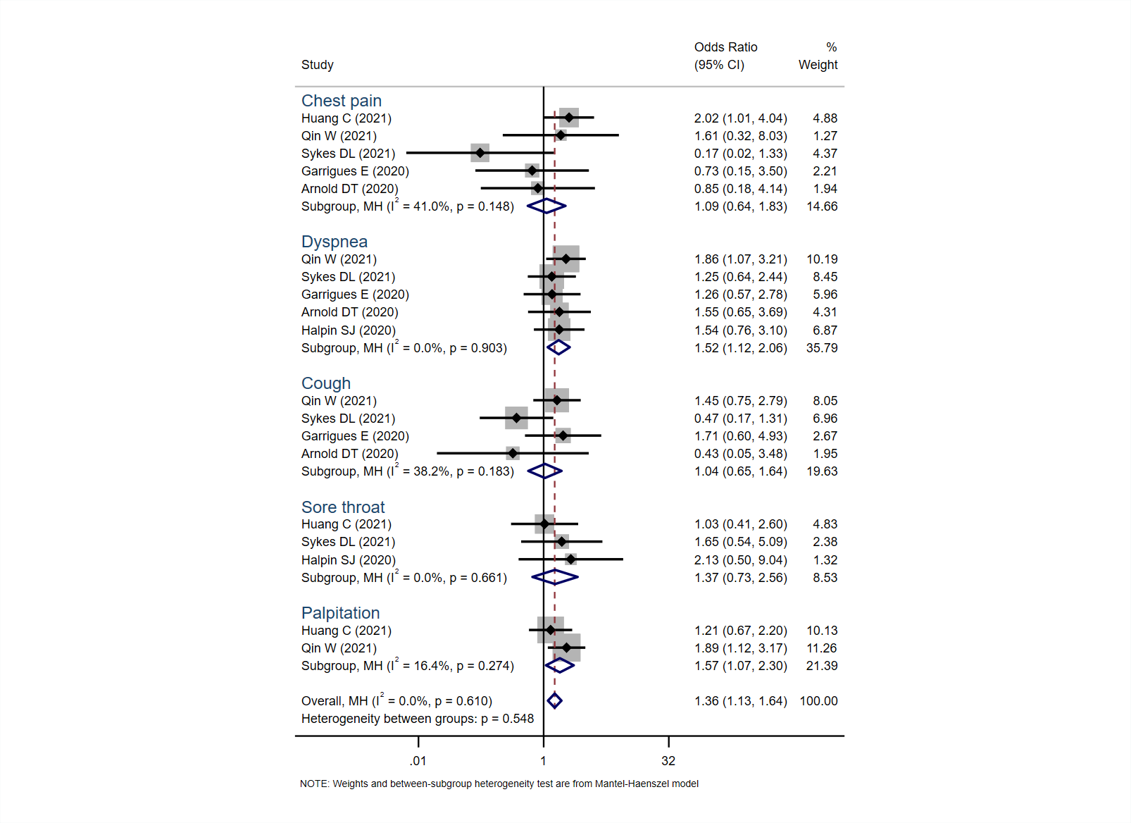
Supplementary Figure 17. The forest plot for risk of cardiopulmonary manifestations in severe patients compared to non-severe patients.

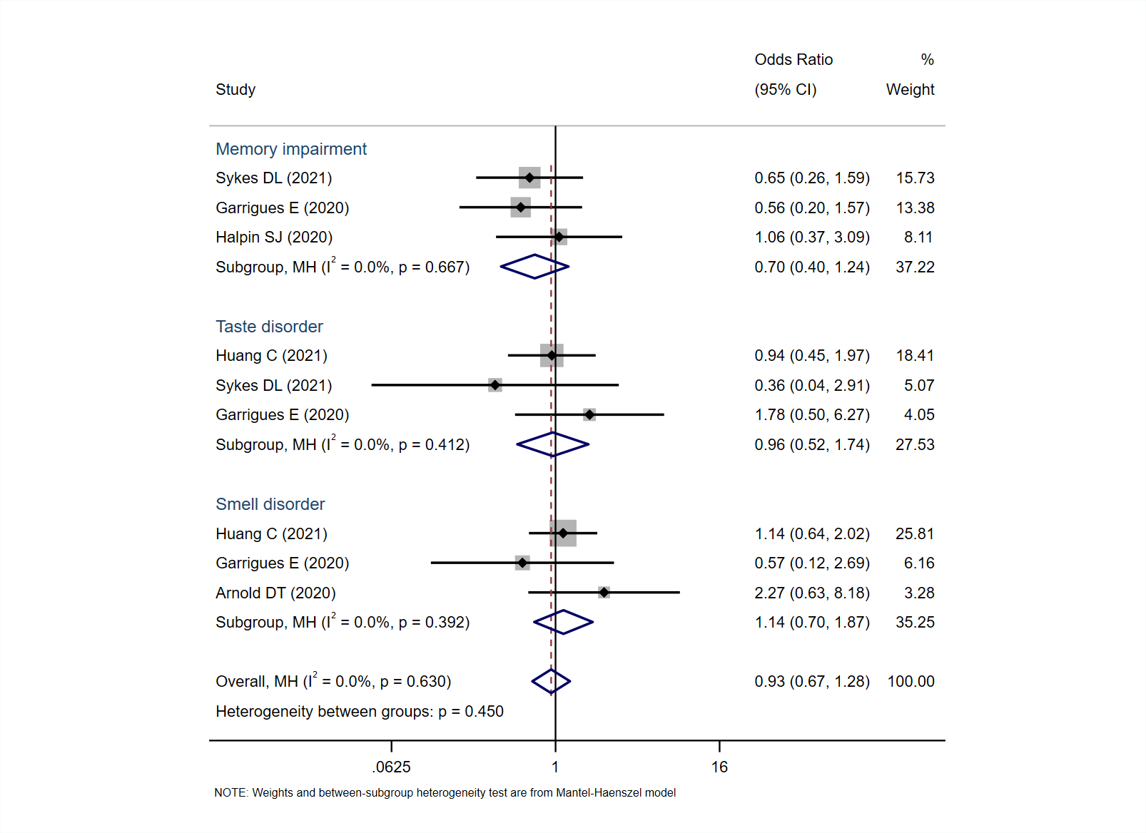
Supplementary Figure 18. The forest plot for risk of neurological manifestations in severe patients compared to non-severe patients.

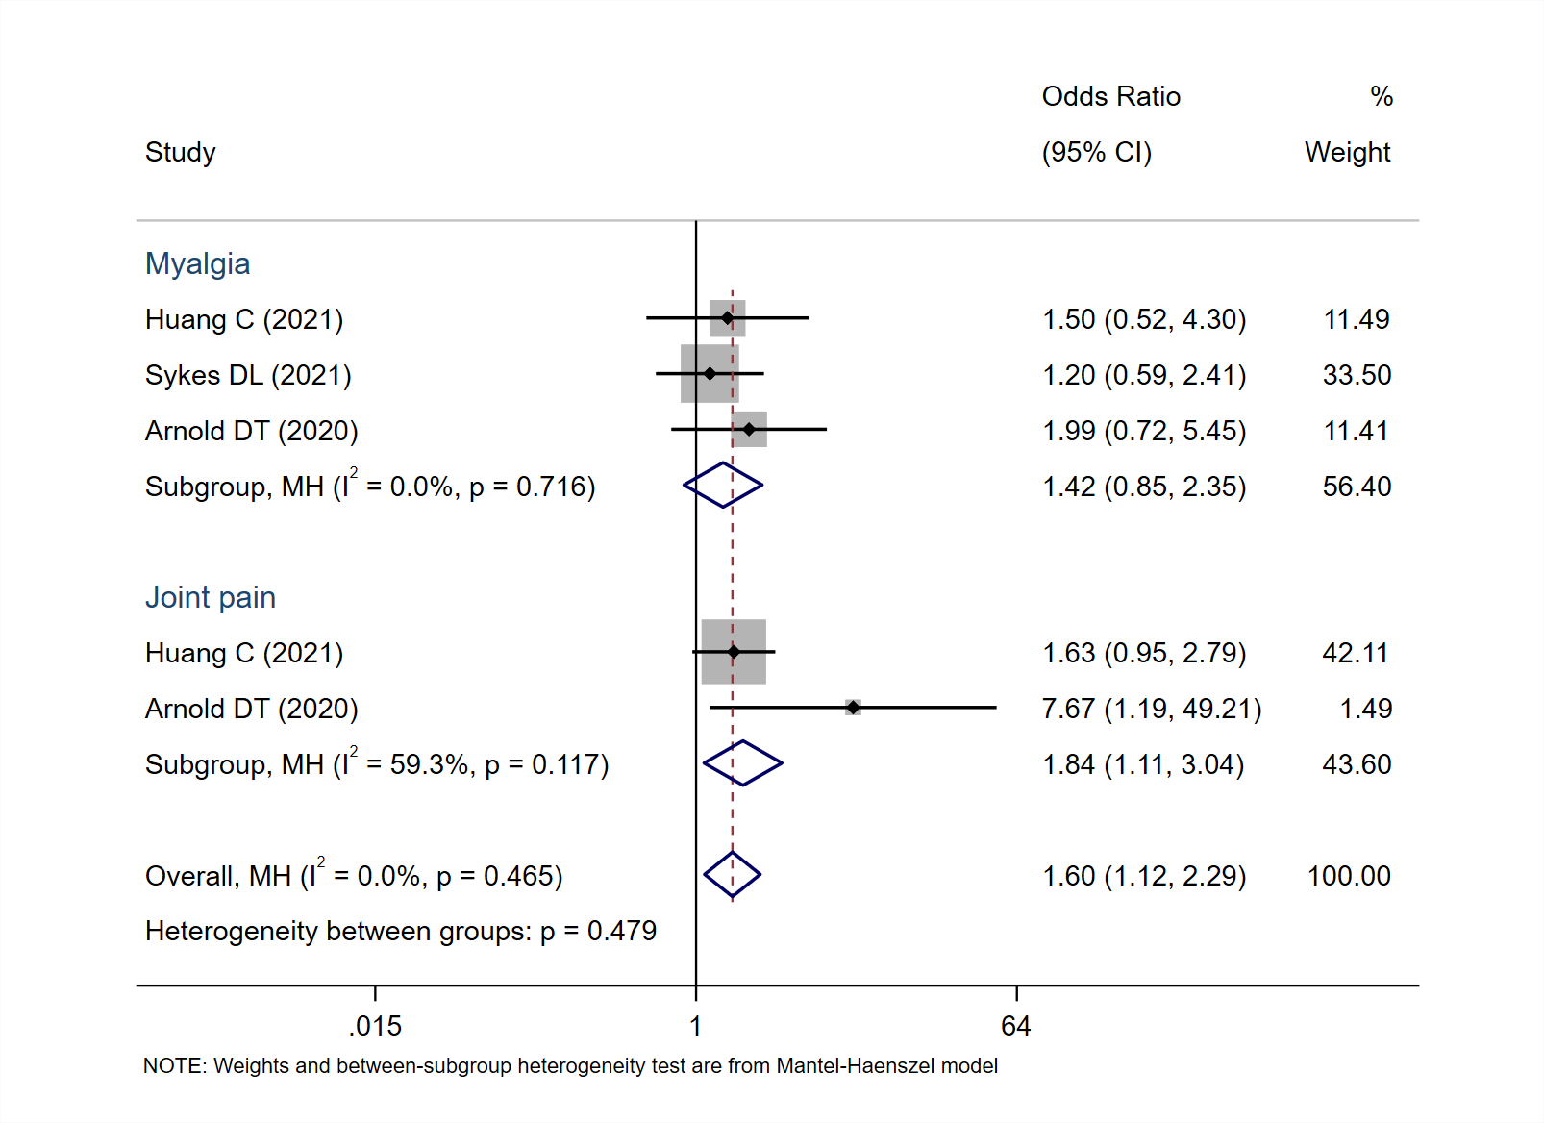

Supplementary Figure 19. The forest plot for risk of musculoskeletal manifestations in severe patients compared to non-severe patients.
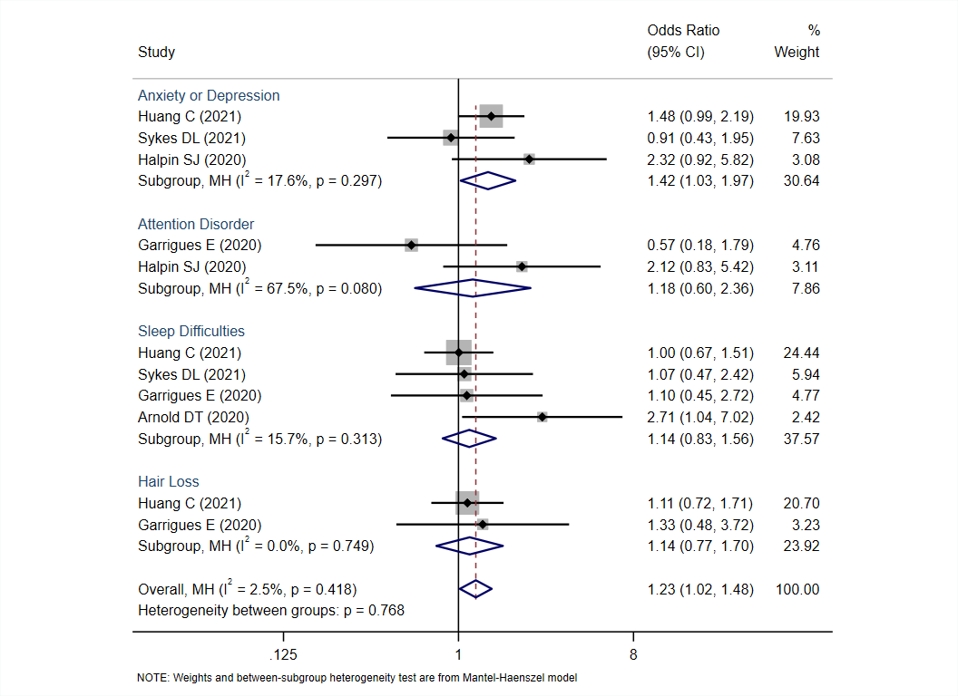
Supplementary Figure 20. The forest plot for risk of psychological manifestations in severe patients compared to non-severe patients.

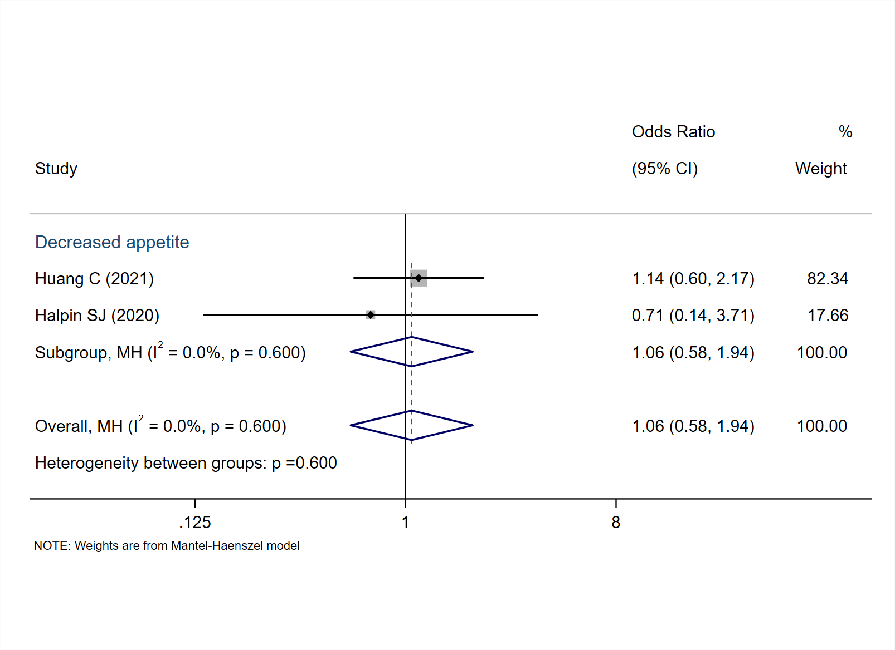
Supplementary Figure 21. The forest plot for risk of gastrointestinal manifestations in severe patients compared to non-severe patients.

