Supplementary Material

Supplementary Tables
Supplementary Table S1 Summary of primary antibodies and immunohistochemical technique.
Antibodies | Source | Clone | Dilution | Antigen retrieval
CD56 | Gene | 12303 | 1 : 200 | Citrate acid
CD68 | Novcastra | KP1 | 1 : 150 | EDTA
CD1a | Novcastra | MTB1 | 1 : 30 | EDTA
CD83 | Sigma-Aldrich | HB15e | 1 : 150 | EDTA
CD57 | Thermo | NK1 | 1 : 100 | Citrate acid
CD8 | Novcastra | 4B11 | 1 : 150 | Citrate acid
FoxP3 | eBioscience | 236A/E7 | 1 : 100 | EDTA
Note: Citrate acid: PH = 5.80-6.00, EDTA (ethylenediaminetetraacetic acid): PH = 8.95-9.05.

Supplementary Table S2 Baseline characteristics in the subgroups.
 | Ovarian endometriosis (n = 44) | Pelvic endometriosis (n = 57) | Mixed endometriosis (n = 16) | Control (n = 200) | P-value
Age (years) | 34.0 (31.0, 36.0) | 35.0 (32.0, 38.0) | 34.0 (30.3, 38.0) | 34.0 (31.0, 38.0) | 0.286
BMI (kg/m²) | 20.3 (18.9, 22.2) | 20.8 (19.2, 23.0) | 20.2 (18.4, 21.8) | 21.6 (19.5, 23.4) | 0.080
E2 (pg/mL) | 44.5 (34.2, 56.7) | 35.0 (25.8, 44.2) | 37.9 (28.0, 52.0) | 32.2 (23.9, 46.2) | 0.005**
P (ng/mL) | 0.4 (0.2, 0.5) | 0.4 (0.3, 0.5) | 0.2 (0.1, 0.6) | 0.4 (0.3, 0.6) | 0.225
FSH (IU/L) | 7.3 (5.5, 9.0) | 6.9 (6.0, 7.9) | 7.5 (5.9, 8.5) | 6.9 (5.7, 8.3) | 0.808
LH (IU/L) | 4.1 (2.6, 5.4) | 4.5 (3.1, 5.8) | 3.7 (3.2, 4.9) | 4.7 (3.7, 6.6) | 0.005**
PRL (ng/mL) | 14.8 (12.0, 18.6) | 15.5 (12.4, 18.3) | 13.5 (9.7, 17.4) | 16.2 (11.3, 21.0) | 0.486
T (ng/mL) | 0.3 (0.2, 0.4) | 0.2 (0.2, 0.3) | 0.2 (0.1, 0.2) | 0.2 (0.1, 0.3) | 0.126
Endometrial preparation program |  |  |  |  | 0.880
Natural cycle | 61.4% (27/44) | 54.4% (31/57) | 56.3% (9/16) | 59.0% (118/200)
Hormone replacement therapy cycle | 38.6% (17/44) | 45.6% (26/57) | 43.8% (7/16) | 41.0% (82/200)
The percentage of RIF/RM/Others |  |  |  |  | < 0.001***
RIF | 36.4% (16/44) | 38.6% (22/57) | 25.0% (4/16) | 16.5% (33/200)
RM | 11.4% (5/44) | 17.5% (10/57) | 37.5% (6/16) | 46.0% (92/200)
Others | 52.3% (23/44) | 43.9% (25/57) | 37.5% (6/16) | 37.5% (75/200)
Duration of post-operative period (years) | 3.5 (2.0, 5.8) | 3.0 (1.9, 5.0) | 2.0 (1.5, 6.5) | /
Note: BMI: body mass index; E2: estradiol; P: progesterone; FSH: follicle-stimulating hormone; LH: luteinizing hormone; PRL: prolactin; T: testosterone; RIF: repeated implantation failure; RM: recurrent miscarriage; Others: reproductive failure patients who failed to achieve a pregnancy or experienced miscarriage but not meeting the standard of RIF or RM; Mixed endometriosis: endometriotic lesions within both the pelvis and ovary.
Serum hormone levels were all detected on day 3 of the menstrual cycle.
Continuous variables without normal distribution: Kruskal-Wallis test, and shown as median (interquartile range); categorical variables: Chi-square test, shown as percentages of participants.
E2: Ovarian endometriosis versus Control, P = 0.003.
LH: Ovarian endometriosis versus Control, P = 0.023.
The percentage of RIF: Ovarian endometriosis versus Control, P = 0.002; Pelvic endometriosis versus Control, P < 0.001.
The percentage of RM: Ovarian endometriosis versus Control, P < 0.001; Pelvic endometriosis versus Control, P < 0.001.
The percentage of Others: Ovarian endometriosis versus Control, P = 0.040.
**：P < 0.01; ***: P < 0.001.

Supplementary Table S3 Baseline characteristics in the “Others” population.
 | Endometriosis (n = 54) | Control (n = 75) | P-value
Age (years) | 33.0 (30.8, 36.0) | 34.0 (31.0, 37.0) | 0.330
BMI (kg/m²) | 21.3 ± 2.7 | 21.8 ± 3.0 | 0.339
E2 (pg/mL) | 39.8 (30.8, 53.4) | 28.0 (22.0, 45.6) | 0.006**
P (ng/mL) | 0.3 (0.2, 0.4) | 0.4 (0.3, 0.5) | 0.052
FSH (IU/L) | 6.8 (5.6, 7.7) | 7.0 (6.1, 8.4) | 0.320
LH (IU/L) | 4.1 (2.7, 5.4) | 4.7 (3.6, 6.9) | 0.011*
PRL (ng/mL) | 15.2 (12.7, 20.3) | 17.0 (11.3, 21.0) | 0.684
T (ng/mL) | 0.3 (0.1, 0.4) | 0.2 (0.1, 0.3) | 0.403
Endometrial preparation program |  |  | 0.137
Natural cycle | 48.1% (26/54) | 61.3% (46/75)
Hormone replacement therapy cycle | 51.9% (28/54) | 38.7% (29/75)
Duration of post-operative period (years) | 3.0 (2.0, 4.5) | /

Supplementary Table S4 Immune responses of the “Others” population.
 | Endometriosis (n = 54) | Control (n = 75) | P-value
eCD56⁺ (%) | 10.7 (7.2, 16.5) | 12.2 (8.7, 20.6) | 0.104
eCD68⁺ (%) | 2.0 (1.4, 2.9) | 2.2 (1.6, 2.8) | 0.551
eCD1a⁺ (%) | 0.06 (0.03, 0.10) | 0.06 (0.03, 0.12) | 0.599
eCD83⁺ (%) | 1.6 (1.0, 2.4) | 1.8 (1.2, 2.9) | 0.317
eCD57⁺ (%) | 0.4 (0.2, 0.5) | 0.3 (0.2, 0.6) | 0.753
eCD8⁺ (%) | 3.0 (2.0, 3.9) | 3.1 (2.0, 4.4) | 0.532
eFoxP3⁺ (%) | 0.08 (0.05, 0.11) | 0.10 (0.06, 0.16) | 0.069
pCD3⁺ (%) | 70.5 ± 6.8 | 67.7 ± 8.8 | 0.067
pCD3⁺CD8⁺ (%) | 26.7 (23.5, 31.7) | 25.3 (22.5, 28.1) | 0.055
pCD3⁺CD4⁺ (%) | 36.2 ± 5.8 | 35.4 ± 7.0 | 0.518
pCD56⁺CD16⁺ (%) | 15.2 ± 6.0 | 17.6 ± 8.4 | 0.066
pCD19⁺ (%) | 12.0 (9.9, 15.8) | 12.5 (10.5, 15.2) | 0.705
Cytotoxicity at ET25 (%) | 19.9 (15.8, 29.4) | 35.6 (23.9, 43.6) | < 0.001***
Cytotoxicity at ET50 (%) | 32.6 (21.5, 39.6) | 48.3 (33.7, 53.9) | < 0.001***

Supplementary Table S5 Baseline characteristics in the RIF population.
 | Endometriosis (n = 42) | Control (n = 33) | P-value
Age (years) | 34.9 ± 4.1 | 35.9 ± 5.2 | 0.368
BMI (kg/m²) | 20.3 ± 2.0 | 21.5 ± 3.0 | 0.033*
E2 (pg/mL) | 39.6 ± 15.4 | 43.6 ± 20.1 | 0.348
P (ng/mL) | 0.4 (0.2, 0.6) | 0.4 (0.2, 0.6) | 0.803
FSH (IU/L) | 7.4 (6.0, 9.3) | 7.3 (6.0, 8.6) | 0.610
LH (IU/L) | 4.2 (3.0, 5.3) | 4.7 (3.7, 6.5) | 0.040*
PRL (ng/mL) | 15.6 ± 5.0 | 16.2 ± 4.4 | 0.587
T (ng/mL) | 0.2 (0.2, 0.3) | 0.3 (0.1, 0.4) | 0.538
Endometrial preparation program |  |  | 0.482
Natural cycle | 61.9% (26/42) | 69.7% (23/33)
Hormone replacement therapy cycle | 38.1% (16/42) | 30.3% (10/33)
Duration of post-operative period (years) | 4.0 ± 2.7 | /

Supplementary Table S6 Immune responses of the RIF population.
 | Endometriosis (n = 42) | Control (n = 33) | P-value
eCD56⁺ (%) | 14.0 (8.8, 21.2) | 13.1 (9.8, 20.3) | 0.991
eCD68⁺ (%) | 2.5 ± 1.1 | 2.3 ± 1.3 | 0.498
eCD1a⁺ (%) | 0.06 (0.04, 0.10) | 0.06 (0.03, 0.12) | 0.543
eCD83⁺ (%) | 1.9 (1.3, 2.4) | 1.9 (1.3, 2.3) | 0.818
eCD57⁺ (%) | 0.4 (0.2, 0.5) | 0.4 (0.2, 0.5) | 0.974
eCD8⁺ (%) | 2.9 (2.3, 3.9) | 2.8 (2.0, 4.1) | 0.839
eFoxP3⁺ (%) | 0.11 (0.07, 0.15) | 0.08 (0.06, 0.12) | 0.055
pCD3⁺ (%) | 68.0 ± 6.7 | 68.2 ± 7.2 | 0.882
pCD3⁺CD8⁺ (%) | 25.2 ± 5.9 | 26.0 ± 7.6 | 0.630
pCD3⁺CD4⁺ (%) | 37.7 ± 6.4 | 35.7 ± 6.7 | 0.201
pCD56⁺CD16⁺ (%) | 17.6 ± 7.3 | 17.0 ± 7.7 | 0.730
pCD19⁺ (%) | 13.2 ± 4.0 | 13.6 ± 3.4 | 0.627
Cytotoxicity at ET25 (%) | 29.0 ± 14.4 | 32.4 ± 15.5 | 0.332
Cytotoxicity at ET50 (%) | 39.1 ± 15.2 | 42.1 ± 16.1 | 0.407

Supplementary Table S7 Baseline characteristics in the RM population.
 | Endometriosis (n = 21) | Control (n = 92) | P-value
Age (years) | 35.7 ± 4.1 | 33.9 ± 5.0 | 0.119
BMI (kg/m²) | 21.0 ± 2.2 | 21.7 ± 2.8 | 0.302
E2 (pg/mL) | 36.8 (27.2, 52.2) | 31.4 (25.0, 43.7) | 0.122
P (ng/mL) | 0.3 (0.2, 0.6) | 0.4 (0.3, 0.6) | 0.306
FSH (IU/L) | 7.4 (6.0, 9.0) | 6.7 (5.5, 8.2) | 0.132
LH (IU/L) | 4.6 (3.7, 5.9) | 4.7 (3.7, 6.4) | 0.726
PRL (ng/mL) | 13.2 (10.9, 17.2) | 15.0 (11.1, 21.7) | 0.349
T (ng/mL) | 0.2 (0.2, 0.3) | 0.2 (0.2, 0.4) | 0.973
Endometrial preparation program |  |  | 0.153
Natural cycle | 71.4% (15/21) | 54.3% (50/92)
Hormone replacement therapy cycle | 28.6% (6/21) | 45.7% (42/92)
Duration of post-operative period (years) | 4.6 ± 2.9 | /

Supplementary Table S8 Immune responses of the RM population.
 | Endometriosis (n = 21) | Control (n = 92) | P-value
eCD56⁺ (%) | 13.8 (7.6, 20.1) | 11.9 (8.1, 16.8) | 0.595
eCD68⁺ (%) | 2.4 ± 0.8 | 2.1 ± 0.9 | 0.133
eCD1a⁺ (%) | 0.07 (0.03, 0.10) | 0.05 (0.03, 0.09) | 0.150
eCD83⁺ (%) | 1.9 (1.4, 2.4) | 1.6 (1.1, 2.3) | 0.271
eCD57⁺ (%) | 0.4 (0.3, 0.6) | 0.4 (0.2, 0.5) | 0.400
eCD8⁺ (%) | 3.0 ± 1.5 | 3.2 ± 1.7 | 0.606
eFoxP3⁺ (%) | 0.13 (0.08, 0.17) | 0.10 (0.06, 0.13) | 0.021*
pCD3⁺ (%) | 70.0 ± 7.1 | 69.1 ± 8.1 | 0.676
pCD3⁺CD8⁺ (%) | 25.5 ± 5.7 | 27.4 ± 6.8 | 0.224
pCD3⁺CD4⁺ (%) | 38.0 ± 7.6 | 36.1 ± 6.6 | 0.248
pCD56⁺CD16⁺ (%) | 15.9 (13.2, 20.7) | 16.7 (11.9, 20.2) | 0.788
pCD19⁺ (%) | 12.0 ± 3.1 | 12.7 ± 3.9 | 0.438
Cytotoxicity at ET25 (%) | 28.8 ± 17.6 | 32.5 ± 13.8 | 0.294
Cytotoxicity at ET50 (%) | 37.4 (20.7, 54.9) | 44.5 (33.2, 51.8) | 0.136
Note: e: endometrial cell; p: peripheral blood mononuclear cell.
Cytotoxicity: cytotoxicity of peripheral NK cells, shown as the ratios of target cell lysis. ET: the ratios between effectors and target cells.
Continuous variables with normal distribution: t-test, and shown as mean ± standard deviation; Continuous variables without normal distribution: Mann–Whitney U test, and shown as median (interquartile range).
*: P < 0.05; **: P < 0.01; ***：P < 0.001.

Supplementary Table S9 Correlation analysis.
 |  | The whole study population |  |  |  |  |  | Endometriosis group |  |  |  |  |  | Control group
 |  | E2 | LH | BMI | eCD68 | ET25 | ET50 | E2 | LH | BMI | eCD68 | ET25 | ET50 | E2 | LH | BMI | eCD68 | ET25 | ET50
E2 | Pearson correlation | 1 | 0.020 | -0.107 | .150** | -0.048 | -0.047 | 1 | -0.065 | 0.078 | .251** | -0.065 | -0.053 | 1 | 0.089 | -.169* | 0.084 | -0.019 | -0.021
 | Sig.（two-tail） |  | 0.722 | 0.060 | 0.008 | 0.408 | 0.416 |  | 0.505 | 0.419 | 0.009 | 0.506 | 0.586 |  | 0.212 | 0.017 | 0.238 | 0.794 | 0.768
LH | Pearson correlation | 0.020 | 1 | -.118* | -0.062 | -0.047 | -0.063 | -0.065 | 1 | -0.065 | -0.092 | 0.016 | 0.021 | 0.089 | 1 | -.180* | -0.027 | -0.131 | -.162*
 | Sig.（two-tail） | 0.722 |  | 0.039 | 0.280 | 0.412 | 0.270 | 0.505 |  | 0.501 | 0.340 | 0.871 | 0.833 | 0.212 |  | 0.011 | 0.703 | 0.064 | 0.022
BMI | Pearson correlation | -0.107 | -.118* | 1 | -0.047 | 0.009 | 0.031 | 0.078 | -0.065 | 1 | -0.025 | -0.017 | 0.000 | -.169* | -.180* | 1 | -0.040 | -0.027 | -0.005
 | Sig.（two-tail） | 0.060 | 0.039 |  | 0.409 | 0.868 | 0.591 | 0.419 | 0.501 |  | 0.793 | 0.863 | 0.999 | 0.017 | 0.011 |  | 0.570 | 0.701 | 0.947
eCD68 | Pearson correlation | .150** | -0.062 | -0.047 | 1 | -0.038 | -0.063 | .251** | -0.092 | -0.025 | 1 | -0.064 | -0.055 | 0.084 | -0.027 | -0.040 | 1 | -0.001 | -0.045
 | Sig.（two-tail） | 0.008 | 0.280 | 0.409 |  | 0.507 | 0.267 | 0.009 | 0.340 | 0.793 |  | 0.504 | 0.560 | 0.238 | 0.703 | 0.570 |  | 0.991 | 0.526
ET25 | Pearson correlation | -0.048 | -0.047 | 0.009 | -0.038 | 1 | .950** | -0.065 | 0.016 | -0.017 | -0.064 | 1 | .955** | -0.019 | -0.131 | -0.027 | -0.001 | 1 | .943**
 | Sig.（two-tail） | 0.408 | 0.412 | 0.868 | 0.507 |  | 0.000 | 0.506 | 0.871 | 0.863 | 0.504 |  | 0.000 | 0.794 | 0.064 | 0.701 | 0.991 |  | 0.000
ET50 | Pearson correlation | -0.047 | -0.063 | 0.031 | -0.063 | .950** | 1 | -0.053 | 0.021 | 0.000 | -0.055 | .955** | 1 | -0.021 | -.162* | -0.005 | -0.045 | .943** | 1
 | Sig.（two-tail） | 0.416 | 0.270 | 0.591 | 0.267 | 0.000 |  | 0.586 | 0.833 | 0.999 | 0.560 | 0.000 |  | 0.768 | 0.022 | 0.947 | 0.526 | 0.000
Note: E2: baseline estradiol; LH: baseline luteinizing hormone; BMI: body mass index; e: endometrial cell; ET: cytotoxicity of peripheral NK cells, shown as the ratios between effectors and target cells; *: P < 0.05; **: P < 0.001.

Supplementary Figures
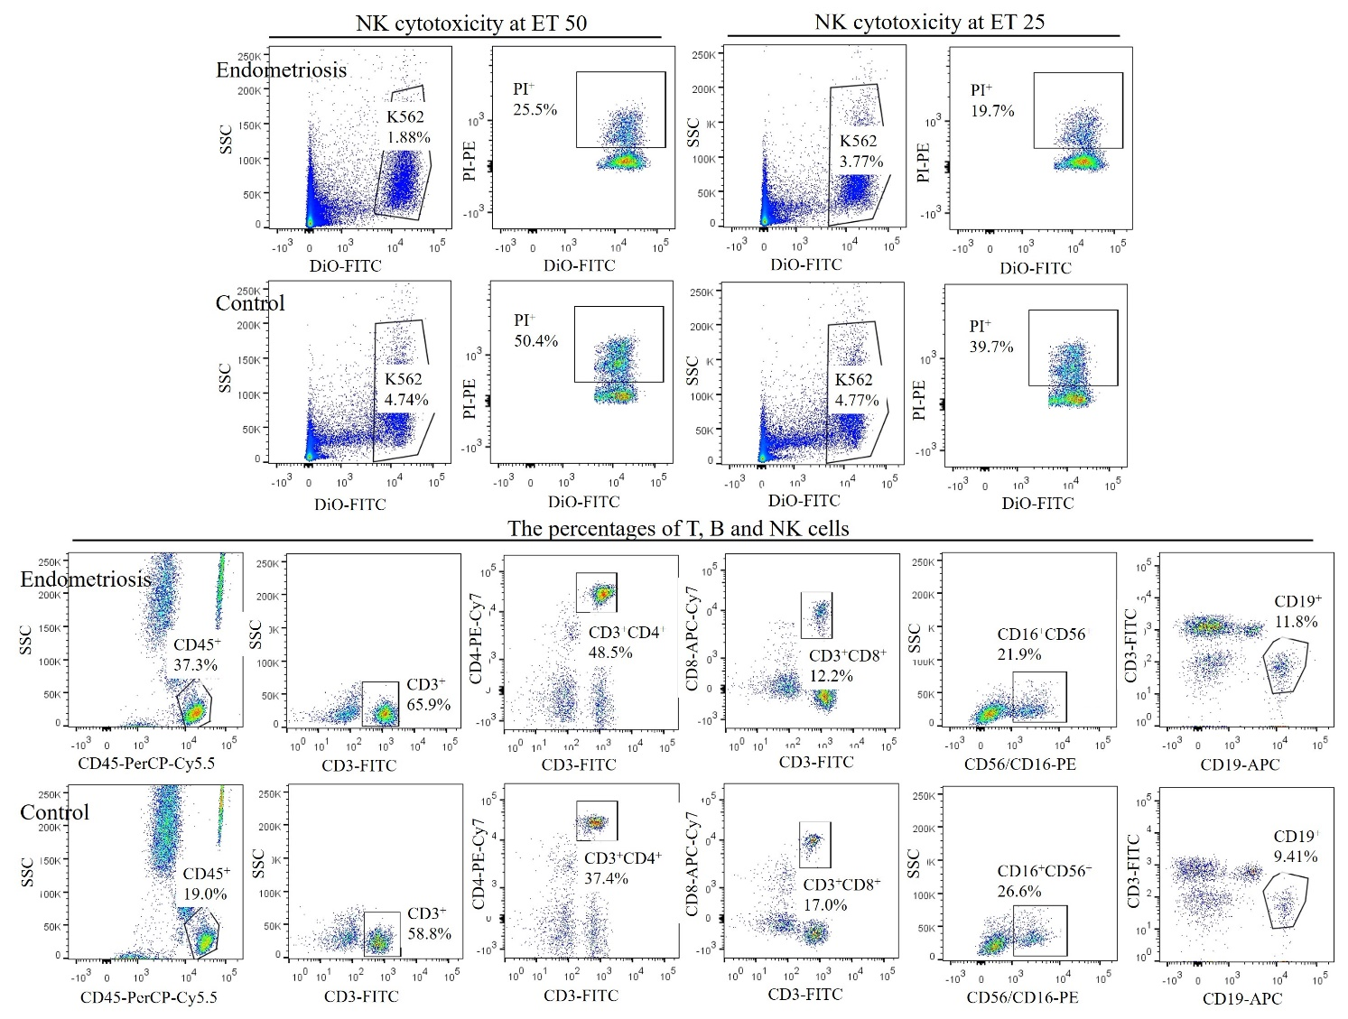
Supplementary Figure S1. Representative images of peripheral NK cytotoxicity and lymphocyte subsets in the study population.
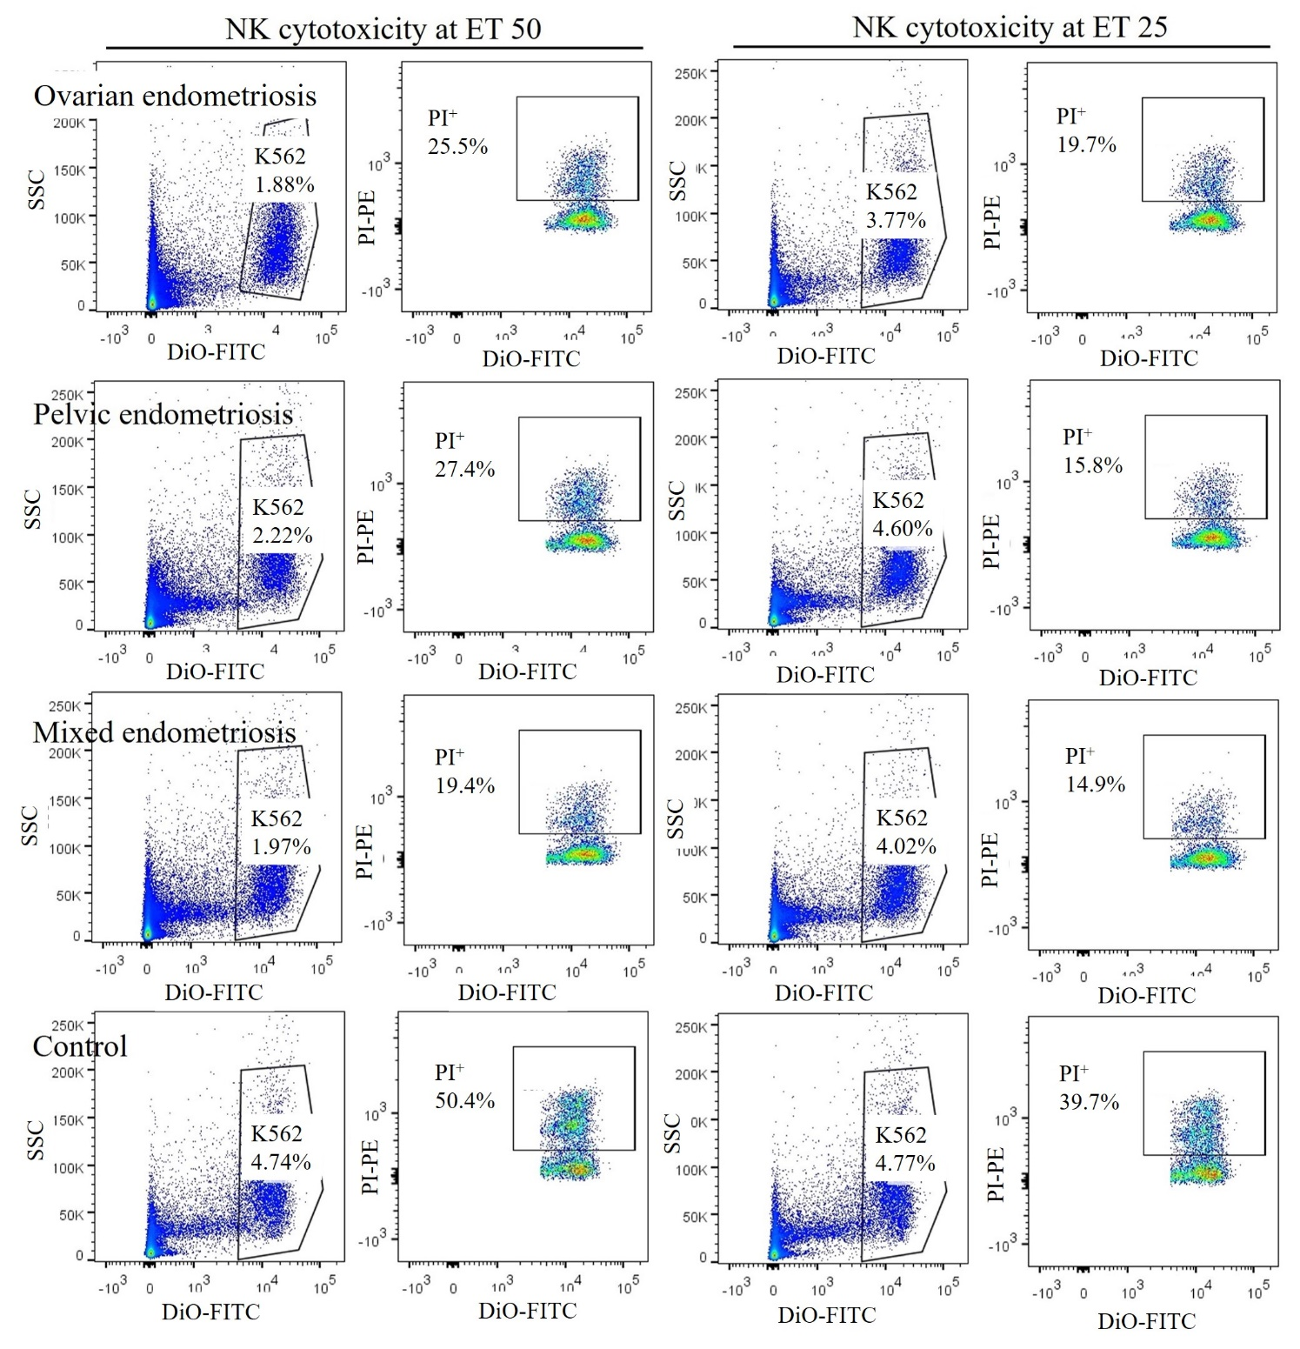
Supplementary Figure S2. Representative images of peripheral NK cytotoxicity in the subgroups.
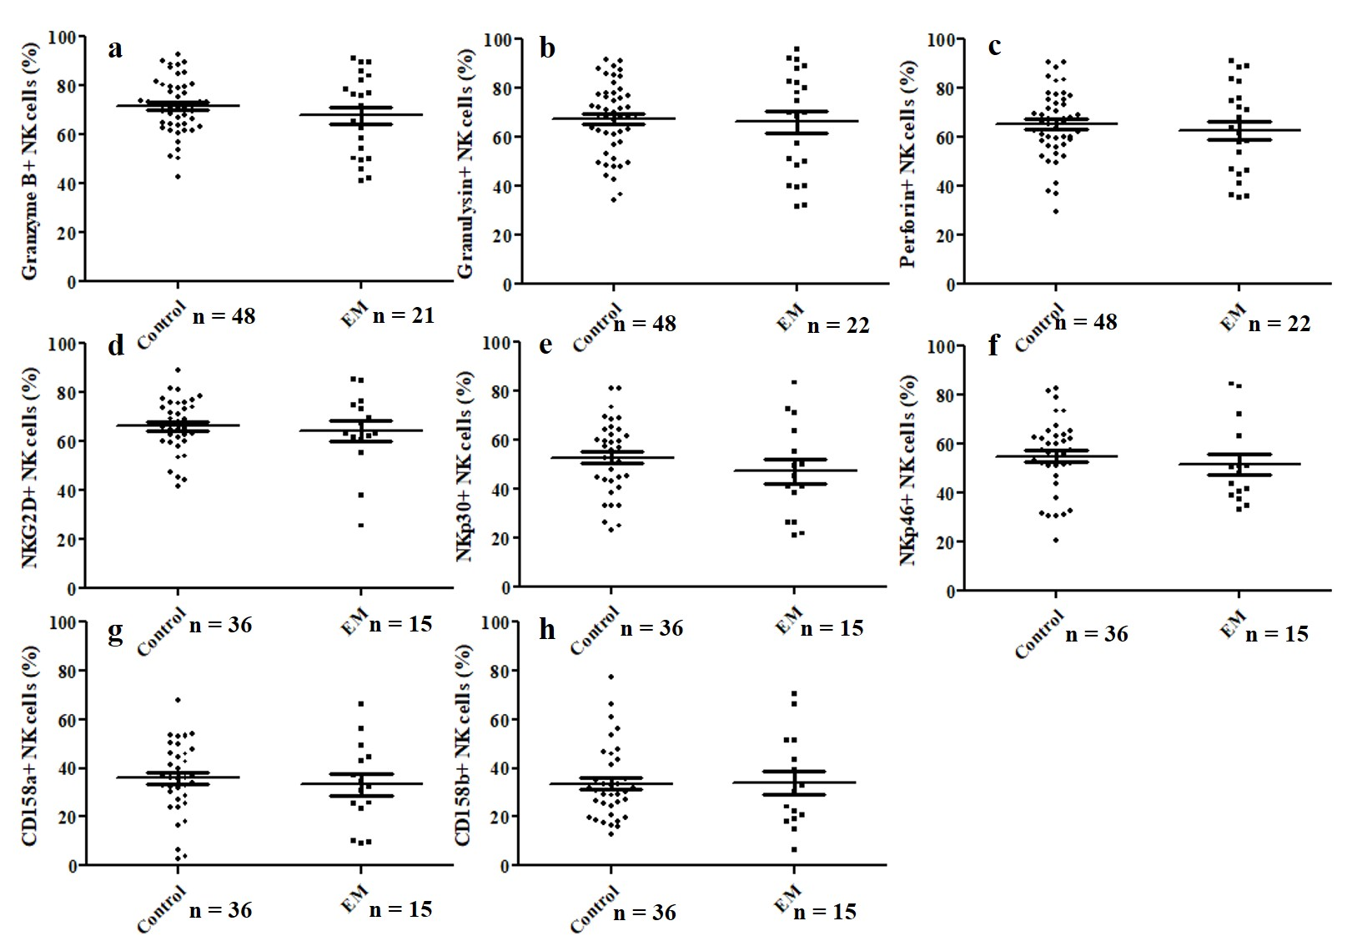
Supplementary Figure S3. Expression of intracellular immune mediators of peripheral NK cells and expression of NK cell surface receptors of part of the study population. Comparison of the expression of granzyme B (a), granulysin (b), perforin (c), NKG2D (d), NKp30 (e), NKp46 (f), CD158a (g), and CD158b (h) of peripheral NK cells between non-endometriosis and endometriosis groups.
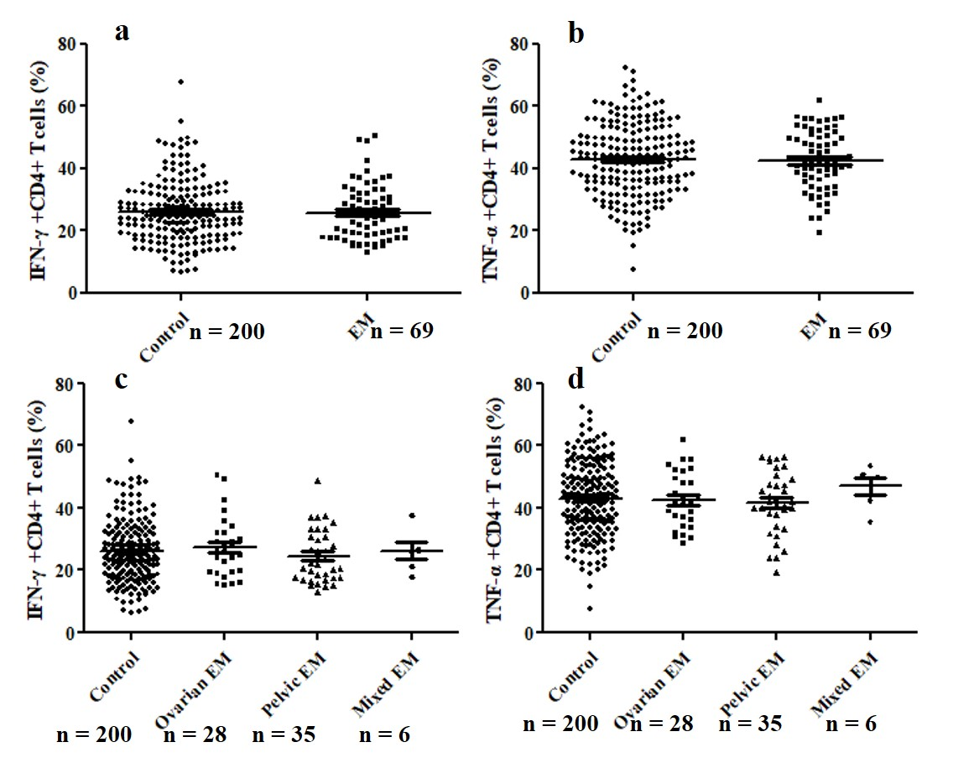
Supplementary Figure S4 Production of IFN-γ and TNF-α by peripheral CD4⁺ T cells in part of the study population. Expressions of IFN-γ and TNF-α were similar between patients with or without endometriosis (a, b) and similar among the subgroups (c, d).
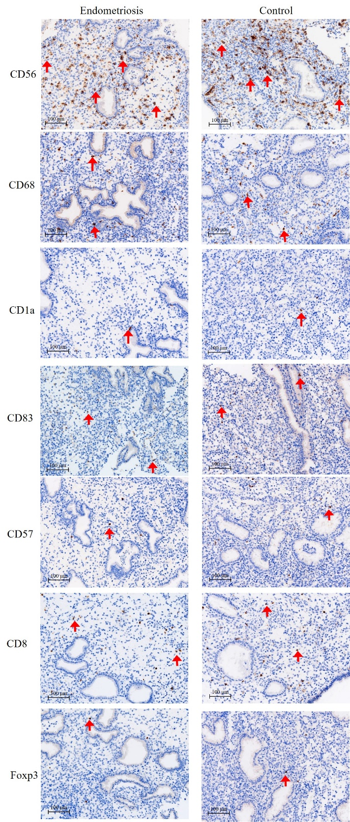
Supplementary Figure S5. Representative images of uterine immune cells in the study population. Classical endometriotic immune cells are marked with red arrows. Magnification: 200 X.
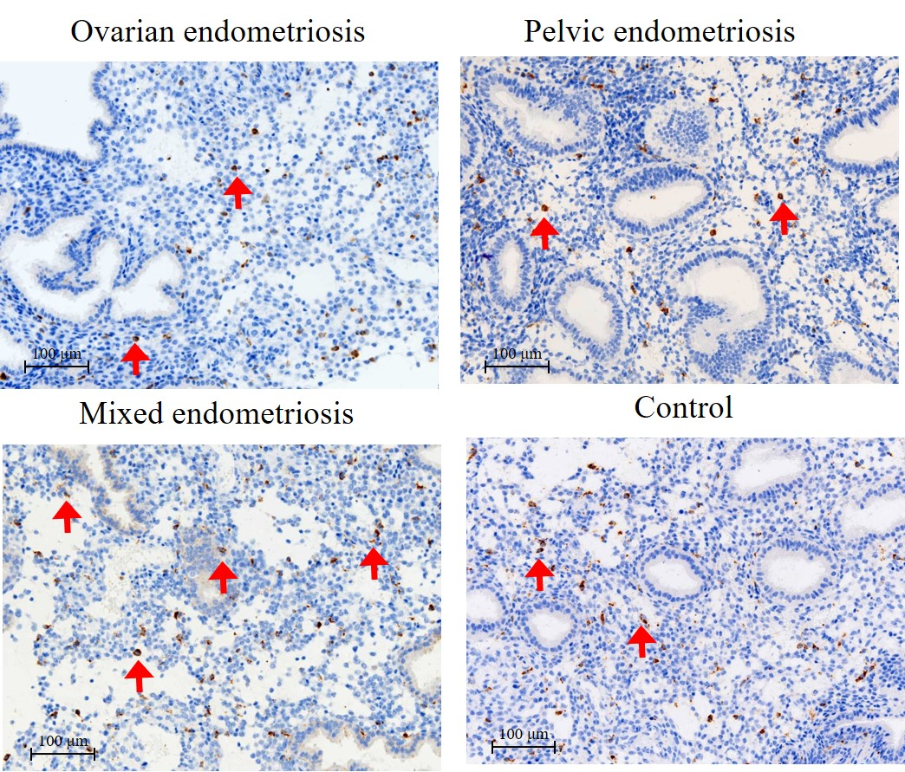
Supplementary Figure S6. Representative images of uterine CD68⁺ macrophages in the subgroups. Classical CD68⁺ macrophages are marked with red arrows. Magnification: 200 X.
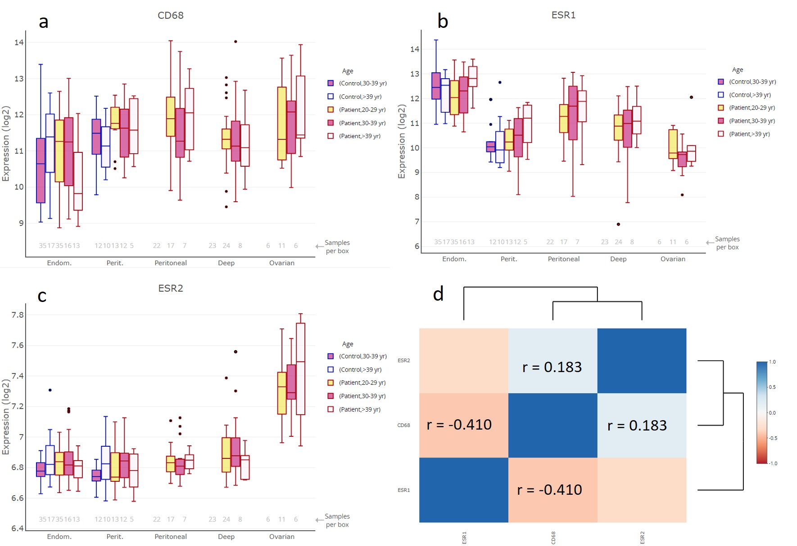
Supplementary Figure S7. mRNA expression of ESR1, ESR2, and CD68 in the endometrium and peritoneum of the control group, and in the eutopic and ectopic endometria and peritoneum of patients with endometriosis in EndometDB, as well as their correlation. (a) mRNA expression of CD68; (b) mRNA expression of ESR1; (c) mRNA expression of ESR2; (d) correlation between ESR1, ESR2, and CD68 in the study population.

