Supplementary Material

Supplementary Figure 1
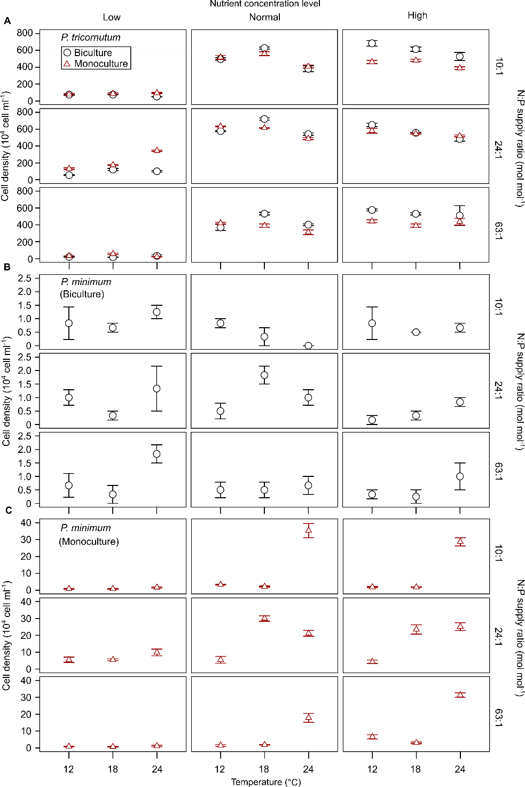
Supplementary Figure 1. Cell density of Phaeodactylum tricornutum (A) and Prorocentrum minimum (B and C) at steady state in the different treatments in bicultures and mono-cultures.

Supplementary Figure 2
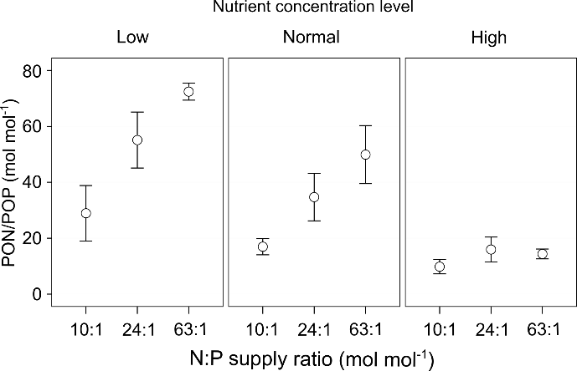
Supplementary Figure 2. The responses of PON/POP (mean ± SE) to N:P supply ratios under different nutrient concentration levels across three temperature levels in bicultures.

Supplementary Figure 3
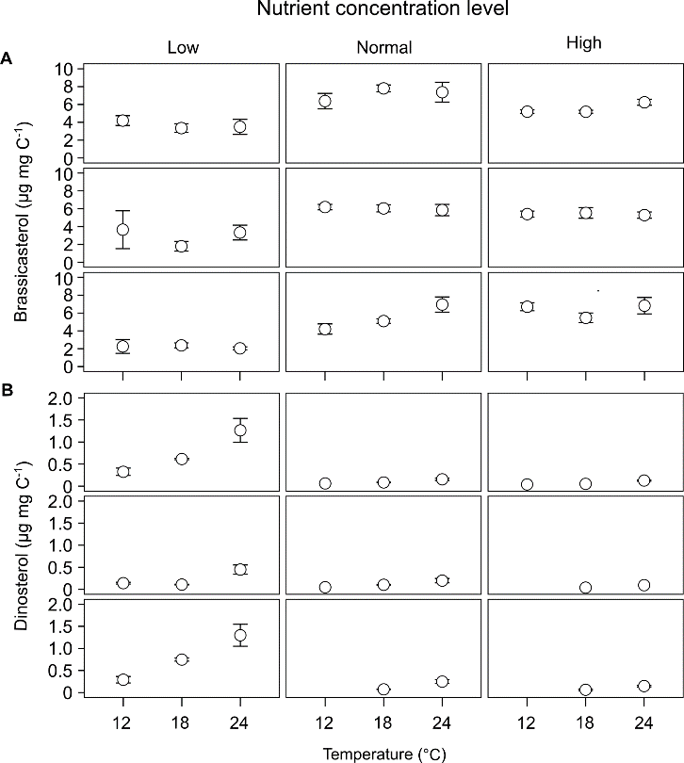
Supplementary Figure 3. The responses of carbon-normalized contents of brassicasterol/epi-brassicasterol and dinosterol (mean ± SE) to temperature, N:P supply ratios and nutrient concentrations in the bicultures of Phaeodactylum tricornutum and Prorocentrum minimum.

Supplementary Table 1. The observed maximal growth rate (μ_{max}, d⁻¹) of Phaeodactylum tricornutum in batch cultures, and the gross growth rate (μ, d⁻¹), the daily renewal rate (D, d⁻¹), the cell density of the diatom P. tricornutum and the dinoflagellate Prorocentrum minimum at day 0 (N_{diatom0} and N_{dino0}) and steady state (N_{diatom1} and N_{dino1}; 10⁴ cells ml⁻¹) during semi-continuous cultures under different temperatures (12, 18 and 24 ºC), N:P supply ratios (molar ratios 10:1, 24:1 and 63:1) and nutrient concentrations (low, normal and high levels) in bicultures of P. tricornutum and P. minimum. r_{diatom} (d⁻¹) and K_{diatom} (10⁴ cells ml⁻¹) are the maximum growth rate and carrying capacity for P. tricornutum in monoculture, and r_{dino} and K_{dino} for P. minimum. The interaction coefficient α (mean±SE) and C:N:P stoichiometry (particulate organic carbon to nitrogen (POC/PON) and particulate organic nitrogen to phosphorus (PON/POP); mol mol⁻¹; mean±SE) are also shown for each treatment in bicultures.
 | Low nutrient level |  |  | Normal nutrient level |  |  | High nutrient level
 | N:P = 10:1 | N:P = 24:1 | N:P = 63:1 | N:P = 10:1 | N:P = 24:1 | N:P = 63:1 | N:P = 10:1 | N:P = 24:1 | N:P = 63:1
12 ºC
μ_{max} | 0.64 | 0.65 | 0.51 | 0.84 | 0.94 | 1.06 | 0.75 | 0.95 | 1.02
μ | 0.13 | 0.13 | 0.10 | 0.17 | 0.19 | 0.21 | 0.15 | 0.19 | 0.20
D | 0.12 | 0.12 | 0.10 | 0.15 | 0.17 | 0.19 | 0.14 | 0.17 | 0.18
N_{diatom0} | 47.5±2.5 | 51.7±6.7 | 21.5±6.8 | 400.8±17.3 | 495.8±52.3 | 148.3±22.2 | 639.2±10.2 | 636.7±49.7 | 561.7±20.2
N_{diatom1} | 74.2±9.2 | 54.8±4.8 | 20.0±2.0 | 495.8±17.6 | 577.5±5.2 | 369.2±36.8 | 683.3±33.9 | 650.0±21.3 | 576.7±12.3
N_{dino0} | 1.7±0.3 | 1.7±0.8 | 2.2±1.2 | 1.2±0.2 | 0.7±0.4 | 1.3±0.4 | 1.2±0.3 | 1.3±0.3 | 2.2±0.8
N_{dino1} | 0.8±0.6 | 1.0±0.3 | 0.7±0.4 | 0.8±0.2 | 0.5±0.3 | 0.5±0.3 | 0.8±0.6 | 0.2±0.2 | 0.3±0.2
r_{diatom} | 1.15 | 0.65 | 1.01 | 0.92 | 0.93 | 0.83 | 0.87 | 0.98 | 1.03
r_{dino} | 0.37 | 0.26 | 0.61 | 0.28 | 0.45 | 0.93 | 0.89 | 0.55 | 0.28
K_{diatom} | 80.5 | 138.0 | 42.5 | 506.3 | 596.5 | 395.6 | 448.3 | 609.5 | 441.9
K_{dino} | 0.8 | 4.5 | 0.9 | 3.4 | 5.2 | 1.5 | 2.3 | 3.7 | 6.3
α | 14.4±6.3 | 100.0±45.8 | 36.2±11.3 | 39.4±10.1 | 40.6±28.0 | 116.5±51.0 | -190.2±11.5 | -57.4±37.7 | -74.8±0.9
POC/PON | 21.7±2.1 | 16.7±1.9 | 10.2±0.9 | 10.9±0.5 | 6.5±0.1 | 8.1±0.2 | 6.5±0.05 | 6.1±0.1 | 6.2±0.1
PON/POP | 43.4±21.2 | 56.6±16.6 | 69.4 | 23.3±6.3 | 16.4±0.8 | 30.8±1.7 | 13.6±6.3 | 11.6±4.1 | 12.0±1.2
18 ºC
μ_{max} | 0.80 | 1.12 | 0.62 | 1.03 | 0.66 | 0.99 | 0.96 | 1.11 | 1.05
μ | 0.16 | 0.22 | 0.12 | 0.21 | 0.13 | 0.20 | 0.19 | 0.22 | 0.21
D | 0.15 | 0.20 | 0.12 | 0.19 | 0.12 | 0.18 | 0.18 | 0.20 | 0.19
N_{diatom0} | 79.2±0.8 | 100.0±8.7 | 47.5±2.9 | 493.3±5.8 | 462.5±3.8 | 290.8±7.3 | 669.2±8.8 | 721.7±5.1 | 514.2±5.1
N_{diatom1} | 75.0±3.8 | 124.2±7.9 | 15.0±0.8 | 627.5±12.3 | 720.8±13.0 | 533.3±15.3 | 613.3±25.3 | 556.7±3.0 | 531.3±13.8
N_{dino0} | 3.5±0.3 | 1.8±0.2 | 1.3±0.2 | 2.0±0.3 | 2.7±0.4 | 4.5±0.3 | 2.7±0.2 | 2.2±0.4 | 1.7±0.2
N_{dino1} | 0.7±0.2 | 1.0±0 | 1.5±0.3 | 0.3±0.3 | 1.8±0.3 | 0.5±0.3 | 0.5±0 | 0.3±0.2 | 0.3±0.3
r_{diatom} | 0.92 | 1.17 | 0.75 | 0.95 | 1.13 | 0.80 | 0.92 | 0.83 | 0.88
r_{dino} | 0.57 | 0.59 | 0.65 | 0.76 | 0.35 | 0.67 | 1.14 | 0.46 | 0.86
K_{diatom} | 93.3 | 163.2 | 53.8 | 497.2 | 591.7 | 391.4 | 477.2 | 646.5 | 386.4
K_{dino} | 0.9 | 5.9 | 0.9 | 2.6 | 27.6 | 2.6 | 2.1 | 24.9 | 2.8
α | 8.4±1.7 | 34.0±5.8 | 23.8±2.7 | -78.0±20.3 | -13.1±4.4 | -21.9±7.1 | -100.4±4.2 | 26.6±7.0 | -136.5±5.2
POC/PON | 19.9±0.5 | 16.1±0.4 | 10.5±0.6 | 11.2±0.2 | 6.7±0.1 | 8.0±0.1 | 6.6±0.03 | 6.7±0.1 | 6.3±0.2
PON/POP | 12.8±0.5 | 53.6±14.9 | - | 13.6±2.3 | 54.4±20.2 | 88.9±7.6 | 4.8±0.2 | 10.0±4.9 | 17.1±4.2
24ºC
μ_{max} | 0.41 | 0.66 | 0.36 | 1.13 | 1.13 | 1.09 | 1.07 | 1.20 | 1.02
μ | 0.08 | 0.13 | 0.07 | 0.23 | 0.23 | 0.22 | 0.21 | 0.24 | 0.20
D | 0.08 | 0.12 | 0.07 | 0.20 | 0.20 | 0.20 | 0.19 | 0.21 | 0.19
N_{diatom0} | 35.8±2.2 | 74.2±2.2 | 22.5±1.2 | 439.2±26.0 | 457.5±7.6 | 365.0±5.2 | 534.2±5.1 | 505.0±23.2 | 450.0±18.9
N_{diatom1} | 51.3±1.3 | 100.0±7.5 | 32.0±12.8 | 380.8±34.4 | 540.8±14.5 | 402.5±10.1 | 425.8±10.1 | 468.3±10.9 | 470.8±38.4
N_{dino0} | 3.8±0.6 | 2.2±0.3 | 1.0±0.5 | 2.5±0.3 | 6.3±0.6 | 4.0±0 | 3.8±0.2 | 3.8±0.6 | 3.5±0.6
N_{dino1} | 2.8±1.6 | 1.3±0.8 | 1.8±0.3 | 0 | 1.0±0.3 | 0.7±0.3 | 0.8±0.2 | 0.3±0.3 | 1.2±0.2
r_{diatom} | 1.47 | 0.58 | 0.99 | 1.43 | 1.18 | 1.53 | 1.60 | 0.83 | 1.40
r_{dino} | 0.65 | 0.43 | 0.37 | 0.57 | 0.64 | 0.73 | 0.79 | 0.57 | 0.41
K_{diatom} | 94.8 | 184.3 | 24.9 | 385.5 | 541.7 | 318.3 | 394.4 | 569.3 | 446.9
K_{dino} | 1.5 | 10.5 | 1.4 | 29.5 | 21.5 | 17.3 | 29.7 | 20.9 | 31.9
α | 22.1±2.4 | 43.0±7.8 | 2.4±0.1 | -20.9±22.8 | 8.7±2.6 | -29.6±4.2 | -34.5±6.0 | 45.0±6.3 | -9.0±11.3
POC/PON | 18.7±1.0 | 16.8±3.1 | 10.9±1.0 | 10.6±0.3 | 6.7±0.03 | 8.5±0.1 | 6.2±0.02 | 6.1±0.04 | 6.2±0.1
PON/POP | 33.8 | - | 75.5 | 12.4±0.02 | 33.3±9.4 | 39.4±4.5 | 9.4±2.3 | 31.4±10.6 | 14.0±3.3

Supplementary Table 2. Results of Akaike information criterion corrected (AICc) in GLMMs for testing the effects of temperature, N:P supply ratios and nitrate concentrations on interaction coefficient α, POC/PON, PON/POP, 16:1/16:0, EPA/DHA and the ratios of brassicasterol/epi-brassicasterol to (brassicasterol/epi-brassicasterol + dinosterol) (B/(B + D)) in bicultures. The selected models are in bold. POC: particulate organic carbon; PON: particulate organic nitrogen; POP: particulate organic phosphorus; EPA: eicosapentaenoic acid (20:5n-3); DHA: docosahexaenoic acid (22:6n-3). The effect builder of ‘main’ refers to models containing first order effects of the three factors, with that of ‘main, two way’ for models containing first order effects and second order interactions and that of ‘main, two way and three way’ for models containing first order effects, second and third order interactions.
Variable | Effect builder | AICc
Interaction coefficient α | Main, two way and three way | 835.166
 | Main, two way | 816.835
 | Main | 803.190
POC/PON | Main, two way and three way | 42.484
 | Main, two way | 11.785
 | Main | -45.161
PON/POP | Main, two way and three way | 145.609
 | Main, two way | 118.778
 | Main | 60.283
16:1/16:0 | Main, two way and three way | 36.101
 | Main, two way | 33.416
 | Main | 25.970
EPA/DHA | Main, two way and three way | 440.900
 | Main, two way | 417.449
 | Main | 378.176
B/(B + D) | Main, two way and three way | -134.275
 | Main, two way | -136.747
 | Main | -137.953

Supplementary Table 3. The profiles of fatty acids (expressed as carbon-normalized content (µg mg C⁻¹) and percentages of total fatty acids (% of TFAs); mean ± SE) and sterols (expressed as μg mg C⁻¹; mean±SE) under different temperatures (12, 18 and 24 ºC), N:P supply ratios (molar ratios 10:1, 24:1 and 63:1) and nutrient concentrations (low, normal and high levels) in the bicultures of Phaeodactylum tricornutum and Prorocentrum minimum. SFAs, saturated fatty acids; MUFAs, monounsaturated fatty acids; PUFAs, polyunsaturated fatty acids; TFAs, total fatty acids.
 | 12 ºC
 | Low nutrient level |  |  |  |  |  | Normal nutrient level |  |  |  |  |  | High nutrient level
 | N:P = 10:1 |  | N:P = 24:1 |  | N:P = 63:1 |  | N:P = 10:1 |  | N:P = 24:1 |  | N:P = 63:1 |  | N:P = 10:1 |  | N:P = 24:1 |  | N:P = 63:1
 | Content | % | Content | % | Content | % | Content | % | Content | % | Content | % | Content | % | Content | % | Content | %
14:0 | 39 | 6 | 46±7 | 8 | 18±0.4 | 6 | 45±4 | 8 | 18±4 | 8 | 31±2 | 10 | 14±1 | 7 | 14±2 | 7 | 15±6 | 8
16:0 | 255 | 39 | 241±37 | 44 | 124±11 | 37 | 159±10 | 29 | 43±9 | 21 | 95±6 | 30 | 37±3 | 18 | 35±4 | 18 | 33±12 | 19
16:1n-7 | 273 | 42 | 235±107 | 37 | 129±31 | 37 | 233±28 | 42 | 59±15 | 28 | 116±13 | 36 | 55±2 | 27 | 51±5 | 27 | 55±22 | 31
18:0 | 6 | 1 | 8±1 | 1 | 5±0.1 | 1 | 6±1 | 1 | 2±0.2 | 1 | 5±0.2 | 2 | 2±1 | 1 | 2±0.2 | 1 | 1±0.4 | 1
18:1n-9 | 39 | 6 | 25±9 | 4 | 24±5 | 7 | 12±4 | 2 | 10±3 | 4 | 8±1 | 2 | 11±1 | 5 | 10±2 | 5 | 7±3 | 4
18:2n-6 | 9 | 1 | 8±3 | 1 | 5±1 | 1 | 19±5 | 3 | 12±4 | 6 | 12±2 | 4 | 12±1 | 6 | 11±0.3 | 6 | 11±5 | 6
18:3n-6 | 3 | 0.4 | 2±1 | 0.3 | 2±1 | 1 | 2±1 | 0.3 | 1±0.2 | 0.3 | 1±0.1 | 0.2 | 0.5±0.03 | 0.2 | 0.3±0.04 | 0.1 | 0.4±0.2 | 0.2
20:4n-6 | 0 | 0 | 1±0 | 0.1 | 0.4±0.1 | 0.1 | 0.4±0.1 | 0.1 | 0.3±0.1 | 0.2 | 0.2±0.02 | 0.1 | 0.4±0.04 | 0.2 | 0.2±0.1 | 0.1 | 0.2±0.1 | 0.1
22:2n-6 | 1 | 0.1 | 1±1 | 0.2 | 1±0.2 | 0.2 | 1±1 | 0.2 | 1±0.3 | 0.4 | 2±0.3 | 0.6 | 1±0.1 | 0.7 | 1±0.1 | 0.5 | 0.2±0.1 | 0.2
24:0 | 2 | 0.3 | 2±0.1 | 0.3 | 1±0.05 | 0.3 | 3±1 | 0.5 | 4±0.02 | 2 | 4±0.3 | 1 | 4±0.4 | 2 | 4±1 | 2 | 3±0.3 | 2
20:5n-3 | 14 | 2 | 16±9 | 2 | 11±4 | 3 | 67±27 | 11 | 56±19 | 26 | 39±4 | 12 | 63±11 | 30 | 58±13 | 30 | 50±26 | 25
22:6n-3 | 3 | 0.5 | 2±1 | 0.3 | 17±6 | 5 | 8±3 | 1 | 5±2 | 2 | 4±0.5 | 1 | 5±1 | 2 | 4±1 | 2 | 5±2 | 2
∑SFAsª | 303 | 47 | 298±46 | 54 | 149±12 | 45 | 214±13 | 39 | 67±13 | 32 | 137±8 | 43 | 57±5 | 28 | 55±6 | 29 | 53±19 | 31
∑MUFAs^{b} | 313 | 49 | 262±117 | 41 | 154±36 | 45 | 247±26 | 44 | 69±17 | 33 | 125±13 | 39 | 67±2 | 33 | 62±5 | 32 | 63±25 | 35
∑PUFAs^{c} | 29 | 5 | 31±14 | 5 | 38±13 | 11 | 99±36 | 17 | 76±25 | 35 | 58±6 | 18 | 82±13 | 39 | 75±14 | 39 | 67±34 | 34
∑TFAs | 646 |  | 590±177 |  | 340±61 |  | 560±73 |  | 213±55 |  | 319±27 |  | 207±8 |  | 193±10 |  | 183±78
Brassicasterol/epi-brassicasterol | 4±1 |  | 4±2 |  | 2±1 |  | 6±1 |  | 6±0.3 |  | 4±1 |  | 5±0.2 |  | 5±0.3 |  | 7±0.5
Dinosterol | 0.3±0.08 |  | 0.1±0.02 |  | 0.3±0.07 |  | 0.1 |  | 0.1 |  | 0 |  | 0.04 |  | 0 |  | 0
ª also includes 20:0 and 22:0 present at < 0.5% of TFAs in all treatments. ^{b} also includes 14:1, 20:1n-9, 22:1n-9 and 24:1n-9 present at < 0.5% of TFAs in all treatments. ^{c} also includes 18:3n-3, 20:2n-6, 20:3n-6 and 20:3n-3 present at < 0.5% of TFAs in all treatments.

Supplementary Table 3. Continued.
 | 18 ºC
 | Low nutrient level |  |  |  |  |  | Normal nutrient level |  |  |  |  |  | High nutrient level
 | N:P = 10:1 |  | N:P = 24:1 |  | N:P = 63:1 |  | N:P = 10:1 |  | N:P = 24:1 |  | N:P = 63:1 |  | N:P = 10:1 |  | N:P = 24:1 |  | N:P = 63:1
 | Content | % | Content | % | Content | % | Content | % | Content | % | Content | % | Content | % | Content | % | Content | %
14:0 | 45±9 | 7 | 38±3 | 9 | 46±4 | 8 | 45±3 | 9 | 25±2 | 10 | 35±4 | 10 | 21±2 | 9 | 17±2 | 7 | 16±1 | 8
16:0 | 296±28 | 46 | 175±12 | 43 | 224±10 | 38 | 144±13 | 29 | 48±5 | 19 | 114±8 | 30 | 52±4 | 21 | 48±4 | 20 | 41±1 | 21
16:1n-7 | 220±46 | 33 | 149±30 | 35 | 194±27 | 33 | 211±26 | 42 | 70±8 | 28 | 156±14 | 41 | 72±7 | 30 | 66±7 | 28 | 54±2 | 28
18:0 | 12±2 | 2 | 7±0.4 | 2 | 9±0.1 | 1 | 6±0.3 | 1 | 2±0.1 | 1 | 6±0.4 | 2 | 2±0.1 | 1 | 2±0.1 | 1 | 2±0.01 | 1
18:1n-9 | 55±8 | 8 | 18±3 | 4 | 66±5 | 11 | 10±2 | 2 | 20±3 | 8 | 10±1 | 2 | 19±3 | 8 | 22±4 | 9 | 13±1 | 7
18:2n-6 | 6±1 | 1 | 6±1 | 2 | 7±1 | 1 | 15±3 | 3 | 9±2 | 4 | 9±1 | 2 | 10±1 | 4 | 10±1 | 4 | 8±0.3 | 4
18:3n-6 | 2±0.3 | 0.2 | 1±0.4 | 0.3 | 3±1 | 0.5 | 2±1 | 0.4 | 1±0.1 | 0.4 | 1±0.2 | 0.3 | 1±0.2 | 0.3 | 1±0.1 | 0.3 | 1±0.04 | 0.3
20:4n-6 | 0±0 | 0 | 0.5±0.04 | 0.1 | 1±0.1 | 0.1 | 1±0.2 | 0.1 | 1±0.1 | 0.4 | 0.4±0.1 | 0.1 | 1±0.2 | 0.3 | 1±0.2 | 0.4 | 1±0.1 | 0.3
22:2n-6 | 0.4±0.04 | 0.1 | 1±0.3 | 0.3 | 1±0.3 | 0.2 | 1±0.4 | 0.2 | 1±0.2 | 0.4 | 3±0.4 | 1 | 1±0.3 | 1 | 1±0.2 | 0.4 | 1±0.1 | 1
24:0 | 2±0.1 | 0.3 | 2±0.2 | 1 | 1±0.04 | 0.2 | 3±0.5 | 1 | 4±0.4 | 2 | 4±0.2 | 1 | 4±0.3 | 1 | 3±0.3 | 1 | 4±0.2 | 2
20:5n-3 | 9±2 | 1 | 12±4 | 3 | 12±4 | 2 | 60±20 | 11 | 61±12 | 24 | 38±7 | 9 | 57±13 | 23 | 64±14 | 26 | 49±8 | 25
22:6n-3 | 4±0.2 | 1 | 1±0.3 | 0.3 | 16±3 | 3 | 7±2 | 1 | 4±1 | 2 | 3±0.4 | 1 | 3±1 | 1 | 3±1 | 1 | 4±1 | 2
∑SFAsª | 357±34 | 55 | 224±16 | 55 | 282±14 | 48 | 200±16 | 40 | 80±6 | 32 | 160±12 | 42 | 80±6 | 33 | 71±6 | 30 | 65±1 | 33
∑MUFAs^{b} | 277±55 | 42 | 167±33 | 40 | 261±32 | 44 | 222±28 | 44 | 90±11 | 36 | 167±15 | 44 | 92±10 | 38 | 89±11 | 37 | 68±3 | 35
∑PUFAs^{c} | 22±3 | 3 | 23±5 | 5 | 49±17 | 8 | 86±26 | 16 | 79±15 | 31 | 55±9 | 14 | 74±16 | 30 | 81±16 | 33 | 64±9 | 32
∑TFAs | 656±92 |  | 414±54 |  | 593±64 |  | 509±70 |  | 248±33 |  | 382±36 |  | 245±32 |  | 241±33 |  | 197±13
Brassicasterol/epi-brassicasterol | 3±0.4 |  | 2±1 |  | 2±0.3 |  | 8±0.4 |  | 6±0.4 |  | 5±0.2 |  | 5±0.2 |  | 6±1 |  | 5±1
Dinosterol | 0.6±0.01 |  | 0.1±0.01 |  | 0.8±0.04 |  | 0.1±0.01 |  | 0.1±0.01 |  | 0.1±0.002 |  | 0.1 |  | 0.04 |  | 0.06±0.01

Supplementary Table 3. Continued.
 | 24ºC
 | Low nutrient level |  |  |  |  |  | Normal nutrient level |  |  |  |  |  | High nutrient level
 | N:P = 10:1 |  | N:P = 24:1 |  | N:P = 63:1 |  | N:P = 10:1 |  | N:P = 24:1 |  | N:P = 63:1 |  | N:P = 10:1 |  | N:P = 24:1 |  | N:P = 63:1
 | Content | % | Content | % | Content | % | Content | % | Content | % | Content | % | Content | % | Content | % | Content | %
14:0 | 45±1 | 6 | 29±8 | 6 | 27±5 | 6 | 26±7 | 7 | 18±3 | 8 | 23±2 | 7 | 20±2 | 7 | 18±3 | 8 | 20±3 | 7
16:0 | 323±33 | 44 | 179±55 | 38 | 191±46 | 44 | 102±22 | 29 | 49±7 | 21 | 94±10 | 29 | 55±0.4 | 20 | 48±3 | 21 | 62±2 | 22
16:1n-7 | 263±47 | 35 | 178±43 | 39 | 132±33 | 30 | 143±27 | 40 | 67±6 | 29 | 131±17 | 39 | 77±4 | 28 | 64±7 | 28 | 82±6 | 29
18:0 | 13±1 | 2 | 10±4 | 2 | 9±2 | 2 | 4±1 | 1 | 2±0.4 | 1 | 5±0.4 | 2 | 3±1 | 1 | 3±0.3 | 1 | 4±1 | 2
18:1n-9 | 62±4 | 8 | 29±12 | 6 | 55±20 | 12 | 12±1 | 3 | 16±0.4 | 7 | 13±5 | 4 | 25±3 | 9 | 21±4 | 9 | 23±3 | 8
18:2n-6 | 6±2 | 1 | 5±0.1 | 1 | 5±1 | 1 | 7±1 | 2 | 9±0.1 | 4 | 8±2 | 2 | 11±1 | 4 | 9±1 | 4 | 12±1 | 4
18:3n-6 | 3±1 | 0.4 | 3±1 | 1 | 2±1 | 0.4 | 2±0.1 | 1 | 1±0.1 | 1 | 3±1 | 1 | 1±0.1 | 0.4 | 1±0.2 | 0.5 | 1±0.2 | 0.5
20:4n-6 | 1±0.4 | 0.1 | 2±1 | 0.4 | 1±0.2 | 0.1 | 2±0.1 | 0.5 | 2±0.2 | 1 | 1±1 | 0.4 | 2±0.3 | 1 | 2±0.3 | 1 | 2±0.4 | 1
22:2n-6 | 1±1 | 0.1 | 1±0.4 | 0.3 | 1±0.2 | 0.2 | 1±0.04 | 0.3 | 1±0.2 | 1 | 4±1 | 1 | 1±0.1 | 0.3 | 1±0.1 | 0.3 | 1±0.2 | 0.3
24:0 | 2±0.3 | 0.3 | 1±0.1 | 0.3 | 1±0.1 | 0.2 | 3±0.5 | 1 | 3±0.2 | 1 | 2±0.04 | 1 | 3±0.3 | 1 | 3±0.04 | 1 | 4±0.3 | 1
20:5n-3 | 22±15 | 3 | 17±3 | 5 | 7±2 | 2 | 42±6 | 13 | 54±13 | 24 | 45±18 | 13 | 69±14 | 25 | 57±14 | 24 | 68±15 | 23
22:6n-3 | 4±1 | 1 | 2±0.3 | 1 | 7±2 | 2 | 5±0.4 | 1 | 3±1 | 2 | 3±1 | 1 | 4±1 | 1 | 3±1 | 1 | 4±0.5 | 1
∑SFAsª | 385±35 | 52 | 220±67 | 47 | 229±53 | 53 | 136±31 | 38 | 73±10 | 32 | 126±12 | 38 | 82±1 | 30 | 72±6 | 32 | 91±3 | 32
∑MUFAs^{b} | 326±48 | 43 | 208±55 | 45 | 187±53 | 42 | 155±28 | 44 | 83±6 | 36 | 145±22 | 43 | 102±7 | 37 | 85±10 | 37 | 106±9 | 37
∑PUFAs^{c} | 38±20 | 5 | 31±3 | 8 | 23±5 | 5 | 59±5 | 18 | 72±14 | 32 | 66±25 | 19 | 89±16 | 32 | 73±17 | 31 | 90±18 | 31
∑TFAs | 748±82 |  | 460±120 |  | 439±111 |  | 351±54 |  | 228±3 |  | 337±59 |  | 274±25 |  | 231±33 |  | 287±30
Brassicasterol/epi-brassicasterol | 3±1 |  | 3±1 |  | 2±0.2 |  | 7±1 |  | 6±1 |  | 7±1 |  | 6±0.3 |  | 5±0.4 |  | 7±1
Dinosterol | 1.3±0.3 |  | 0.5±0.1 |  | 1.3±0.3 |  | 0.2±0.03 |  | 0.2±0.05 |  | 0.3±0.04 |  | 0.1±0.01 |  | 0.1 |  | 0.2±0.02

