Supplementary Material

Supplementary Figures

Supplementary Figure 1. Characterization of pri enhancers with minor activity during embryogenesis. (A) Schematic representation of the pri locus. Genomic regions tested using LacZ-reporter lines are represented as white boxes. (B) Activity of pri genomic regions C, D, E, H, I and J from stage-11 to -16, showing weak expression and/or expression in other tissues than the epidermis and trachea.

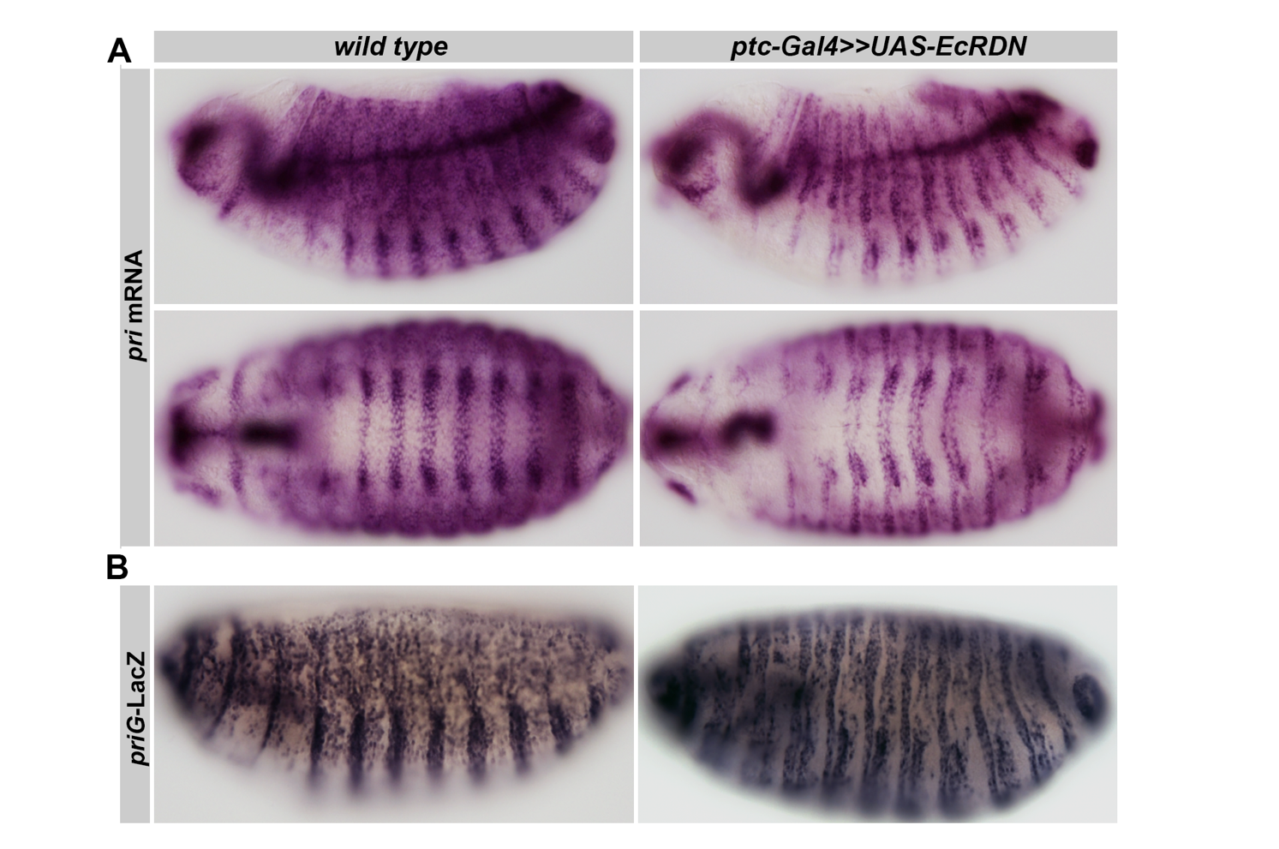

Supplementary Figure 2. Lack of ecdysone impairs pri expression and priG activity. (A) In situ hybridization showing pri mRNA expression in wild type embryos (left) and embryos expressing EcR^{DN} driven by ptc-Gal4 (right). pri expression is abolished in cell stripes expressing Ptc. Top panels show lateral views, bottom panels show ventral views. (B) LacZ immunostaining showing that priG activity is impaired in epidermal cells expressing EcR^{DN} (right) compared to control conditions (left).

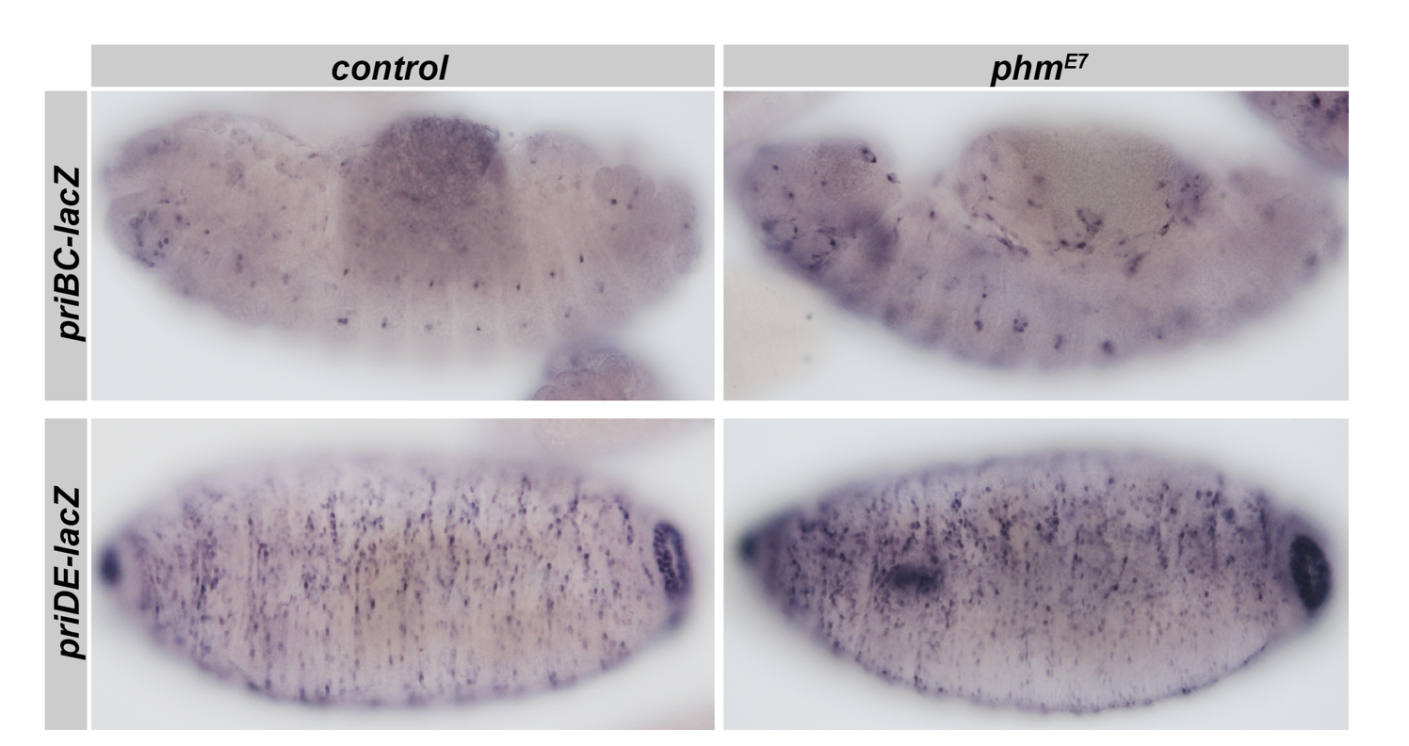

Supplementary Figure 3. Expression driven by priBC and priDE regions during embryogenesis. LacZ immunostaining show no obvious changes in priBC and priDE activity between phm^{E7} mutant embryos deprived of ecdysone (right) and control sibling embryos (left). Pictures show stage-14 embryos for priBC and stage-16 embryos for priDE.

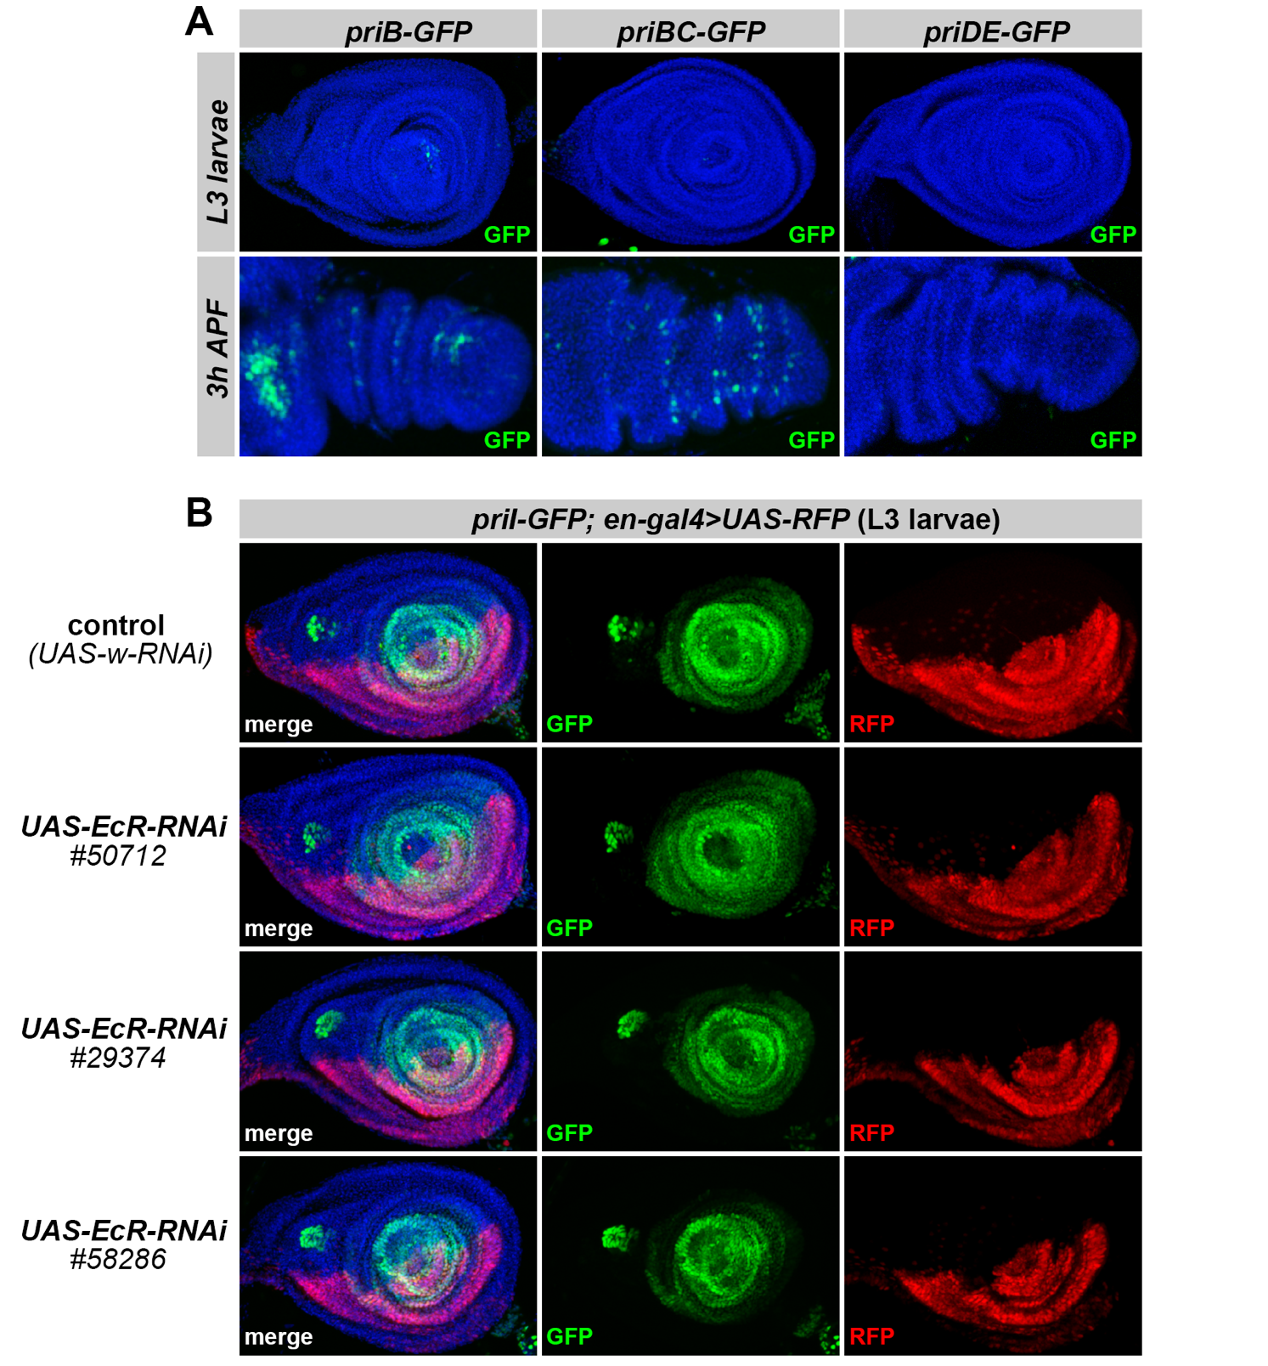

Supplementary Figure 4. (A) Expression of priB, priBC and priDE in the larval and pupal leg primordia. (B) Expression of priI-GFP in larval leg discs (mid-L3) in control conditions, or following concomitant expression of three different EcR-RNAi driven by en-gal4 (monitored by RFP expression, red). Control individuals express an unrelated RNAi (directed against w). Blue is DAPI, and green is GFP.

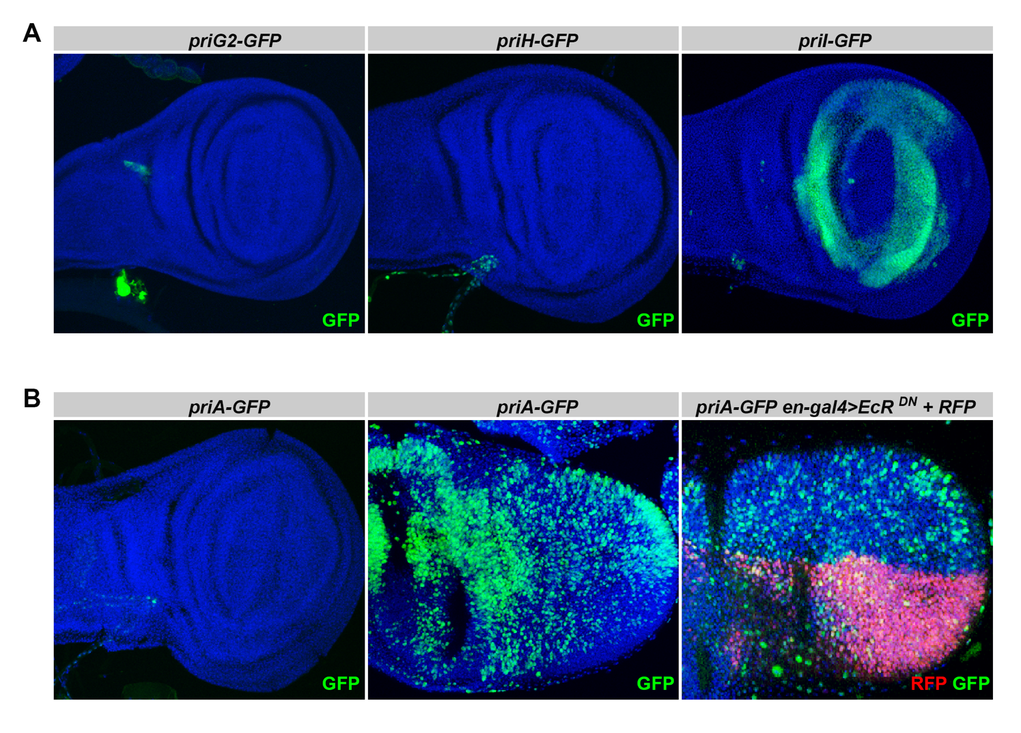

Supplementary Figure 5. Expression driven by pri enhancers in the wing imaginal disc. (A) expression of priG2, priH and priI in the wing larval imaginal discs in mid third instar larvae. (B) Expression of priA-GFP in larval (left panel) and pupal (right panels) wing discs in control conditions, or following concomitant expression of EcR^{DN} driven by en-gal4 (monitored by RFP expression, red). The activity of priA is unchanged in cells expressing EcR-DN. In all pictures, blue is DAPI, green is GFP.

Supplementary tables

constructs | start (3R:) | end (3R:) | size (bp)
priA | 13 789 349 | 13 791 404 | 2 055
priA-EcR1mut | 13 789 349 | 13 791 404 | 2 055
priA-EcR2mut | 13 789 349 | 13 791 404 | 2 055
priA-EcRmut | 13 789 349 | 13 791 404 | 2 055
priAb1 | 13 789 349 | 13 790 704 | 1 355
priAb2 | 13 790 601 | 13 791 404 | 803
priAse | 13 790 753 | 13 791 174 | 421
priAs | 13 790 835 | 13 791 161 | 326
priB | 13 790 903 | 13 796 523 | 5 620
priC | 13 796 024 | 13 801 009 | 4 985
priBC | 13 795 378 | 13 798 178 | 2 800
priD | 13 800 509 | 13 803 761 | 3 252
priE | 13 806 614 | 13 812 824 | 6 210
priDE | 13 805 078 | 13 808 878 | 3 800
priF | 13 810 400 | 13 813 525 | 3 125
priG | 13 814 566 | 13 819 339 | 4 773
priG1 | 13 814 566 | 13 815 557 | 991
priG2 | 13 815 540 | 13 816 559 | 1 019
priG2-EcRmut | 13 815 540 | 13 816 559 | 1 019
priG3 | 13 816 536 | 13 817 556 | 1 020
priG4 | 13 815 297 | 13 815 880 | 583
priG5 | 13 816 279 | 13 816 862 | 583
priH | 13 819 320 | 13 824 323 | 5 003
priI | 13 824 304 | 13 829 359 | 5 055
priJ | 13 829 348 | 13 834 473 | 5 125
bac1_CH321-08H01 | 13 790 547 | 13 843 138 | 52 591
bac2_CH322-176K10 | 13 796 285 | 13 816 692 | 20 407
bac3_CH321-51O01 | 13 782 785 | 13 881 493 | 98 708
bac4_CH322-150C08 | 13 807 968 | 13 829 890 | 21 922

Supplementary Table 1. Genomic position of transgenic constructs used in this study.

construct | name | sequence
priA | fwA3’hind3 | 5'-CGGATCCAAGCTTAGCAAATCAGTAATG-3'
 | rvA3' | 5'-GCGGAAATGCATTTCTATGGACTGACTTAC-3'
priAb1 | fwA3’hind3 | 5'-CGGATCCAAGCTTAGCAAATCAGTAATG-3'
 | rvA3'block1 | 5'-ACACAAGTTCTAGACCACAAGTCATGCCAGAGCC-3'
priAb2 | fwA3'block2 | 5'-TACAATCtAAGCTTGCGACAGGGAGGGCAGCATC-3'
 | rvA3'block2 | 5'-ATCCAATAGCGGCCGCAGTTATTAGTAAATGTATGC-3'
priAse | fwA3'S | 5'-TTCCGCAAAGCTTACACCACTAAAAAGTCCAAAAAGAAGG-3'
 | rvA3'S | 5'-GGTTTCAAGAATTCAGCATGAATATTCGG-3'
priAs | fwA3'ms | 5'-TTGTTTACAAGCTTGTTGTGGGGCGTTCGTTAGC-3'
 | rvA3'ms | 5'-TTAATTATGCGGCCGCGGAGACAATGCAAATGATTG-3'
priA-EcR1mt | gblockA3EcR1fw | 5'-GTAAGTCAGTCCATAGAAATGCATTTCCGC-3'
 | gblockA3EcR1rv | 5'-CAGAGTAACAGATAAGGCCATATCATGAC-3'
priA-EcR2mt | gblockA3EcR2fw | 5'-AGTCCTCTTCAGATCTGCTCAGTTGTTGC-3'
 | gblockA3EcR2rv | 5'-GGGGTTTCAAGAATTCAGCATGAATATTCG-3'
priG | priGfw | 5'-GACTCGAGGCGGCCGCTCGACCGACATCCAGAGAAC-3'
 | priGrv | 5'-GACTCGAGGCGGCCGCGTGTGTAGAGATGCTGATGC-3'
priG1 | priG1fw | 5'-GACTCGAGGCGGCCGCTCGACCGACATCCAGAGAAC-3'
 | priG1rv | 5'-GATAAATTGCGGCCGCGTTCCTGGGAAGATCTGATTGCAGGC-3'
priG2 | priG2fw | 5'-GATAAATTGCGGCCGCTCAGATCTTCCCAGGAACCCACACAC-3'
 | priG2rv | 5'-GATAAATTGCGGCCGCTTCATATACAATATAAACATTGATTCAGGCCC-3'
priG3 | priG3fw | 5'-CGGACGCTCTAGAATCAATGTTTATATTGTATATGAATCGCCAGG-3'
 | priG3rv | 5'-GATAAATTGCGGCCGCTCATTGACCCTTTCTGCCTCGAGTTG-3'
priG4 | priG4fw | 5'-GATAAATTGCGGCCGCAGAGAGACTATTAATAGACACGCGCGCAC-3'
 | priG4rv | 5'-GATAAATTGCGGCCGCACCAATTGAATCCCATAAGATATAAAAGGC-3'
priG5 | priG5fw | 5'-GTAATTTCTAGAGTTCCAGCTCCAGCTCCCAACG-3'
 | priG5rv | 5'-GATAAATTGCGGCCGCGTGTAAATTGAACGCGGAGC-3'
priG2EcRmut | fwG2HindIII | 5'-CTAGCGGATCCAAGCTTGCATGCTG-3'
 | rvG2EcR1_EcR2mt | 5'-TTGGCCCCCCCCAAAAAAATCTTTTTTCATTTCTCAGAGCG-3'
 | fwG2EcR1_EcR2mt | 5'-TTTTTTTGGGGGGGGCCAATTTTTTGGGGGGGGCTGGCCGGGCCTGAATCAATG-3'
 | rvG2BSU36I | 5'-CAGTATCGGCCTCAGGAAGATCGCAC-3'
priH | priHfw | 5'-CTCTCGAGGCGGCCGCGCATCAGCATCTCTACACAC-3'
 | priHrv | 5'-GACTCGAGGCGGCCGCCCAGTCTATTACTTCTACGC-3'
priI | priIfw | 5'-CTCTCGAGGCGGCCGCGCGTAGAAGTAATAGACTGG-3'
 | priIrv | 5'-GACTCGAGGCGGCCGCCACTTTTCATCAAACTTATATTAATAAG-3'
priJ | priJfw | 5'-CTCTCGAGGCGGCCGCCTTATTAATATAAGTTTGATGAAAAGTG-3'
 | priJrv | 5'-GACTCGAGGCGGCCGCATATCTTACTTGCAGAGTGG-3'
pAttb | attbFW | 5'-AAATGGTGGGCATAATAGTGTTG-3'
 | attbRv | 5'-CCCAGACCGGCAACGAAAATCACG-3'
pri | oligo1pri | 5'-CTAAGCAAGTACGGCAGATATGTTCATAG-3'
 | WH3'/RB3' out | 5'-CCTCGATATACAGACCGATAAAAC-3'

Supplementary Table 2. Sequence of the oligonucleotides used in this study.

