Supplementary Figures
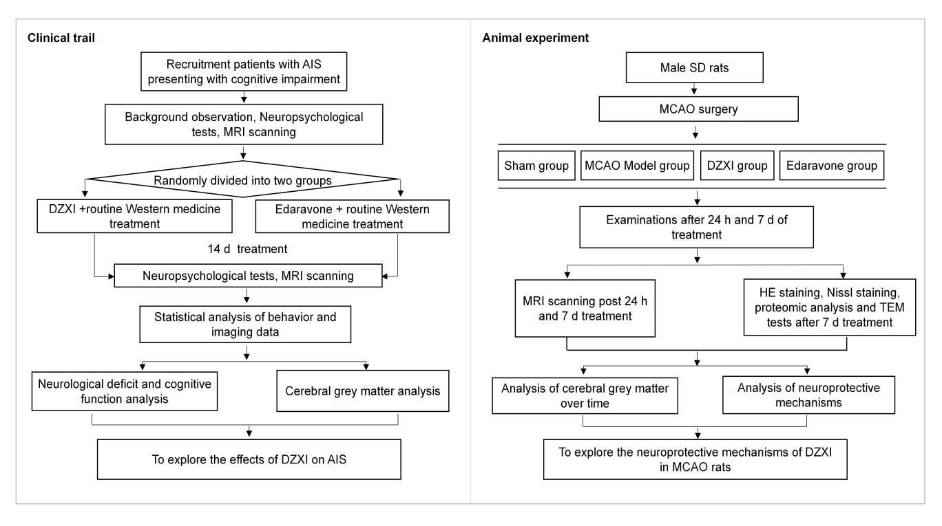
Supplementary Figure S1. The procedures of the clinical trial and animal experiment.

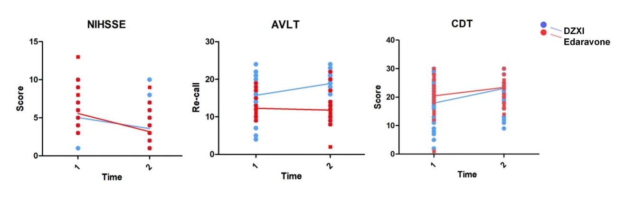
Supplementary Figure S2. DZXI and edaravone exerted different performance in the NIHSS, AVLT and CDT. The significant interaction effects between treatment groups (DZXI and edaravone) and treatment time were shown in these neuropsychological tests as indicated by two-way repeated measures ANOVA analysis. Time 1, baseline; time 2, the end of the treatment; blue, DZXI group; red, edaravone group. Each point represents an individual’s score on each neuropsychological test, and lines links the average at the two points.

