**Facile synthesis of Holmium-based nanoparticles as a CT and MRI Dual-modal imaging for Cancer Diagnosis**

**Tianqi Zhang1,4, Mo Deng2, Lei Zhang3, Yang Liu4,5, Shuyan Song4, Tingting Gong1* and Qinghai Yuan1\***

1Department of Radiology, the Second Hospital of Jilin University, Changchun, China

2Department of Clinical Laboratory, the Second Hospital of Jilin University, Changchun, China

3Department of Neurology, the Second Hospital of Jilin University, Changchun, China

4State Key Laboratory of Rare Earth Resource Utilization, Changchun Institute of Applied Chemistry, Chinese Academy of Sciences, Changchun, China

5University of Science and Technology of China, Hefei, China

**\* Correspondence:**Tingting Gong; Qinghai Yuan

gongtt01@jlu.edu.cn; yqh@jlu.edu.cn

**1. Characterization**

Transmission electron microscope (TEM) images were performed on a FEI Tecnai G2 F20 microscope. Field emission scanning electron microscope (FESEM) images were analyzed on a Hitachi S-4800 microscope. X-ray powder diffraction (XRD) of the samples was examined on a D8 Focus diffractometer (Bruker., Germany) using Cu-Ka radiation (0.15405 nm). The concentration of the nanomaterial was obtained by inductively coupled plasma-mass spectrometry (ICP-MS). X-ray photoelectron (XPS) measurements were performed on an ESCALAB-MKII spectrometer (VG Co., United Kingdom). IR measurements were performed on a fourier transform infrared spectrometer (Bruker., Germany). Zeta potential and DLS were analyzed on a Zetasizer Nano (Malvern., England). CT was performed by a 256-slice CT scanner (Brilliance iCT, Philips Healthcare). MR Imaging was performed on a 3.0 T human clinical MRI scanner (Ingenia 3.0T CX, Philips Healthcare).

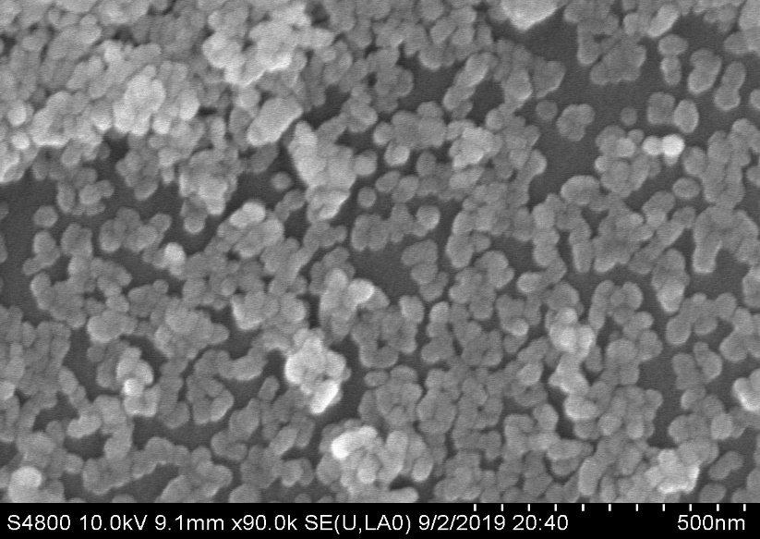

Figure S1. SEM image of PEG-HoF3 NPs and the average size is about 38 nm.

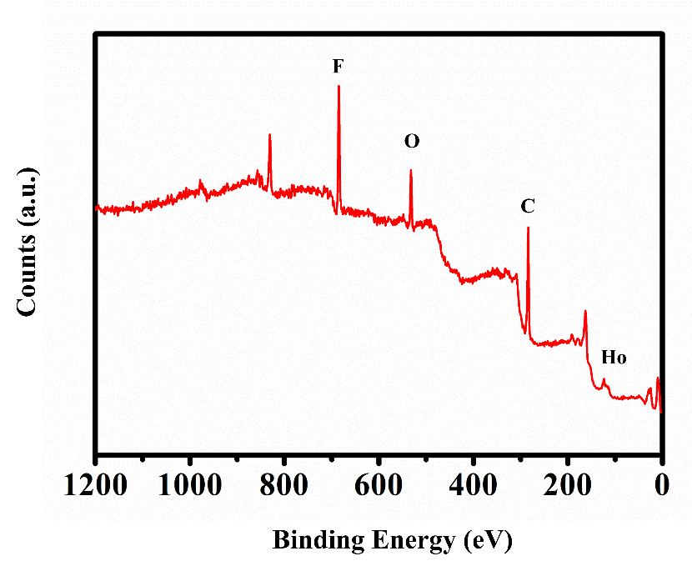

Figure S2. XPS wide scan of PEG-HoF3 NPs.



**-OH**

Figure S3. The peak in 3391 cm-1 verify the existence of PEG.

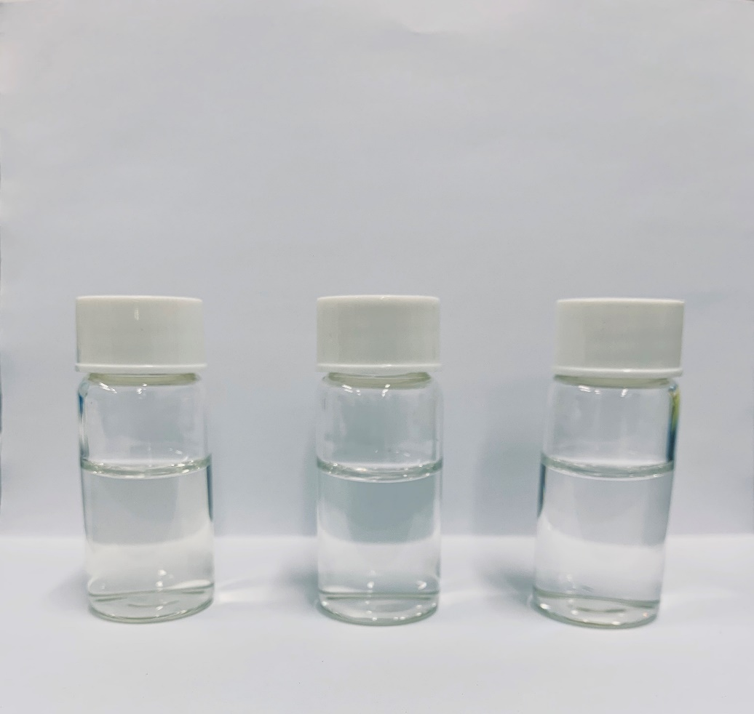

Figure S4. From the left to right are PEG-HoF3 NPs in water, normal saline and PBS solution.

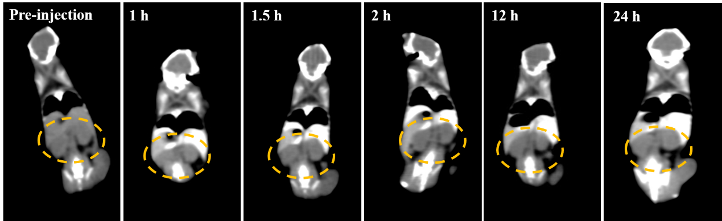

Figure S5. CT images of mouse kidney in different time point after intravenous injection of PEG-HoF3 NPs. Yellow circle indicates the kidney.