STable 1. Classification of prognostic score.
Model | Score
Model 1
A | 0~2
B | 3~4
C | 5~6
Model 2
A | >151.9
B | 51.0<, ≤151.9
C | ≤51.9
Optimal cut-point for nomogram system was based on the results of maximally selected rank statistics from R package “maxstat”.

sFIG1. Flow chart of patient selection.

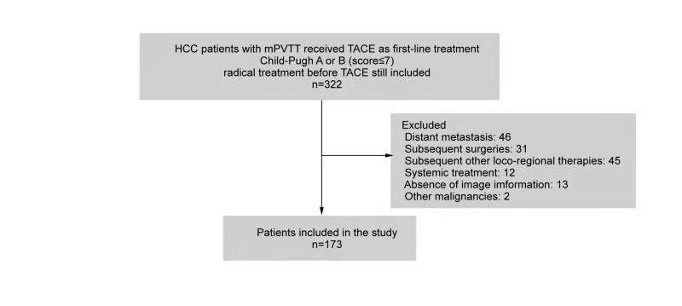

sFIG2. Kaplan-Meier curves of overall survival of all 173 patients.

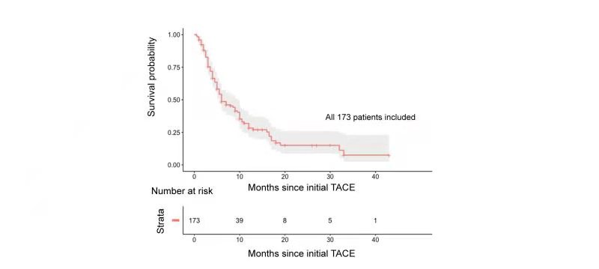

sFIG3. Kaplan-Meier curves illustrating overall survival (OS).
Kaplan-Meier survival curves for comparison of OS between patients with (A) tumor diameter ≥8cm and <8cm; (B) complete mPVTT and partial mPVTT; (C) multiple tumor number and single tumor; (D) AFP ≥400ng/ml and AFP <400ng/ml.

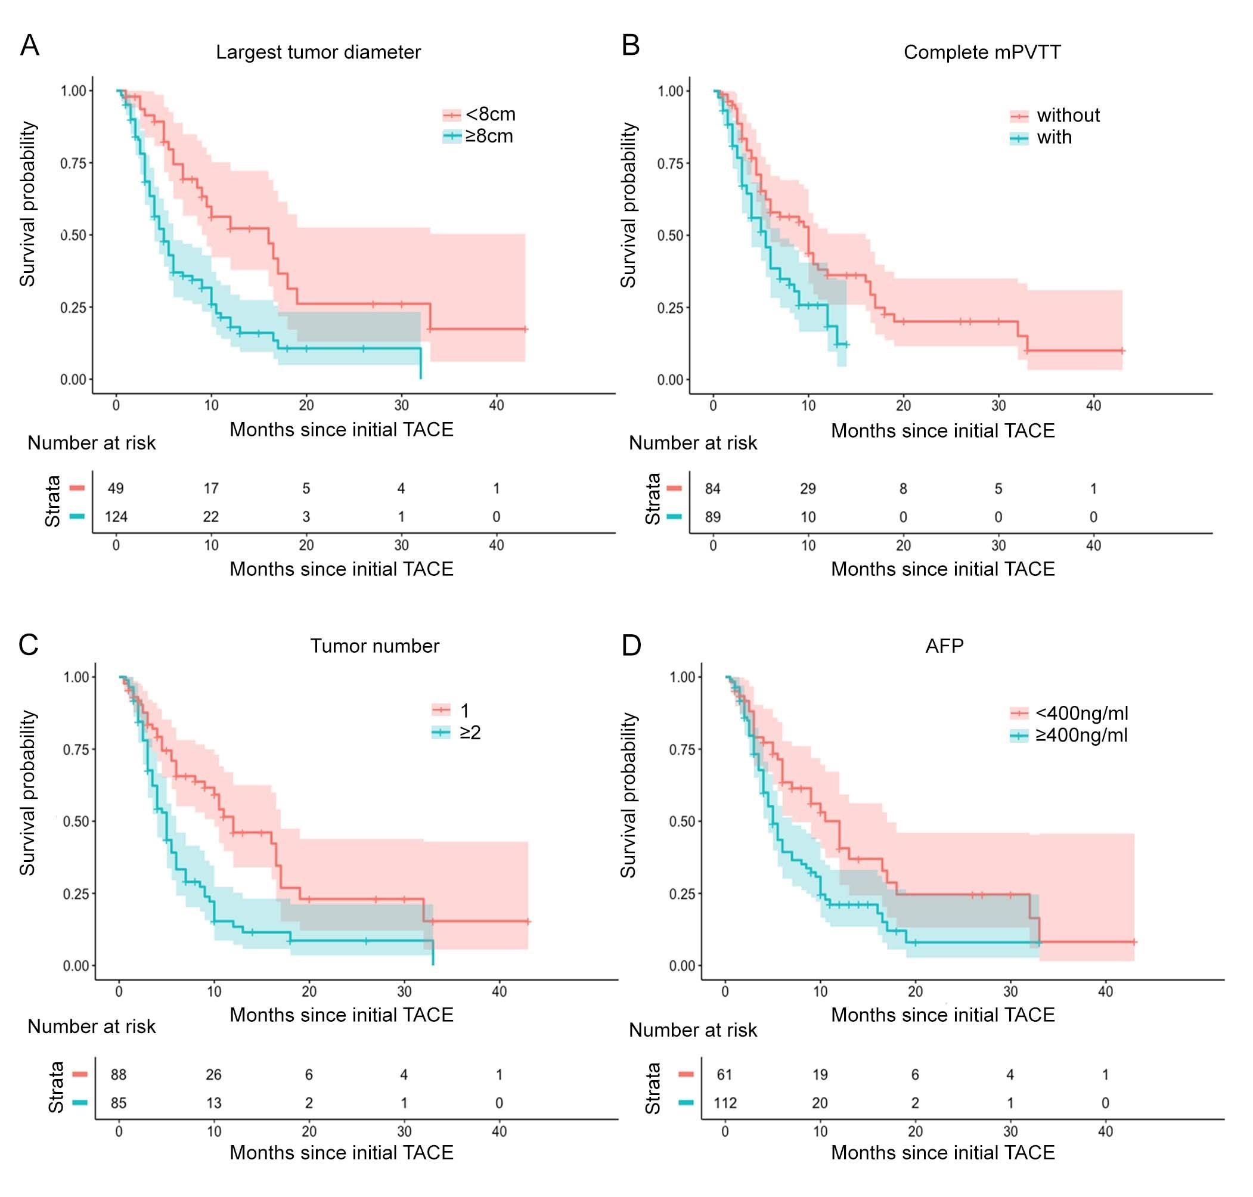

sFIG4. The plot of Schodenfeld residuals test.
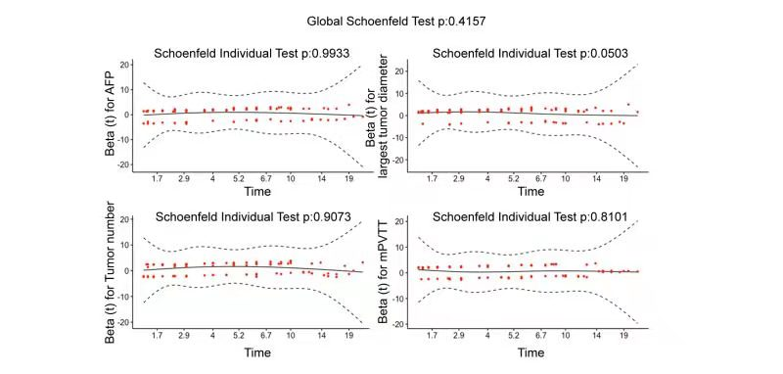

sFIG5. Kaplan-Meier estimated curves of overall survival of 173 studied patients stratified by current model 1 score.
