Supplementary Material

Supplementary Figure 1. Furcal length (FL) and otolith radius relationship of Pagellus bogaraveo in (A) Western, (B) Central, and (C) Eastern island groups (Number of individuals=75/location). Adjusted R-squared, slope, intercept and p-values are presented.

Supplementary Figure 2. (A) Life span of fish used in the study, each line representing an individual fish, from birth to capture; (B) Box-and-whiskers plot of annual otolith increment measurements of fish captured in the island groups, with lines, boxes, and whiskers representing medians, interquartile range (IQR), and 1.5 IQR, respectively. Blue=western islands, Red=central islands, Green=eastern islands. FishID=unique identifier for each fish.
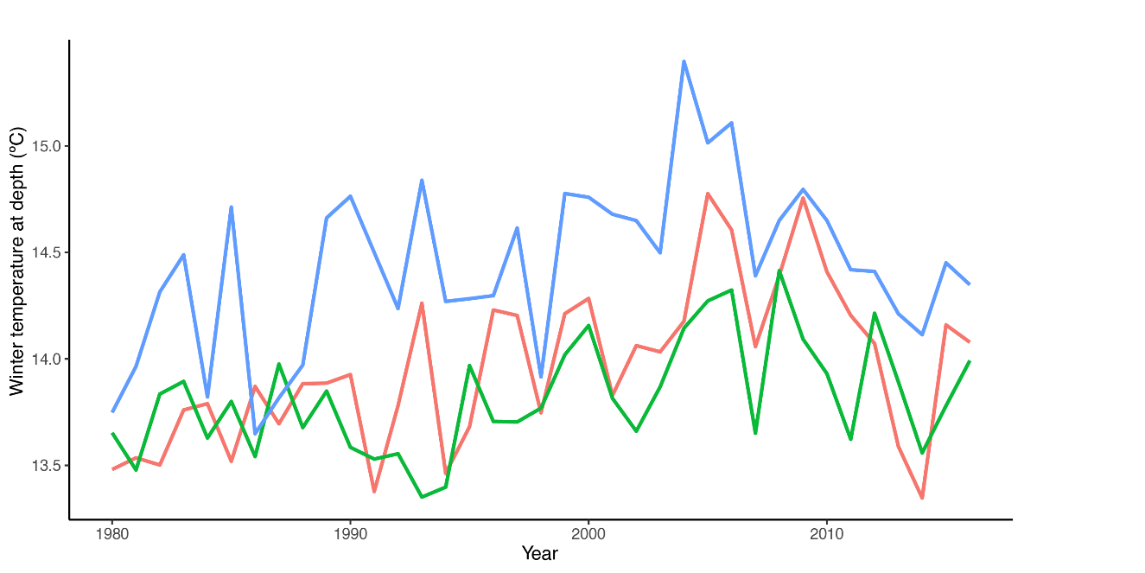
Supplementary Figure 3. Annual average winter temperature (January-March) at depth (98-618m) in Western (blue), Central (red), and Eastern (green) island groups of the Azores archipelago.

Supplementary Table 1. Summary of samples used in this study. N fish=number of individuals, N increments=number of otolith increments measured.

Sampling year | N fish | N increments | Furcal length range (cm) | Age range (years)
1995 | 27 | 393 | 30 – 53 | 7 – 21
1996 | 1 | 12 | 33 | 12
1997 | 8 | 119 | 37 – 44 | 10 – 19
1999 | 44 | 627 | 31 – 49 | 8 – 22
2000 | 14 | 182 | 30 – 45 | 8 – 22
2001 | 24 | 387 | 30 – 52 | 6 – 26
2002 | 34 | 407 | 30 – 44 | 6 – 21
2003 | 34 | 448 | 31 – 46 | 9 – 20
2004 | 35 | 498 | 30 – 47 | 6 – 22
2005 | 51 | 765 | 30 – 50 | 8 – 28
2007 | 50 | 677 | 31 – 48 | 8 – 21
2008 | 30 | 336 | 30 – 49 | 7 – 19
2010 | 29 | 429 | 32 – 49 | 8 – 22
2011 | 14 | 196 | 31 – 44 | 10 – 20
2012 | 20 | 267 | 31 – 41 | 9 – 20
2013 | 27 | 394 | 30 – 50 | 9 – 25
2016 | 45 | 688 | 30 – 50 | 9 – 20
2017 | 39 | 591 | 30 – 51 | 6 – 25
total | 526 | 7416 | 30-53 | 6-28

Supplementary Table 2. Results of random effect and fixed effect model optimization. The best-supported model, based on dAICc, is highlighted in bold. Random Age slopes for variables are denoted by “Age|variable”. Definitions of random and fixed terms are available in Supplementary Table 3. df=degrees of freedom, AICc=corrected Akaike information criterion, dAICc = difference in AICc between a particular model and the model with the lowest AICc, wAICc=Akaike weights.

Random effect structure
Random intercept | Random slope | df | AICc | dAICc | wAICc
FishID, IslandGroup:Year |  | 12 | 967.9 | 669.8 | <0.001
FishID, IslandGroup:Year | Age|FishID | 14 | 298.1 | 0.0 | 0.458
FishID, IslandGroup:Year | Age|FishID, Age|IslandGroup:Year | 16 | 302.0 | 3.9 | 0.064
FishID, IslandGroup:Cohort | Age|FishID | 14 | 304.0 | 5.8 | 0.025
FishID, IslandGroup:Cohort | Age|FishID, Age|IslandGroup:Cohort | 16 | 303.8 | 5.7 | 0.027
FishID,IslandGroup:Year, IslandGroup:Cohort | Age|FishID | 15 | 298.7 | 0.6 | 0.338
FishID,IslandGroup:Year, IslandGroup:Cohort | Age|FishID, Age|IslandGroup:Year | 17 | 302.5 | 4.4 | 0.050
FishID,IslandGroup:Year, IslandGroup:Cohort | Age|FishID, Age|IslandGroup:Year, Age|IslandGroup:Cohort | 19 | 303.1 | 5.0 | 0.038
Fixed effect structure
Terms |  | df | AICc | dAICc | wAICc
Age |  | 7 | 245.0 | 17.99 | 0.000
Age + Age-at-Capture |  | 8 | 243.6 | 16.52 | 0.000
Age + IslandGroup |  | 9 | 240.8 | 13.71 | 0.001
Age + Age-at-Capture + IslandGroup |  | 10 | 241.0 | 13.96 | 0.001
Age + Age-at-Capture:IslandGroup |  | 12 | 238.0 | 10.97 | 0.003
Age:IslandGroup |  | 11 | 229.9 | 2.88 | 0.162
Age:IslandGroup + Age-at-Capture |  | 12 | 230.1 | 3.03 | 0.150
Age:IslandGroup + Age-at-Capture:IslandGroup |  | 14 | 227.1 | 0.00 | 0.683

Supplementary Table 3. Summary of predictors used for linear mixed models. Data source: a - SODA3 (https://www.atmos.umd.edu/~ocean/)– accessed December 18, 2020; b - Data source: NOAA Climate Prediction Center (http://www.cpc.ncep.noaa.gov) – accessed October 20, 2019; c - Data source: LOTAÇOR (http://www.lotacor.pt) – accessed October 20, 2019.

Predictors | Description | Range | Mean
Fixed effects
Age | Age (years) in which increment was formed | 2 – 20 | 7.9
Age at capture | Age (years) at time of capture | 6 – 28 | 14.1
Temperatureª | Mean temperature (98-618m depth, ºC) | 12.94 – 15.40 | 13.98
NAO^{b} | North Atlantic Oscillation Index | -1.94 – 1.77 | 0.01
EAP^{b} | East Atlantic Pattern | -1.66 – 2.46 | 0.07
Landings^{c} | Annual landings in the Azores (tonnes) | 2052 – 838293 | 273567
Random effects
FishID | Unique identifier for each fish
Cohort | Group of fish spawned in the same year
Year | Year in which increment was formed
IslandGroup | Island group where individuals were captured
Age | Random age slope for FishID, Year and Cohort random intercepts

Supplementary Table 4. Among-individual (amongIDV; average winter temperature experienced by each individual over its lifetime) and within-individual (withinIDV; deviation of annual winter temperatures from amongIDV) variation. The best-supported model, based on dAICc, is highlighted in bold. Random slopes for variables are denoted by “x_variable|y_variable”. Interactions are denoted by “*”. Term definitions available in Supplementary Table 3. df=degrees of freedom, AICc=corrected Akaike information criterion, dAICc = difference in AICc between a particular model and the model with the lowest AICc, wAICc=Akaike weights.

Fit | Extra terms | df | AICc | dAICc | wAICc
Final extrinsic model | Age:IslandGroup + Age-at-Capture:IslandGroup | 14 | 287.2 | 7.5 | 0.0227
WithinAmong1 | amongIDV, withinIDV*IslandGroup | 18 | 309.4 | 29.7 | <0.001
WithinAmong2 | amongIDV, withinIDV, withinIDV|FishID | 19 | 279.7 | 0.0 | 0.9762
WithinAmong3 | amongIDV, withinIDV*IslandGroup, withinIDV|FishID | 21 | 293.3 | 13.6 | 0.0011

